GCSE Religious Studies
Islam: Practices

Name:

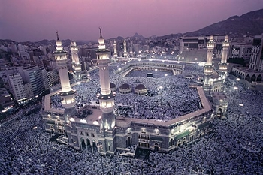

Five Pillars of Sunni Islam
Ibadah: worship
For Muslims, actions speak louder than words and it is not enough to just have faith in God. They believe that it is necessary to show religious commitment through the way they live their entire lives. Every action is a form of worship; this is called ibadah. People in Western countries sometimes think that religions are just sets of beliefs, or a collection of option faith-based activities. However, Muslims have always been very clear that Islam is a complete way of life; worship is a 24/7 reality, to be lived fully, not just as an afterthought to add on to our secular lives.
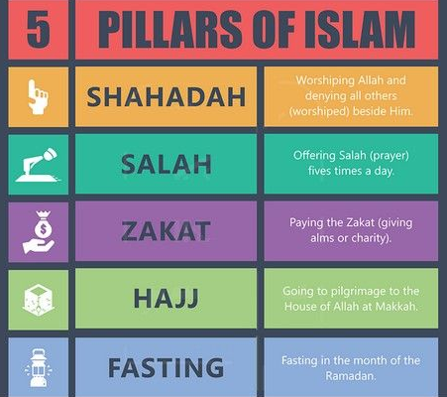
The Five Pillars
Sunni Islam teaches that all Muslims have a duty to worship God by following the Five Pillars. These actions are all ibadah, acts of worship carried out with the intention of obeying God. They are:
- Shahadah: the declaration of faith which says “There is no god but God and Muhammad is his prophet.”
- Salah: prayer, five times a day
- Zakah: charity, giving money to the poor
- Sawm: fasting during the month of Ramadan
- Hajj: pilgrimage to Makkah
By following these rules, Muslims believe that they can show their obedience to the will of God. The Shari’ah (Islamic Law) sets out the Five Pillars as religious duties; they are seen as practical signs which demonstrate true submission to the divine creator.
They must be carried out with niyyah, the true intention to submit to the will of God. Muslims say that there can be no doubt that they have been instructed by God to complete the Five Pillars: the Qur’an contains many references as to their importance and, in his last sermon, Prophet Muhammad makes clear mention of them:
“O People, listen to me in earnest, worship God, perform your five daily prayers, fast during the month of Ramadan and offer Zakah. Perform Hajj if you have the means.” (Hadith)
Niyyah: Intention
Niyyah means having the right intention to worship God. Muslims believe that it is important to have God consciousness (taqwa). They may not always be in the right mood to worship God, or they may feel unworthy to meet him, but when praying it is important to dedicate that time to being in his presence. Sometimes there may be a strong feeling that God is present and at other times he may seem distant, but God is merciful and judges the desire to communicate with him, even if we feel we do not succeed.
Five Pillars: Questions
- What is ibadah?
………………………………………………………………………………………………………………………...
- For Muslims, what else is Islam, other than a religion?
………………………………………………………………………………………………………………………...
- What are the Five Pillars acts of?
………………………………………………………………………………………………………………………...
- What is Shahadah?
………………………………………………………………………………………………………………………...5. What is Salah?
………………………………………………………………………………………………………………………...
- What is Zakah?
………………………………………………………………………………………………………………………...
- What is Sawm?
………………………………………………………………………………………………………………………...
- What is Hajj?
………………………………………………………………………………………………………………………...
- What does following the Five Pillars demonstrate?
………………………………………………………………………………………………………………………...
- What is niyyah?
………………………………………………………………………………………………………………………...

Shahadah: The Declaration of Faith
The First Pillar
The first pillar of Islam is the Shahadah. It declares that ‘there is no god but God, and Muhammad is the prophet of God.’ This statement forms the central support for the ‘House of Islam’: the other four pillars are all outward expressions of this deeply held belief.
The Shadadah sums up the religion of Islam: the belief in the one and only almighty God and the acceptance of Muhammad as the final messenger, a man sent by God to reveal the divine path to life (the Shari’ah).
“God witnesses that there is no deity except Him, and [so do] the angels and those of knowledge – [that He is] maintaining [creation] in justice. There is no deity except Him, the Exulted in Might, the Wise.” (Qur’an 3:18)
A statement of faith
For Muslims, the words of the Shahadah are heard throughout the day in countless aspects of their lives. They are announced in the adhan (call to prayer) from the minaret in the mosque and recited in each of the five daily prayers. These words are also known as the Kalimah prayer. They are the first words whispered into a new-born baby’s ear and, if possible, they are the last words a dying Muslim hears on their death-bed. Muslim soldiers have these words on their lips as they go into battle.
Monotheism
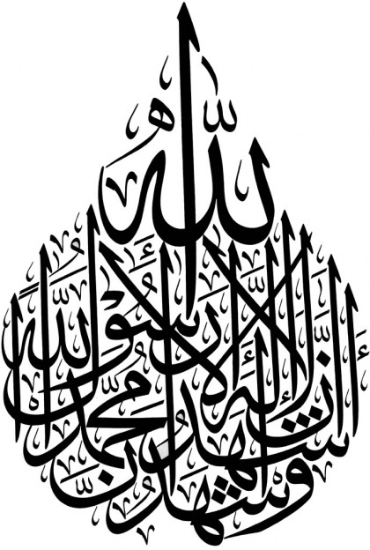
The Shahadah states the existence of one God; this is called monotheism. This means that Muslims reject belief in many gods (polytheism) and they oppose the atheist concept of a world without a God. The Shahadah also denies the Christian belief in the Trinity (Father, Son and Holy Spirit). Muslims have a deep respect for Jesus (Isa) but to them he is a great prophet, not a divine being. Islam (like Judaism and Sikhism) declares that God is one.
Conversion or reversion
There are no ceremonies or rituals to welcome new believers to Islam. All one needs to do to become a Muslim is to recite the Shahadah. Some refer to this as conversion, to change from one religion to another; others call it reversion. They say that, because God is our creator, we were all born as worshippers of the true God and so when we discover faith we return (revert) to our natural faith.
Famous converts
Famous people who have converted (or reverted) to Islam include: Yusuf Islam (Cat Stevens), Muhammad Ali, Mike Tyson, Janet Jackson and Malcolm X.
‘The Prophet said: “Whoever says: there is no god but God enters paradise.”’ (Hadith)
Shahadah: Questions
- What is the first pillar of Islam called and what does it declare?
………………………………………………………………………………………………………………………...
- When is the Shahadah heard in everyday life?
………………………………………………………………………………………………………………………...
- When else is the Kalimah prayer said?
………………………………………………………………………………………………………………………...
- What do Muslim soldiers do when going into battle?
………………………………………………………………………………………………………………………...5. What is monotheism?
………………………………………………………………………………………………………………………...
- What do Muslims believe about Jesus (Isa)?
………………………………………………………………………………………………………………………...
- What do Muslims call ‘conversion’?
………………………………………………………………………………………………………………………...
- Why do Muslims believe in ‘reversion’?
………………………………………………………………………………………………………………………...
- Name three people who famously converted (reverted) to Islam.
………………………………………………………………………………………………………………………...
- What did the Prophet say in the Hadith?
………………………………………………………………………………………………………………………...
Salah
The Second Pillar
Salah means bowing or worship. There are over 700 verses in the Qur’an that refer to it!
The second pillar of Islam is Salah, the practice of prayer. For Muslims, prayer is the most important way to worship God. It is a duty for all Muslims to pray five times a day. Muhammad called prayer the ‘pillar of religion’ and it reminds them to give thanks for God’s blessings and of the importance of submitting to God’s will. It is a physical, mental and spiritual activity that draws believers closer to God.
Preparation for prayer
Preparation for prayer is vital because coming into the presence of God requires a deep sense of respect and reverence. Prayer begins with a declaration of intent (niyyah). It must be a deliberate act, to set aside a few minutes to focus on God and enter into a state of ‘God consciousness’. This allows Muslims to concentrate on God’s greatness, to thank and praise him and ask for his forgiveness.
Wudu: ablution (washing)
Before starting to pray, Muslims must practise wudu, washing specific parts of the body: hands, mouth, nose, face, arms, head and feet, in a particular order. This is an outward sign of the inner cleanliness needed to face God.
How to pray
The Qur’an and the Sunnah give Muslims clear guidance on how and when to pray. Salah takes place five times a day:
- Fajr (just after dawn)
- Zuhr (just after midday)
- As’r (late afternoon)
- Maghrib (just after sunset)
- Isha (after dark)
Muslims must find somewhere with a room to stand, bow and prostrate themselves (kneeling with their face to the ground). This can be at the mosque, at home or anywhere safe and clean. Muslims pray by facing Makkah; this direction is called Qibla.
The rak’ahs
A rak’ah is a sequence of movements, following a set pattern, which make up the prayer routine. The different prayers during the day require different numbers of rak’ahs. During worship the worshipper will:
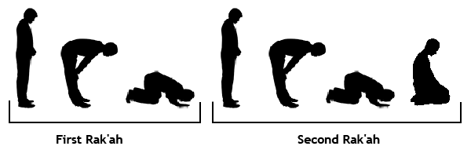
- Stand quietly, reciting the prayers from the Qur’an
- Bow low, with hands on knees
- Prostrate on the floor, in submission to God
Mosque or masjid is a place of prostration for Muslims; it is a communal place of worship for a Muslim community.
- Kneel with feet folded up under body
- Stand, reciting ‘Peace be upon you, and God’s blessing’, once facing to the right, once facing to the left
The aims of prayer:
- As a constant reminder of the presence of God
- To show submission to the will of God
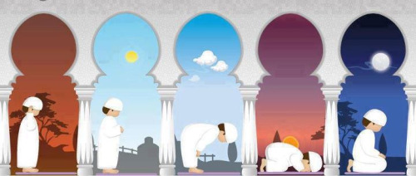
- To cleanse away the corruption of the world
- To unite all Muslims
- To bring about peace in the world
- To remove sins, just as water removes dirt
Jumu’ah (congregational) prayers
In Islam, Friday is the day when Muslims come together at the mosque for Jumu’ah (congregational) prayer. Muslim men are expected to gather for the Friday midday (Zuhr) prayers. Muslim women may attend these community prayers, but traditionally they pray at home. One of the main features of the Jumu’ah prayers is the sermon (khutbah) given by the imam. Unlike the Sabbath for Jews and Christians, Friday is not seen as a ‘holy’ day. In some Muslim countries it is a day of rest, but in Western countries it may well be a working day.
Du’a (personal) prayer
The Salah prayers are a duty for all Muslims, five times a day, but people who love God will often choose to find time to make their own, personal connection with God. There are no set times for Du’a prayers; they are spontaneous opportunities to spend time in the presence of God.
Missed prayers
Muslims should try to pray at the allocated times, set out clearly in the Islamic prayer schedule for every day of the year, but if they miss a prayer then it is acceptable to catch up later. However, it would be seen as a sin to miss prayers regularly without a valid reason.
“If one of you sleeps and misses a prayer, or forgets it, let him offer the prayer when he remembers.” (Hadith)
Why do Muslims pray five times a day?
Both the Qur’an and the Hadith contain Prophet Muhammad’s night journey. In the story, Muhammad is woken from his sleep and taken on a winged horse to Jerusalem and then up through seven levels of heaven, to the very presence of God. Here, God reveals to Prophet Muhammad that Muslims must pray continuously, 50 times a day. Worship must be a constant presence throughout life. However, Moses intervenes and says this is too much and eventually it was agreed that there must be five prayer times each day.
Salah: Questions
- What is the second pillar of Islam called and what does it remind Muslims to do?
………………………………………………………………………………………………………………………...
- What does prayer begin with?
………………………………………………………………………………………………………………………...
- What is wudu and what does it symbolise?
………………………………………………………………………………………………………………………...
- How many times a day does Salah take place?
………………………………………………………………………………………………………………………...5. What are the rak’ahs?
………………………………………………………………………………………………………………………...
- State three aims of prayer.
………………………………………………………………………………………………………………………...
………………………………………………………………………………………………………………………...
………………………………………………………………………………………………………………………...
- What are Jumu’ah prayers?
………………………………………………………………………………………………………………………...
- What is the difference between male and female worship on the Sabbath?
………………………………………………………………………………………………………………………...
- What is Du’a?
………………………………………………………………………………………………………………………...
- What happens if a Muslim misses his/her prayers?
………………………………………………………………………………………………………………………...
- What do Muslims pray five times a day?
………………………………………………………………………………………………………………………...
………………………………………………………………………………………………………………………...
Zakah: Charity
The Third Pillar
The third pillar of Islam is Zakah, the practice of charity, giving money to the poor. All Muslims are expected to be charitable as a regular duty, giving 2.5% of their wealth every year. They can be sure that God will reward them for their acts of giving.
Be generous and kind
The Qur’an makes a clear command: to give to those in need, to widows, orphans and travellers. It is an obligation and a form of worship to be generous and kind for the benefit of humanity. Zakah is closely associated with prayer; what value is it to pray for others if you are not prepared to share with them?
Zakah is purity
Giving a sign of cleansing and purity. The Qur’an teaches that money may have a corrupting influence; wealth can be an evil thing because it may cut us off from each other and from God. Zakah is a purifying influence, giving us the opportunity to share our wealth and offering us a means of purification.
Wealth is not ours; it must be shared
According to Islam, our wealth and our property are not ours; wealth is given to us by God, for the benefit of all humans. It is our duty to share the good fortune that we have received, not to hoard it and spend it purely for selfish reasons. Islam disapproves of gambling. Money should be shared, not wasted for personal satisfaction. Gambling is seen as a great sin, because it makes people dependent on chance rather than relying on God to provide.
Humans are khalifahs (stewards)
The Qur’an teaches that humans are khalifahs (God’s representatives on earth). This means that we are stewards and trustees of the world; we do not own it, we are looking after it in trust, for God, to hand it on to our children and to future generations. Therefore, we should not view our possessions as our own; they are on loan to us from God, so we do not have the absolute right to spend our money as we choose.
Prophet Muhammad practised Zakah
The practice of giving Zakah began when Prophet Muhammad was the ruler in Madinah. After the first battles, there were many orphans and widows and the prophet instructed people to care for all those in need.
“The one who looks after and works for a widow and for a poor person is like a warrior fighting for God’s cause.” (Hadith)
Zakah: Questions
- What is Zakah?
………………………………………………………………………………………………………………………...
- What percentage of their wealth must Muslims give per year?
………………………………………………………………………………………………………………………...
- What is giving to charity a form of?
………………………………………………………………………………………………………………………...
- What sort of influence can Zakah have?
………………………………………………………………………………………………………………………...5. Why must wealth be shared?
………………………………………………………………………………………………………………………...
- What is seen as a great sin?
………………………………………………………………………………………………………………………...
- What are khalifahs?
………………………………………………………………………………………………………………………...
- What do Muslims consider ‘on loan’ to us from God?
………………………………………………………………………………………………………………………...
- How did the Prophet Muhammad practise Zakah?
………………………………………………………………………………………………………………………...
- What does the Hadith say about charity work?
………………………………………………………………………………………………………………………...

Sawm: Fasting During Ramadan
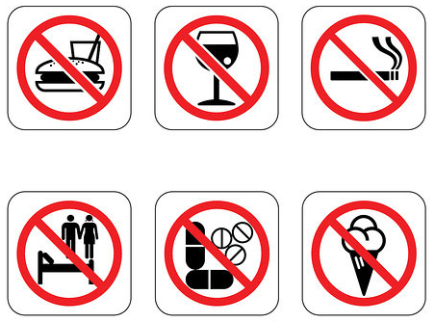
The Fourth Pillar
The fourth pillar of Islam is Sawm, the practice of fasting during the month of Ramadan. For many Muslims, it is the holiest month of the year, being a time dedicated to self-discipline and spiritual reflection. Ramadan holds a special place in the Muslim calendar, because it is believed to be the month in which the Prophet Muhammad received the first verses of the Qur’an, revealed to him by God.
Fasting: self-control
Fasting is the deliberate control of the body and Muslims are expected to refrain from eating, drinking (including water), smoking and sexual intercourse from dawn until dusk for the period of 29/30 days. They must also abstain from evil thoughts, harmful actions and unkind speech.
When to fast?
The beginning of Ramadan is marked by the appearance of the new (crescent) moon in the sky, signalling the start of a new month. It ends 29/30 days later with the beginning of the tenth month, Shawwal, heralding the start of celebrations for Id-ul-Fitr.
According to the Qur’an, the fast must begin each day at first light and continue until dusk. At dawn, eating and drinking must cease at the moment when it becomes light enough to distinguish a black thread from a white one. Food and drink may only be consumed again at the end of the day, after dark.
A special meal, known as suhur, is eaten before dawn. At dusk, the fast is broken by the iftar meal, often consisting of dates and water, before a bigger meal is shared. These meals during Ramadan are often very social events, with family, neighbours and friends gathering in homes and mosques to provide for each other. In this way, Ramadan brings a very happy, community focus to Islamic society.

Celebrating the Qur’an
During Ramadan, Muslims gather at the mosque for extra night prayers. This includes the recitation of a section of the Qur’an each day, so that by the end of the month, the whole Qur’an has been recited. All Muslims should try to attend the mosque on the 27th day of Ramadan to celebrate Laylat-ul-Qadr, the night of power. This is remembered as the date of the first revelation of the Qur’an, when the Angel Jibril first visited Prophet Muhammad.
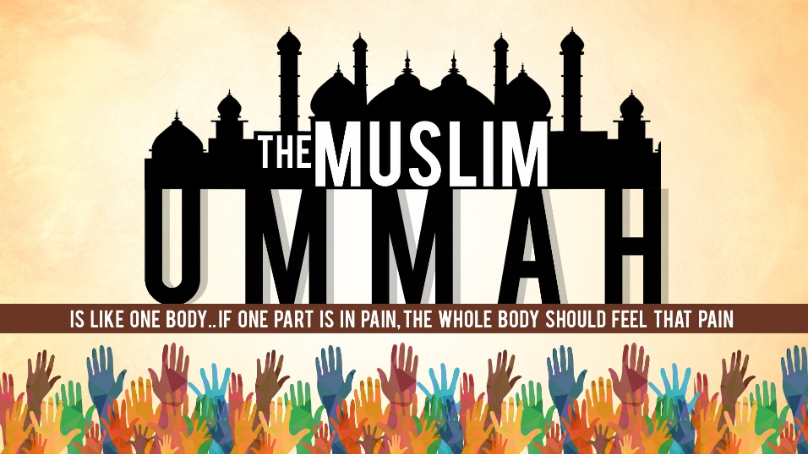
Why do Muslims fast?
Muslims believe that the fast is important because it:
- Is commanded in the Qur’an by God
- Follows the example of the Prophet Muhammad (Sunnah)
- Celebrates the fact that God has given humans the Qur’an
- Brings people closer to God
- Is a reminder of the mercy and blessings of God
- Helps Muslims to identify with the poor
- Promotes self-control
- Helps to recharge spiritual batteries
- Unties Muslim communities (ummah)
Who should fast?
God has instructed that all adult Muslims are to fast during Ramadan. Children, from quite a young age, often begin to fast for just a few days in the month. According to the Qur’an, if someone is ill or travelling they are exempt from fasting, although they would be expected to make up the days at a later time.
Some Muslims argue that fasting times should be standardised. Muslims who live in the Middle East (nearer to the equator) only ever have to fast for a maximum of 15 hours, whereas in an English summer, Muslims might need to fast for up to 19 hours each day. This is especially difficult for school students who are doing exams in the summer months.
Sawm: Questions
- What is Sawm?
………………………………………………………………………………………………………………………...
- Why is Ramadan special to Muslims?
………………………………………………………………………………………………………………………...
- What are Muslims expected to refrain from during their fast?
………………………………………………………………………………………………………………………...
- When do Muslims start and end their fast each day?
………………………………………………………………………………………………………………………...5. How does celebrating Ramadan bring the community together?
………………………………………………………………………………………………………………………...
- Where might Muslims gather at night?
………………………………………………………………………………………………………………………...
- Why should all Muslims attend the mosque on the 27th day of Ramadan?
………………………………………………………………………………………………………………………...
………………………………………………………………………………………………………………………...
- State four reasons why Muslims fast.
………………………………………………………………………………………………………………………...
………………………………………………………………………………………………………………………...
………………………………………………………………………………………………………………………...
………………………………………………………………………………………………………………………...
- Who is exempt from fasting?
………………………………………………………………………………………………………………………...
- Why do some people believe that fasting times should be standardised?
………………………………………………………………………………………………………………………...
………………………………………………………………………………………………………………………...
Hajj: Pilgrimage to Makkah
The Fifth Pillar
The fifth pillar of Islam is Hajj, the pilgrimage to Makkah. This is the only pillar of Islam that Muslims don’t have to perform. It is compulsory for those who are able to make the journey, but the Qur’an only commands it as a duty for those who:
The Qur’an instructs believers to go on Hajj, but does not specify many details. The Sunnah describes the pilgrimages the Prophet Muhammad performed and how he worshipped in Makkah. This forms the pattern for today’s pilgrimage.
- Have enough money to leave their homes for a lengthy period
- Are physically and mentally fit enough to carry out this demanding ritual
For most Muslims, to set out for the Hajj would be the ambition of a lifetime. Those who have succeeded in completing it often count it as the greatest achievement of their lives. Hajji (male) or Hajjah (female) is the special title given to someone who has successfully completed the Hajj pilgrimage. This is a great honour.
The importance of Makkah
Makkah is considered by Muslims to be the holiest city on earth. Because it is the city of God, it has immense spiritual significance in Islam. Muslims believe that it is here that:
- Prophet Ibrahim (Abraham) was commanded by God, in a dream, to sacrifice his son, Isma’il
- Ibrahim overcame a test when the devil appeared, trying to trick him into denying God’s word. Ibrahim threw stones to drive the devil away
- Ibrahim’s wife, Hajar, searched frantically for water in the desert. Miraculously, an angel showed her the Zamzam well
- Ibrahim built the Ka’ba as a place of worship to the one true God
- Prophet Muhammad was born
Ihram is a sacred state of purity, symbolised by the white garments worn on Hajj. Muslims must make a special intention (niyyah) to dedicate themselves to worshipping God when they arrive in Makkah. Hajjis/Hajjahs are often buried in these white garments, at the end of their lives, to remind God of their dedication to worship him.
- Prophet Muhammad received the first revelations from God
- Prophet Muhammad returned before his death to reclaim the city for God
The route of the Hajj pilgrimage takes believers to the sacred sites where many of these events are said to have taken place.
Preparations: entering a state of ihram
On arriving in Makkah, pilgrims enter a state of ihram (purity), where they dedicate themselves to humility and prayer. Normal clothing is put away and the pilgrims put on special garments: men must wear two sheets of white, unsewn cloth; women must put on a plain, ankle-length garment, but they can leave their faces uncovered, since no man will stare lustfully at a woman on Hajj.
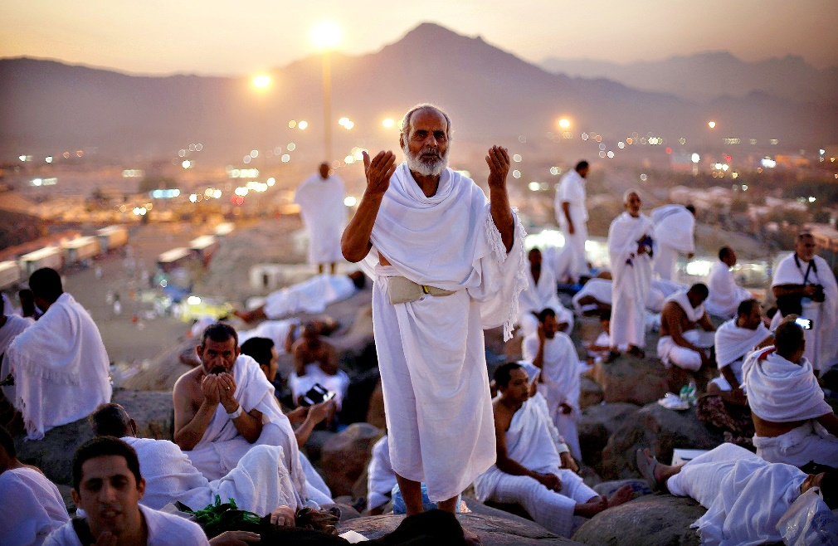
British Muslims undertaking Hajj
Every year, about three million Muslims from around the world converge on Makkah for the annual Hajj pilgrimage. Of these, 100,000 will be from Britain; some will be returning having made the pilgrimage before, others will be experiencing it for the first time. For many it will be a deeply spiritual experience.
The pilgrimage begins
The pilgrimage usually lasts five days. It includes:
- The tawaf: circling the Ka’ba seven times. If they can get close enough, pilgrims try to kiss the Black Stone
- Walking seven times between two hills of Mawah and Safa, in memory of Hajar, Ibrahim’s wife, in her frantic search for water for her son
- Drinking from the Zam Zam well, remembering the spring of water revealled to Prophet Ibrahim’s wife Hajar by the angel
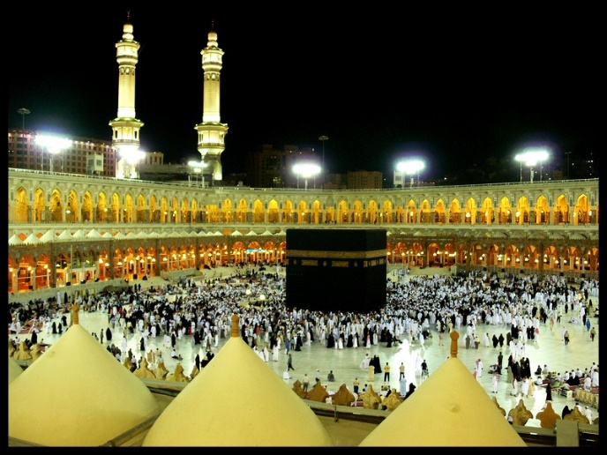
- The wukuf: standing before God on the Plain of Arafat, at the Mount of Mercy, remembering God’s mercy and forgiveness. This is, perhaps, the most important part of the whole Hajj
- Collecting pebbles at Muzdalafah
- Hurling these pebbles at the pillars at Mina to show rejection of the devil, as Ibrahim did when faced with temptation
- Camping at Mina, sacrificing an animal
- Men shaving their heads when Hajj is complete
- Returning to Makkah to repeat the tawaf (circling the Ka’ba)
The climax of the Hajj is the annual festival of Id-ul-Adha, the most important of all Muslim celebrations. This is a special time for the pilgrims, because this part of the Hajj is celebrated by all Muslims, whether they have made the journey to Makkah or not. It is an opportunity for the Muslim community (ummah) to join together in worship of God.
Hajj: Questions
- What is Hajj?
………………………………………………………………………………………………………………………...
………………………………………………………………………………………………………………………...
- Who is Hajj a duty for?
………………………………………………………………………………………………………………………...
………………………………………………………………………………………………………………………...
- What are the titles given to men and women who have completed Hajj?
………………………………………………………………………………………………………………………...
- Give three reasons why Makkah is considered important.
………………………………………………………………………………………………………………………...
………………………………………………………………………………………………………………………..
………………………………………………………………………………………………………………………...5. What is ihram?
………………………………………………………………………………………………………………………...
………………………………………………………………………………………………………………………...
- When dead, why are Hajjis/Hajjahs buried in their white Hajj garments?
………………………………………………………………………………………………………………………...
………………………………………………………………………………………………………………………...
- Why can a woman leave her face uncovered during Hajj?
………………………………………………………………………………………………………………………...
………………………………………………………………………………………………………………………...
- What is the tawaf?
………………………………………………………………………………………………………………………...
………………………………………………………………………………………………………………………...
- Which two hills do pilgrims walk between and why do they do it?
………………………………………………………………………………………………………………………...
………………………………………………………………………………………………………………………...
- Why do pilgrims drink from the Zam Zam well?
………………………………………………………………………………………………………………………...
………………………………………………………………………………………………………………………...
- What is the wukuf?
………………………………………………………………………………………………………………………...
………………………………………………………………………………………………………………………...
- Where are pebbles collected from?
………………………………………………………………………………………………………………………...
………………………………………………………………………………………………………………………...
- Why throw pebbles?
………………………………………………………………………………………………………………………...
………………………………………………………………………………………………………………………...
- What is the climax of Hajj?
………………………………………………………………………………………………………………………...
………………………………………………………………………………………………………………………...
- Why is this annual festival important to the ummah?
………………………………………………………………………………………………………………………...
………………………………………………………………………………………………………………………...

Jihad: Striving for Right
What is jihad?
Jihad is the struggle to live according to God’s laws. It is one of the most misunderstood worlds in Islam, because to many people ‘jihad’ means ‘holy war’, but in fact it has a deeper meaning than this. Jihad actually means ‘directed struggle’:
Jihad means ‘to strive’. There are two forms of jihad: the greater jihad is the daily struggle and inner spiritual striving to live as a Muslim. The lesser jihad is a physical struggle or ‘holy war’ in defence of Islam.
- Striving to serve God
- Making an effort to live a moral life
- Actively trying to live in peace
The greater jihad and the lesser jihad
Muslims make a distinction between the greater jihad (the personal struggle for right) and the lesser jihad (the desire to remove evil from society). It is the duty of all Muslims to try to remove evil from society, but you can only fight for justice in the world when you have truly removed the evil from your own life.
Prophet Muhammad said that the supreme jihad is against oneself.
The greater jihad
The greater jihad is a spiritual struggle with oneself. It is the desire and commitment to live the perfect Muslim life:
- To perform the Five Pillars with devotion
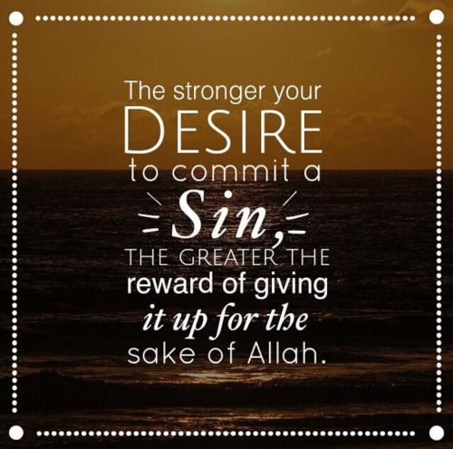
- To practise the path set out by the Prophet Muhammad
- To seek justice and fairness for all
- To rise above one’s own greed and selfishness
The need to control desires
Islam teaches than Muslims need to control their own desires and behaviour, to follow the Five Pillars and live a life that is pleasing to God. This will ensure that when the last day comes, and they are brought to judgement by God, they will be worthy to receive God’s favour and thus to enter paradise.
The battle against laziness
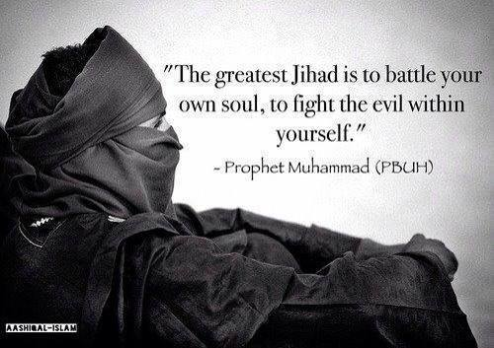
There is a prayer of Prophet Muhammad which says: “God, I seek thy protection against helplessness and laziness, and against cowardice…and miserliness.” This describes the greater jihad. It is the commitment to make the effort to be a better person and live as God has instructed.
The greater jihad is the spiritual fight against the tendency to be lazy: to get up for prayers before dawn, to only eat food that is halal (permitted), to show kindness and generosity towards other people.
Encourage what is right
The Qur’an urges Muslims to ‘encourage what is right (ma’ruf), and forbid what is wrong’ (3:104). This process is partly about removing evil from yourself, but also about making the world a better place. Prophet Muhammad says, “Whoever amongst you sees an evil, he must change it with his hand. If he is not able to do so, then with his tongue. And if he is not able to do so, then with his heart, and that is the weakest form of faith.” (Hadith)
Respect for the beliefs of others
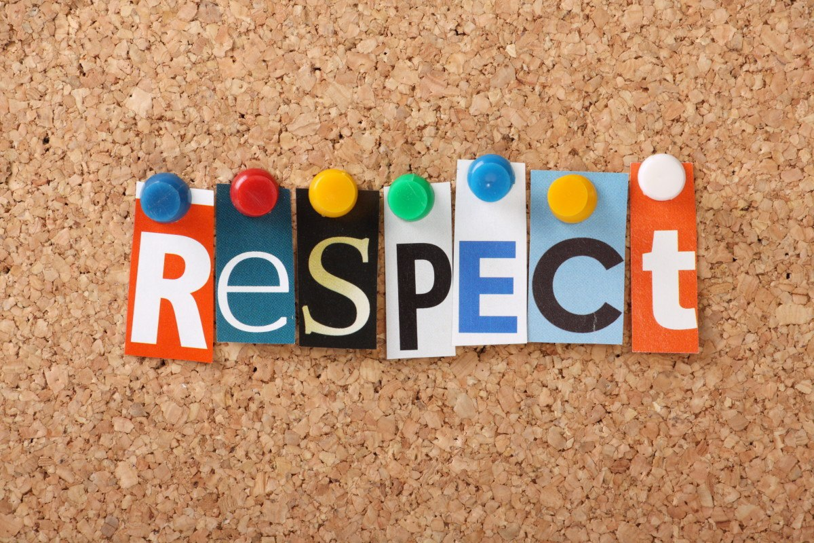
The Qur’an encourages Muslims to be tolerant and respectful towards the beliefs of others. ‘To you be your religion, and to me mine’ (109:6) Muslims should live in peace and harmony in society, celebrating differences and obeying the law.
The Qur’an makes it clear that every single life is precious: “If anyone slew a person…it would be as if he slew the whole people; and if anyone saved a life, it would be as if he saved the life of the whole people.”

Jihad: Questions
- What is jihad?
………………………………………………………………………………………………………………………...
- What is the difference between the greater jihad and the lesser jihad?
………………………………………………………………………………………………………………………...
………………………………………………………………………………………………………………………...
- What did the Prophet Muhammad say about the supreme jihad?
………………………………………………………………………………………………………………………...
- What four things are included in living the perfect Muslim life?
………………………………………………………………………………………………………………………...
………………………………………………………………………………………………………………………..
………………………………………………………………………………………………………………………..
………………………………………………………………………………………………………………………...5. What will controlling your desires ensure?
………………………………………………………………………………………………………………………...
………………………………………………………………………………………………………………………...
- What is the battle against laziness?
………………………………………………………………………………………………………………………...
………………………………………………………………………………………………………………………...
- What is ma’ruf?
………………………………………………………………………………………………………………………...
………………………………………………………………………………………………………………………...
- What does the Qur’an say about respecting other life / the beliefs of others?
………………………………………………………………………………………………………………………...
………………………………………………………………………………………………………………………...
………………………………………………………………………………………………………………………...
Lesser Jihad: (Holy War)
There are certain circumstances in which Islam accepts that force needs to be used, but only ever in self-defence. While the greater jihad is the personal struggle against sin, the lesser jihad or holy was is the struggle to remove evil from society. This involves the whole community, rather than the individual, and there are strict rules for the use of force in jihad. “To those against whom war is made, permission is given to fight, because they are wronged.” (Qur’an 22:39)
Lesser jihad or military jihad is sometimes known as ‘jihad with the sword’ or holy war.
The origin of lesser jihad
The concept of lesser jihad arose during the Prophet Muhammad’s lifetime, when he gave his faithful followers authorisation to fight. Muhammad’s enemies in Makkah planned to wipe out all the Muslims and do they believed that there was no choice but to engage in conflict.
“Permission [to fight] has been given to those who are being fought, because they were wronged. And indeed, God is competent to give them victory." (Qur’an 22:39)
This passage records the permission given by God for the Muslims to defend themselves against their enemies. Some argue that war with such a pure motive (to establish the principles of religious freedom) is a true jihad.
“Fight in the way of God whose who fight against you but do not transgress. Indeed, God does not like transgressors.” (Qur’an 2:190)
Jihad must never be aggressive
The Qur’an lays down the condition that the Muslims must not be the first to attack; a war of aggression is prohibited. However, if it can be agreed that a war is a ‘jihad’, then it is a duty to fight back, but only against those who are attacking you, never to kill civilians.
Who can declare jihad?
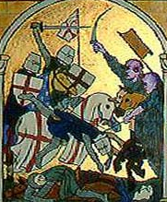
Muslim law is clear that jihad can only be declared by a Muslim leader who is holy and pure and who has the support of the whole Muslim community. Some Muslim communities do believe their leaders are able to declare jihad. However many Muslims today say that it is difficult to see how these conditions for jihad could be met, because there is no one, indisputable Muslim ruler who would be eligible to declare it.
The Crusades
Many Muslims would say that it was a jihad when Muslims fought against the Christians in the Middle Ages. The crusades were military campaigns by Christians between 1095CE and 1291CE. Their aim was to win back the Holy Land for Christianity, from Muslim control, and in 1099CE they succeeded in re-taking Jerusalem. Muslims vowed to wage jihad (holy war) against the invaders from Europe and the Muslim armies eventually defeated the Christian Crusaders.
Jihad today
Today, most Muslims agree that a holy war can only be called against an aggressor that threatens Islam. Some Islamic extremist groups argue that the attack on the World Trade Centre (the Twin Towers) in New York, on September 11 2001, commanded by Osama Bin Laden, was an act of jihad. However, moderate Muslims reject this idea, arguing that this attack was an aggressive act, which targeted innocent civilians and so fails the test set by the Qur’an.
The rise of jihadist groups
The Muslim Council of Britain (MCB) speaks on behalf of British Muslims. They have strongly condemned the actions of IS, saying they are horrified by the group’s “twisted message” and barbarous behaviour. The #notinmyname hashtag has been widely used to make it clear that IS does not represent the view of British Muslims.
There are a number of groups who have labelled themselves as jihadists in recent years (for example, Al-Qaeda, Boko Haram, Islamic State/Daesh). They are prepared to use violence in order to create an Islamic State that would be governed in accordance with Islamic (Shari’ah) law. Western governments regard these groups as terrorist organisations and moderate Muslims reject this form of extreme Islam.
In 2014, jihadi fighters, saying they were loyal to Islam, captured large areas of Northern Syria and Iraq, setting up what they called a ‘caliphate’. This is a state governed in accordance with Islamic (Shari’ah) law. Islamic state (IS) say they want to restore God’s rule on earth and defend the ummah (Muslim community) against infidels (non-believers).
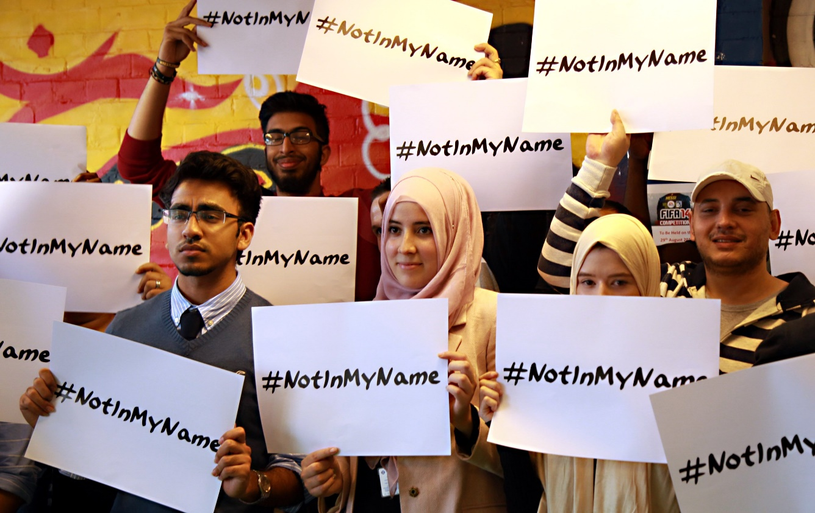

Lesser Jihad: Questions
- What is the lesser jihad?
………………………………………………………………………………………………………………………...
- Where does the idea of the lesser jihad (holy war) come from?
………………………………………………………………………………………………………………………...
………………………………………………………………………………………………………………………...
- What must Muslims not do in a holy war?
………………………………………………………………………………………………………………………...
- Who can declare jihad? What is the problem with this?
………………………………………………………………………………………………………………………...
………………………………………………………………………………………………………………………..
5. What happened in the Crusades?
………………………………………………………………………………………………………………………...
………………………………………………………………………………………………………………………...
- Why do moderate Muslims reject the attack on Sep 11, 2001 as jihad?
………………………………………………………………………………………………………………………...
………………………………………………………………………………………………………………………...
- What are jihadist groups prepared to do?
………………………………………………………………………………………………………………………...
………………………………………………………………………………………………………………………...
- Who are the Muslim Council of Britain and what do they believe about IS?
………………………………………………………………………………………………………………………..
………………………………………………………………………………………………………………………...
- What is the aim of extremist Muslims/jihadi fighters?
………………………………………………………………………………………………………………………...
………………………………………………………………………………………………………………………...
Festivals in Islam
Feasts and festivals have always been a part of human society. They are special because they mark times when families and communities can gather to remember, celebrate and offer thanksgiving. They may be anniversaries of important events or re-enactments of ancient rituals. All Muslim festivals have special significance, often relating to events or stories from Islamic history. However, festivals in Islam are not just moments of joy and happiness, they are also occasions to worship and remember the presence of God.
Id: the Muslims word for festival. It means ‘an event that returns every year.’
Moderation not excess
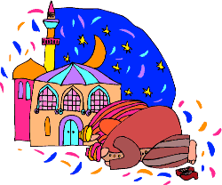
Islam has relatively few holidays and Muslim festivals are usually quite restrained events. Islam is a religion of moderation: the Qur’an forbids indulgence and extravagance and Muslims are instructed not to eat so much as to fill the whole stomach. Prophet Muhammad encouraged his followers not to drink water greedily, in one gulp, but to pause and sip. The Prophet Muhammad said: “He is not a Muslim who goes to bed with a full stomach while his neighbour goes hungry.”
One of the central features of Muslim festivals is the importance of sharing happiness with others and, in particular, giving to the needy and poor.
Festivals in Islam
There are two main festivals in Islam: Id-ul-Adha and Id-ul-Fitr, but there are also other important days to be remembered.
Mawlid an-Nabi: the birth of the prophet
Mawlid an-Nabi is the celebration of the birth of the Prophet Muhammad. It is a public holiday in many countries. In Britain, Muslims celebrate this day with joyful processions through the streets, chanting stories in praise of his life.
Laylat-ul-Qadr: the Night of Power
Laylat-ul-Qadr is one of the holiest days in the Muslim calendar, marking the date when the Qur’an was first revealed to the Prophet Muhammad. Islamic tradition is not certain of the exact day, so this event is remembered throughout the last ten days of the month of Ramadan. During this time, Muslims may stay up all night, reciting the Qur’an, praying and remembering God’s mercy and forgiveness.
Laylat-ul-Miraj: the night journey
Laylat-ul-Miraj remembers Prophet Muhammad’s miraculous journey on a winged horse to Jerusalem and then up through the heavens into the presence of God. Today, Muslims commemorate these events at the mosque by saying particular prayers and at home by telling the story to their children and reciting special night-time prayers.
Laylat-ul-Bara’at
Laylat-ul-Bara’at is the night of the full moon in the month before Ramadan. This is the night on which Muhammad used to begin his preparations for Ramadan and many Muslims stay up all night reciting the Qur’an.
Muharram
Muharram is the first month of the Islamic calendar and it remembers the Hijrah, when Muhammad and his followers fled from Makkah, to establish the first Muslim community in Madinah. Sunnis fast on the tenth day of Muharram. Shi’as observe Muharram as the month when Husayn (Prophet Muhammad’s grandson) was martyred and so they refrain from joyous events in his memory.
Festivals in Islam: Questions
- What do festivals mark?
………………………………………………………………………………………………………………………...
- What are Muslims instructed not to do?
………………………………………………………………………………………………………………………...
- What are the two main festivals in Islam?
………………………………………………………………………………………………………………………...
- What does Mawlid an-Nabi remember? How is it celebrated?
………………………………………………………………………………………………………………………...
………………………………………………………………………………………………………………………..
- What does Laylat-ul-Qadr remember? How is it celebrated?
………………………………………………………………………………………………………………………...
………………………………………………………………………………………………………………………...
- What does Laylat-ul-Miraj remember? How is it celebrated?
………………………………………………………………………………………………………………………...
………………………………………………………………………………………………………………………...
- What does Laylat-ul-Bara’at remember? How is it celebrated?
………………………………………………………………………………………………………………………...
………………………………………………………………………………………………………………………...
- What does Muharram remember? How is it celebrated?
………………………………………………………………………………………………………………………...
………………………………………………………………………………………………………………………...
Id-ul-Adha: the Festival of Sacrifice
‘Adha’ means ‘sacrifice’
The ‘Big Id’
Id-ul-Adha is the festival of sacrifice. It is the most important event in the Muslim calendar and, to many, it is known as the Greater Id or the ‘Big Id’. It marks the end of the annual Hajj pilgrimage and it is a chance for all Muslims, across the world, to worship and celebrate together. For the Hajjis/Hajjahs, who have just completed Hajj, it is the culmination of five intense days of worship, but it is also special for those who have been unable to travel to Makkah, who will celebrate in their home communities.
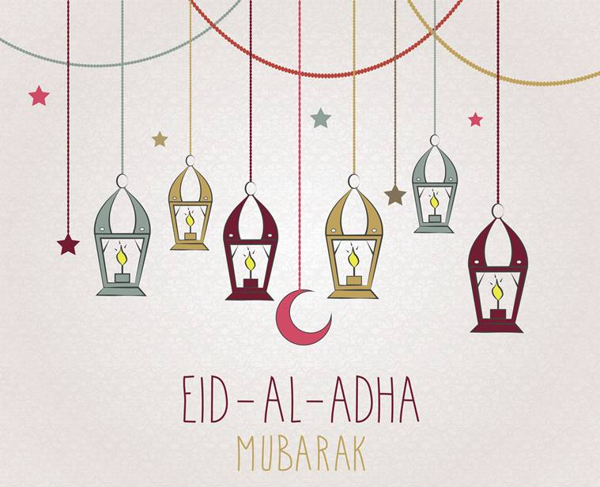
Ibrahim’s Commitment to God
At this time, Muslims remember the story of Ibrahim, told in the Qur’an. Ibrahim was willing to sacrifice his son, Ishma’il, to show his love for God. Just in time he heard a voice telling him to spare his son and sacrifice a sheep instead. Today an animal, such as a sheep or a goat, is killed at Id-ul-Adha as part of the commemoration. The meat is shared among family and friends, as well as being distributed to the poor.
In the story it tells how the devil came to tempt Ibrahim, but his faith was too strong. This symbolises how each individual has to struggle against sin and it shows the importance of total commitment to God.
True sacrifice
The Qur’an is very clear that it is not the physical act of killing an animal that is pleasing to God. What is truly valuable is the personal sacrifice that each individual makes in their heart, offering their life in service to God.
“Their meat will not reach God, nor will their blood, but what reaches Him is piety from you.” (Qur’an 22:37)
Preparations for Id-ul-Adha
This is a very important occasion for Muslim families and communities, so preparations begin in good time:
- Gifts are bought
- Clothes are made
- Food is prepared in advance
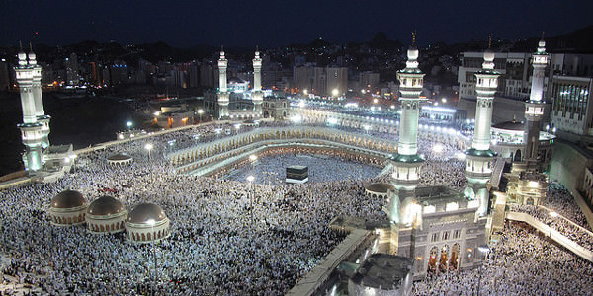
- Arrangements are made for the sacrifice

Celebrations
Id-ul-Adha is a public holiday in some countries where there are Muslim majority populations, such as Indonesia, Turkey and Jordan. It is not an official holiday in the UK, but some Muslim organisations and businesses may close and Muslim children have the day off school. Celebrations include:
- Going to the mosque to pray and listen to an Id prayer
- Wearing new clothes
- Visiting friends and relatives
Sacrificing an animal
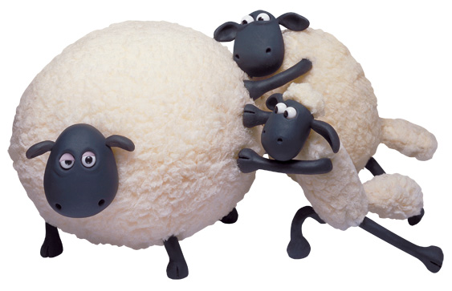
It is traditional for each Muslim family or community to buy and sacrifice their own animal, but in Britain it is illegal to kill and animal without a licence and most families do not have the space and skills to keep and kill and sheep or a goat! People may ask a butcher to slaughter a sheep for them; they will then share it amongst family and neighbours as a communal meal. Giving some of this meat to the poor is a sacred duty.

Id-ul-Adha: Questions
- What is Id-ul-Adha?
………………………………………………………………………………………………………………………...
- What does Id-ul-Adha celebrate or remember?
………………………………………………………………………………………………………………………...
………………………………………………………………………………………………………………………...
- What does the story of the devil tempting Ibrahim symbolise?
………………………………………………………………………………………………………………………...
- What is it about the sacrifice that is important to God?
………………………………………………………………………………………………………………………...
………………………………………………………………………………………………………………………..
5. What four ways do Muslims prepare for the festival?
………………………………………………………………………………………………………………………...
………………………………………………………………………………………………………………………...
- What is different about celebrating Id-ul-Adha in Muslim countries compared to Britain?
………………………………………………………………………………………………………………………...
………………………………………………………………………………………………………………………...
- How do Muslims celebrate Id-ul-Adha?
………………………………………………………………………………………………………………………...
………………………………………………………………………………………………………………………...
- What is a difficulty with wanting to sacrifice an animal in Britain?
………………………………………………………………………………………………………………………..
………………………………………………………………………………………………………………………...
- What is a sacred duty, if an animal is sacrificed?
………………………………………………………………………………………………………………………...
………………………………………………………………………………………………………………………...
Id-ul-Fitr: the Festival of Fast-Breaking
Breaking the fast
‘Fitr’ means ‘breaking the fast’. It shares the same root (ftr) as ‘iftar’, which is the light meal Muslims share when they break their fast at the end of each day during Ramadan.
At Id-ul-Fitr Muslims greet each other with the phrase: “id Mubarak”, meaning, ‘Happy Id’.
Id-ul-Fitr is a joyful three-day celebration which takes place at the end of Ramadan, on the start of a new month of Shawwal. It is a well-deserved reward for the completion of a monthof fasting, when Muslims thank God for giving them the strength and self-control needed to give up food and water over so many days. The festival begins with the new moon being observed in the sky, but in Britain, where the weather is often cloudy, Muslims often have to rely on getting the news from other countries.
A special day
In Muslim-majority countries, Id-ul-Fitr is a public holiday; in Britain, many Muslim businesses close and Muslim chidlren are often given a day off school, especially in areas where there is a high Muslim population. It is an occasion when people feel a strong sense of generosity and gratitude towards each other and to God.
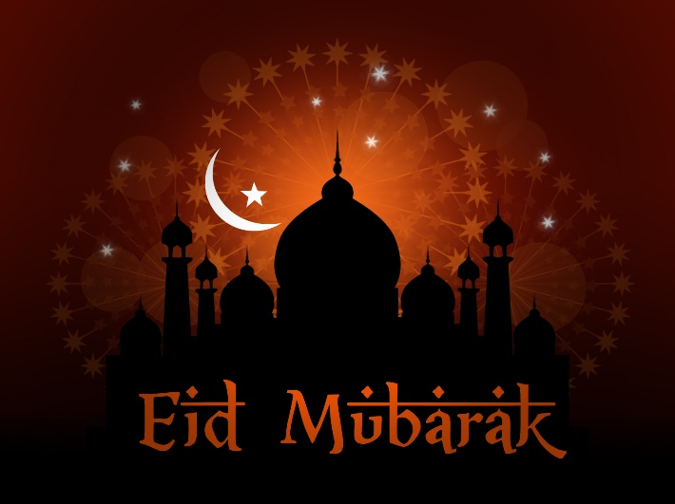
Celebrating Id-ul-Fitr in Britain
On the day of Id, Muslims will:
- Decorate their houses with colourful lights, banners and flags
- Dress in their finest, newest clothes
- Gather early in mosques or outdoors to perform congregational prayers and listen to a sermon, usually on the subject of sharing and community
- Send ‘Id Mubarak’ greetings cards
- Visit family and friends to share food and festivities
- Visit the cemetary to remember loved ones who have been divided from the family through death
- Give gifts and money to children
- Share a delicious meal, where everyone joins in with food preparation and organisation
- Give generously to the poor
Unusual ways to celebrate Id-ul-Fitr
Around the world there are many different ways in which Muslims celebrate Id-ul-Fitr:
- Egypt: fish recipes form the centrepiece of the feast
- Afghanistan: men gather in parks for egg fights. Armed with hard-boiled eggs, they try to break each other’s eggs
- Turkey: children are given sweets by neighbours and relatives
- India: women beautify themselves, applying henna to their hands and feet
Zakat-ul-fitr: festival tax
Islam places a high value on the whole community (ummah) experiencing the blessings and mercy of God, so in addition to the duty to pay the annual 2.5% Zakah tax, Muslims are expected to pay Zakat-ul-Fitr. This donation, given at the end of Ramadan, goes to the poor. It allows everyone, even those in poverty, to eat a generous meal at Id-ul-Fitr.

Id-ul-Fitr: Questions
- What is Id-ul-Fitr?
………………………………………………………………………………………………………………………...
- What do Muslims thank God for?
………………………………………………………………………………………………………………………...
………………………………………………………………………………………………………………………...
- When does the festival begin and why might this be a problem for Muslims in Britain?
………………………………………………………………………………………………………………………...
………………………………………………………………………………………………………………………...
- How is Id-ul-Fitr a special day?
………………………………………………………………………………………………………………………...
………………………………………………………………………………………………………………………...
5. State four things that Muslims do to celebrate the festival.
………………………………………………………………………………………………………………………...
………………………………………………………………………………………………………………………...
………………………………………………………………………………………………………………………...
………………………………………………………………………………………………………………………..
- What are some unusual ways of celebrating Id-ul-Fitr?
………………………………………………………………………………………………………………………...
………………………………………………………………………………………………………………………...
- What is Zakat-ul-Fitr?
………………………………………………………………………………………………………………………...
………………………………………………………………………………………………………………………...
- What does the festival fax ensure?
………………………………………………………………………………………………………………………..
………………………………………………………………………………………………………………………...
Ashura: Day of Sorrow and Inspiration
Ashura is an important festival for all Muslims, but it has enormous significance in Shi’a Islam. It is celebrated (or commemorated) on the tenth day of Muharram.
Ashura literally means ‘tenth’. It falls on the tenth day of the month of Muharram, the first month of the Islamic calendar.
Sunni Islam: day of fasting
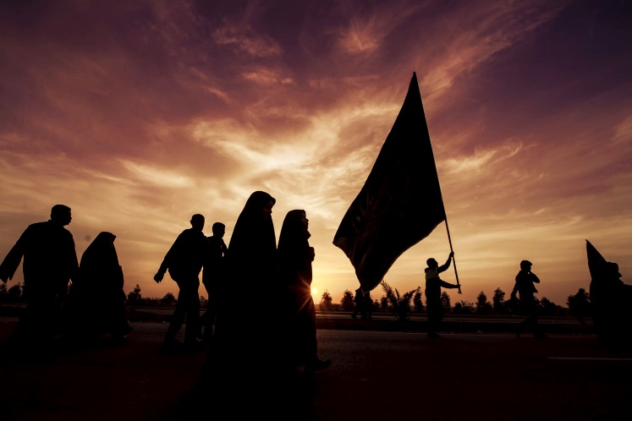
Many Muslims today fast on the day of Ashura. The Prophet Muhammad established Ashura as a day of fasting, based on the Jewish day of atonement, when sacrifices are made for the sins of the people. Ashura is an occasion to thank God for saving the Israelites from the Pharaoh. Sunni Muslims remember how much Musa (Moses) fasted in gratitude to God for opening up the Red Sea to allow his people to escape from the Egyptian chariots.
Shi’a Islam: the martyrdom of Husayn
Ashur is of particular importance to the Shi’a Muslim community because it remembers the death of Husayn in battle at Karbala in 680CE. This event triggered a split between Sunni and Shi’a Muslims that continues to divide Islam today. Shi’as believe that Husayn was the rightful successor to the Prophet Muhammad, so the massacre of Husayn and his followers carries great significance. They refer to Husayn as the third Imam, following his father Ali and his older brother Hasan. Still today they remember his betrayal and death with a deep sense of injustice.
Shi’a celebration of Ashura today
For Shi’as, Ashura is an emotionally charged day, remembering the martyrdom of Husayn, the grandson of Muhammad, and it is celebrated with processions, plays and public displays of grief in the streets. Blood is often spilled and people cry and wail.
How is Ashura celebrated around the world?
The death of Husayn gave rise to Shi’a cult of martyrdom and to a sense of betrayal and struggle against injustice and oppression. Ashura is a day of great sorrow, mourning and self-mutilation, where much public grief is expressed. Central to the events is the need to share in the sufferings of Husayn. Ashura is celebrated in communities across the Shi’a world (for example, in Iran and Iraq), but many Shi’a Muslims feel the need to make the pilgrimage to Karbala every year to take part:
- Men and women dress in black and march through the streets, slapping their chests and chanting
- There are processions and religious gatherings
- Plays re-enact the martyrdom
- Fervent men beat themselves with hcains and cut their heads with swords
Ashura in Britain today
Ashura is not a public holiday in Britain, but Shi’a Muslim children can be given permission to have the day off school. Many people will fast and pray on this day. In cities such as Manchester and London, Shi’as gather together in large crowds and take part in public marches. The men often slap their chests violently, in time to their chanting, but it is uncommon to see them drawing blood through whipping and beating themselves, as happens in many countries in the Middle East. Those who feel that they should lose blood may be encouraged, by Shi’a leaders, to donate blood to the blood transfusion service.
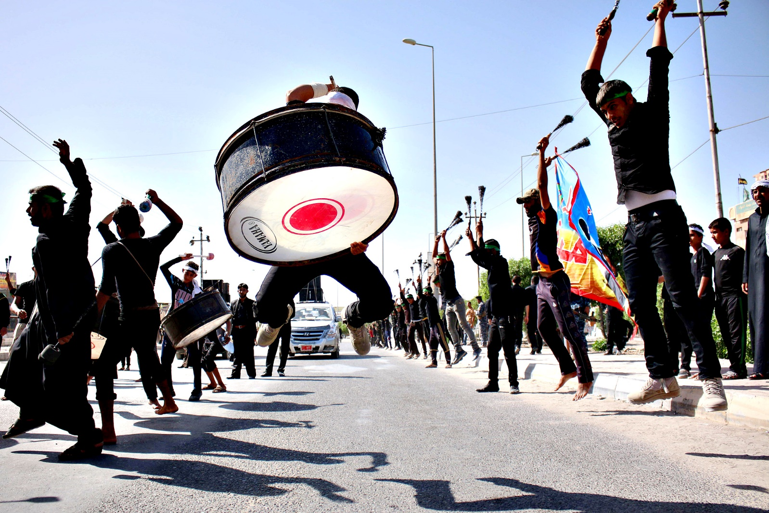
Ashura: Questions
- What is Ashura?
………………………………………………………………………………………………………………………...
- What did the Prophet Muhammad establish Ashura as?
………………………………………………………………………………………………………………………...
………………………………………………………………………………………………………………………...
- In Shi’a Islam, what does Ashura remember?
………………………………………………………………………………………………………………………...
………………………………………………………………………………………………………………………...
- What do Shi’a Muslims refer to Husayn as?
………………………………………………………………………………………………………………………...
………………………………………………………………………………………………………………………...
5. How is Ashura celebrated today?
………………………………………………………………………………………………………………………...
………………………………………………………………………………………………………………………...
………………………………………………………………………………………………………………………...
………………………………………………………………………………………………………………………..
- How is Ashura celebrated around the world?
………………………………………………………………………………………………………………………...
………………………………………………………………………………………………………………………...
………………………………………………………………………………………………………………………...
………………………………………………………………………………………………………………………...
- How is Ashura celebrated in Britain?
………………………………………………………………………………………………………………………...
………………………………………………………………………………………………………………………...
………………………………………………………………………………………………………………………...
Ten Obligatory Acts (Furu ad-Din) of Shi’a Islam
Five roots and ten branches of Shi’a belief
An obligation is a duty. The obligatory acts are practices that Muslims believe God has made compulsory.
For Shi’a Muslims, Islam is often pictured as a bountiful tree. The five roots of religion act as the source of strength for the Mulim life of faith. These are the central beliefs, with the trunk and branches growing up from these roots. There are ten branches or obligatory acts which form the key feature of religious life.
The Ten Obligatory Acts (Furu ad-Din)
- Salah (prayer): There are five daily prayers (Salah), where Muslims face towards the Ka’ba in Makkah (Qibla), but many Shi’as combine these into three. These prayer times are:
  - Between dawn and sunrise
  - Just after noon
  - At dusk, after sunset
They do this because they say that Muhammad allowed the combination of prayers: Zuhr with As’r and Maghrib with Isha.
- Sawm (fasting): Like Sunnis, Shi’as practise fasting (Sawm) during the month of Ramadan, but from the 20th day of Ramadan they remember the death of Ali (son-in-law of the prophet) spending three days in mourning.
- Hajj (pilgrimage): Like Sunnis, Shi’as go on the annual pilgrimage to Makkah in the 12th month of the Muslim calendar (Dhul Hijjah). In addition to Hajj, they also make pilgrimages to Shi’a shrines and graves, in particular visiting the grave of Husayn in Karbala (in modern-day Iraq).
- Zakah (charity): Like Sunnis, Shi’as make a charity payment of 2.5% of their wealth every year. This goes to support the poor and those in need.
- Khums (wealth tax): In addition to Zakah, Shi’as are expected to pay Khums, a wealth tax of 20% of their savings. This money is paid to Muslim scholars and community leaders for the welfare of the community.
- Jihad (struggle): Jihad is the duty to struggle against sin. For the sake of God, Muslims should fight against injustice, removing any obstacles that might prevent people from being able to worship God.
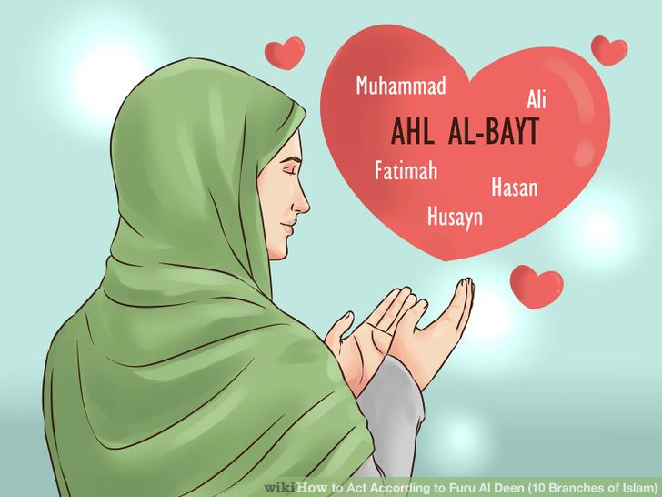
- Amr-bil-Maroof (encouraging others to do good): The central purpose of Islam is to create a society where people can live in peace and harmony. Therefore it is a the duty of all Muslims to encourage others to do good, for the sake of God. In the Hadith Muhammad promised that the person who persuades someone else to do a good deed will get the same reward as the person he persuaded.
- Nahil Anril Munkar (discouraging the bad): It is the duty of all Muslims to forbid evil; when someone sees a wrong, they should correct it. It is the responsibility of the whole Muslim community (the ummah) to discourage others from harmful actions, such as bribery, corruption and dishonesty. This applies to individuals, families and the whole society.
“Whoever among you sees an evil should change it with his hand. If he is unable to do that then with his tongue. If he is unable to do that, then with his heart, and this is the weakest level of faith.” (Hadith)
- Tawalia (to love the friends of God): Tawalia means having love for God and for the Prophet Muhammad. We should love all those who are friends of God: people who are truthful and kind, honest and fair. We should try to associate ourselves with people who are kind and trustworthy. For Shi’a Muslims it also means having love for the ‘Ahl al-Bayt’, the 12 infallible Imams who are descendents of the Prophet Muhammad.
- Tabarra (to hate evil-doers): Muslims believe that it is important to dissociate themselves from the enemies of God. We should hate, and separate ourselves from, people who are impure and those who oppress others. However, Muslims often disagree on exactly who are the enemies of God.
Ten Obligatory Acts: Questions
- What is an obligation?
………………………………………………………………………………………………………………………...
- What is Salah?
………………………………………………………………………………………………………………………...
………………………………………………………………………………………………………………………...
- What are the three prayer times Shi’as follow? Why do they do this?
………………………………………………………………………………………………………………………...
………………………………………………………………………………………………………………………...
- What is Sawm?
………………………………………………………………………………………………………………………...
………………………………………………………………………………………………………………………...
5. How is Sawm performed differently from Sunni Muslims?
………………………………………………………………………………………………………………………...
………………………………………………………………………………………………………………………...
6. What is Hajj? ………………………………………………………………………………………………………………………...
………………………………………………………………………………………………………………………...
- How is Hajj performed differently from Sunni Muslims?
………………………………………………………………………………………………………………………...
- What is Zakah and how much is given?
………………………………………………………………………………………………………………………...
………………………………………………………………………………………………………………………...
- What is Khums and where does it go to?
………………………………………………………………………………………………………………………...
………………………………………………………………………………………………………………………...
- What is jihad?
………………………………………………………………………………………………………………………...
- What is Amr-bil-Maroof?
………………………………………………………………………………………………………………………...
………………………………………………………………………………………………………………………...
- What is Nahil Anril Munkar?
………………………………………………………………………………………………………………………...
………………………………………………………………………………………………………………………...
- What does the Hadith say about discouraging the bad?
………………………………………………………………………………………………………………………..
………………………………………………………………………………………………………………………....
- What does ‘Tawalia’ mean?
………………………………………………………………………………………………………………………...
………………………………………………………………………………………………………………………...
- What does ‘Tawalia’ mean, in addition to the Sunni meaning, for Shi’a Muslims?
………………………………………………………………………………………………………………………...
………………………………………………………………………………………………………………………...
- What is Tabarra?
………………………………………………………………………………………………………………………..
………………………………………………………………………………………………………………………..
- What do Muslims disagree on?
………………………………………………………………………………………………………………………...
………………………………………………………………………………………………………………………...
………………………………………………………………………………………………………………………...

