GCSE Religious Studies
Practices Within Christianity Workbook

Name:

Key Concepts in
Christianity

- Omnipotent: The belief that God is all-………………………….. With God’s omniscience, He created the world in six days and on the seventh day, He rested.
- Omnibenevolent: The belief that God is all-loving. God loves us so much that he sent his one and only Son, ………………………….., to save the sins of humanity.
- Trinity: The belief that God is a ………………………….. God – in three parts: the Father, the Son and the Holy Spirit. Each part is distinct and separate, yet of the same …………………………...
- Incarnation: This is the belief that God came to earth in human ………………………….., i.e. Jesus. This is told in the Nativity story in the Bible, where Jesus was born to Mary – a …………………………...
- Atonement: “At-one-ment” means to say sorry and ………………………….. with God for your sins. Because of Jesus’ sacrifice, humans are able to atone with God for their …………………………...
- Resurrection: This is the belief that Jesus came back to life after he was …………………………... For Christians, this reflects the belief in life after death and the Hope of the spiritual resurrection of the …………………………...
- Sacraments: This is a ceremony where a person receives
………………………….. grace. For example, in the Sacrament of Baptism,
a person’s sins are washed away and they receive God’s grace as they
become a member of God’s …………………………...
Word Box
Gospel
virgin
powerful
faith
soul
tripartite
Jesus
family
God
form
reconcile
sins
crucified

- Evangelism: Spreading ………………………….. to others and to convert
others to your faith. Missionaries go to other communities and countries
to tell the world about Jesus and spread the …………………………..
(the ‘good news’).
You will need to learn these words and definitions for your exam! In our a) style questions, you will have to give a definition and an example for each word!

Forms of Worship
Worship is expressing adoration towards God. Worship is an essential part of a Christian's faith. Christians worship God to thank him for his love, ask for forgiveness for their sins and try to understand his 'will' for them.
There are a variety of types of worship:
- Liturgical: Formal worship based around the sacraments, usually the Holy Communion (Mass). It usually follows a set form or plan.
- Informal Worship: Informal worship has no set form. It can sometimes be unstructured and spontaneous.
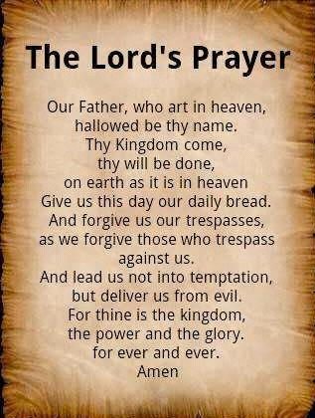
- Individual (private) worship: Worship on your own to seek a personal relationship with God, e.g. praying or reading the Bible at home.
Matthew 18:20: “For where two or three gather in my name, there am I with them”
The Nature and Importance of Prayer
The Lord’s Prayer was taught by Jesus to the disciples when they asked Jesus how they should pray to God.
Set prayers:
Set prayers are a model or pattern of prayer, for example the Hair Mary or the Lord’s Prayer.
Informal prayers:
Informal prayers follow no set formula. They are open and could include anything that is on the prayer’s mind.
Society of Friends (Quakers) and Evangelical Worship:
The Quakers (the Society of Friends) call worship events ‘meetings’ for worship rather than services in a ‘meeting house’ rather than a church. Quaker worship doesn't follow a set liturgy or code of rules - a service has no structure, and no one leads it. This is called informal worship.
A meeting begins when two or more worshipers come together to be in the presence of God. Often, worshippers can sit in a room in silence for an hour. From time to time someone may speak briefly, but sometimes the entire hour may pass without a word being spoken. They usually sit facing each other in a square or a circle. This helps them to be aware that they are a group together for worship, and puts everybody in a place of equal status.
Everyone waits in shared silence until someone is moved by the Spirit (i.e. has a strong religious feeling) to do something as part of their worship. A person will only speak if they are convinced that they have something that must be shared, and it is rare for a person to speak more than once.
Quakers believe that God speaks through the contributions made at the meeting. Some people say that there is often a feeling that a divine presence has settled over the group.
The words should come from the soul - from the inner light - rather than the mind. Quakers know that even if the words they feel moved to speak have no particular meaning for themselves, they may carry a message from God to other people. The Spirit assures Quakers that we belong to God as he “speaks to us deep in our hearts” (Romans 8:16).
Worship: Questions

- What is worship?
………………………………………………………………………………………………………………………...
………………………………………………………………………………………………………………………...
- What are the three types of worship?
………………………………………………………………………………………………………………………...
……………………………………………………………………………………………………………………......
- What does Matthew 18:20 say about prayer?
………………………………………………………………………………………………………………………...
………………………………………………………………………………………………………………………...
- What did Jesus teach the disciples, when asked how to pray to God?
………………………………………………………………………………………………………………………...
………………………………………………………………………………………………………………………...
- What is a set prayer?
………………………………………………………………………………………………………………………...
- What is an informal prayer?
………………………………………………………………………………………………………………………...
- What is another name for the denomination called the Quakers?
………………………………………………………………………………………………………………………...
- Where do Quakers meet?
………………………………………………………………………………………………………………………...
………………………………………………………………………………………………………………………...
- Describe Quaker worship.
………………………………………………………………………………………………………………………...
………………………………………………………………………………………………………………………...
………………………………………………………………………………………………………………………...
………………………………………………………………………………………………………………………...
- What is it that moves Quakers to speak?
………………………………………………………………………………………………………………………...
………………………………………………………………………………………………………………………...
Sacraments
That sacraments are ceremonies where a person receives God’s grace. They are a visible sign of an invisible grace. There are seven sacraments in total. Different denominations (branches of Christianity, e.g. RC or CoE) emphasise the importance of different sacraments.
Baptism
Welcoming into the Church through cleansing of Holy Water. Full submersion occurs in believer’s baptisms.
Confirmation
A believer confirms the promises made on their behalf at baptism.
The believer receives the Holy Spirit.
Holy Communion
Celebrates the death and resurrection of Jesus. Believers eat the bread (body) and wine (blood) during Mass.
Confession
Believers confess their sins to God through a priest.
Believers reconcile and atone for their sins.
Marriage
The couple live a faithful, holy life within the Church community. The couple raise children knowing God and the Gospel.
Holy Orders
Serving the God and the Church community through service and vocation. Believers dedicate their lives to God.
Anointing of the Sick
Helping those who are in spiritual, physical or emotional pain. A priest anoints the body with Holy Oil.

Diversity of Beliefs
The Roman Catholic Church recognises all seven sacraments. However, most Protestant (CofE) denominations recognise at least two sacraments – Baptism and the Eucharist. This is because they believe that these are the only two sacraments commanded by Jesus and reported by the Gospels. (Jesus himself was baptised by his cousin, John, in the River Jordan; Jesus broke bread at the Last Supper and told his followers to ‘do this in memory of me.’ Luke 22:19)
Christians have differed widely as to the meaning of the sacraments and how God works through them. Catholics, and many Protestants, consider them means of grace through which God bestows spiritual blessing.
Other Protestants view the sacraments as signs of Christian profession and testimony to grace that has already been given through faith. They hold that the other five rites are not made sacraments by the New Testament. So while Protestant churches have marriage ceremonies, and many have ordained clergy and a ceremony conferring ordination, they consider these rites to be ordinances rather than sacraments.
Sacraments: Questions
- What is a sacrament?
………………………………………………………………………………………………………………………...
………………………………………………………………………………………………………………………...
- How many sacraments are there in total?
………………………………………………………………………………………………………………………...
………………………………………………………………………………………………………………………...
- Name and briefly describe each of the seven sacraments.
………………………………………………………………………………………………………………………...
………………………………………………………………………………………………………………………...
………………………………………………………………………………………………………………………...
………………………………………………………………………………………………………………………...
………………………………………………………………………………………………………………………...
………………………………………………………………………………………………………………………...
………………………………………………………………………………………………………………………...
………………………………………………………………………………………………………………………...
- How many sacraments do the Church of England recognise?
………………………………………………………………………………………………………………………...
………………………………………………………………………………………………………………………...
- Why do the Church of England only recognise these sacraments?
………………………………………………………………………………………………………………………...
………………………………………………………………………………………………………………………...
- What do Catholics and many Protestants consider the sacraments to mean?
………………………………………………………………………………………………………………………...
………………………………………………………………………………………………………………………...
- What do other Protestants consider the sacraments to mean?
………………………………………………………………………………………………………………………...
………………………………………………………………………………………………………………………...

Baptism
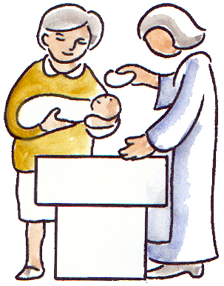
John 3: 5 “Unless one is born of water and the Spirit he cannot enter into the kingdom of God”
Meaning and celebration of Baptism:
Baptism is the sacrament of cleansing of sins. Before Jesus ascended to heaven, he commanded, “Go and make disciples of all nations, baptizing them in the name of the Father and of the Son and of the Holy Spirit.” (Matthew 28: 19-20) Therefore, Baptism is important because Jesus commanded it.
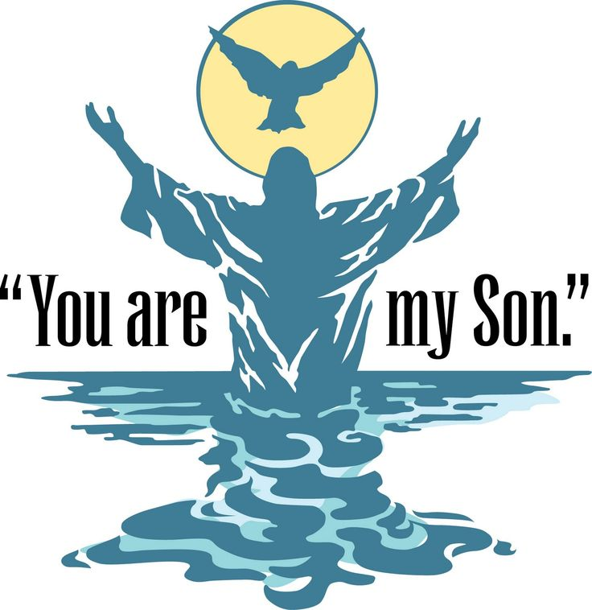
Baptism is also important because it is a public declaration of faith. Believer’s announce that they have been cleansed and have begun a new life with Christ.
The water is a symbol of the person’s sins being washed away and the believer can start a new life with God. There are two types of Baptism – Infant and Believer’s. Infant Baptism normally happens in the RC or CofE Churches. However, Believer’s Baptism usually happens in Baptist Churches.
Infant Baptism:
- Parents and godparents promise on the child’s behalf
- Baby is baptised at the font, which is usually near the door of the church to symbolise welcome into God’s family
- Priest says, “I baptise you in the name of the Father, and of the Son and of the Holy Spirit”. The priest pours Holy Water on the infant’s head three times.
- A candle is given to the parents “to show you have passed from darkness to light. Shine as a light in the world.”
Believer’s Baptism:
- Also known as ‘adult baptism’
- Believer promises for themselves
- Believers may give a short talk about their faith and how they became a Christian. This is called their ‘testimony’.
- The believer accepts Jesus as saviour and Lord, and promises to serve God with the help of the Holy Spirit.
- Believer is baptised by full immersion into a pool or body of water
- Believer arises spiritually ‘clean’

Baptism: Questions
- What does John 3:5 say about entering the Kingdom?
………………………………………………………………………………………………………………………...
………………………………………………………………………………………………………………………...
- What is Baptism the sacrament of?
………………………………………………………………………………………………………………………...
………………………………………………………………………………………………………………………...
- What did Jesus command the disciples to do?
………………………………………………………………………………………………………………………...
…………………………………………………………………………………………………………………..........
- Why is Baptism important?
………………………………………………………………………………………………………………………...
………………………………………………………………………………………………………………………...
- What does Baptism symbolise?
………………………………………………………………………………………………………………………...
………………………………………………………………………………………………………………….........
- What is water a symbol of?
………………………………………………………………………………………………………………………...
………………………………………………………………………………………………………………………...
- Explain the difference between infant and adult baptism.
………………………………………………………………………………………………………………………...
………………………………………………………………………………………………………………………...
………………………………………………………………………………………………………………………...
………………………………………………………………………………………………………………………...
………………………………………………………………………………………………………………………...
………………………………………………………………………………………………………………………...

Eucharist
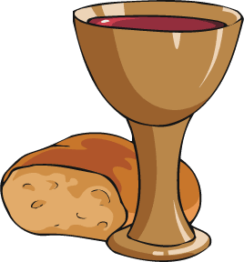
The Eucharist can also be known as The Last Supper, Mass, The Breaking of Bread and Holy Communion.
Luke 22:19 “He [Jesus] took bread, gave thanks and broke it, and gave it to them, saying, "This is my body given for you; do this in remembrance of me."
Meaning and celebration of the Eucharist:
On the night before Judas betrayed him, Jesus shared a meal with his disciples. It was to be the Last Supper they were to share together before his death. It was a meal to celebrate the Jewish festival of Passover. At the meal Jesus gave the disciples the instruction to remember him by breaking bread together (Luke 22:14-20). As soon as Jesus left the earth the disciples started to meet together to ‘break bread’. Christians continue to do this today and the act is remembered through the receiving of the Eucharist during church services.
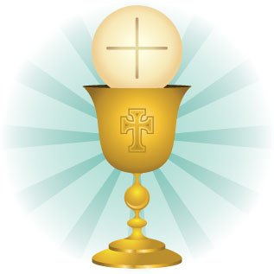
What do Christians believe about Holy Communion?
The Church of England believes that Holy Communion is a time for remembering and being thankful for the death of Jesus. During the service the bread and wine are simply that – bread and wine.
However, Roman Catholics believe that at some time during the service the bread and wine are mysteriously transformed into the physical body and blood of Jesus. This is called transubstantiation.

Eucharist: Questions
- What else can the Eucharist be known as?
………………………………………………………………………………………………………………………...
………………………………………………………………………………………………………………………...
- What did Jesus do, to set the example of celebrating the Eucharist?
………………………………………………………………………………………………………………………...
………………………………………………………………………………………………………………………...
- Why can this also be known as the ‘Last Supper’?
………………………………………………………………………………………………………………………...
………………………………………………………………………………………………………………………...
- Why do Christians continue to ‘break bread’ today?
………………………………………………………………………………………………………………………...
………………………………………………………………………………………………………………………...
- What do the Church of England believe about the Eucharist?
………………………………………………………………………………………………………………………...
………………………………………………………………………………………………………………………...
………………………………………………………………………………………………………………………...
………………………………………………………………………………………………………………………...
- What for the Roman Catholic Church believe about the Eucharist?
………………………………………………………………………………………………………………………...
………………………………………………………………………………………………………………………...
………………………………………………………………………………………………………………………...
………………………………………………………………………………………………………………………...
- What is transubstantiation?
………………………………………………………………………………………………………………………...
………………………………………………………………………………………………………………………...

Pilgrimage
Pilgrimage is when a person goes on a spiritual journey to a place of religious
significance, for example, Walsingham, Lourdes or Taizé.
Pilgrimage is important to Christians for many reasons. Believers can:
- Find spiritual nourishment. Believers can pray, read the Bible and be
with other people of the same faith
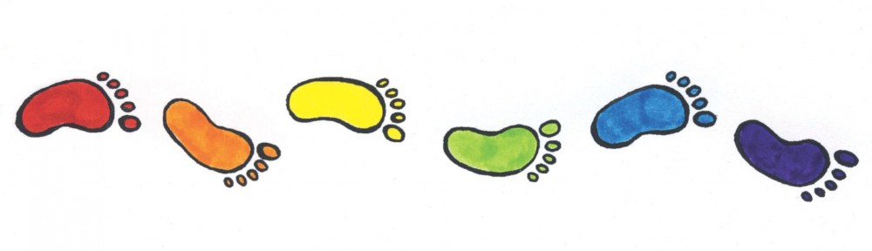
- Receive physical, mental or emotional healing
- Be with God
- Learn more about their faith
- Walk where Jesus walked (and other people from the Bible)
- Ask for forgiveness or help (for themselves or for others)
- Thank God
Places of Pilgrimage:
- Walsingham: Pilgrims travel to Walsingham in Norfolk. Chrisitans believe
that Mary appeared to Richeldis three times, showed her the house
where the Angel Gabriel appeared to her and told Richeldis to build a
copy of it in Walsingham. However, the builders couldn’t build on the
designated plots because of heavy moisture, but miraculously the
chapel was found built on the only dry spot. Since then, Walsingham
has been recognised as one of the holiest places in England, and
countless people have visited the village to ask Mary to pray to Jesus on their behalf.
- Taizé: Taizé is a community in central France. Pilgrims travel to Taizé to share in the community’s way of life. Prayer and silence are at the heart of the Taizé experience. Young people from every corner of the globe are encouraged to live out the Christian gospel in a spirit of joy, simplicity and reconciliation.
Ecumenism (a movement promoting Christian unity among Churches) is the key to Taizé’s appeal, making it a magnet for people of many different cultures and traditions. Taizé has spawned a unique style of worship that has become popular in churches, retreat centres and seminaries throughout the world. The singing of distinctive and much-repeated prayer chants during candlelit prayer services is one of its trademarks. Throughout the summer months, thousands of young people, aged 17 to 30, come to Taizé to explore or rediscover their Christian faith. They will typically camp in the fields around the church and monastery, joining in the community's worship three times a day. They will also spend time studying the Bible, reflecting in silence and meeting in discussion groups.
Pilgrimage: Questions

- What is a pilgrimage?
………………………………………………………………………………………………………………………...
………………………………………………………………………………………………………………………...
- Give three reasons why pilgrimage is believed to be important.
………………………………………………………………………………………………………………………...
………………………………………………………………………………………………………………………...
- Why might a pilgrim go to Walsingham?
………………………………………………………………………………………………………………………...
………………………………………………………………………………………………………………………...
- Why might a pilgrim go to Taizé?
………………………………………………………………………………………………………………………...
………………………………………………………………………………………………………………………...
- What is Ecumenism?
………………………………………………………………………………………………………………………...
………………………………………………………………………………………………………………………...
- What is distinctive at Taizé?
………………………………………………………………………………………………………………………...
………………………………………………………………………………………………………………………...
- Where will pilgrims stay during their pilgrimage to Taizé?
………………………………………………………………………………………………………………………...
………………………………………………………………………………………………………………………...
- What else will pilgrims do during their pilgrimage to Taizé?
………………………………………………………………………………………………………………………...
………………………………………………………………………………………………………………………...
Celebrations
Christmas
Christmas marks the birth of Jesus, who is considered to be the Son of God. It is celebrated on December 25th and the story is known as the Nativity. It is the first story told in the accounts of Matthew and Luke in the New Testament. Both accounts tell us that Jesus was born to a woman called Mary who was engaged to Joseph, a carpenter. The Gospels state that Mary was a virgin when she became pregnant. They do, however, have some differences:
Matthew’s Account
- Joseph was visited by an angel to told him to marry Mary and not expose her pregnancy
- Wise men followed a star to Jesus’ birthplace

Luke’s Account
- Mary is visited by an angel who told her she would give birth to God’s son
- Shepherds were led to Bethlehem by an angel

Both Gospels tell how Joseph and Mary travelled from Nazareth to Bethlehem before Jesus' birth to take part in the census. But when they arrived in Bethlehem the inn was already full, so they had to stay in the stable. It was here, next to the noise and filth of the animals, that Mary gave birth to her son and laid him in a manger.
Today, Christmas is celebrated at the end of the season of Advent. This is an important time in the Christian calendar because it is a period of preparation for the birth of Jesus. Some Christians fast during this time.
For non-Christians, Christmas is the biggest holiday of the year, with the main focus on exchanging gifts.
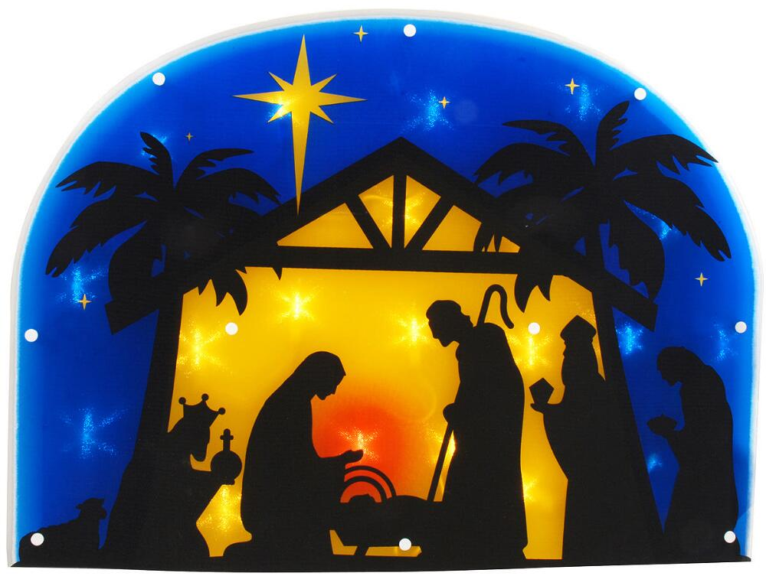
Why is Christmas important?
- Jesus is God incarnate (God in human form)
- It marks the end of a world of ignorance, greed and hatred
- Jesus’ coming signifies a spiritual turn for mankind that is to be celebrated: "I bring you good news of great joy that will be for all the people." Luke 2:10
- Because of God’s reason for sending Him to earth: "God loved the world so much that he gave his one and only Son, so that everyone who believes in him will not perish but have eternal life."
- God became one of us, a human being, so we could understand what he is really like.
Celebrating Christmas: Christmas is a time to be with loved ones, to pray and to thank God for the gift of sending his Son, Jesus, so that mankind has a chance at salvation (being saved from their sin). Features of Christmas can include:
- Nativities to act out the story of when Jesus was born (usually performed by children)
- Advent candles at church count the weeks until Christmas. Churches hold special services, e.g. midnight mass or carol services.
- Exchanging of gifts to remember the gifts that the wise men brought for the ‘new king’ Jesus
- Cards are sent to family and friends to wish them a ‘Happy Christmas’
- Holly and ivy is often used for decoration. This reminds Christians of Jesus’ crown of thorns
Easter
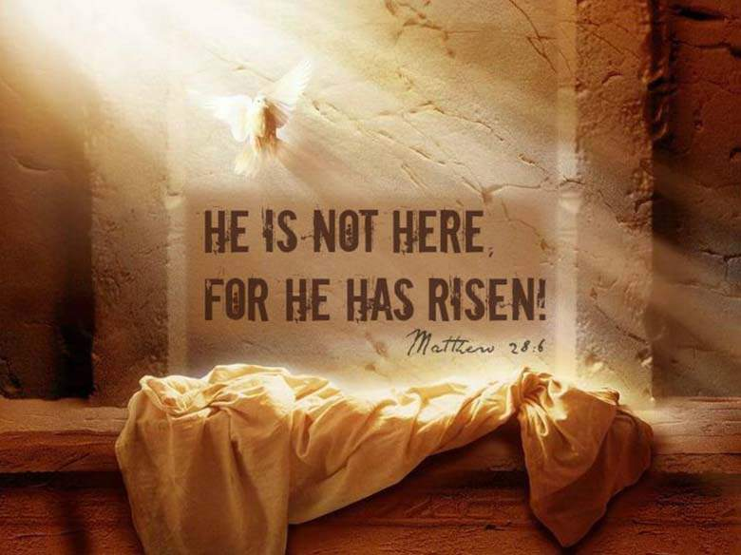
Easter is at the end of Holy Week – the last week in the life of Jesus, before his crucifixion. It remembers the sacrifice made by Jesus on mankind’s behalf and celebrates the resurrection of Jesus.
Jesus had his last meal with his disciples on the evening of a Thursday (remembered as Holy Thursday), was arrested during the night, tried Friday morning (Good Friday), condemned, crucified, and died before sundown on Friday. And, according to the Gospel accounts, he was bodily raised from the dead on the third day — Sunday, the day of Easter.
Easter is important to Christians because:
- It demonstrates that Jesus must be the Son of God as he had the power to resurrect
- It is a triumph over death – not just for Jesus, but for humans too
- In Jesus’ sacrifice, death and resurrection, sin and death were destroyed
- It is so special that it needs to be prepared for. Christians fast for 40 days during Lent
- It offers reconciliation and the chance at a new life with God
- Jesus restores Christians’ ‘brokenness’ by forgiving all wrongdoings of those people who truly repent
- Jesus’ death for mankind shows God’s unconditional love for all humans
How is Easter celebrated?
- Attending church for a special service. This could be a sunrise service, to celebrate at the very start of Easter Day, or Roman Catholics might go to Rome to take part in a large Mass held by the Pope in St. Peter’s Square
- Lighting candles to remember that Jesus is the light of the world, who has driven out the darkness through His sacrifice
- Churches are filled with flowers to symbolise new life
- Priests wear bright robes in celebration
- Easter is the end to the fasting season of Lent, so a celebratory meal might be shared
- Easter eggs are given out to remind Christians of new life
Celebrations: Questions

- What does Christmas mark?
………………………………………………………………………………………………………………………...
………………………………………………………………………………………………………………………...
- What is the difference between Matthew’s and Luke’s account of the nativity?
………………………………………………………………………………………………………………………...
………………………………………………………………………………………………………………………...
- Today, when is Christmas celebrated?
………………………………………………………………………………………………………………………...
………………………………………………………………………………………………………………………...
- Give three reasons why Christmas is important.
………………………………………………………………………………………………………………………...
………………………………………………………………………………………………………………………...
- How do Christians celebrate Christmas? (State 5 ways)
………………………………………………………………………………………………………………………...
………………………………………………………………………………………………………………………...
- What does Easter remember?
………………………………………………………………………………………………………………………...
………………………………………………………………………………………………………………………...
- What are the days of Holy Week and what happened on each day?
………………………………………………………………………………………………………………………...
………………………………………………………………………………………………………………………...
- Why is Easter important to Christians? (Give 5 reasons)
………………………………………………………………………………………………………………………...
………………………………………………………………………………………………………………………...
………………………………………………………………………………………………………………………...
………………………………………………………………………………………………………………………...
………………………………………………………………………………………………………………………...
- How is Easter celebrated? (Give 5 ways)
………………………………………………………………………………………………………………………...
………………………………………………………………………………………………………………………...
- What to Easter Eggs remind people of?
………………………………………………………………………………………………………………………...
………………………………………………………………………………………………………………………...
Christianity in Britain
2011 census compared to 2001 census
- Showing an increase in diverse religious and non-religious beliefs and practices
- Over half of those who responded to the census considered themselves Christian
  - The results when asked, “What is your religion?”
2011 Census
- 59.3% Christian
- 25.1% No religion
- 7.2% Religion not stated
- 4.8% Muslim
- 1.5% Hindu
- 0.8% Sikh
- 0.5% Jewish
- 0.4% Buddhist
- 0.4% Other religion

2001 Census
- 72% Christian
- 15.5 % No religion
- 7.3% Religion not stated
- 3% Muslim
- 1% Hindu
- 0.6% Sikh
- 0.5% Jewish
- 0.3% Buddhist
- 0.3% Other religion

-12.7% difference
+14.7% difference
Increase in other world religions from 2001 to 2011.

Is Britain a Christian country?
Yes:
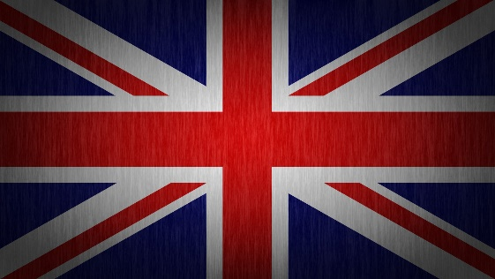
- UK laws, festivals (e.g. Christmas) and traditions (shops being closed on Sundays) that are rooted in the Christian tradition. Our law system is founded on the Ten Commandments, e.g. ‘do not murder’ and ‘do not steal.’
- Britain has an established Church and its bishops sit in the House of Lords and debate on political issues
- The Queen’s title is, “Defender of the Faith”.
- ‘Cultural Christianity’ is socially accepted because of tradition. We sing carols, celebrate Christian festivals (e.g. Christmas and Easter), accept Christian symbols and phrases, (e.g. “it is my cross to bear”) and attend marriages and special ceremonies in religious buildings.
- Our public holidays still orientate around the Christian calendar, e.g. Christmas and Easter
- Our national flag includes in it St. George’s cross, reminding us once again of our Christian heritage
No:
- Attendance in church is declining. The public worship of Christianity is dying out.
- Laws about abortion and same-sex marriage have changed, despite opposition from religious groups (e.g. some Roman Catholics)
- More faiths are contributing to British culture nowadays, e.g. Muslims, Hindus and Jews.
- Rise of other religions and the non-religious in Britain (see 2011 census)
Christianity in Britain: Questions

- According to the 2011 census, what is Britain’s most popular religion?
………………………………………………………………………………………………………………….........
………………………………………………………………………………………………………………………...
- What are the main differences between in 2001 and the 2011 censuses?
………………………………………………………………………………………………………………………...
………………………………………………………………………………………………………………………...
………………………………………………………………………………………………………………………...
………………………………………………………………………………………………………………………...
- Give four arguments why Britain is a Christian country.
………………………………………………………………………………………………………………………...
………………………………………………………………………………………………………………………...
………………………………………………………………………………………………………………………...
………………………………………………………………………………………………………………………...
………………………………………………………………………………………………………………………...
………………………………………………………………………………………………………………………...
- Give four arguments why Britain is not a Christian country.
………………………………………………………………………………………………………………………...
………………………………………………………………………………………………………………………...
………………………………………………………………………………………………………………………...
………………………………………………………………………………………………………………………...
………………………………………………………………………………………………………………………...
………………………………………………………………………………………………………………………...
- Does anything surprise you about the census results?
………………………………………………………………………………………………………………………...
………………………………………………………………………………………………………………………...
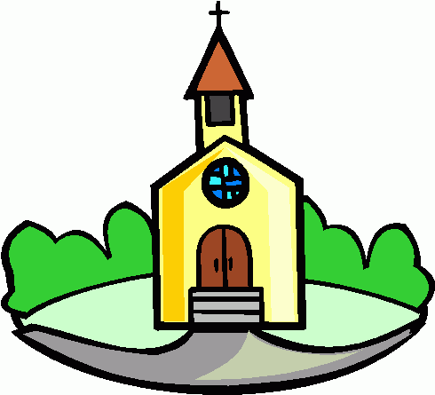
The Church in the Local Community
Church = the wider Christian community. It was officially founded on the day of Pentecost, when the Holy Spirit visited the apostles.
church = the church building
Church as a place of worship:
For worshippers, a church is ‘God’s house’ and is sacred (special). It is a place for quiet and reflection as well as celebration and joy. Christians will worship here and there are many features of a church to remind Christians of their focus whilst worshipping:
- The church itself is in the shape of a cross. Crosses and crucifixes might decorate the building. These are to remember the sacrifice, death and resurrection of Jesus
- Stained glass windows remind worshippers of the stories in the Bible
- The altar is a symbol of God welcoming the people. It is also where Holy Communion or the Eucharist is celebrated. Christians are reminded of the body and blood of Jesus, broken and spilt for mankind
- The font is where babies are baptised. It is a symbol of welcome into God’s family. The water is a symbol of the washing away of sin and starting a new life with God
- The lectern is where the Bible is read from and is usually in the shape of an Eagle. This is a symbol of God’s message flying the highest and spreading the farthest (like the eagle)
- Candles are lit around the church. This is to remind worshippers that Jesus is the light of the world
Why worship in a church?
- The Bible shows communities worshipping together
- There are signs and symbols that are helpful for worship, e.g. the cross
- You can talk to other people of the same faith and grow in your own faith
- Religious leaders are available for prayer, reconciliation and spiritual guidance
- In the Bible, Christians are told to, “speak with one another with psalms, hymns and songs from the Spirit.” (Ephesians 5:19)
Church for social and community functions:
Churches try to make a positive impact on their local communities. Through their participation in the saving work of Jesus’ and the following of the teachings in the Gospels, they are involved in peoples’ lives to promote faith and the message of God’s love. They do this in several ways:
- Charity, e.g. helping the homeless, food and clothes drives, raising money through fairs and events
- Community projects, e.g. cleaning up an area; blood drives
- Providing a youth service or club
- Evangelistic outreach (spreading faith to others)
- Advice centres and polling stations
- Venue for special events and occasions – religious and non-religious, e.g. birthday parties, Baptisms and weddings
Church: Questions:
- What is the difference between a ‘Church’ and a ‘church’?
………………………………………………………………………………………………………………………...
………………………………………………………………………………………………………………………...
- Why is the church special?
………………………………………………………………………………………………………………………...
………………………………………………………………………………………………………………………...
- What is the altar a symbol of?
………………………………………………………………………………………………………………………...
………………………………………………………………………………………………………………………...
- What is the font a symbols of?
………………………………………………………………………………………………………………………...
………………………………………………………………………………………………………………………...
- What is the lectern a symbol of?
………………………………………………………………………………………………………………………...
………………………………………………………………………………………………………………………...
- What do candles represent?
………………………………………………………………………………………………………………………...
………………………………………………………………………………………………………………………...
- Why might a person choose to worship in a church? (Give three reasons)
………………………………………………………………………………………………………………………...
………………………………………………………………………………………………………………………...
………………………………………………………………………………………………………………………...
- Why do Christians try to make a positive impact in their communities?
………………………………………………………………………………………………………………………...
………………………………………………………………………………………………………………………...
- How do Christians try to make a positive impact in their communities? (Give three ways)
………………………………………………………………………………………………………………………...
………………………………………………………………………………………………………………………...
………………………………………………………………………………………………………………………...
The Worldwide Church
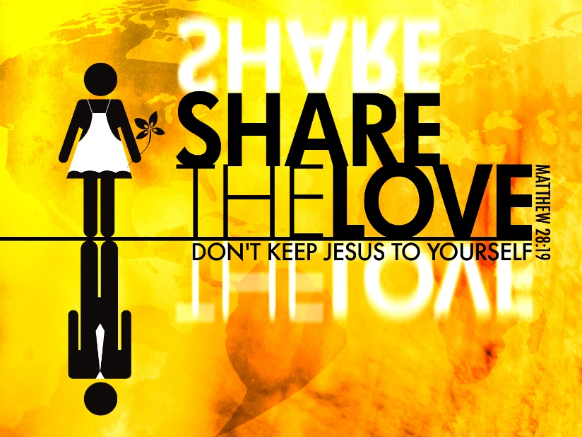
Mission, evangelism and church growth:
Mission: A vocation or calling to go out and spread the Christian faith
Evangelism: Spreading faith to others. Jesus said to ‘make disciples of all nations’ (Matthew 28:19).
Church growth: The effort to expand the numbers of people in the Church
Christians follow Jesus who said, "As the Father has sent me, so I send you"(John 20.21). They are called to serve God's mission by living and proclaiming the good news (the ‘Gospel’).
For Christians, God's mission is about transformation - transforming individual lives, transforming communities and transforming the world. By following Jesus Christ, they believe that God's mission is revealed to them by the Holy Spirit in three ways:
- through the Bible
- through the tradition and life of the Church
- through listening, praying, thinking and sharing
Christian beliefs in action: Tearfund
Tearfund are a relief and development charity who aim to tackle the causes and effects of poverty worldwide. Tearfund tackle physical and spiritual poverty by building churches, carrying out community development projects, providing disaster relief and changing unjust practices and policies.
Tearfund do this because they recognise the presence of Jesus in all on earth. They believe that each person should be treated equally, with dignity and respect, as Jesus taught. They give everything to follow Jesus, just as in the Parable of the Rich Young Man. “It is easier for a camel to pass through the eye of a needle than it is for a rich man to enter heaven“ (Matthew 19:24).
Persecution of Christians
Early Christians were persecuted for their faith. Christian missionaries and converts, both, were killed. Immediately after Jesus’ death, Christians were hunted down as we are told in the famous conversion of Saul, who thereafter was known as Paul. The New Testament details many examples of Christian persecution at the hands of the Roman Empire. This led to the canonisation of many saints and therefore a more rapid spread of Christianity.
The Great Persecution in the 4th Century AC ordered the imprisonment of Christian priests and Christians were forced to sacrifice to the Roman gods, or face execution. 20,000 Christians died during this time.
Today, Christian persecution largely exists among Middle Eastern countries, such as Saudi Arabia, where freedom of religious expression is not practised or allowed.
Working for reconciliation: The World Council of Churches
The World Council of Churches (WCC) is an inter-church organisation seeking worldwide fellowship and unity for all Christians.
The WCC brings together churches, denominations and church fellowships in more than 110 countries and territories throughout the world, representing over 500 million Christians and including most of the world's Orthodox churches, scores of Anglican, Baptist, Lutheran, Methodist and Reformed churches, as well as many United and Independent churches. While the bulk of the WCC's founding churches were European and North American, today most member churches are in Africa, Asia, the Caribbean, Latin America, the Middle East and the Pacific. There are now 348 member churches.
For its member churches, the WCC is a unique space: one in which they can reflect, speak, act, worship and work together, challenge and support each other, share and debate with each other. As members of this fellowship, WCC member churches:
- are called to the goal of visible unity in one faith and one Eucharistic fellowship;
- promote their common witness in work for mission and evangelism;
- engage in Christian service by serving human need, breaking down barriers between people, seeking justice and peace, and upholding the integrity of creation; and
- foster renewal in unity, worship, mission and service.

Working for reconciliation: The Ecumenical Movement
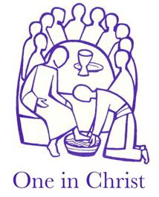
The Ecumenical Movement is the movement towards worldwide Christian unity or cooperation. Due to historical schisms (splits), the Christian church has divided into many different denominations (branches within Christianity) such as Roman Catholic and Church of England. In some circumstances, the conflict has become so tense that war has broken out within communities, such as the Roman Catholic/Protestant divide in Northern Ireland.
Ecumenism understands that these divisions must be overcome, as people are all members of one faith; one Church. Therefore, Ecumenism seeks to reunite what was divided during the schisms in the past.
Underlying the movement is the belief that people should be focusing on Jesus and Salvation, not on their individual denominations or organisations. People should be coming together in a dialogue of love and a dialogue of truth, to spread the Gospel and follow in Jesus’ footsteps on earth.
Galatians 3:28 “There is neither Jew nor Greek, neither slave nor free, nor is there male and female, for you are all one in Christ Jesus.”

Worldwide Church: Questions:
- What is ‘mission’?
………………………………………………………………………………………………………………………...
………………………………………………………………………………………………………………………...
- What is ‘evangelism’?
………………………………………………………………………………………………………………………...
………………………………………………………………………………………………………………………...
- How are Christians called to serve God’s mission?
………………………………………………………………………………………………………………………...
………………………………………………………………………………………………………………………...
- What is meant by: “God’s mission is about transformation”?
………………………………………………………………………………………………………………………...
………………………………………………………………………………………………………………………...
- What three ways is God’s mission revealed through the Holy Spirit?
………………………………………………………………………………………………………………………...
………………………………………………………………………………………………………………………...
- Who are Tearfund and what do they do?
………………………………………………………………………………………………………………………...
………………………………………………………………………………………………………………………...
- What was Paul previously known as?
………………………………………………………………………………………………………………………...
………………………………………………………………………………………………………………………...
- How many Christians dies during the Great Persecution?
………………………………………………………………………………………………………………………...
………………………………………………………………………………………………………………………...
- What does ‘WCC’ stand for?
………………………………………………………………………………………………………………………...
………………………………………………………………………………………………………………………...
- What are the aims of the WCC?
………………………………………………………………………………………………………………………...
………………………………………………………………………………………………………………………...
- What are the member churches of the WCC expected to do? (Name three)
………………………………………………………………………………………………………………………...
………………………………………………………………………………………………………………………...
………………………………………………………………………………………………………………………...
- What is the Ecumenical Movement?
………………………………………………………………………………………………………………………...
………………………………………………………………………………………………………………………...
- Which country is an example of how war has broken out between Christian denominations?
………………………………………………………………………………………………………………………...
………………………………………………………………………………………………………………………...
- What underlies the Ecumenical Movement?
………………………………………………………………………………………………………………………...
………………………………………………………………………………………………………………………...
- What does Galatians 2:28 say?
………………………………………………………………………………………………………………………...
………………………………………………………………………………………………………………………...

