eduqas

GCSE Religious Studies
Philosophy & Ethics:
Human Rights

Name:

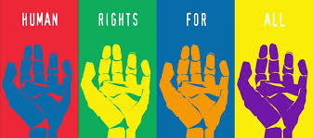

Key Concepts in
Philosophy and Ethics:
Human Rights

Censorship: When the government or an authority denies people ………………………….. or their right free speech. Jesus said that we should obey Caesar, meaning that we must follow the ………………………….. of the land.
Discrimination: Treating people differently because of their religion, sexuality, race, gender, etc. Christians believe that we should ‘treat others as we would like to be treated’, meaning that we should treat all ………………………….. .
Extremism: Holding ………………………….. political or religious views. Recently, extreme views have led to terrorist actions, however Jesus taught that ‘those who take up the sword, die by the …………………………..,’ and therefore discouraged such actions.
Human Rights: The things all humans should expect to have or be able to do. For example, every person has the right to religious freedom and freedom of …………………………...
Personal Conviction: A strong opinion or belief based on personal opinion or …………………………... For example, Martin Luther ………………………….. Jnr believed that all human beings were equal.
Prejudice: Pre-judging someone without any evidence. Jesus told the parable of the Good ………………………….. to show how we shouldn’t judge others, but instead we
must love our neighbours.
Word Box
King
charity
expression
information
food
Samaritan
sword
equally
experiences
law
aggressive
country
wealth
Relative and Absolute Poverty: Relative poverty is defined by the
………………………….. a person is in. For example, not having a television in British
society might be considered relative poverty – it is poverty in relation to the rest
of the country. However, absolute poverty is when there is severe depravation of
basic needs (e.g. …………………………..) and human rights. Currently,
approximately 1.2bilion people are living in absolute poverty.
Social Justice: When there is a fair distribution of …………………………..,
opportunities and privileges within society. For example, Jesus said that the
way to get to the Kingdom of God was to give all you own to …………………………..
and to follow him.
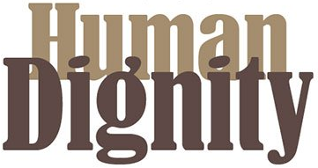
- Human Rights and Social Justice
  - Human dignity
Human dignity is an individual’s sense of self-worth or self-respect.
Christian teachings about human dignity:
Genesis 1: 26-27: “Let us make mankind in our image, in our likeness… male and female he created them.”
All people should be treated with dignity - we were all made equal, individual and unique. The Bible says that we are all ‘created in the image of God,’ and therefore no one should be treated unfairly or have their human dignity taken away.
God is the creator of all and everyone is 'one in Christ'. Christians believe that God gave His only son, Jesus, so that we all could find salvation (freedom from sin). God did not offer salvation only for those who were rich or those who were Jewish, for example. Therefore, each and every person deserves to be treated with respect as they are equally important to God and His plan for the world and His creation.
Jesus showed in his teachings and actions that all people have dignity. Jesus said that ‘a servant is not greater than his master,’ meaning that rank or social status does not put a person higher in God’s opinion, just because they are a ‘master’. Jesus said, ‘masters, treat your servants justly and fairly, knowing that you also have a master in heaven.’

Jesus mixed with tax collectors like Zacchaeus, who lied, cheated and stole money. Zacchaeus was an outcast of his society but still Jesus dined with him and showed him the error of his ways through treating him with dignity and respect – something Zacchaeus wasn’t used to giving or receiving.

Jesus also showed the importance of caring for all through parables, such as the Parable of the Good Samaritan, which shows us to love our neighbours, regardless of who they are.

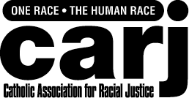
Christian charities, such as the Campaign for Racial Justice (CARJ) encourage racial justice and support refugees (someone who leaves their country because of war or being threatened) and asylum seekers (someone who has left their home country as a political refugee and is seeking protection in another country).

CARJ are a Roman Catholic organisation. They were set up in 1984 to support people to achieve a more fair and just society. They treat everyone with respect and human dignity by raising community awareness of the issues faced by minority ethnic groups.

CARJ raise community awareness by holding event such as ‘Racial Justice Sunday’ that has the tag line, ‘being in an inclusive church... is not an exclusive club’.

It is a duty to treat others well according to the teachings in sacred texts, e.g. the Bible. The Golden Rule states that we should ‘treat others the way we would like to be treated’, meaning that if we ourselves would like to be treated with dignity and respect, then we should treat others that way too.

Christians believe that has human beings we all have a soul – an inner spirit that has a direct link with God. If God is in all of us then when we respect others and treating them well, we are really respecting God.
Questions:
- What is human dignity?
……………………………………………………………………………………………………………………….............
- What does Genesis 1: 26-27 say about the human race?
……………………………………………………………………………………………………………………….............
- Why do Christians believe that God sacrificed His son, Jesus?
……………………………………………………………………………………………………………………….............
- Jesus said, ‘a servant is not greater than his master’. What does this mean?
……………………………………………………………………………………………………………………….............
- Explain Jesus’ dealings with Zacchaeus.
……………………………………………………………………………………………………………………….............
- What does the Parable of the Good Samaritan teach us?
……………………………………………………………………………………………………………………….............
- Complete this diagram about CARJ:
………………………………………………………………………………………………………………………………….………………………………………………………………………………………………………………………………………………………………………………………………………………………………………………………………
………………………………………………………………………………………………………………………………….………………………………………………………………………………………………………………………………………………………………………………………………………………………………………………………………
………………………………………………………………………………………………………………………………….………………………………………………………………………………………………………………………………………………………………………………………………………………………………………………………………
………………………………………………………………………………………………………………………………….………………………………………………………………………………………………………………………………………………………………………………………………………………………………………………………………
………………………………………………………………………………………………………………………………….………………………………………………………………………………………………………………………………………………………………………………………………………………………………………………………………
………………………………………………………………………………………………………………………………….………………………………………………………………………………………………………………………………………………………………………………………………………………………………………………………………

Christian Views of Human Rights
Human rights are the things that every human should expect to be able to have or do. For example, every human has a right to food, water, shelter, etc.
Christian teachings about human rights:
“There is neither Jew nor Greek, there is neither slave nor free, there is neither male nor female; for you are all one in Jesus Christ”. Galatians 3:28
“A new commandment I give unto you, that you loved one another – even as I have loved you, so you also love one another”. John 13:34
Christian practices to promote human rights:
Christianist teaches that everyone should have the opportunity to enjoy the wealth that God’s world has to offer. Humans were created equally and in God’s image.
Today, Christians are still working to combat human rights abuses and to promote the welfare of all people. As they preach the Gospel around the world, they are digging wells, planting crops, giving clothes, dispensing medicine, and providing education for the destitute.

Questions:
- What are human rights?
………………………………………………………………………………………………………………………...
- State one Christian teaching about human rights.
………………………………………………………………………………………………………………………
- What does Christianity believe that everyone should be able to enjoy?
………………………………………………………………………………………………………………………...
- What do Christians preach?
………………………………………………………………………………………………………………………...
- What else do Christians do to fight against human rights abuses around the world?
………………………………………………………………………………………………………………………...

Muslim Views of Human Rights

- Islam teaches that all people are creations of Allah; therefore there are basic rights that should be shared by the whole of humanity.

- Human rights are God given and therefore should be followed, it is the will of Allah (God).

- Muslims are taught they should protect human rights because their existence stops tyranny, fighting and rioting. So while people should follow authority, the people who are in a position of authority, have the responsibility to ensure people receive their basic human rights.

"As you are, so you will have rulers over you” (Hadith, Saying of the Prophet)

- All life is created by Allah and therefore is sacred and should be protected.

- Justice should be administered fairly and equally.
Questions:
- What is the relationship between God (Allah) and Human Rights?
………………………………………………………………………………………………………………………..................................................................................................................................................................................................................................................................................................................................................................................................................................................................................................................
- State Muhammad’s (pbuh) view on human rights.
………………………………………………………………………………………………………………………………………………………………………………………………………………………………………………………………………………………………………………………………………………………………………..
- Why should human rights and human life be protected?
………………………………………………………………………………………………………………………...……………………………………………………………………………………………………………………………………………………………………………………………………………………………………………......
- What is the Islamic attitude to justice?
…………………………………………………………………………………………………………………………………………………………………………………………………………………………………………………………………………………………………………………………………………………………………………………..
  - Agape in action (Christian Aid / Martin Luther King Jr.)
Agape, or ‘unconditional love’ is central to Christian belief. It is the highest form of love, where charitable actions are done for their own sake and for the love of the person affected, not for personal or selfish reasons. Agape originates from God and extends to love of our fellow human beings.
Christian Aid:
Whenever you helped one of the least important ... you did it for me (Jesus). (Matthew 25:40)
Christians believe that caring for others and sharing with others – in other words ‘loving’ them – is not just something they should do, but a command of Jesus himself. Jesus taught that all people have human dignity and should be treated with justice
He also said that only loving the people who love you in return is not difficult; loving someone who is your enemy, or who dislikes you, or someone who is a complete stranger, is another matter. So Christians try to put this into practice in their day – to – day lives, and also support organisations that do it globally.
Who? What is Christian Aid? It is a charity organisation working in partnership with local organisations in over 60 countries in the developing world.
Why? Which religion does it belong to? Christianity. In fact, it is supported by more than 40 different Christian denominations in the U.K.
What? What are the main aims of this organisation?
- To expose the scandal of poverty.
- To contribute to stopping poverty.
- To be inspired by the Gospel of good news to the poor (Christian teaching), which promises a good life for all and hope.
How? How does Christian Aid work for justice?
- To improve lives of people in poor countries.
- To support the poorest groups of people, whatever their religion or culture.
- To campaign for fair trade and greater equality.
How? How does the work demonstrate the teachings of the religion? Christian Aid believes in a God who loves the world and all who are in it and that they should be following the example of Jesus and speaking out against injustice.
Case Study:
In Senegal, Christian Aid works with local groups of Farmers by
- Farming and environment: including planting new trees, animal fattening, producing animal feeds.
- Training including literacy classes (for women), management classes (budgets etc.), and a theatre group to communicate ideas visually / dramatically to help the illiterate.
- Village water: well digging (two per year) and irrigation systems.
- Savings and credits: giving access to money through loans at low interest to allow trading and development.
Martin Luther King Jnr. (MLK):
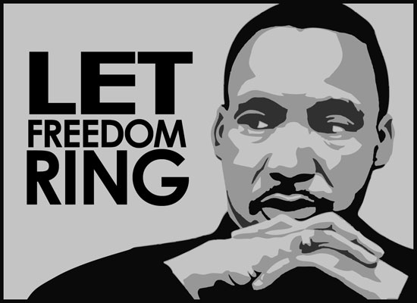
“An eye for an eye leaves everyone blind.” – MLK
“Forgiveness is not an occasional act, it is a constant attitude.” – MLK
Martin Luther King organised non-violent protests to make sure that he was heard in a peaceful and non-violent way.
Martin Luther King organised the Montgomery Bus Boycott, where black people refused to use buses for 382 days causing the bus companies to lose thousands of pounds. The Supreme Court took notice of this and changed the law so black people no longer had to give up their seat on the bus for white people. He achieved what he wanted, but in a peaceful manner.
Martin Luther King believed in equal human rights for all – he knew that the way Black people were being treated was wrong and that all people are entitled to the same Human Rights regardless of the colour of their skin.
Martin Luther King worked closely with an organisation called the Fellowship of Reconciliation (FOR) to solve the problems of racial discrimination in a peaceful way. Together they tried to reconcile the problems started by race in America. Even when King’s house was bombed, his family assaulted and he was put in prison, his only request was for reconciliation.
Martin Luther King worked hard throughout his life for justice and equality for Black people. He knew that the way he and Black people through the world were being treated in an unjust (unfair) way and worked hard to make sure this changed. He campaigned his whole life so that Black people were treated exactly the same as white people. In his famous ‘I have a dream’ speech Martin Luther King said this:
“I have a dream that my four little children will one day live in a nation where they will not be judged by the colour of their skin but by the content of their character.”
Martin Luther King was assassinated in 1968 by James Earl Ray, because Ray did not believe in equal rights. However, the words of Martin Luther King ring on: “Darkness cannot drive out darkness; only light can do that. Hate cannot drive out hate; only love can do that.”

Questions:
- What is agape?
………………………………………………………………………………………………
- Where does agape originate from?
………………………………………………………………………………………………
- What did Jesus command people to do?
………………………………………………………………………………………………
- Who are Christian Aid and what are their main aims?
………………………………………………………………………………………………
- How do Christian Aid work for justice?
………………………………………………………………………………………………
- How does Christian Aid demonstrate Christianity?
………………………………………………………………………………………………
- What did Martin Luther King organise?
………………………………………………………………………………………………
- What did MLK believe in?
………………………………………………………………………………………………
- What was MLK’s only request for?
………………………………………………………………………………………………
- What did MLK work hard throughout his life for?
………………………………………………………………………………………………
- What did MLK’s dream envisage?
………………………………………………………………………………………………
- According to MLK, what can drive out darkness?
………………………………………………………………………………………………

Malala Yousafzai
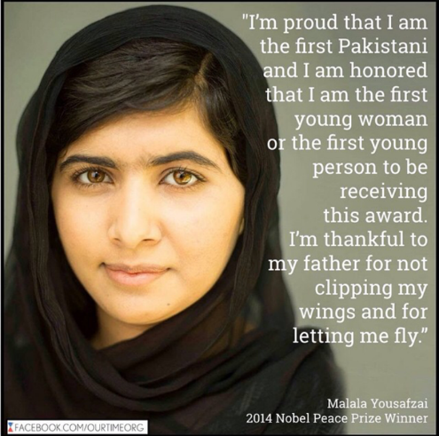

Malala Yousfazai is a Muslim, Pakistani school girl born in the Swat Valley. The area she lived in was occupied by the Taliban (A Muslim extremist group) and they banned girls from going to School.
At the age of 12 Malala started campaigning for Girls to be free to go to School and gain an education. The Taliban did not like this message and one day on her way to School, Malala’s bus was stopped. The Taliban tried to assassinate her. She was shot three times.
She narrowly survived this attack and ever since has been campaigning for every child’s right to an education.
The assassination attempt sparked a national and international wave of support for Malala.
In January 2013 she became one of the most famous teenagers in the world.
In April 2013 Malala featured in the Time magazine as one of the “100 most influential people in the world”.
She was the winner of Pakistan’s first National Youth Peace Prize.
In July 2013 Malala had the chance to speak at the United Nations to call for everybody in the world to have access to education.
On Friday 10th Oct 2014, aged 17, Malala became the youngest Person ever to receive the Nobel Peace Prize. The average age of previous recipients was 62.
The prize judges said about Malala: "Through her heroic struggle she has become a leading spokesperson for girls' rights to education."
She followed the example of Muhammad who suggested that girls should be educated.
Questions:
1. What is happened to Malala Yousfazai?
……………………………………………………………………………………………………………………………………………………………………………………………………………………………………………………………………………………………………………………………………………………………………………………….
2. What does Malala Yousfazai campaign for?
………………………………………………………………………………………………………………………………………………………………………………………………………………………………………………………………………………………………………………………………………………………………………………………..
3. What was the response to Malala Yousfazai throughout the world?
……………………………………………………………………………………………………………………………………………………………………………………………………………………………………………………………………………………………………………………………………………………………………………………………………………………………………………………………………………………………………………………
4. What awards did she win, why?
…………………………………………………………………………………………………………………………………………………………………………………………………………………………………………………………………………………………………………………………………………………………………………………………………………………………………………………………………………………………………………………………………………………………………………………………………………………………………………………..
5. Why were the actions of the Taliban unIslamic? Explain your answer.
………………………………………………………………………………………………………………………………………………………………………………………………………………………………………………………………………………………………………………………………………………………………………………………………………………………………………………………………………………………………………………………………………………………………………………………………………………………………………………………………………………………………………………………………………………………………………………………………………………………………………………………………………………………………………………………………………………………………………………………………………………………………………………………………………………………………………………………………………………………………………..

  - Conflict between the law and personal conviction
Jesus said, “Give to Caesar what belongs to Caesar, and give to God what belongs to God.” Jesus meant that we must obey the authority or the law and we must obey God. However, only our physical bodies are restricted by the law. Our hearts, our souls, belong to God.
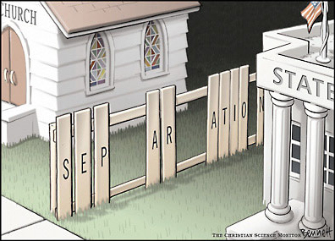
Examples of when the law conflicts with religious beliefs:
- Abortion: Some Christians believe that life begins at conception. This means that at conception an embryo is a person and God gave the commandment, ‘thou shalt not murder’. Therefore the conflict lies in the fact that the law allows abortion up to 24 weeks (or 28 if the pregnancy is affecting the health of the mother), however for some Christians, abortion is considered murder. In addition, some Christians believe that it is their duty to protect the innocent.
- IVF: Some Christians believe that life begins at conception. This means that at conception an embryo is a person and God gave the commandment, ‘thou shalt not murder’. Therefore the conflict lies in the fact that during the IVF procedure (which is legal) many fertilised embryos are thrown away before the chosen few are implanted into the woman’s womb. However for some Christians IVF is considered murder because these fertilised eggs are people and they are being destroyed.
- Euthanasia: All life is special and unique. It is sacred and belongs to God. Some Christians may consider euthanasia a viable option if the patient is terminally ill, has a sound mentality and is suffering with immense pain. Some Christians might consider euthanasia the most loving thing to do in a situation. However, euthanasia is not legal and people who assist in euthanasia can be arrested and prosecuted.
- Same-Sex Relationships: The law allows same-sex couples to get married. In some Churches, e.g. Church of England, same-sex couples can marry, depending on the view of the vicar. However in other churches, e.g. Roman Catholic, same-sex couples are not allowed to marry as they see same-sex couples as going against God’s plan for creation, ‘Go forth and multiply’.

- Women priests: The law demands that we do not discriminate on the grounds of gender. However in some churches, e.g. Roman Catholic, women are not allowed to become priests because Jesus has all-male disciples.
- Just War: God gave the commandment, ‘thou shalt not murder’, and therefore some Christians see taking a life, regardless of the circumstance, as wrong. However, the law allows for war as long as the conditions for a ‘just war’ are met, e.g. right intention / protect the innocent.
What happens if there is a conflict between the law and personal conviction?
A Christian might:
- Pray or speak to a religious leader about the issue
- Consult the Bible or think about what Jesus might do in that situation
- Speak to the religious community and get their perspective on the issue
- Listen to their conscience. This is considered the voice of God.
- Follow the authority anyway since he/she might be divinely chosen by God.
- Stand up against the authority using non-violent protests, e.g. Martin Luther King

Questions
- What did Jesus mean by, “Give to Caesar what belongs to Caesar, and give to God what belongs to God”?
……………………………………………………………………………………………………………………………..
……………………………………………………………………………………………………………………………..
- Explain how the issue of abortion might conflict with the law.
……………………………………………………………………………………………………………………………..
……………………………………………………………………………………………………………………………..
- Explain how the issue of IVF might conflict with the law.
……………………………………………………………………………………………………………………………..
……………………………………………………………………………………………………………………………..
- Explain how the issue of euthanasia might conflict with the law.
……………………………………………………………………………………………………………………………..
……………………………………………………………………………………………………………………………..
- Explain how the issue of same-sex relationships might conflict with the law.
……………………………………………………………………………………………………………………………..
……………………………………………………………………………………………………………………………..
- Explain how the issue of women priests might conflict with the law.
……………………………………………………………………………………………………………………………..
……………………………………………………………………………………………………………………………..

- Explain how the issue of Just War might conflict with the law.
……………………………………………………………………………………………………………………………..
……………………………………………………………………………………………………………………………..
Islam and Abortion
Islam does not allow abortion ‘after a foetus is completely formed and has been given a soul.’ This allows a variety of views within Islam.

Against
- ‘Kill not your children on a plea of want. We shall provide sustenance for them… the killing of them is a great sin.’ (Surah 17:31)
- Children will be able to ask their mother on the Day of Judgement why they were killed.
- Only Allah gives life, only Allah can take it away.
- Some Muslims believe the soul enters the unborn child at conception.

For
- Some Muslims believe that ensoulment (the embryo is given a soul by Allah) takes place at 120 days, and up to that point abortion is allowed.
- The Shari’ah (Islamic Law) says that the mother’s life takes precedence. So if there is a choice about saving the mother or unborn child, the mother should be saved (so only if the mother’s life is at risk)

Islam and IVF
Most Islamic scholars are of the opinion that IVF is allowable in instances where a Muslim couple is unable to conceive in any other way. Scholars agree that there is nothing in Islamic law which forbids many types of fertility treatment, provided the treatments do not go outside the bounds of the marriage relationship. If in vitro fertilization is chosen, the fertilization must be done with sperm from a husband and an egg from his wife; and the embryos must be transplanted into the wife's uterus.

Euthanasia
Euthanasia comes from the Greek meaning "good death." It now means the act of ending another person's life, in order to stop suffering. There are two types of Euthanasia:
Passive Euthanasia- this is the speeding up of death by the removal of life support equipment or medical procedures.
Active Euthanasia- causing the death of a person through a direct action.

Arguments for Euthanasia
- People’s quality of life is appalling- they would have died long ago if not for modern medicine.
- Puts people out of their pain.
- Turning off life support machines is just the same.
- It is your life, you should be able to decide.

Islamic Views of Euthanasia
The Qur’an states: "Take not life which Allah made sacred otherwise than in the course of justice." (Surah 6:151)

There is no right in Islam to suicide. Islam believes that since we did not create ourselves we do not own our own bodies. Allah is the owner and giver of life and His rights in giving and in taking are not to be changed.
Muhammad (pbuh) is reported to have said:
"Whoever kills himself with an iron instrument will be carrying it forever in hell. Whoever takes poison and kills himself will forever keep sipping that poison in hell. Whoever jumps off a mountain and kills himself will forever keep failing down in the depths of hell." (Hadith, saying of the Prophet Muhammad pbuh)

There is no place for mercy killing in Islam. The pain should be born with patience, Muhammad (pbuh) taught.
"When the believer is afflicted with pain, even that of a prick of a thorn or more, Allah forgives his sins, and his wrongdoings are discarded as a tree sheds off its leaves." (Hadith, saying of the Prophet Muhammad (pbuh)

Accepting and withstanding pain will be to the sufferer's credit in heaven.

A person should seek medical treatment in Islam, but when the treatment holds no promise it ceases to be mandatory. This applies to surgical, pharmaceutical and artificial measures that prolong life. Therefore passive euthanasia would be acceptable in the last resort.
But the idea of a total and unrestricted conflict is completely unIslamic.

Islam and Same-Sex Relationships
Generally speaking, Islam does not tolerate homosexuality or same-sex relationships, because there are teachings in the Qur'an which argue that it is unnatural and against the will of Allah.
‘And as for the two of you men who are guilty of lewdness, punish them both. And if they repent and improve, then let them be. Lo! Allah is Merciful.’ (Surah 4:16)
Most schools of Shari'ah (Islamic) Law view homosexual sex as deserving the same punishment as adultery, the death penalty. This means that some Islamic states impose the death penalty on people caught taking part in homosexual acts.
In the UK, there are some Muslims who are openly homosexual or in same-sex relationships. Although they are protected by European anti-discrimination laws, they sometimes face strong opposition from fellow Muslims and within their own families.

Islam and Just War
Islam is in favour of peace and against violence. Murdering the innocent leads to punishment in Hell. The Qur’an states that:
‘If anyone killed a person - unless it was for murder or for spreading mischief in the land - it would be as if he killed the whole people.’ (Surah 5:32)
The Qur’an also states that when fighting Muslim soldiers should be merciful:
‘Fight in the cause of God against those who fight you, but do not transgress limits. God does not love transgressors.’ (Surah 2:190)
The Qur'an emphasises that war should be fought only for noble motives without seeking any earthly reward:
‘Those who readily fight in the cause of God are those who forsake this world in favour of the Hereafter. Whoever fights in the cause of God, then gets killed, or attains victory, we will surely grant him a great recompense.’ (Surah 4:74)

Islam bans the killing of non-combatants (innocent civilians) (Qur'an 2:190, above), or of a soldier who has been captured. Muslims are forbidden from attacking wounded soldiers (unless the wounded person is still fighting).

The Prophet's view of non-combatants is shown by a hadith in which Muhammad sees a woman killed in the battlefield and condemns the action.

The Qur’an states that when an enemy is defeated he should be made prisoner rather than be killed:
‘So when you meet in battle those who disbelieve, then smite the necks until when you have overcome them, then make (them) prisoners, and afterwards either set them free as a favour or let them ransom (themselves) until the war ends.’ (Surah 47:4).
What happens if there is a conflict between the law and personal conviction?
A Muslim might:
- Pray or speak to a religious leader (Imam) about the issue
- Consult the teachings in the Qur’an for guidance on the issue.
- Look towards the saying and teaching of Muhammad (pbuh) on the issue for guidance.
- Speak to the religious community and get their perspective on the issue
- Listen to their conscience. This is considered the voice of God.
- Consult Islamic law or an Islamic judge for guidance on the issue.

Questions
1. Explain why some Muslims think abortion is acceptable.
……………………………………………………………………………………………………………………………..
……………………………………………………………………………………………………………………………..
2. Explain why some Muslims think abortion is unacceptable.
……………………………………………………………………………………………………………………………..
……………………………………………………………………………………………………………………………..
3. Explain the Islamic view of IVF.
……………………………………………………………………………………………………………………………..
………………………………………………………………………………………………………………………………………………………………………………………………………………………………………………………………………………………………………………………………………………………………………………………..
4. Explain Muhammad’s (pbuh) view of euthanasia.
……………………………………………………………………………………………………………………………..
……………………………………………………………………………………………………………………………………………………………………………………………………………………………………………………………………………………………………………………………………………………………………………………….
5. Why do many Muslims object to same-sex relationships?
……………………………………………………………………………………………………………………………..
…………………………………………………………………………………………………………………………………………………………………………………………………………………………………………………………………………………………………………………………………………………………………………………….....

6. How did the Prophet Muhammad (pbuh) think people should be treated in conflicts?
……………………………………………………………………………………………………………………………..
………………………………………………………………………………………………………………………………………………………………………………………………………………………………………………………………………………………………………………………………………………………………………………………..

  - Censorship
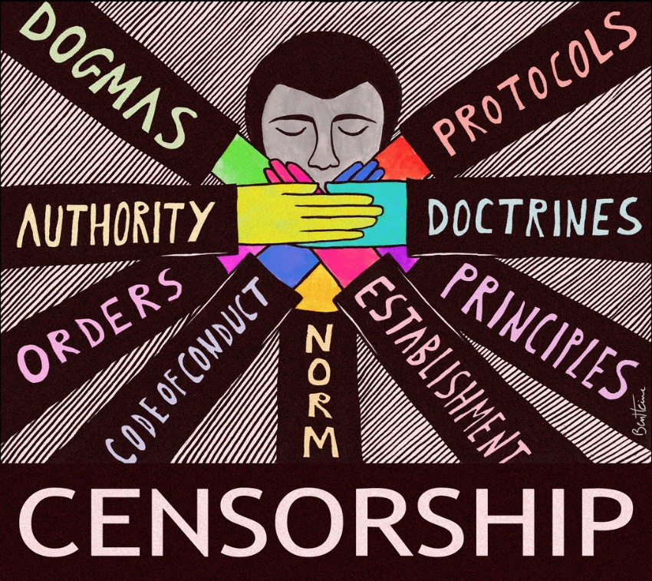
Religious censorship suppresses views that are contrary to the religion. For example, in the past, the Catholic Church has banned hundreds of books because they were considered ‘dangerous’ to the minds of the people reading them. This list of ‘banned books’, which included the work of Galileo, no longer exists.
This sort of censorship limits freedom of religious expression, which is considered a human right. Nowadays, many religions still exercise censorship.
In the secular world, censorship limits free speech, public communication or freedom of information that might be harmful, sensitive or political. It is usually determined by the government (authority in charge), the media or other powerful groups/institutions.
Is censorship right?
Yes:
- Censorship helps to prevent conflict. Censoring hate helps to promote peace.
- It provides security for the country, e.g. certain information is ‘confidential’ and therefore cannot be used against the country, e.g. terrorism
- It avoids children being exposed to adult content, including issues of sex, war, drugs and violence
- It helps to control panic and fear. Completely free media fans the flames of panic. Therefore government intervention can control rumours and over-exaggeration.
- Religious values would be reinforced
No:
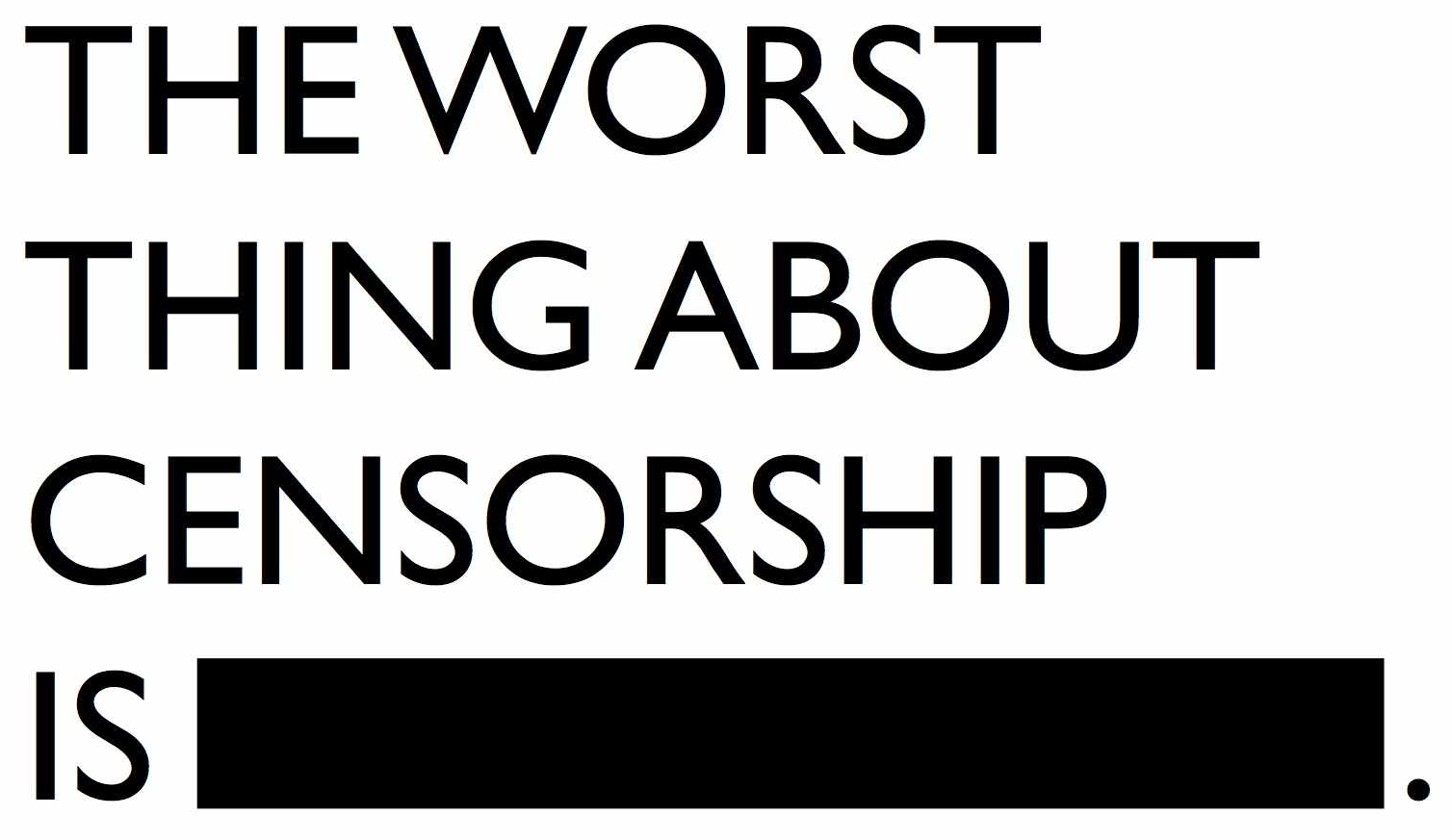
- Censorship can promote negative agendas – the information can be manipulated and therefore the country and what it is thinking can be controlled.
- It violates the rights of citizens as it puts a stop to freedom of expression and free speech
- Censorship only promotes ways of living life that are considered “morally correct,” which would no doubt end up offending some people by labelling a person’s lifestyle choice as ‘immoral’ or ‘wrong’.
- Companies have a powerful place in governments and can control censorship. Big companies might therefore censor their competition or any information that might lead to a reduction in profit.

Questions
- Why did the Catholic Church ban books in the past?
……………………………………………………………………………………………………………………………..
- What is ‘freedom of religious expression’ considered to be?
……………………………………………………………………………………………………………………………..
- What does censorship limit in the secular (non-religious) world?
……………………………………………………………………………………………………………………………..
- Who or what is censorship usually determined by?
……………………………………………………………………………………………………………………………..
- Give two arguments why censorship might be the right thing to do.
……………………………………………………………………………………………………………………………..
- Give two arguments why censorship might be the wrong thing to do:
……………………………………………………………………………………………………………………………..
Islam and Censorship
What is censorship?
Censorship is the examination of different forms of media and the suppression of parts considered unacceptable. Media can be deemed unacceptable for reasons including being violent, sexually explicit or using bad language. Some Muslims state that views that differ from Islamic laws, such as positive promotion of same-sex relationships in school, should be censored. In secular (non-religious) education in the UK resist this as everyone is equal under UK law.

Some people can be limited in their speech by censorship laws. In the United Kingdom people have freedom of speech as long as it does not incite hatred. This means that people are allowed to express their views.

Censorship means to suppress or control anything which could be considered offensive to others.
The have been demonstrations where Muslims have been offended by cartoons of the Prophet Muhammad (pbuh) and books written about him that Muslims consider to be disrespectful.

Within most religious traditions views are expressed about what is morally acceptable. Many support censorship of the media because this helps to limit the extreme behaviour we might otherwise see.

There are arguments both for and against religious groups being able to censor what is shown in the media.

For:
Young people would be safer from exposure to sex, violence, bad language and bad behaviour
The media would be an example of how to behave in society
Religious values would be reinforced
Against:
Atheists and some religious people might not agree with religious groups 'controlling' the media
People's freedom of choice regarding their consumption of mass media would be taken away
Tougher censorship might lead to a dull and unrealistic media
Different religious groups may not be able to agree about what should be censored
Article 19
In Article 19 of the UN Charter of Human Rights, every person is entitled to freedom of opinion and expression. This right includes freedom to hold opinions without interference and to seek, receive and impart information and ideas through any media and regardless of frontiers.

This is considered to be a basic human right for everyone.

Questions
1. Should religious groups be able to censor what is shown in the media? Explain your answer.
………………………………………………………………………………………………………………………………………………………………………………………………………………………………………………………………………………………………………………………………………………………………………………………………………………………………………………………………………………………………………………………………………………………………………………………………………………………………………………………………………………………………………………………………………………………………………………
2. What sort of things do Muslims think should be censored? Explain why.
………………………………………………………………………………………………………………………………………………………………………………………………………………………………………………………………………………………………………………………………………………………………………………………………………………………………………………………………………………………………………………………………………………………………………………………………………………………………………………………………………………………………………………………………………………………………………………
3. Should be ‘Freedom of Expression’ be a universal human right? Explain your answer.
………………………………………………………………………………………………………………………………………………………………………………………………………………………………………………………………………………………………………………………………………………………………………………………………………………………………………………………………………………………………………………………………………………………………………………………………………………………………………………………………………………………………………………………………………………………………………………………………………………………………………………………………………………………………………………………………………………………………………………………………………………………………………………………………………………………………………………………………………………………………………..

  - Freedom of religious expression
In UK, people have the rights to express their religious beliefs, as long as it doesn’t hurt anyone. ‘Freedom of religious expression’ also refers to our tolerance of other peoples’ beliefs.
However, there have been some notable cases where this freedom of religious expression has been denied to people. For example:
- In UK, Nadia Eweida was sent home from her job with British Airlines at an airport for not covering or removing her cross necklace
- Lilian Ladele refused to conduct civil partnerships for same-sex couples as it was against her religious belief. As a result, Ladele has to leave her job as she felt it was a choice between her faith and her employment.
- In France, all religious clothing and symbols has been banned from being worn in public. However, this does result in cases like a woman being forced to remove her hijab whilst she is playing on the beach with her children, despite it being against her religious beliefs. Many would consider her lack of dignity whilst she undressed in public a denial of her human rights.
How does religion use the media?
- Evangelism: Some religious programmes have a regular slot on television or the radio. Songs of Praise is a popular television programme on Sundays, with real-life stories, interviews and live music, bringing the Christian community together across the nation.
- Celebrating Festivals: Christians can tune into broadcasts which are held during religious festivals, such as Christmas and Easter Sunday. They enable people to worship together as a community despite differences in location. Muslim festivals such as Ramadan and Eid Ul Fitr are also celebrated on TV.
- Community Cohesion: Local media can be very useful in keeping faith communities together, e.g. Flame FM on Wirral reflects Christian belief locally. There are also several Islamic radio stations.
- Debates: The Big Questions is a television show which discusses problems within society. The show shares the opinions of religious and non-religious people, which can benefit religion, as their beliefs and ideas are being expressed and understood and common concerns are recognised.
- Education: Most religious groups see the media as a useful tool to provide people outside of their religion with information and to promote their faith in a positive way. Religious Education is taught in all state schools focusing on different religious groups.
- Awareness: Documentaries can help raise the profile of a religion among the population. BBC documentaries such as Life of the Buddha and Life of Muhammad help the audience to understand important historical facts about Buddhism and Islam.
- Charity: Religious groups can also promote their religion through radio, television, or via the internet. For example, charities such as Christian Aid and World Vision and Islamic Aid rely on public exposure in order to bring awareness to their causes and to raise donations.

Questions
- What does ‘freedom of religious expression’ refer to?
………………………………………………………………………………………………………………………………………………………………………………………………………………………………………………………………………………………………………………………………………………………………………………………………………………………………………………………………………………………………………………………………………………………………………………………………………………………………………………….
- What did France ban? What did this result in?
……………………………………………………………………………………………………………………………..
………………………………………………………………………………………………………………………………………………………………………………………………………………………………………………………………………………………………………………………………………………………………………………………..

- State the different ways that religion uses the media.
……………………………………………………………………………………………………………………………..……………………………………………………………………………………………………………………………..
……………………………………………………………………………………………………………………………..
……………………………………………………………………………………………………………………………..
……………………………………………………………………………………………………………………………..
……………………………………………………………………………………………………………………………..
……………………………………………………………………………………………………………………………..

- How is educational useful for religions?
…………………………………………………………………………………………………………………………………………………………………………………………………………………………………………………………………………………………………………………………………………………………………………………………………………………………………………………………………………………………………………………………………………………………………………………………………………………………………………………..
- Which television show debates issues in society?
……………………………………………………………………………………………………………………………………………………………………………………………………………………………………………………………………………………………………………………………………………………………………………………………………………………………………………………………………………………………………………………..
- Name two charities who rely on public exposure to bring awareness to their causes.
……………………………………………………………………………………………………………………………..
……………………………………………………………………………………………………………………………………………………………………………………………………………………………………………………………………………………………………………………………………………………………………………………………………………………………………………………………………………………………………………………

  - Religious extremism
Extremism: Holding aggressive political or religious views. Recently, extreme views have led to terrorist actions, however Jesus taught that ‘those who take up the sword, die by the sword’ and therefore discouraged such actions.

Extremism within Christianity:
One of the earliest examples of extremism within Christianity is the famous Gunpowder Plot in 1605, where Guy Fawkes attempted to assassinate King James I and to blow up the government buildings.
Today, Fundamentalist schools are teaching girls that they should obey men, that homosexuality is “unnatural” and that the account of creation in Genesis is the only true account. This is because of a specific type of interpretation of Biblical texts. For example, in Genesis Eve was created ‘as a helper’ for Adam, and therefore these schools teach women to obey and be of service to men. The Bible also states how God destroyed the cities of Sodom and Gomorrah because of their constant sinning against God. Fundamentalists believe this ‘vice’ to be a metaphor for homosexuality and bestiality.
Creationism is usually taught alongside scientific theories such as the Big Bang and Evolution. However, some schools explicitly only teach Creationism (creation according to the Bible), presenting this as fact. This has resulted in many extreme Christians rejecting science completely.
From 1865, the Ku Klux Klan (Protestant-led) beat, burned, raped and killed African Americans, Jews, Roman Catholics and any other minority group. Their goal was to re-establish Protestant Christian values in America by any means necessary, and believed that Jesus was the first ‘Klansmen’. From 1915 onward, Klansmen conducted cross-burnings not only to intimidate targets, but also to demonstrate their respect and reverence for Jesus Christ, and the ritual of lighting crosses was steeped in Christian symbolism, including prayer and singing hymns.
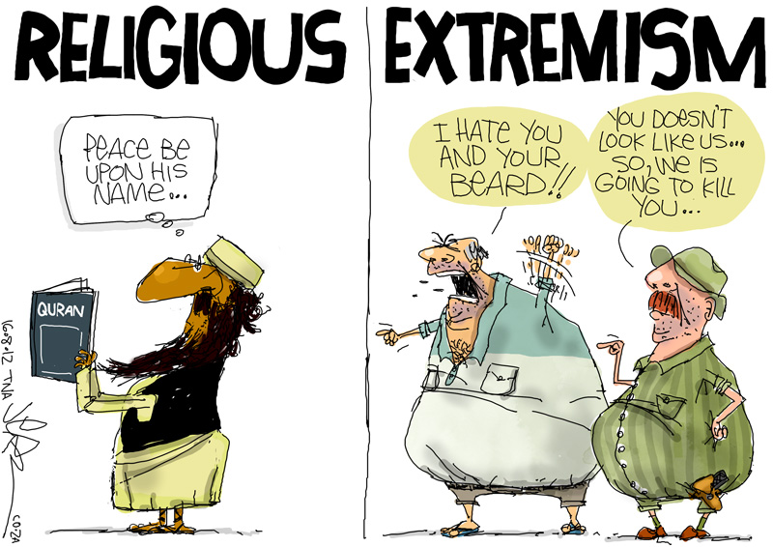
Christians Against Extremism:
- Christian charities have been set up to reconcile different Christian groups and bring an end to violence and conflict, e.g. Corrymeela in Northern Ireland work to bring Roman Catholics and Protestants together as part of one community.
- Jesus said, “those who live by the sword, die by the sword”. This means that violence and extreme action will only ever result in bloodshed. Nothing good can come of it. Jesus was a pacifist and believed that Love would be the answer. In the Parable of the Good Samaritan, Jesus showed the importance of ‘loving thy neighbour’, regardless of who they are or where they are from. Christians believe that they “are all one in Christ Jesus.”
- Martin Luther King famously stood up against racism and injustice in a non-violent and peaceful way. As a result of his protests, e.g. the bus boycott, he was able to change the segregation laws that saw white people take priority over black people. This was a victory for Christian peacemakers everywhere. Jesus called all people to be peacemakers.
- On 1st October 2016, the World Council of Churches (WCC) came together in interfaith dialogue (different religions coming together to talk about their faith). This resulted in peace-building and a breakdown of misunderstanding and intolerance. They agreed that, “religion should never be used to justify violence.” The people who claim to be acting in the name of religion when they shed blood are using religion incorrectly, to justify their own, selfish desires.
Questions:
- What is extremism?
……………………………………………………………………………………………………………………………..……………………………………………………………………………………………………………………………..

- What was one of the earliest examples of extremism within Christianity?
……………………………………………………………………………………………………………………………..
……………………………………………………………………………………………………………………………..

- What three things are Fundamentalist schools teaching children?
……………………………………………………………………………………………………………………………..
……………………………………………………………………………………………………………………………..
- Which group believed that Jesus was the first ‘Klansmen’?
……………………………………………………………………………………………………………………………..……………………………………………………………………………………………………………………………..

- What do Corrymeela do?
……………………………………………………………………………………………………………………………..
……………………………………………………………………………………………………………………………..

- Jesus said, “those who live by the sword, die by the sword.” What does this mean?
……………………………………………………………………………………………………………………………..
……………………………………………………………………………………………………………………………..

- How did Martin Luther King stand up against extremist action?
……………………………………………………………………………………………………………………………..
……………………………………………………………………………………………………………………………..

- On October 1st 2016, what did the World Council of Churches agree?
……………………………………………………………………………………………………………………………..
……………………………………………………………………………………………………………………………..

Islamic Extremism
What is Extremism and Radicalisation?
Islamic Extremism: The holding of extreme political or Muslim views
Islamic Radicalisation: This is a process by which an individual or group comes to adopt increasingly extreme political, social, or religious ideals and aspirations that (1) reject or undermine the non-Islamic views or (2) reject and/or undermine contemporary ideas and expressions of religious freedom and freedom of choice.
ISIS:
This group has been designated as a terrorist organisation by the United Nations. ISIS is known for its videos of beheadings and other types of executions of both soldiers and civilians, including journalists and aid workers, and its destruction of cultural heritage sites. The United Nations holds ISIS responsible for committing human rights abuses, genocide, war crimes, and crimes against humanity. The Islamic State committed genocide and ethnic cleansing on a historic scale in northern Iraq.
Muslim Responses to Extremism:
The Qur’an warns against extremism: "O people of the scripture, do not exceed the limits in your religion.” (Surah 4:171)
The Qur’an condemns murder (terrorist or otherwise) “…whoever kills a soul it is as if he had killed mankind entirely. And whoever saves one - it is as if he had saved mankind entirely.” (Surah 5:32)

Prophet Muhammad said opposed extremism and the corruption of the Muslim faith: ”O people, beware of being extreme and exceeding the limits in religion, for that which destroyed the people before you was none other than extremism in religion.”
Prophet Muhammad warned against future radicalisation of Islam, "Towards the latter times a people will come who have little knowledge; are deficient in intellect; will speak quoting the best of people; have thick beards; wearing shortened garments; have shaved heads; have good speech but foul actions; claiming to act upon the Book of God but have no relation to it; they recite the Quran but it doesn't pass their throats; and they exit from Islam as an arrow exits from its bow."
Questions:
1. What is ISIS and why is it commended by the United Nations?
………………………………………………………………………………………………………………………………………………………………………………………………………………………………………………………………………………………………………………………………………………………………………………………………………………………………………………………………………………………………………………………………………………………………………………………………………………………………………………….

- Explain the Quranic response to extremism in your own words.
……………………………………………………………………………………………………………………………..
………………………………………………………………………………………………………………………………………………………………………………………………………………………………………………………………………………………………………………………………………………………………………………………..

3. What were Muhammad’s predictions about radicalisation?
……………………………………………………………………………………………………………………………..……………………………………………………………………………………………………………………………..
……………………………………………………………………………………………………………………………..
……………………………………………………………………………………………………………………………..
……………………………………………………………………………………………………………………………..
……………………………………………………………………………………………………………………………..
……………………………………………………………………………………………………………………………..

- Prejudice and Discrimination
  - Christian teachings about prejudice and discrimination
How should we treat others?
- Equally as we are all a part of God’s creation
- It is a duty to treat others well according to the teachings in the Bible
- The Golden Rule states to treat others as we would like to be treated
- Stories in the Bible, e.g. Parables, show how we should treat everyone with dignity. The Parable of the Good Samaritan shows how we should care for everyone
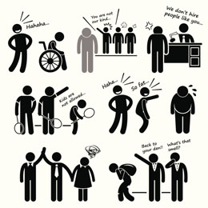
What is fair and unfair?
- Fair:
  - When there are equal opportunities and rights
  - When there is justice
  - When everyone has similar treatment
- Unfair:
  - When there is corruption and injustice
  - When human rights aren’t exercised
  - When people are discriminated against
  - When people don’t share with others
Racial, Social and Gender Divisions
- The Golden Rule: treat others as you would like to be treated
- Although people are equal it doesn’t mean that we are all the same. Each person is unique
- God created all human beings as equal, regardless of gender or race
- Jesus’ had dealings with the ‘outcasts’ of society. His healings included lepers and the sick; his friends included reformed tax collectors, cheaters and prostitutes
- The Parable of the Good Samaritan shows the importance of caring for all
- Christians such as Martin Luther King and Bishop Tutu have campaigned against discrimination
- Although Jesus didn’t have any female apostles, many of his teachings and miracles were with women
- However, in Roman Catholic churches women cannot be priests because of Jesus’ all-male apostles
Why are people prejudiced?
- Family and peer pressure can influence beliefs (adopting others’ beliefs without doing the research ourselves)
- Ignorance (people don’t know any better / different)
- Didn’t learn about it at school (lack of education)
- Specific groups always do so well (envy or jealousy)
- Fear of there being no people left like them (fear of change)
- Bad experiences from a specific group, e.g. stereotyping

Is equality possible?
- It is something to be strived for but it doesn’t come naturally
- Some things are not supposed to be equal, e.g. the Prime Minister or Queen
- Equality of opportunity should be strived for. It is every person’s human right to have equal opportunities
- Christianity shows us the importance of treating others as you would wish to be treated (The Golden Rule)
- Being equal doesn’t mean that everyone is the same
Questions:
- How should we treat others?
…………………………………………………………………………………………………………………..
- What is fair and what is unfair?
…………………………………………………………………………………………………………………..
- What is the Golden Rule?
…………………………………………………………………………………………………………………..
- What does the Parable of the Good Samaritan show?
…………………………………………………………………………………………………………………..
- What can be said about Jesus and women?
…………………………………………………………………………………………………………………..
- What do the Roman Catholic Church believe about women priests?
…………………………………………………………………………………………………………………..
- State three reasons why a person might be prejudiced.
…………………………………………………………………………………………………………………..
- Why might equality be possible?
…………………………………………………………………………………………………………………..
- Why might equality not be possible?
…………………………………………………………………………………………………………………..
Racial prejudice (Martin Luther King)
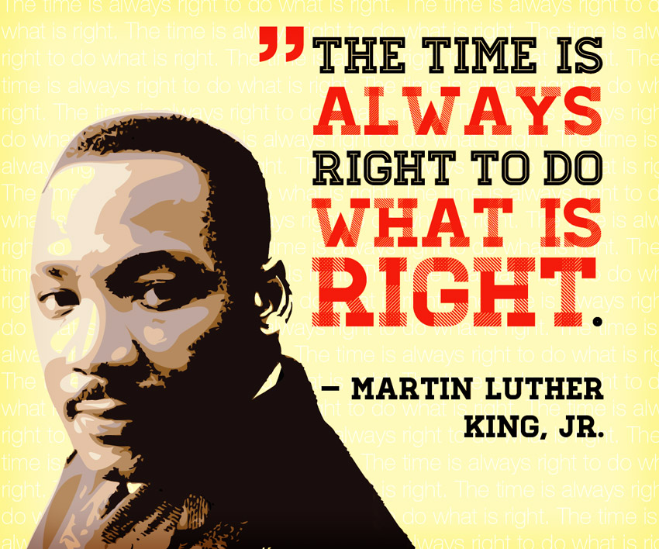
Martin Luther King Jnr was a black civil rights activist in America in 1960s. He was a pastor of a Baptist church where both his father and grandfather had worked, led by his strong Christian faith. In 1955 he organised the bus boycott, which resulted in the end of segregation on buses. He also organised many non-violent protests throughout America to achieve his goals of an equal America.
Martin Luther King believed that all humans were equal before God, made equally by God and deserved equal human rights. In 1964, he achieved the Nobel Peace Prize for his work, including his famous “I have a dream speech” that he gave to Washington.
King was assassinated in 1968 in by James Earl Ray – a known racist who did not want equal rights for all races. King is remembered as a visionary who was guided by his strong Christian principles of non-violence and love. Although white people had committed atrocious crimes against black people at the time, King asked for reconciliation and forgiveness, rather than revenge. He said, “an eye for an eye makes the whole world blind”, and implored (begged) his followers to embrace one another as brothers and sisters in Christian fellowship.

Islamic responses to Prejudice and Discrimination
Muslims believe that all people are equal, as all people are created by Allah. However, they do believe that people have different roles to play. Prophet Muhammad showed in his actions that everyone should be treated equally and fairly. The Ummah (Muslim community) accepts Muslims from all countries, races and backgrounds. During prayer believers pray beside each other to show equality. During Hajj (pilgrimage to Mecca) Muslims all wear white as a symbol of equality, this is called Ihram. It is now accepted in many Muslim communities that Muslim women can work. Khalijah, Prophet Muhammad’s first wife, was a successful business woman.
Islam teaches that all people are created by Allah. All are equal (though not the same). All are important in their own right.
Muhammad treated others with respect and dignity: Muslims must follow example.
During Salah (Prayer) Muslims pray together to shoulder this is powerful expression equality of all regardless of race, wealth or status
Questions:
1. Why do Muslims think that everyone is equal?
………………………………………………………………………………………………………………………………………………………………………………………………………………………………………………………………………………………………………………………………………………………………………………………
2. What Islamic religious actions show that that all Muslims are equal? Provide examples.
……………………………………………………………………………………………………………………………………………………………………………………………………………………………………………………………………………………………………………………………………………………………………………………………………………………………………………………………………………………………………………………………………………………………………………………………………………………………………………………………………………………………………………………………………………………………………………………………………………………………………………………………………………………………………………..
3. How did Muhammad’s (pbuh) life, example and actions show how Muslims should treat everyone equally? Explain your answer.
…………………………………………………………………………………………………………………………………………………………………………………………………………………………………………………………………………………………………………………………………………………………………………………………………………………………………………………………………………………………………………………………………………………………………………………………………………………………………………………………………………………………………………………………………………………………………………………………………………………………………………………………………………………………………………….
- Issues of Wealth and Poverty
  - Christian Ethics of acquiring money
- Material wealth isn’t the most important thing in life
- Your afterlife is not dependent on the amount of wealth you have at death
- Money should be earned honestly. This includes no: gambling; lying; deceit; illegal action; immoral action
- Many Christians will try to work vocational jobs where they are helping others, e.g. nursing or teaching
- The Bible states: “the love of money is the root of all evil”

  - Ethics of using money
- It is important how you use your wealth (to help others). Those who have wealth have a duty and a responsibility to help those who don’t.
- Wealth should be used wisely and not squandered or wasted
- Spiritual values are more important than material things
- Jesus taught ‘blessed are you who are poor, yours is the kingdom of God’
- Jesus told the Parable of the Rich Young Man, where he was asked how a man (who was rich) could get into heaven. Jesus told him to sell everything he has, give it to charity and to follow Jesus. However, the rich man couldn’t do this. Jesus said, “it is easier for a camel to pass through the eye of a needle than it is for a rich man to enter heaven.” This means that if a person has hoarded their wealth and been greedy, they have not used it to help others – they have not followed Jesus, and therefore they will not enter heaven.
- Some Christian denominations such as the Quakers do not take part in gambling nor the lottery. Money is not respected here, nor earned honestly
- The Bible teaches the importance of sharing, e.g. John the Baptist taught that those with two coats should share one
- Some Christians tithe, which means to give regularly to charity out of their salary or wage

  - Christian charities in 21st century Britain (Christian Aid)
There are many charities, e.g. Christian Aid, who are set up to help others in need and distribute wealth more evenly
- Who? Christian Aid are a charity who have worked for over 60 years
- What? They fight against poverty and injustice by redistributing wealth and resources to give some of the world’s poorest people their basic human needs
- Where? Christian Aid work in over 60 different countries all over the world
- When? Christian Aid was founded in 1940s and continues its work to this day
- How? They provide short-term and long-term aid to those in need. They raise money and campaign for justice and gender equality worldwide. They raise money through events like Christian Aid Week.
- Why? The Bible teaches to ‘treat others as we would like to be treated’ and to love our neighbours. Christian Aid aim to continue Jesus’ saving work on earth and to spread the message (gospel) of God.
- Christian Aid work towards a world where everyone can live a full life, free from poverty
Christian Aid Project:
In Senegal, Christian Aid works with local groups of Farmers by:
- Farming and environment: including planting new trees, animal fattening, producing animal feeds.
- Training including literacy classes (for women), management classes (budgets etc), and a theatre group to communicate ideas visually / dramatically to help those who can’t read and write.
- Village water: well digging (two per year) and drainage systems to stop disease.
- Savings and credits: giving access to money through loans at low interest to allow trading and development.

Questions
- Complete the diagram for Martin Luther King and Christian Aid:
Martin Luther King:
………………………………………………………………………………………………………………………………….………………………………………………………………………………………………………………………………………………………………………………………………………………………………………………………………
………………………………………………………………………………………………………………………………….………………………………………………………………………………………………………………………………………………………………………………………………………………………………………………………………
………………………………………………………………………………………………………………………………….………………………………………………………………………………………………………………………………………………………………………………………………………………………………………………………………
………………………………………………………………………………………………………………………………….………………………………………………………………………………………………………………………………………………………………………………………………………………………………………………………………
………………………………………………………………………………………………………………………………….………………………………………………………………………………………………………………………………………………………………………………………………………………………………………………………………
………………………………………………………………………………………………………………………………….………………………………………………………………………………………………………………………………………………………………………………………………………………………………………………………………

Christian Aid:
………………………………………………………………………………………………………………………………….………………………………………………………………………………………………………………………………………………………………………………………………………………………………………………………………
………………………………………………………………………………………………………………………………….………………………………………………………………………………………………………………………………………………………………………………………………………………………………………………………………
………………………………………………………………………………………………………………………………….………………………………………………………………………………………………………………………………………………………………………………………………………………………………………………………………
………………………………………………………………………………………………………………………………….………………………………………………………………………………………………………………………………………………………………………………………………………………………………………………………………
………………………………………………………………………………………………………………………………….………………………………………………………………………………………………………………………………………………………………………………………………………………………………………………………………
………………………………………………………………………………………………………………………………….………………………………………………………………………………………………………………………………………………………………………………………………………………………………………………………………

- How should money be acquired?
……………………………………………………………………………………………………………………………..
……………………………………………………………………………………………………………………………..
……………………………………………………………………………………………………………………………..

- How should money be used?
……………………………………………………………………………………………………………………………..
……………………………………………………………………………………………………………………………..
……………………………………………………………………………………………………………………………..

- Finish the sentence: ‘Blessed are you who are poor…………………………………………………...
……………………………………………………………………………………………………………………………..
……………………………………………………………………………………………………………………………..

- Which Christian denomination do not take part in gambling because the money is not used wisely or earned honestly?
……………………………………………………………………………………………………………………………..

- What is the meaning of ‘tithe’?
……………………………………………………………………………………………………………………………..
……………………………………………………………………………………………………………………………..
- What do Christian Aid do in Senegal?
……………………………………………………………………………………………………………………………..
……………………………………………………………………………………………………………………………..
……………………………………………………………………………………………………………………………..
……………………………………………………………………………………………………………………………..

Muslim Attitudes of Acquiring Wealth
One of the ‘Five Pillars of Islam’, is Zakah, a compulsory payment to the poor. It is an annual payment made up of around 2.5% of any excess wealth a person has (i.e. cash, savings and value of any jewellery etc.). It is not seen as charity, which is optional, or tax which is for the state. It is based on social welfare and the distribution of wealth. Muslims regard this as simple justice because it is working towards a more equal justice.

Muslims are taught that everyone has a duty to treat each other fairly. Those who have money should help those who do not have money. The Qur’an teaches that it is unjust for someone to loan money to another person and charge them interest because that only makes the rich person richer and the poor person poorer. Muslims try to use an Islamic bank for their savings, so that any money earned goes to help those who are less fortunate. Some High street banks like Natwest or HSBC have a special account so Muslims can obey Shari’ah (Islamic) law.
Muslim Charities in the 21st Century
Muslim Aid
Muslim Aid is a UK-based charity founded in 1985 which works in more than 70 of the poorest countries to alleviate suffering and poverty.
Muslim Aid is guided by the teachings of Islam. Its aim is to tackle poverty and its causes and to respond to emergencies caused by natural disasters and war. It aims to eliminate poverty by working on projects which:
- Provide food and shelter
- Provide education and training
- Supply clean water
- Make healthcare available
- Generate income for communities
Islamic Relief
Islamic Relief is an international charity founded in 1984. The charity aims to improve the lives of the poorest people by responding to natural disasters and emergencies. The organisation also works with local communities to develop social and economic growth.
Islamic Relief relies on donations. Muslims have an obligation to give a percentage of their income, Zakat, to charity. The money raised supplies people in need with food, water, clothing, education and other basic necessities.
The mission of this organisation is based on the teachings of Islam using quotes from the Qur'an as a guide, for example:
“Whoever saved a life; it would be as if he saved the life of all mankind.” (Qur'an 5:32).
Questions:
1. Explain the concept of Zakat.
………………………………………………………………………………………………………………………………………………………………………………………………………………………………………………………………………………………………………………………………………………………………………………………
2. What is the Muslim view of loaning money? Why is this the case?
…………………………………………………………………………………………………………………………………………………………………………………………………………………………………………………………………………………………………………………………………………………………………………………………………………………………………………………………………………………………………………………………………………………………………………………………………………………………………………………
3. How do Muslim bank accounts work?
……………………………………………………………………………………………………………………………………………………………………………………………………………………………………………………………………………………………………………………………………………………………………………………….Muslim Aid:
………………………………………………………………………………………………………………………………….………………………………………………………………………………………………………………………………………………………………………………………………………………………………………………………………
………………………………………………………………………………………………………………………………….………………………………………………………………………………………………………………………………………………………………………………………………………………………………………………………………
………………………………………………………………………………………………………………………………….………………………………………………………………………………………………………………………………………………………………………………………………………………………………………………………………
………………………………………………………………………………………………………………………………….………………………………………………………………………………………………………………………………………………………………………………………………………………………………………………………………
………………………………………………………………………………………………………………………………….………………………………………………………………………………………………………………………………………………………………………………………………………………………………………………………………
………………………………………………………………………………………………………………………………….………………………………………………………………………………………………………………………………………………………………………………………………………………………………………………………………

