eduqas

GCSE Religious Studies
Philosophy & Ethics:
Good and Evil

Name:

Key Concepts in
Philosophy and Ethics:
Good & Evil

- Good and Evil: Good things are approved of and can be called ‘moral’ or ‘acceptable’. Bad things are disapproved of and can be considered ‘immoral’ or ‘…………………………...’ For Christians, the Bible states what is considered ‘good’ and ‘evil’ in God’s eyes, e.g. murder.
- Forgiveness: To let go of the suffering someone has caused you and to ………………………….. . Jesus said to ‘forgive seventy times seven’, because we ………………………….. forgiveness ourselves.
- Free Will: The ability to make free ………………………….. in life. Christians believe that they have the free will to choose whether to follow God’s ………………………….. .
- Justice: When people get equal rights and …………………………... Jesus supported and promoted justice in his teachings. For example, the Parable of the Unforgiving ………………………….. .
- Morality: A ………………………….. of values, telling us what is right and wrong. The Bible guides Christians to understand moral behaviour and act in accordance with
………………………….. expectations.
Word Box
unacceptable
forgiveness
system
opportunities
sharing
move on
choices
expect
laws
judge
Servant
God’s
atoned
- Punishment: Making someone suffer pain or loss for a wrongdoing. For
example, ‘at the end of time, God will be the final …………………………...’
- Sin: An immoral act that goes against one of God’s laws. Christians believe
that sins need to be ………………………….. for and reconciliation must
happen in order to gain God’s ………………………….. for the sins we
have committed during our lives.
- Suffering: Experiencing pain, distress or hardship. Christians believe that
suffering can be a test from God or a way of ………………………….. in the
suffering of Jesus’.

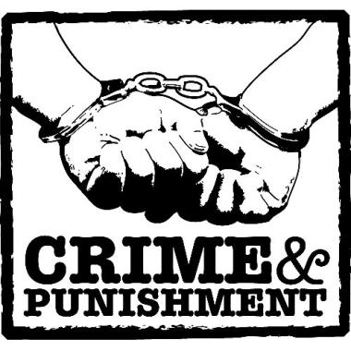
Morality
What makes an act ‘wrong’?
Morality is concerned with what is right and wrong. We begin learning from the moment we are born. At first we learn from the people who bring us up but as we grow, so do our influences. The way we learn about the correct way to behave in our own society, and the habits, customs, language and manners of our society is called socialisation. We also slowly learn what is right and what is wrong, what is good and what is bad.
Christians believe that all humans were given a conscience by God. A conscience is an inner voice which tells your right from wrong and it is believed that this comes into play each time we are faced with a decision.
Aristotle, a philosopher, came up with a list of virtues that we need to gain through education in order to have a happy life.
Aristotle believes in absolute morality - it is always good to be honest, kind, courageous etc. Other modern virtue ethicists say that values change, and different societies hold up believe that different virtues are desirable.
For example, today in Britain, strong, intelligent women are considered virtuous. However, a hundred years ago, women were considered virtuous if they were seen and not heard, or if they obeyed their husband.
Some of the ways we begin to discover what is right and wrong are:
By consequence – if you do this, such and such a thing will happen
By example – watching how others behave
By experience – if you do something yourself you find out what happens
By emotions – the reactions of others e.g. making someone happy/sad/angry
By following rules – the law or the Ten Commandments
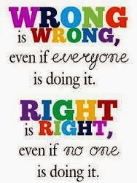
For Christians, morality is influenced by scripture (the Bible), religious leaders, the official teaching of their religion and personal conscience. There are two types of morality that affect the decisions people make - absolute morality and relative morality.

Absolute morality
If you believe in absolute morality you believe that actions are
always right or wrong, regardless of circumstance, culture,
religious tradition, time or age.
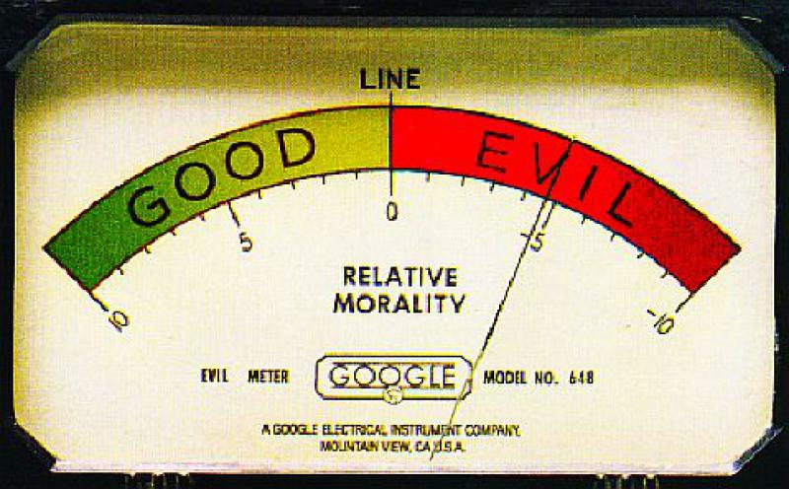
How would a follower of this sort of morality respond to the
commandment 'Do not kill'? They would try to make sure that
they were not involved in any killing, which would affect their
views on issues such as war, abortion and euthanasia. An
absolutist would say that these actions are wrong in all
circumstances.

Relative morality
If you believe in relative morality you believe that what is considered ‘moral’ will vary from situation to situation.
How would a follower of this sort of morality respond to the commandment 'Do not kill'? They would agree that killing is wrong, but would look at a range of other issues as well and say that sometimes killing might be necessary in a particular situation, such as abortion, if continuing the pregnancy would result in the birth of a very disabled child, or if the mother had been raped.
Making Moral Decisions
Absolute vs Relative Morality
​
Absolute morality is when moral rules, e.g. 'do not kill', are true in every circumstance. It doesn't matter, for example, if it is killing in a war - war, regardless of situation - is always wrong. Absolutists in Christianity are Quakers and Roman Catholics. If the Ten Commandments say not to steal, then stealing is always wrong.
​
Relative morality is where the person takes the situation as a one-off moral dilemma and judges how to act based on the circumstances. E.g. killing in a time of war might be acceptable for a relativist, as the result would be to reduce suffering over all. Moral relativist would judge a situation independently and not compare it to moral rules or absolutes, such as the Ten Commandments. Even though the commandments state to not steal, it might be allowable if a parent had stolen a loaf of bread to feed their starving children.

Utilitarianism:
​
This means that we should make decisions based on the greatest good for the greatest number. So, when faced with a moral dilemma, we should weigh up the impact of our decision on the people it will affect. We should always choose the action that causes the most happiness.

Using Reason and Logic
​
Reason and logic guide some peoples' decision making. They might try to look at the situation or a dilemma in a factual way, i.e. trying to avoid emotional influence, religion or law. People who try to make moral decisions this way might be considered moral relativists.

Virtue Ethics​
​
Aristotle believed that 'good' actions are those that are virtuous and bad actions are those without virtue.
Virtues are qualities thought of as good, right and honest. Examples are:
1.Chastity (not having sex until marriage)
2.Temperance (not drinking alcohol)
3.Charity (volunteering time and effort)
4.Diligence (careful and persistent effort)
5.Patience (acceptance or tolerance or problems)
6.Kindness (compassion towards others)
7.Humility (modest view of your own importance)

Practising these virtues is believed to keep people safe from the temptation to commit sin.

Morality Questions
- What is morality concerned with?
………………………………………………………………………………………………………………………...
………………………………………………………………………………………………………………………...
- What do Christians believe they were given by God?
………………………………………………………………………………………………………………………...
………………………………………………………………………………………………………………………...
- What did Aristotle come up with?
………………………………………………………………………………………………………………………...
………………………………………………………………………………………………………………………...
- Name two examples of Aristotle’s virtues
………………………………………………………………………………………………………………………...
………………………………………………………………………………………………………………………...
- State five ways in which we discover what is right and wrong.
………………………………………………………………………………………………………………………...
………………………………………………………………………………………………………………………...
- What is absolute morality?
………………………………………………………………………………………………………………………...
………………………………………………………………………………………………………………………...
- What is relative morality?
………………………………………………………………………………………………………………………...
………………………………………………………………………………………………………………………...
- How does a Utilitarian make a moral decision?
………………………………………………………………………………………………………………………...
………………………………………………………………………………………………………………………...
- How might reason and logic be used to make moral decisions?
………………………………………………………………………………………………………………………...
………………………………………………………………………………………………………………………...
- What needs to be practised in order to stay safe from temptation or committing sin?
………………………………………………………………………………………………………………………...
………………………………………………………………………………………………………………………...
Crime

The Seven Deadly Sins
Crime vs Sin
Some sins are not considered crimes in our society, e.g. adultery or working on a Sunday (these are both against Ten Commandments)
Unlike crime, which can lead to punishment, sin can lead to personal suffering, offending God or excommunication (being cut off from the Church) or even exclusion from heaven

Religions agree on the 7 deadly sins:
- Pride
- Greed
- Lust
- Envy
- Gluttony
- Wrath
- Sloth
Questions About Crime
What is Crime?
Any offence that is punishable by law
Who are the government?
Crime in 21st Century Britain
Over 30,000 crimes are committed each day, ranging from crimes against property and people to internet crime and fraud. Statistically, the most danger is by anti-social behaviour. Society has become concerned with extremism and sexual offences.

The government makes the laws which govern our
behaviour.

What about the police?
The police prevent and detect crime.
What does the criminal justice system do?
criminal justice system enforces these laws and
punishes crime

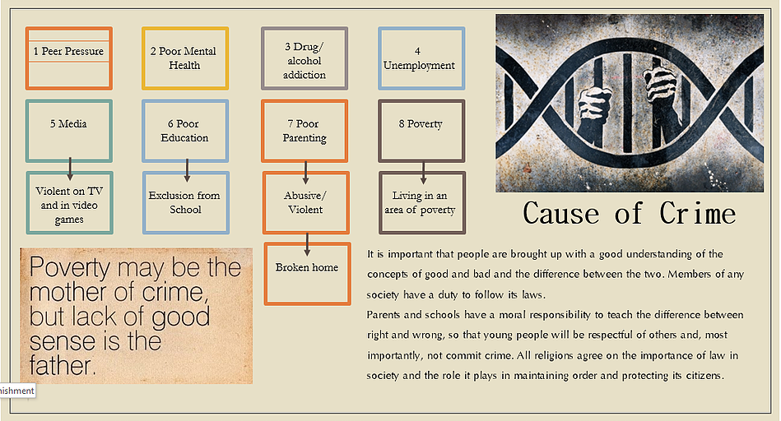

Crime Questions
- What are the seven deadly sins?
………………………………………………………………………………………………………………………...
………………………………………………………………………………………………………………………...
- What is crime?
………………………………………………………………………………………………………………………...
………………………………………………………………………………………………………………………...
- Who are the government?
………………………………………………………………………………………………………………………...
………………………………………………………………………………………………………………………...
- Who are the police?
………………………………………………………………………………………………………………………...
………………………………………………………………………………………………………………………...
- What does the criminal justice system do?
………………………………………………………………………………………………………………………...
………………………………………………………………………………………………………………………...
- What is an example of a sin that is not considered a crime?
………………………………………………………………………………………………………………………...
………………………………………………………………………………………………………………………...
- Name 8 causes of crime:
………………………………………………………………………………………………………………………...
………………………………………………………………………………………………………………………...
………………………………………………………………………………………………………………………...
………………………………………………………………………………………………………………………...

- Who has a moral responsibility to teach the difference between right and wrong
………………………………………………………………………………………………………………………...
………………………………………………………………………………………………………………………...

The Aims of Punishment

◦Protection: To protect society from becoming victims of crime, e.g. a prison sentence removes a criminal from society. Terrorists, murderers, rapists and drug dealers are given prison sentences as they are a threat to the rest of society.
◦Reparation: Repairing the damage done through crime. Restorative justice programmes, such as community service clean-up schemes for vandals, allow offenders to attempt to make up for the crime that have committed.
◦Vindication: Effective punishment that shows that the law and government deserve respect and should be followed. This allows people to have confidence in the law and respect the role it plays in creating order.
◦Retribution: This is revenge or ‘getting even’ with the person who has committed the crime. For some victims of crime, this is the only way they feel that justice can be done.
◦Deterrence: To deter or put people off doing the crime. Historically, this was the main purpose of the death penalty. For a deterrent to work, the criminals who are caught need to be made an example of in order to warn others in society not to commit crime.
◦Reformation: This attempts to address the cause of crime by rehabilitating or reforming offenders so that they can understand why their action was an offence. Reform can take the shape of therapy, counselling, education or training.
Punishment Questions
- What are the six aims of punishment and what do they each mean?
………………………………………………………………………………………………………………………...
………………………………………………………………………………………………………………………...
………………………………………………………………………………………………………………………...
………………………………………………………………………………………………………………………...
………………………………………………………………………………………………………………………...
………………………………………………………………………………………………………………………...

Justice
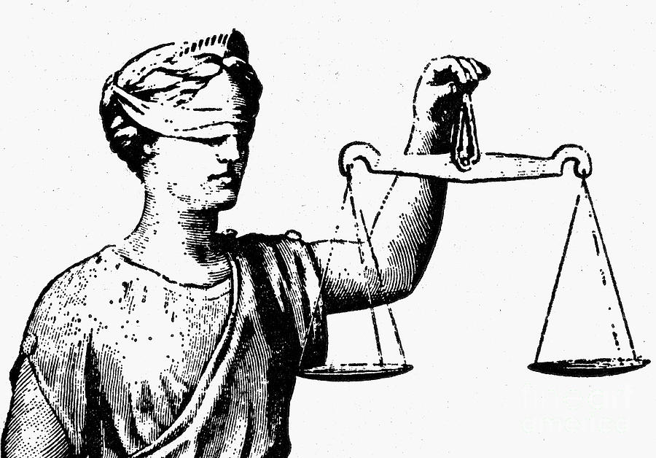
Restorative Justice: A system of justice that enables criminals to make amends for their behaviour by meeting with their victim and apologising.
What is Justice?
•Fairness, fair trial and punishment that fits the crime
•Maintaining justice is a key feature of a moral society
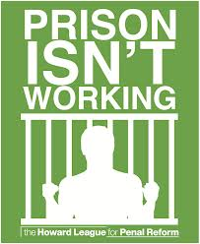
•Justice cannot be achieved without some form of punishment. However the punishment must address the cause of the crime and reflect the severity of the crime, e.g. a murderer shouldn’t be given a fine and person who stole some sweets
shouldn’t go to prison for life
Arguments against prison sentences:
•The prison system in Britain is at a breaking point. Numbers of inmates is too high.
•When released from prison, offenders often reoffend – rehabilitation is needed, not just a prison sentence.
•Some prisoners are given the opportunity to reflect and reform
•It is too difficult to get a job with a criminal record
•Prisoners can often learn even more about the life of crime in prison, educating each other on other
criminal methods

Christian Attitudes to Punishment and Justice
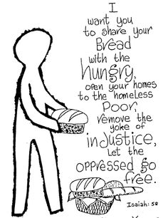
•Christianity teaches forgiveness, so they do not agree with retribution as a purpose of punishment
•Christians believe in justice, which means that forgiveness and punishment should go together
•Christians should try to follow the example of Jesus, who forgave those who betrayed him. He forgave Judas during the Last Supper and on the cross he asked, “Father, forgive them, they don’t know that they are doing.”
•Christians tend to support punishment practices that lead to forgiveness, for example restorative
justice programmes in prisons.
•Jesus taught compassion and not revenge and because of this, many Christians have been actively involved in prison reform to ensure that people are treated humanely in prison.
•They believe that it is important to recognise and address the causes of criminal behaviour, such as poverty, unemployment and poor social conditions as a means of restoring social justice and preventing crime.
•Punishment should enable a person to reform - to change their ways and to be of value to the community
•“Let justice roll on like a river, righteousness like a never-failing stream.” (Amos 5:24)

Most people, regardless of faith, believe that humans should be given a second chance if they are genuinely sorry for what they have done, going by the principle to ‘treat others as you would like to be treated.’

Treatment of Criminals in Modern Prisons
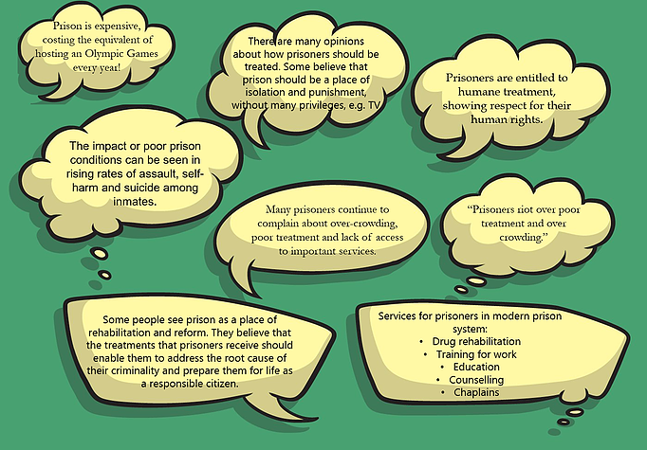

Justice and the Treatment of Criminals: Questions
- What is restorative justice?
………………………………………………………………………………………………………………………...
- What is justice?
………………………………………………………………………………………………………………………...
- State two arguments against prison sentences
………………………………………………………………………………………………………………………...
………………………………………………………………………………………………………………………...
- Whose example should Christians follow when it comes to attitudes to punishment?
………………………………………………………………………………………………………………………...
- What did Jesus say on the cross?
………………………………………………………………………………………………………………………...
………………………………………………………………………………………………………………………...
- What did Jesus teach instead of revenge?
………………………………………………………………………………………………………………………...
- What do Christians believe it is important to recognise?
………………………………………………………………………………………………………………………
- What does Amos 5:24 say about justice?
………………………………………………………………………………………………………………………...
- State three facts about the treatment of criminals in modern prisons.
………………………………………………………………………………………………………………………...
………………………………………………………………………………………………………………………...
………………………………………………………………………………………………………………………...
- What services are available for criminals within prisons?
………………………………………………………………………………………………………………………...
………………………………………………………………………………………………………………………...
Care for Prisoners and
The Role of Prison Chaplains
What is a chaplain?
- A Chaplain is a minister, such as a priest, pastor or community member of a religious tradition.
- They are attached to non-religious institutions such as hospitals, prisons, schools or universities. Their job is to provide pastoral care for patients, pupils or prisoners
​
What is the role of a chaplain?
- They provide counselling to inmates, supporting them through rehabilitation and seeing to their spiritual needs
- Prisoners need someone who is not a prison officer or warden for support due to their complex emotions regarding fear, loneliness, guilt or family concerns
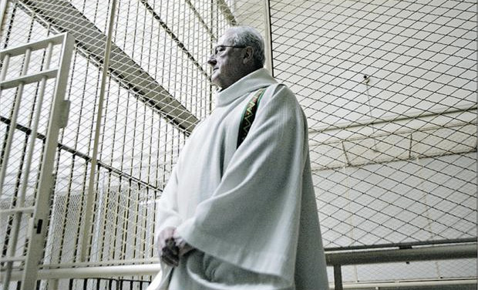
- Chaplains also help prisoners to re-enter the community, working with parole officers and other volunteers
- Families of inmates also have access to prison chaplains
- Family members can be the victims of the inmates’ crimes and require the care of the chaplain just as much as the inmate
- Chaplains do not have to be religious. 32% of prison chaplains are not religious
​
Why become a chaplain?
- There is something of God in everyone – no matter what they have done. It is a duty to support them
- Working as a chaplain is following in Jesus’ footsteps – you are showing compassion, love and kindness
- People are more than the worst thing that have ever done in their lives
- Matters of the spirit can only be solved through a certain type of therapy. Chaplains are not there to judge.

Humanist Prison Chaplains

- Humanist chaplains are there primarily for the inmates.
- Most offenders are also victims. That doesn’t mean that we feel sorry for them; but we do offer them enough compassion.
​
Humanists have been running a project with Humanist Pastoral Support Volunteers at Winchester Prison. This includes meeting inmates with ‘nil’ religion on admission, holding discussion groups and proving counselling, such as bereavement support, for inmates.
This is especially important as often prisoners are unable to attend funerals of loved ones or benefit from the type of community support offered to those who have suffered the loss of family or friends.
Prison Chaplain Questions
  - What is a chaplain?
……………………………………………………………………………………………………………………………..
  - What is the role of a chaplain?
……………………………………………………………………………………………………………………………..
……………………………………………………………………………………………………………………………..
  - Who else has access to the help that chaplains provide?
……………………………………………………………………………………………………………………………..
  - What percentage of chaplains are non-religious?
……………………………………………………………………………………………………………………………..
  - Why become a chaplain?
……………………………………………………………………………………………………………………………..
……………………………………………………………………………………………………………………………..
  - Finish the sentence: “People are more than…”
……………………………………………………………………………………………………………………………..
  - What do Humanists prison chaplains do?
………………………………………………………………………………………………………………………...
………………………………………………………………………………………………………………………...
Capital Punishment / The Death Penalty
The death penalty, also known as Capital Punishment, has been a type of punishment for thousands of years for the worst criminal behaviours.
The death penalty is still legal in over 80 different countries (although 50 of these countries have not used execution as a punishment in the last 10 years).
The majority of the countries that have the death penalty are nations like China, Afghanistan and USA. In America, ‘death row’ (the name given to the area where prisoners waiting to be executed are held) has now become a popular feature of film, TV programmes and documentaries.
82% of global nations do not use the death penalty.

Christian Attitudes to the Death Penalty
Liberal Christians
- Only God has the right to take a life
- Execution goes against the sanctity of life
- All life is precious and only God should end it
- “Thou shalt not kill,” is a clear commandment
- Jesus taught us to be compassionate and forgiving
- Jesus forgave the woman caught in adultery and also pleases with God for his executioners to be forgiven when he was on the cross
- “Father forgive them, for they know not what they do.”
- Christians favour reform over execution. Many work as Chaplains in prisons.
- Jesus taught ‘turn the other cheek’, to love our enemies and to forgive. Execution makes these impossible.

Quakers (Liberal Christians)

- The Quakers have campaigned against the death penalty since 1818
- All human life should be respected and everyone is a reflection of God/contains a little of God
- Punishments should always be used to reform
- Some of the first prison reformers were Quakers who worked to maintain the dignity and humanity of prisoners
- “Do not repay anyone evil for evil. Be careful to do what is right in the eyes of everyone. If it is possible, as far as it depends on you, live at peace with everyone.”

Roman Catholics
- RC Christians are divided on Capital Punishment. Traditionally the Catholic Church has allowed (but not encouraged) capital punishment
- In 1997 the Vatican issued a statement saying that execution was acceptable where the identity of the criminal was absolutely confirmed and where execution was the only means to protect society from the criminal
- The Vatican also states that non-lethal means of punishment were “more in keeping with the concrete conditions of the common good and the dignity of the human person.” (Pope John Paul II)

Conservative Christians

- Some Christians support the death penalty, seeing it as following the Old Testament law of ‘an eye for an eye’. In the Old Testament it states, “Whoever sheds the blood of man, by man shall his blood be shed.”
- The Old Testament specifies 36 capital offences. These are crimes that are deserving of the death penalty and include idolatry, blasphemy and murder.
- Some Christians argue that the death penalty was not only approved, but created by God.
- Capital punishment upholds the commandment, ‘thou shalt not kill’, by showing the seriousness of the crime of murder

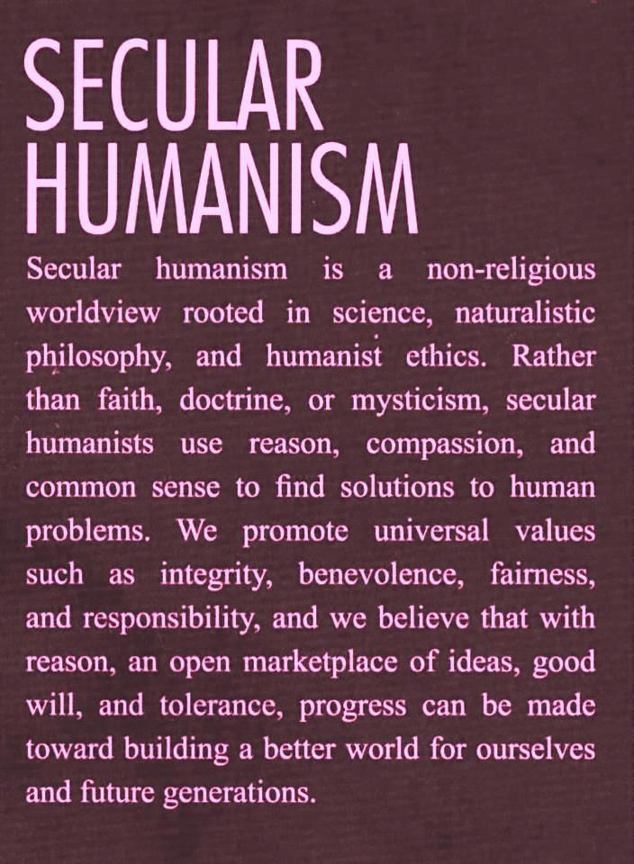
Humanist Attitudes to the Death Penalty
​
- Capital punishment is generally opposed by humanists because they think premeditated killing is wrong, even when carried out by the state
- The death penalty raises the possibility of error and an irreversible failure of justice by issuing a sentence that cannot be reversed
- Humanists believe that treating criminals fairly also helps to ensure that innocent suspects are treated fairly

Arguments for the Death Penalty

Arguments Against the Death Penalty

Capital Punishment: Questions:
- What do liberal Christians believe about capital punishment?
………………………………………………………………………………………………………………………...
………………………………………………………………………………………………………………………...
- What do the Quakers believe about capital punishment?
………………………………………………………………………………………………………………………...
………………………………………………………………………………………………………………………...
- What do Roman Catholics believe about capital punishment?
………………………………………………………………………………………………………………………...
………………………………………………………………………………………………………………………...
- What do conservative Christians believe about capital punishment?
………………………………………………………………………………………………………………………...
………………………………………………………………………………………………………………………...
- What do Humanists believe about capital punishment?
………………………………………………………………………………………………………………………...
………………………………………………………………………………………………………………………...
- State three arguments for the death penalty.
………………………………………………………………………………………………………………………...
………………………………………………………………………………………………………………………...
………………………………………………………………………………………………………………………...
………………………………………………………………………………………………………………………...
- State three arguments against the death penalty.
………………………………………………………………………………………………………………………...
………………………………………………………………………………………………………………………...
………………………………………………………………………………………………………………………...
………………………………………………………………………………………………………………………...
Forgiveness and Reconciliation
Can We Learn To Forgive?
Forgiving enables believers to reach a deeper spiritual understanding about themselves
Forgiveness cannot be taught
We learn to forgive through our own personal, human experience, through others, through religious teachings and through being forgiven ourselves

Does True Forgiveness Exist?
Forgiveness is essential. It enables wrongs to be acknowledged and relationships to be rebuilt
To forgive properly, we need to remember the wrongs done, analyse them, understand them, accept them and then continue to live our lives
Forgiveness is not an action but a process
Some people believe that there are some things that cannot be forgiven, e.g. the murder of a loved one

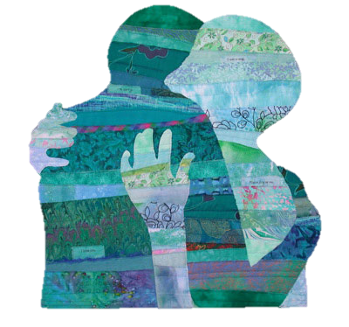
Humanist Attitudes to Forgiveness
- Forgiving is crucial for human relationship. We all make mistakes and are capable of selfish behaviour, but we are also capable of understanding and forgiveness
- The Golden Rule, ‘treat others as we would like to be treated’, requires us to forgive mistakes and selfish behaviour and accept different views.
- The existence of human compassion and common sense compels us to forgive. Humanists recognise that it is not easy to forgive, and sometimes behaviour is so inhuman that forgiveness seems impossible, so the best we can do is work to make sure that whatever needs forgiving does not happen again

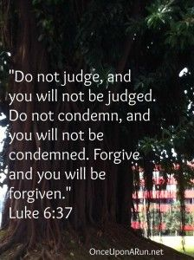
Christian Attitudes to Forgiveness
- Christianity is known as a religion of forgiveness, love and compassion
- Jesus’ teachings and the teachings of moral exemplars, e.g. MLK, show forgiveness to all
- “Do not judge and you will not be judged. Do not condemn and you will not be condemned. Forgive and you will be forgiven.” (Luke 6:37)
- The Lord ’s Prayer: “forgive us our sins as we forgive those who sin against us.”
- In Jesus’ Beatitudes (the blessings listed by Jesus in his sermon on the mount) demonstrate forgiveness: “Blessed are the merciful, for they will be shown mercy.”

Forgiveness can also be evidenced through Jesus’ actions and Bible stories:
​
Jesus’ Actions:
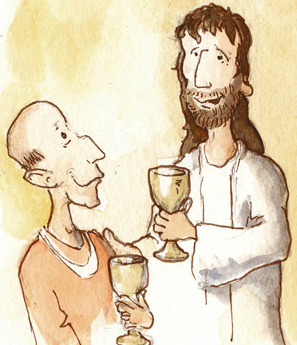
- Jesus visited Zacchaeus, despite his cheating and greed. This enabled Zacchaeus to make amends and reform.
- Jesus forgve the adulterous woman, saying that ‘he who has not sinned can throw the first stone’.

Bible Stories:
- The Parable of the Prodigal Son teaches about forgiveness. A son demands his inheritance from his father, abandons his family and wastes his money. Later, poor and hungry, he returns to his father who forgives his son and welcomes him back.
- The Parable of the Unforgiving Servant tells us that we must forgive others, ‘Seventy times seven’, in order to be forgiven. So, Christians believe they should forgive a limitless number of times because they will be forgiven by God for their many sins.
- “If you do not forgive others, your Father will not forgive your sins.” (Matthew 6:15)

How do Christians get forgiveness?
- For Roman Catholics, forgiveness is supported through confession and atonement, e.g. prayers. RCs believe that Christ started the sacrament of penance and they believe that God’s forgiveness is granted through a priest’s pardon after confession
- Evangelical Christians believe that forgiveness is granted by God and reliant upon faith. Here, confession is not accepted as a route to forgiveness.
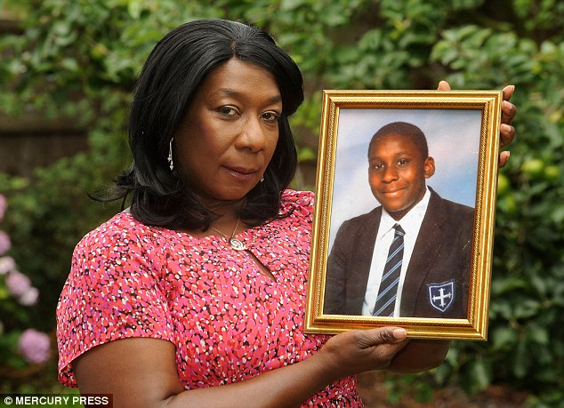
Examples of People Who Forgave
Gee Walker
◦Mother of Anthony Walker who was murdered during a racially motivated attack in Liverpool in 2005.
◦“I have to forgive them. I cannot hate. Hate is what killed Anthony.”
Martin Luther King Jr
◦“Forgiveness is not an occasional act, it is a constant attitude.”
Gee Walker forgave her son's murderers because of her Christian beliefs. She said, "We expect to be forgiven, so I chose to forgive."
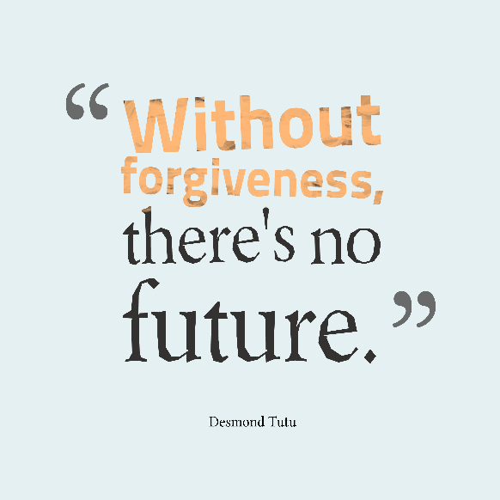
Nelson Mandela
◦“Resentment is like drinking poison and then hoping it will kill
your enemies… As I walked out the door [of prison] I knew if I didn’t
leave by bitterness and hatred behind, I’d still be in prison.”
Desmond Tutu
◦A civil rights activist during apartheid in an African church
◦“When you forgive…it sets you free.”

Forgiveness and Reconciliation: Questions:
  - Give one reason why true forgiveness exists.
……………………………………………………………………………………………………………………………..
  - Give one reason why true forgiveness doesn’t exist.
……………………………………………………………………………………………………………………………..
  - What do Humanists believe about forgiveness?
……………………………………………………………………………………………………………………………..
  - What do Christians believe about forgiveness?
……………………………………………………………………………………………………………………………..
  - How did Jesus show forgiveness?
……………………………………………………………………………………………………………………………..
  - What does the Parable of the Prodigal Son say about forgiveness?
……………………………………………………………………………………………………………………………..
  - What does Matthew 6:15 say about forgiveness?
……………………………………………………………………………………………………………………………..
  - How do Christians get forgiveness?
……………………………………………………………………………………………………………………………..
  - Who was Gee Walker and how/why did she forgive?
……………………………………………………………………………………………………………………………..
  - Who was Martin Luther King and how/why did he forgive?
……………………………………………………………………………………………………………………………..
  - Who was Nelson Mandela and how/why did he forgive?
……………………………………………………………………………………………………………………………..
  - Who was Desmond Tutu and how/why did he forgive?
………………………………………………………………………………………………………………………...

Suffering
Christians view suffering in the following ways:
1. Suffering can be seen to be a test
2. Suffering is a punishment for sin and Roman Catholics believe that it is a result of original sin
3. Suffering is a part of God’s plan – we might not understand it but we should know that God will never allow us to suffer beyond our ability to cope with it
4. Suffering enables Christians to appreciate what is good in the world and allows them to grow close to Jesus, who suffered and died on the cross for the sins of humanity
5. Stories from the Bible, e.g. Job, teach Christians that anyone can suffer and that persevering with
suffering can strengthen faith in God
​
Humanists view suffering as:
1. A result of choice that humans have over their lives. Humans must take some responsibility in how their lives work out.
2. Some evils, e.g. war, famine and poverty are caused or made worse by human greed and foolishness
3. Some evils, e.g. earthquakes, floods, etc, may have natural causes or happen by chance, just because the world is the way it is
4. Often, those who suffer most are not to blame
5. Humanists see the idea of ‘Original Sin’ as unjust and cruel. How can a new-born baby be sinful?
6. Not all humans are innately flawed and ‘sinful’ – it is up to humans to fight evil and suffering in the world
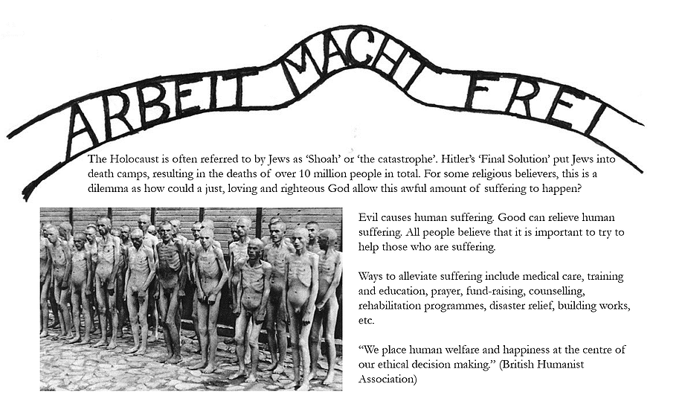
The Problem of Evil and Suffering
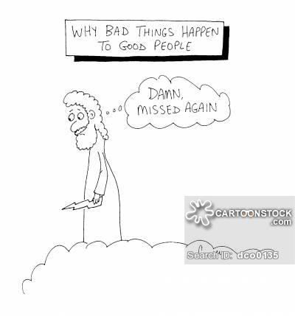
The presence of evil and suffering in the world created a number of problems. God is believed to be omnibenevolent (all loving) omnipotent (all powerful) and omniscient (all knowing). Because of this, evil should not really exist, but it does. There are, therefore, a number of possibilities:

1.God is not powerful enough to stop evil
2.God does not know that evil is happening
3.God does not love us enough to want to stop the evil
None of these are very satisfactory conclusions, however Christians have their own solutions to the Problem of Evil and Suffering:
1. Free will was given to humans by God, therefore humans have to choose to do ‘good’ and avoid ‘evil’
2. RC: as a result of original sin, humans find it easier to do wrong, but with the help of God they can choose to do good. Those who sin can atone and gain forgiveness for their sin through prayer and, for Roman Catholics, confession and penance.

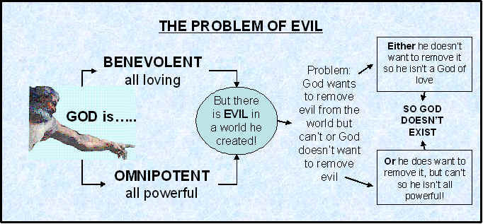

Suffering: Exam-Style Questions
- How do Christians view suffering? State five ways.
………………………………………………………………………………………………………………………...
………………………………………………………………………………………………………………………...
- What do Humanists view suffering as? State five ways.
………………………………………………………………………………………………………………………...
………………………………………………………………………………………………………………………...
- What is the Problem of Evil and Suffering?
………………………………………………………………………………………………………………………...
………………………………………………………………………………………………………………………...
- What does omnibenevolent mean?
………………………………………………………………………………………………………………………...
- What does omnipotent mean?
………………………………………………………………………………………………………………………...
- What does omniscient mean?
………………………………………………………………………………………………………………………...
- What possibilities are there about God, since evil and suffering does exist?
………………………………………………………………………………………………………………………...
………………………………………………………………………………………………………………………...
- What is the argument from Free Will?
………………………………………………………………………………………………………………………...
………………………………………………………………………………………………………………………...
- What is the argument from Roman Catholicism?
………………………………………………………………………………………………………………………...
………………………………………………………………………………………………………………………...
- How can people atone for their sins?
………………………………………………………………………………………………………………………...
………………………………………………………………………………………………………………………...
………………………………………………………………………………………………………………………...
What is ‘Good’?
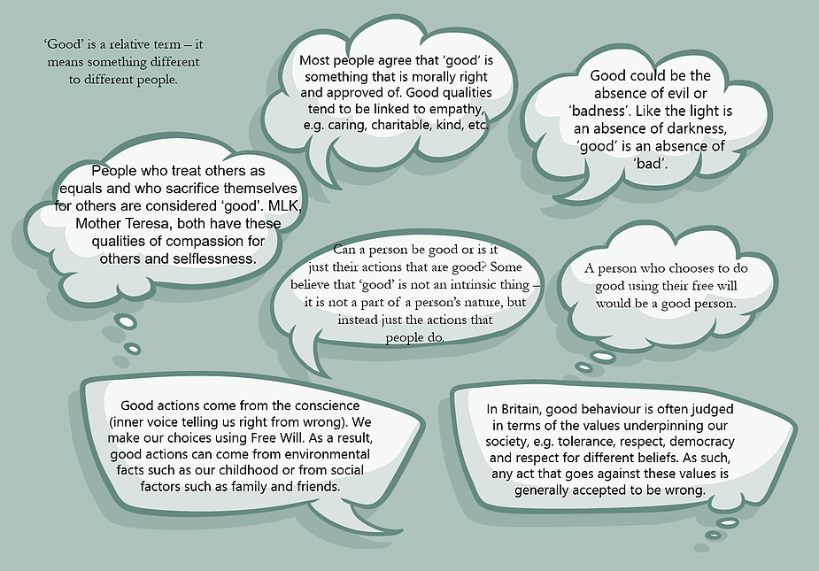
Christian Attitudes to ‘Good’
- In Genesis, God made the earth and it was ‘good’. The world that God has created is basically good.
- God has given people free will – the ability to choose between right and wrong for ourselves.
- The story of humanity’s battle with good and evil is told in the story of Adam and Eve in the Garden of Eden. They decided to disobey God by eating the fruit of the Tree of Knowledge of Good and Evil. This event is called the Fall and explains how free will can be used to stray from what is good.
- God has given the Ten Commandments for people to live a good life and follow certain rules for behaviour
- Jesus’ life and example show Christians the way to lead a moral, good and righteous life. It is up to individuals whether or not to follow God’s instructions.
- Christianity places ‘good’ qualities at its core – tolerance compassion and love. Jesus demonstrated all of these qualities through his life, and it is considered a Christian duty to treat others with kindness, humanity and genuine acceptance.

Christian Attitudes to ‘Evil’
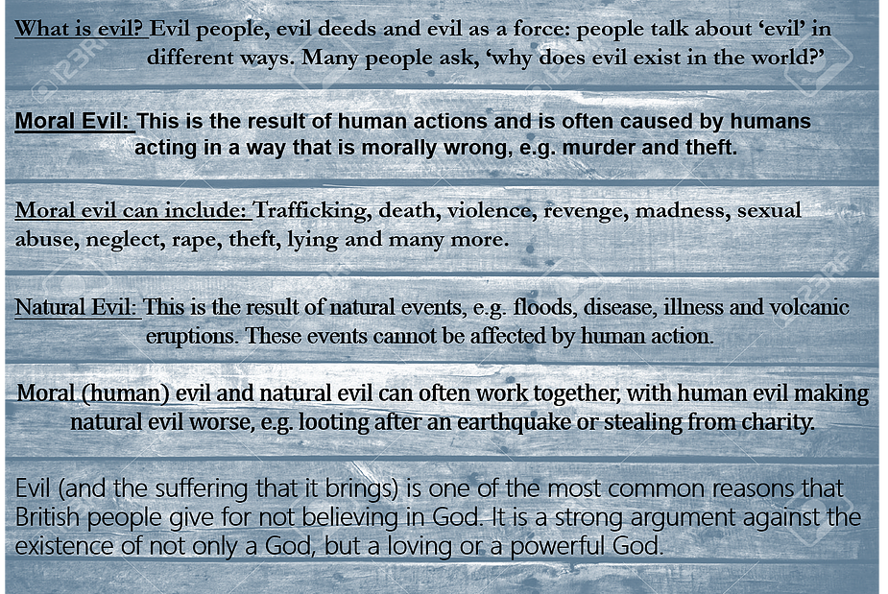
Christian Attitudes to ‘Evil’
- God created people with free will and, because we are not robots, we choose good or evil. Choosing evil causes suffering to happen.
- Some believe that evil exists because it is necessary for people to develop or complete their moral souls. This is called a ‘soul-making’ theory. We need to learn about morality and develop the proper virtues, which we cannot do without the existence of suffering and evil.
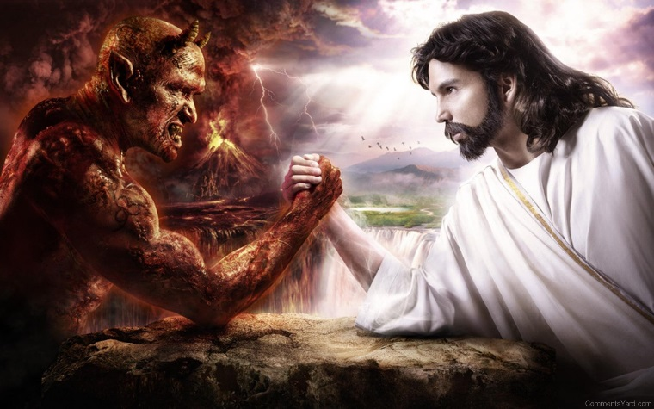
- St Irenaeus: Believed that humans were not created perfect, but that they require growth to become spiritually perfect and moral. God allows evil to exist to enable spiritual growth.
- Irenaeus also believed that God does not intervene in human affairs to prevent evil because that would mean interfering with free will
- John Hick: Argued that the process of ‘soul-making’ is a response to evil in the world. If evil did not exist, e.g. murder and cancer, then we would not be able to develop ourselves spiritually
- Hick argued that since we cannot rationalise the suffering in the world, we mustn’t be able to understand God’s plan or reasons.
- Hick believes that humans were born at a great distance from God. Therefore the process of soul-making involves the struggle to find religious faith.
- Roman Catholics: Original Sin is the cause of sin. Adam and Eve’s disobedience to God caused evil to enter the world. Since then, people have been born with the ability to commit acts of evil. Every baby is born with ‘original sin’.
​
Life as a test?

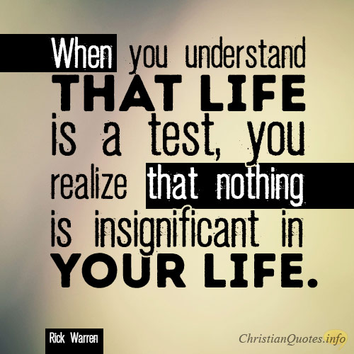
- The story of Job tells Christians that we should not question why we suffer, but accept that we do. “God works in mysterious ways,” and he has reasons for letting evil and suffering happen, but humans will never be able to understand the mind of God.
- God chooses the suffering for us and God has a greater purpose. Christians are reassured with the knowledge that God is compassionate and understanding and will never give humans more suffering than they are truly able to cope with.

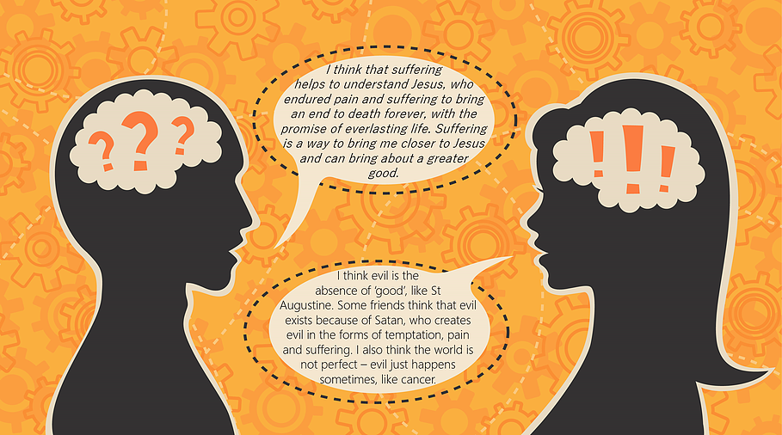

Good and Evil: Exam-Style Questions
1. What is ‘Good’? State four.
………………………………………………………………………………………………………………………...
………………………………………………………………………………………………………………………...
………………………………………………………………………………………………………………………...
………………………………………………………………………………………………………………………...
2. What do Christians believe about ‘Good’?
………………………………………………………………………………………………………………………...
………………………………………………………………………………………………………………………...
3. What is ‘Evil’? State four.
………………………………………………………………………………………………………………………...
………………………………………………………………………………………………………………………...
………………………………………………………………………………………………………………………...
………………………………………………………………………………………………………………………...
4. What do Christians believe about ‘Evil’?
………………………………………………………………………………………………………………………...
………………………………………………………………………………………………………………………...
5. What does Irenaeus believe about ‘evil’?
………………………………………………………………………………………………………………………...
………………………………………………………………………………………………………………………...
6.What does John Hick believe about ‘evil’?
………………………………………………………………………………………………………………………...
………………………………………………………………………………………………………………………...
7.What does Job teach Christians?
………………………………………………………………………………………………………………………...
………………………………………………………………………………………………………………………...

