eduqas

GCSE Religious Studies
Issues of Life and Death
Workbook

Name:

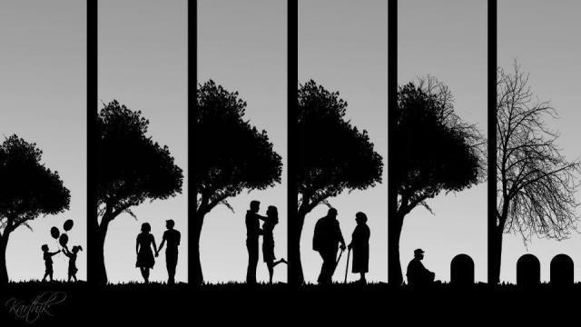

Key Concepts in
Philosophy and Ethics:
Life & Death

Afterlife: The belief that there is some form of life after …………………………... For example, Christians believe that they might go to ………………………….. if they have followed Jesus correctly.
Environmental Sustainability: Making sure that what is taken from - or demanded of - the ………………………….. doesn’t reduce our ability to live well now and in the future. Christians believe that we are given the duty of ………………………….. by God.
Euthanasia: The painless ………………………….. of a patient who is suffering from an incurable illness or disease. The Bible, however, states ‘thou shalt not murder.’ Therefore some people disagree with Euthanasia because only ………………………….. can give and take life.
Evolution: The theory that every living thing has developed from earlier forms of …………………………... For Christians, God started this process of evolution with His ………………………….. for the world.
Abortion: The deliberate termination of a …………………………... The Bible
states, ‘thou shalt not murder,’ therefore Christians may see abortion is wrong
as the ………………………….. is a potential human life.
Word Box
Death
environment
pregnancy
resurrection
plan
life
killing
foetus
heaven
purpose
stewardship
God
died
holy
life
Quality of Life: How pleasurable or meaningful your ………………………….. is.
Christians believe that living a good life in faith and relationship with
God will improve your quality of life, giving it true meaning and
…………………………...
Sanctity of Life: The belief that all life is sacred and belongs to God. The
Bible states that we are ‘created in God’s image,’ and therefore we
are ………………………….. beings.
Soul: The part of the human being that lives on after the physical body has ………………………….. . Christians believe that because of Jesus’ death and ………………………….., our souls will resurrect to join God in heaven.
You will need to learn these words and definitions for your exam! In our a) style questions, you will have to give a definition and an example for each word!

Christian Views of Creation
Genesis 1, 2 and 3 tell the story about how the earth was created. Genesis 2 explains Adam’s role in the garden as a steward and that Eve was created from Adam’s rib. Genesis 3 tells us about Adam and Eve’s exile from the Garden of Eden.
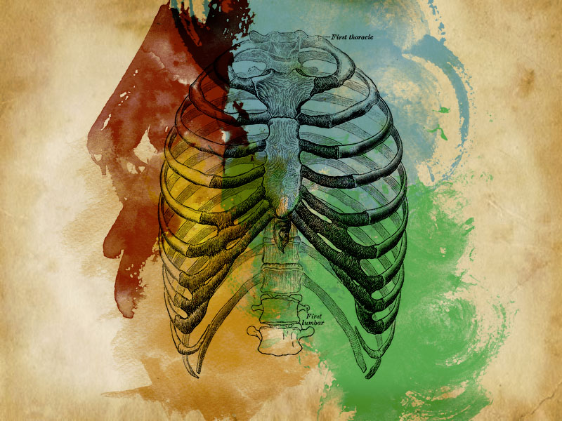
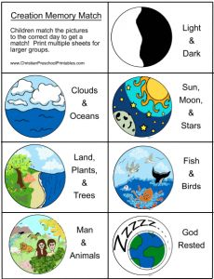
Genesis 2:

“Then the Lord God made a woman from the rib he had taken out of the man, and he brought her to the man.” (Genesis 2:22)

“Bone of my bones, flesh of my flesh. She shall be called ‘woman’ because she was taken out of man.” (Genesis 2:23)
The order of Creation in Genesis 1:

Adam and Eve were told not to eat from the Tree of Knowledge of Good and Evil, otherwise they will ‘surely die’.
Eve is tempted by the snake to eat the fruit. The snake said she would ‘be like God’, knowing good and evil.
Eve ate the fruit and gave some to Adam. Their eyes were opened: they knew they were naked and they were ashamed.
God knew that they had eaten the fruit from the forbidden tree. Eve told God that the snake had deceived her.
God clothed Adam and Eve and banished them from the Garden of Eden. A flaming sword was put to guard the Tree of Life.
God curses the snake to ‘crawl on its belly.’ God curses the man to work the land to survive. God curses the woman with pain in childbirth.
Genesis 3:

Interpretations of Creation:
Different Christians may believe different things when it comes to creation. This is because they interpret the Bible stories in a particular way. Literalist Christians believe that the stories in the Bible happened exactly as they are written – they take the Bible literally.
However, non-literal Christians (liberal Christians) believe that the Bible contains stories about God that need to be interpreted. The stories, therefore, are myths that contain an underlying truth. Usually this truth is that there is a God, God created the world and God cares about the world today.

Non-Literalist Christians:
- Believe that the account of Creation in Genesis is a myth (a story containing a truth)
- The story in Genesis is not a literal account, but there are clear periods of creation, e.g. when land was formed
- The main point of the story is that God created the world
- Scientific theories are evidenced and are therefore undeniable
- The story shows what once was believed to be true, before scientific knowledge developed
Literalist Christians:
- Believe that God created the world in exactly 6 days and rested on 7th
- Sure of the absolute truth of the Bible and what it says about Creation
- Do not accept scientific accounts of Creation as they are not in the Bible
- The Bible is the Word of God and is therefore an exact, word-for-word account

Christian View of Creation: Questions
- What does Genesis tell us?
………………………………………………………………………………………………………………
- What is the order of creation, as given in Genesis 1?
………………………………………………………………………………………………………………
………………………………………………………………………………………………………………
- State a quote from Genesis 2.
………………………………………………………………………………………………………………
………………………………………………………………………………………………………………
- Summarise the story of the Fall in Genesis 3.
………………………………………………………………………………………………………………
………………………………………………………………………………………………………………
- What are the two different interpretations of creation?
………………………………………………………………………………………………………………
………………………………………………………………………………………………………………
- What do literalist Christians believe? (State two beliefs)
………………………………………………………………………………………………………………
………………………………………………………………………………………………………………
- What do non-literalist Christians believe? (State two beliefs)
………………………………………………………………………………………………………………
………………………………………………………………………………………………………………

Muslim Views of Creation

The Qur’an says that Allah (God) is the Creator of the world. Human beings are on the world as trustees or ‘vice-regents’ (Khalifahs) they are told to look after the world for Allah and for the future.
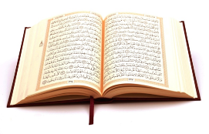
The central concept of Islam is Tawhid or the Unity of God. Allah is Unity; and His Unity is also reflected in the unity of mankind, and the unity of man and nature. His trustees are responsible for maintaining the unity of His creation, the integrity of the Earth, its flora and fauna, (plant life) its wildlife and natural environment.

“The Earth is green and beautiful, and Allah has appointed you his stewards over it. The whole earth has been created a place of worship, pure and clean. Whoever plants a tree and diligently looks after it until it matures and bears fruit is rewarded. If a Muslim plants a tree or sows a field and humans and beasts and birds eat from it, all of it is love on his part.”
Hadith (A saying of the Prophet Muhhamad pbuh)

Devote thyself single-mindedly to the Faith, and thus follow the nature designed by Allah, the nature according to which He has fashioned mankind. There is no altering the creation of Allah.
Surah 30:30

Allah is He Who raised up the heavens without any pillars that you can see. Then He settled Himself on the Throne, and constrained the sun and the moon to serve you; each planet pursues its course during an appointed term. He regulates it all and expounds the Signs, that you may have firm belief in the meeting with your Lord. He it is Who spread out the earth and made therein firmly fixed mountains and rivers, and of fruits of every kind He has made pairs. He causes the night to cover the day. In all this, verily, are signs doer a people who reflect.
Surah 13:3-4
Muslim View of Stewardship and Creation: Questions
- What does the Qur’an say about creation?
………………………………………………………………………………………………………………………………………………………………………………………………………………………………………………………………………………………………………………………………………………………………………………………………………………………………………………………………

- What are Khalifahs and what are their responsibilities to God and his creation?
………………………………………………………………………………………………………………
………………………………………………………………………………………………………………………………………………………………………………………………………………………………………………………………………………………………………………………………………………
- What is the link between Tawhid and creation?
………………………………………………………………………………………………………………
………………………………………………………………………………………………………………………………………………………………………………………………………………………………
- What is Muhammad’s (pbuh) of creation?
………………………………………………………………………………………………………………
………………………………………………………………………………………………………………………………………………………………………………………………………………………………………………………………………………………………………………………………………………
- Summarise a Qur’anic quote about creation.
………………………………………………………………………………………………………………
………………………………………………………………………………………………………………………………………………………………………………………………………………………………………………………………………………………………………………………………………………………………………………………………………………………………………………………………

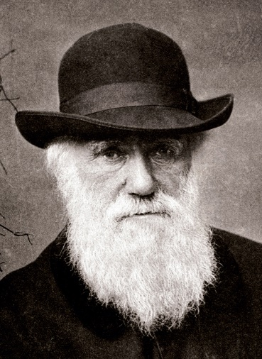
How did the world come to exist?
Atheists and Humanists:
- Charles Darwin: Life has arisen through the slow,
natural process of evolution and therefore the
earth must be millions of years old. The ‘survival
of the fittest’ is evolution by natural selection –
those best suited to their environment.
- The Big Bang Theory (1965) states that the
universe had an origin around 14 billion years
ago. The universe began from a ‘singularity’,
which expanded and particles and atoms started
to appear. This led to the formation of stars and
planets.
- Most scientists believe that the universe will
continue expanding, becoming bigger and colder
Christians:
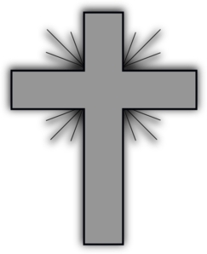
- One, all-powerful creator God is the source of all life
- The Bible tells of the creation story in Genesis
- Literal Christians believe that the events in Genesis
happened exactly as it is written in the Bible
- Liberal Christians believe that there is some room for
interpretation surrounding the stories in the Bible. They
are myths which carry deep, symbolic meanings.
- The Biblical creation stories, for some liberal Christians, are complimentary to and are true alongside scientific theories such as the Big Bang
- Literal Christians however see Darwinian evolution as an attack on their beliefs as it implies that life has developed by chance. Also, if humans have evolved from animals, then there is no special place for the human ‘soul’.
- Literal Christians see the Big Bang Theory as denying God’s power. Also, even if scientists can prove the Big Bang, we are still left with the question of: what caused the Big Bang? Literalists argue that is was God.

I am a Liberal Christian.
People should be free to understand
the Bible in whatever way they choose. For me, some stories should be understood more like metaphors or symbolic stories. They are still true because the stories carry meaning,
even if they don’t refer to actual historical events.
I am a Literal Christian.
I believe that the Bible should
be understood word-for-word. I am also a Creationist: I believe that the creation of the world happened exactly as it is described in
the Bible.
I am a Liberal Christian. People should be free to understand the Bible in whatever way they choose. For me, some stories should be understood more like metaphors or symbolic stories. They are still true because the stories carry meaning, even if they don’t refer to actual historical events.

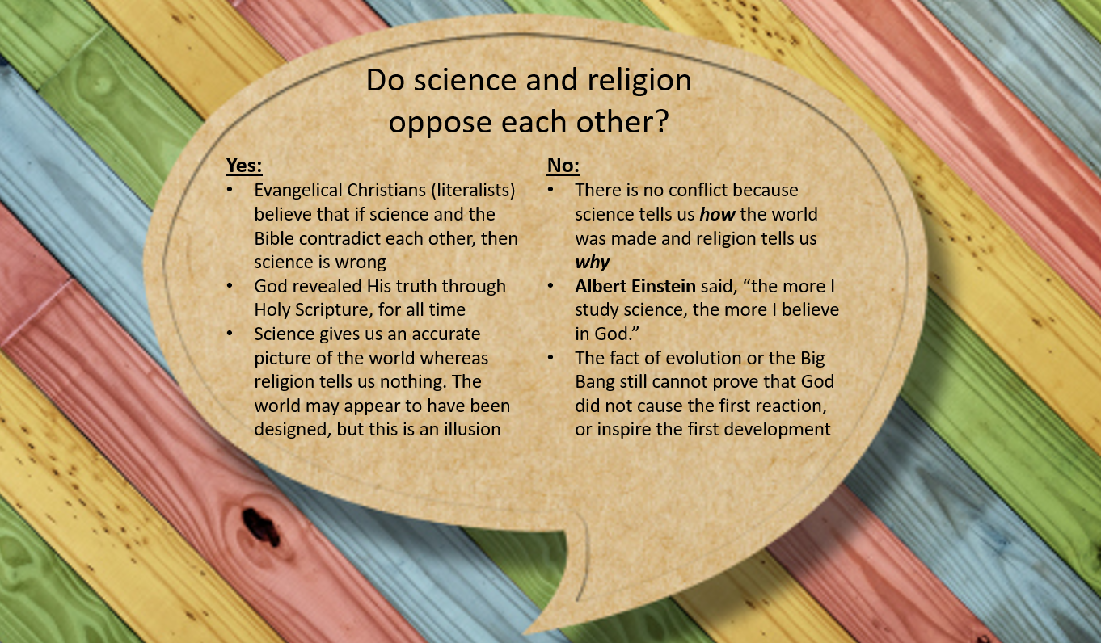

Creation: Questions
- What does Charles Darwin believe about how we have come to exist?
………………………………………………………………………………………………………………
………………………………………………………………………………………………………………
- According to the Big Bang Theory, when did the universe begin?
………………………………………………………………………………………………………………
- What do Christians believe about how the world came to exist?
………………………………………………………………………………………………………………
………………………………………………………………………………………………………………
………………………………………………………………………………………………………………
- What do literal Christians believe about creation?
………………………………………………………………………………………………………………
………………………………………………………………………………………………………………
- What do liberal Christians believe about creation?
………………………………………………………………………………………………………………
………………………………………………………………………………………………………………
- Give two reasons why science and religion might oppose each other.
………………………………………………………………………………………………………………
………………………………………………………………………………………………………………
………………………………………………………………………………………………………………
………………………………………………………………………………………………………………

- Give two reasons why science and religion might not conflict with each other.
………………………………………………………………………………………………………………
………………………………………………………………………………………………………………
………………………………………………………………………………………………………………
………………………………………………………………………………………………………………
Origins of Life
Christians:
- Life is a gift from God and God has given humans
the role of stewardship.
- Genesis 1:26 teaches that God made humans in
his own image, meaning that humans have a soul
which is unique
- Genesis 2:7 says that God formed Adam from dust
and breathed divine life into him. Therefore, humans were
created with a special status, above nature. This can lead to disagreement among Christians about how we should treat the environment:
  - Dominion: To rule over the environment. We can exploit the world’s resources
as we are in charge.
    - When Jesus taught his followers to ‘love your neighbour’ (Matthew 5:43) he did not include animals in this command. Christians have respect for other animal species but they are not seen as equals and most Christians find it acceptable to eat meat.
  - Stewardship: To live in harmony with nature. We cultivate the earth, not exploit it.
    - Humans have responsibility towards the environment, looking after the earth’s precious resources
    - We should be responsible global citizens, using the earth’s resources in a sustainable manner
    - ‘Green Christians’ are environmental activists who promote awareness and action at church, community and national levels
Humanists:
- Try to base their reasoning on evidence
- Most humanists agree with the idea of stewardship
- We have a responsibility to work for a more sustainable
world, causing as little harm to the environment as possible
- Looking after the environment is a sensible thing to
do – human life depends wholly on the environment.
If we misuse or abuse the environment, then in the end
it is us, our children and our children’s children who will suffer
Origins of Life: Questions
- What do Christians believe about the origins of life?
………………………………………………………………………………………………………………
………………………………………………………………………………………………………………

- What does Genesis 1:26 tell us?
………………………………………………………………………………………………………………
………………………………………………………………………………………………………………
………………………………………………………………………………………………………………

- What does Genesis 2:7 say?
………………………………………………………………………………………………………………
………………………………………………………………………………………………………………
………………………………………………………………………………………………………………

- What is the difference between dominion and stewardship?
………………………………………………………………………………………………………………
………………………………………………………………………………………………………………
………………………………………………………………………………………………………………
………………………………………………………………………………………………………………

- What do Humanists believe about the origins of life?
………………………………………………………………………………………………………………
………………………………………………………………………………………………………………
………………………………………………………………………………………………………………

Christian Views of Animal Rights
Along with protecting the environment, God gave Adam the duty of naming all of the animals in the Garden of Eden. However, as with Stewardship, there are two main strands of belief regarding animal rights:
- Stewardship: we are to care for and nurture all life. Life is from God and should be respected.
- Dominion: we are to “rule over the birds of the sky and the fish of the sea,” as God told Adam to do in Genesis.
Christian arguments for animal rights:
- God made animals first in the order of creation. They have a purpose.
- All life is sacred, special and a gift from God. It should be respected.
- We have been given the duty of living in harmony with nature
Christian arguments against animal rights:
- “God made mankind in his image,” therefore we are the superior species.
- God gave us dominion to ‘rule over’ the world
- Jesus said to ‘love thy neighbour’ – not including animal life in this command
Humanist arguments for animal rights:
- Animals feel pain too, just like we do
- Human arrogance has already killed many species of animals
- Some people refuse to eat meat on moral / ethical grounds
Humanist arguments against animal rights:
- It is a natural instinct to eat meat for nourishment
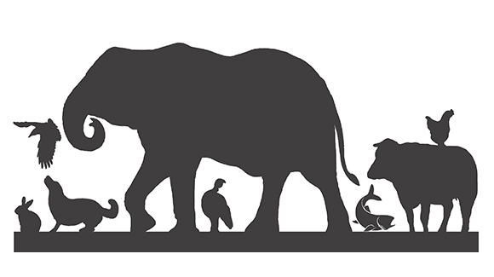
- The human species is at the top of the food chain

Christian Views of Animal Rights: Questions
- What duty is God give to Adam
………………………………………………………………………………………………………………
………………………………………………………………………………………………………………

- What are the two strands of belief regarding animal rights?
………………………………………………………………………………………………………………
………………………………………………………………………………………………………………
………………………………………………………………………………………………………………
………………………………………………………………………………………………………………

- State a Christian argument for animal rights.
………………………………………………………………………………………………………………
………………………………………………………………………………………………………………

- State a Christian argument against animal rights.
………………………………………………………………………………………………………………
………………………………………………………………………………………………………………

- State a Humanist argument for animal rights.
………………………………………………………………………………………………………………
………………………………………………………………………………………………………………

- State a Humanist argument against animal rights.
………………………………………………………………………………………………………………
………………………………………………………………………………………………………………

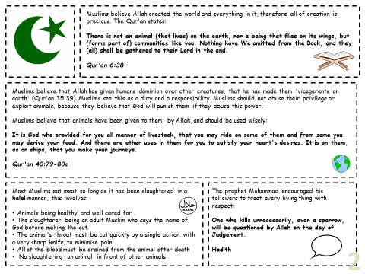

Muslim Views of Animal Rights Questions

- Why does the Qur’an say all creation is special?
………………………………………………………………………………………………………………
………………………………………………………………………………………………………………………………………………………………………………………………………………………………………………………………………………………………………………………………………………

- The Qur’an states that Muslims ham dominion (control) over all creation. How does the Qur’an explain this?
………………………………………………………………………………………………………………
………………………………………………………………………………………………………………
………………………………………………………………………………………………………………
………………………………………………………………………………………………………………

- What does Halal slaughter involve? How might this demonstrate respect for animal rights?
………………………………………………………………………………………………………………
………………………………………………………………………………………………………………………………………………………………………………………………………………………………………………………………………………………………………………………………………………………………………………………………………………………………………………………………

- How does Muhammad (pbuh) encourage his followers to treat living things? Explain your answer.
………………………………………………………………………………………………………………
……………………………………………………………………………………………………………………………………………………………………………………………………………………………………………………………………………………………………………………………………………………..

Sanctity of Life
The belief that all life is previous or sacred. Some people believe that only human life holds this special status

Christian Views of the Sanctity of Life
Most people, regardless of faith, believe that human life is special and worthy of being preserved. The belief in the sanctity of life has a large impact on medical ethics (the process of deciding what is right and wrong in medicine), especially those which relate to creating or life-ending procedures.
Christians:
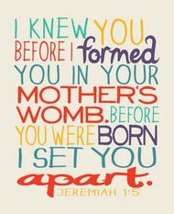
- Life comes from God. It is a gift, unique and priceless.
- God is interested and involved in each human’s life
- God created each person unique and ‘in his image’, just as he created Adam and Eve
- Only God can give and take life
- Quaker Christians oppose the death penalty because each person contains a reflection
of the image of God, which makes every human soul sacred
- “Don’t you know that you yourselves are God’s temple and that God’s Spirit dwells in you?” (1 Corinthians 3:16)
- Catholic Christians disagree with artificial methods of contraception and IVF (creating a baby in a laboratory outside of the act of sex)
- Jesus showed that all life should be valued. He tended to the leper and visited the sick to show that all lives are worthy of respect and compassion.
- “Before I formed you in the womb I knew you, before you were born I set you apart.” (Jeremiah 1:5)
Humanists:
- Life is precious because it is the life we have (we do not get another life)
- The value of life does not come from God. Our lives have value because
we only have one life. There is no soul or afterlife to live on at death
- A central purpose of life is to make ourselves and others around us as
happy as possible; we can benefit others through compassion and kindness
- Life is not ‘sacred’ but is worthy of the highest respect
Christian Views of the Sanctity of Life: Questions

- What is the meaning of ‘sanctity of life’?
………………………………………………………………………………………………………………
………………………………………………………………………………………………………………

- What do Christians believe about the sanctity of life?
………………………………………………………………………………………………………………
………………………………………………………………………………………………………………

- What do Quaker Christians believe about the sanctity of life?
………………………………………………………………………………………………………………
………………………………………………………………………………………………………………

- What do Catholic Christians believe about the sanctity of life?
………………………………………………………………………………………………………………
………………………………………………………………………………………………………………

- What examples did Jesus set about the sanctity of life?
………………………………………………………………………………………………………………
………………………………………………………………………………………………………………
………………………………………………………………………………………………………………

- What do Humanists believe about the sanctity of life?
………………………………………………………………………………………………………………
………………………………………………………………………………………………………………
………………………………………………………………………………………………………………
Muslim Views of the Sanctity of Life

Muslims believe in the sanctity of human life that is humans are created by God and are therefore life is sacred (holy). Chapter 6 in the Qur’an is very clear about this:
Qur’an Surah (Chapter) 6:151
“And do not kill the soul which God has forbidden to be killed except by legal right.”
From this we can see that the Qu’ran (the Word of Allah for Muslims) prohibits anyone from taking the life of another human being.

However, the phrase “except by legal right” means that there are cases where taking a life is acceptable to Allah.

Acceptable reasons to take a life mentioned in the Qur’an and Hadith (sayings of the Prophet Muhammad pbuh).
- Committing murder
- Resisting the true faith, meaning that fighting against a person may be necessary
- Spreading disorder, or striving to overthrow the Islamic government
- Illegitimate sexual intercourse
- Apostasy (a person leaving the Islamic faith)
Muslim Views of the Sanctity of Life: Questions
- What do Muslims believe about the sanctity of life?
………………………………………………………………………………………………………………
………………………………………………………………………………………………………………

- When might it be acceptable to take a human life from an Islamic perspective?
………………………………………………………………………………………………………………
………………………………………………………………………………………………………………
Quality of Life
The extent to which life is pleasurable or meaningful.

Most believe that the quality of our lives is more important than whether it is special or sacred. If our life is free from pain and anxiety and if we live with freedom and dignity, then we have a good quality of life.
How do we measure quality of life?
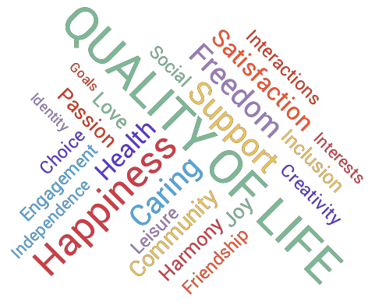
Indicators to measure quality of life include living conditions, health, education, leisure and social interactions, disability, levels of pain and whether human rights are granted. If a person’s life has insufficient quality, some would argue that they should have the right to die.
In medical ethics, treating an illness should be weighed against the extent to which they are going to live a life free from pain and suffering afterwards. Is the treatment cost-worthy?

Quality of Life: Questions
- What is meant by ‘quality of life’?
………………………………………………………………………………………………………………
- What do most people believe about quality of life?
………………………………………………………………………………………………………………
- How do we measure ‘quality of life’?
………………………………………………………………………………………………………………
………………………………………………………………………………………………………………

Christian Views about Abortion
Abortion was first legalised in Britain in 1967. Since then, the issue has been widely debated. On the one hand, it is immoral to kill unborn babies. On the other hand, quality of life might be more important if, for example, the child is going to be born severely disabled or with extreme pain.
Pro-Choice:
- Abortion is acceptable
- Every woman should be able to choose what to do with her body – sometimes the situation might necessitate abortion, for example if the woman were to become pregnant due to rape
Pro-Life:
- Abortion is wrong
- Every living thing has a right to life
Abortion
The deliberate ending of a pregnancy so that it does not result in the birth of a child

Rights of the unborn child:
- The unborn child has rights
- The law is unclear about the rights of an unborn child. In practice, their rights are not distinguishable from the rights of the mother
- A court rules in December 2014 that an unborn child was not ‘a person’

What do Christians believe about abortion?
Christianity:
- There is no single view on abortion in Christianity
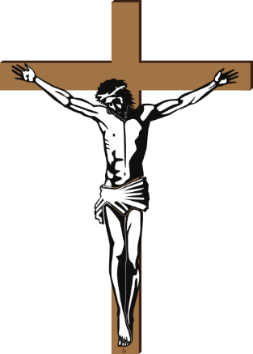
- Some Christians give priority to the belief in the Sanctity of Life
- Some Christians follow Jesus’ example to act with compassion
Roman Catholic Christians:
- Abortion is forbidden as life is sacred and a gift from God
- Life begins at conception: it is not a potential life but a human being with potential
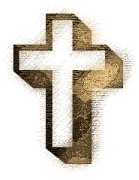
- Abortion is against the Ten Commandments (Do not kill)
- The foetus has a right to live and develop. Terminating the pregnancy is a great moral evil
Church of England Christians:
- There can be allowances for abortion in some conditions
- If the mother’s life is in danger or in the case of rape,
abortion is permitted
- Quality of life should be considered
- Compassion should be used (Treat others as you would like to be treated)
- However, the law in Britain is too liberal when it comes to abortion. In the past, abortions have been carried out for immoral reasons, e.g. when abortion is used as a form of contraception
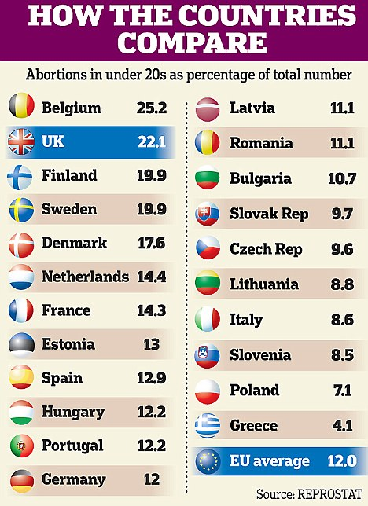
Abortion in Britain today:
- Abortion is legal before 24 weeks of pregnancy
- Two doctors must consent to the procedure and decide whether there will be a risk to the mother’s physical or mental health if the pregnancy were to continue
- In rare cases, where the pregnancy will put the mother’s life at risk, the abortion can be formed after 24 weeks
- It is estimated that 1 in 3 women will, at some point in their life, have an abortion
- The father of the foetus has no legal right at present – even if the couple are married
What do Humanists and Atheists believe about abortion?
- We need to consider the evidence, probable consequences and the rights and wishes of everyone involved before making a decision about abortion
- Find the kindest course of action and the one that would do the least harm
- Because of this ‘situational’ approach to ethics, there is no one right or wrong answer
- Generally, humanists take on a liberal, pro-choice stance
- What would produce more happiness? To abort or to keep the baby?
- Quality of life outweighs the preservation of life
- Abortion is a morally acceptable choice to make, so long as it is an informed choice which considers the short-term and long-term effects.
Christian Views about Abortion: Questions
- What is the meaning of ‘abortion’?
………………………………………………………………………………………………………………
- When was abortion first legalised in Britain?
………………………………………………………………………………………………………………
- What is the difference between pro-life and pro-choice?
………………………………………………………………………………………………………………
………………………………………………………………………………………………………………
- What does the law saw about the rights of an unborn child?
………………………………………………………………………………………………………………
………………………………………………………………………………………………………………
- What do Roman Catholic Christians believe about abortion?
………………………………………………………………………………………………………………
………………………………………………………………………………………………………………
- What do Church of England Christians believe about abortion?
………………………………………………………………………………………………………………
………………………………………………………………………………………………………………
- Until how many weeks is abortion legal in Britain?
………………………………………………………………………………………………………………
- Why might abortion be performed later than the legal limit?
………………………………………………………………………………………………………………
- What do Humanists believe about abortion?
………………………………………………………………………………………………………………
………………………………………………………………………………………………………………
- What might outweigh the principle of the preservation of life?
………………………………………………………………………………………………………………
………………………………………………………………………………………………………………
Muslim Views about Abortion

Islam does not allow abortion ‘after a foetus is completely formed and has been given a soul.’ This allows a variety of views within Islam.

There are variety of Muslim augments against abortion because Muslims believe in the ‘sanctity of life.’ The Qur’an in Surah (Chapter) 7 states:
“Kill not your children on a plea of want. We shall provide sustenance for them… the killing of them is a great sin.” (Surah 17:31)

Children will be able to ask their mother on the Day of Judgement why they were killed. Only Allah gives life, only Allah can take it away. Some Muslims believe the soul enters the unborn child at conception.

There are variety of Muslim augments for abortion:
Some Muslims believe that ensoulment (the unborn born child is given a soul by Allah) takes place at 120 days, and up to that point abortion is allowed.

The Shari’ah (Islamic Law) states that the mother’s life takes precedence. So if there is a choice about saving the mother or unborn child, the mother should be saved (so only if the mother’s life is at risk)
Muslim Views about Abortion: Questions
- When do Muslims NOT believe in abortion?
………………………………………………………………………………………………………………………………………………………………………………………………………………………………………………………………………………………………………………………………………………
- What does the Qur’an say about abortion?
………………………………………………………………………………………………………………………………………………………………………………………………………………………………………………………………………………………………………………………………………………
- When do some Muslims think abortion may be acceptable?
………………………………………………………………………………………………………………
………………………………………………………………………………………………………………………………………………………………………………………………………………………………….....
Christian Views about Euthanasia
Euthanasia: ‘Easy death’ or ‘mercy killing’ for someone who is suffering a painful death from a serious illness.
Why end your own life?
People may want to die a dignified death and die before their illness takes away their ability to kill themselves. Some are afraid of the end stages of their illness, e.g. the pain. Living with constant and unmanageable plain (linked to an injury, disability or a side-effect form previous illnesses) is reason enough. The final stages can take away human dignity, amongst other things. Some people would rather not experience this.
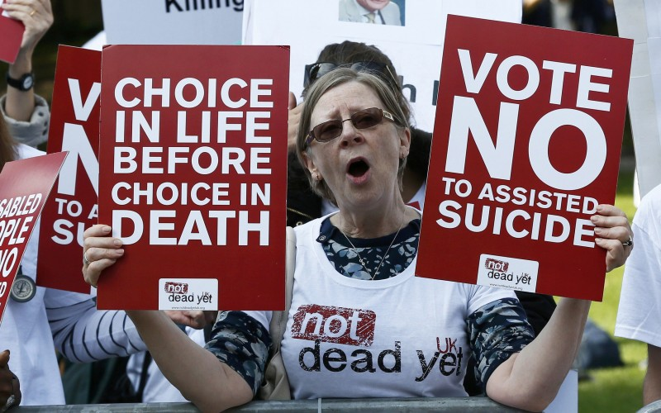
Different Types of Euthanasia:
- Voluntary: (or assisted suicide) is where a person explicitly asks for help to die. Often this is due to a life-limiting or terminal illness.
- Active: when a person takes a specific course of action to end their own life, e.g. overdose
- Passive: where life-sustaining treatment is removed, e.g. a feeding tube or respirator where there is no hope of recovery.
- Involuntary: where death is forced on a person, for example during ethnic cleansing (WWII) or the death sentence
Euthanasia Facts
- A ‘living will’ is a legal document that outlines a person’s wished with regards to their medical care. It can instruct doctors not to resuscitate (revive once the heart has stopped) or intubate (insert a breathing tube) or use artificial methods to keep the person alive
- A DNR or Do Not Resuscitate order is a type of living will
- In Britain today, euthanasia is illegal. Depending on the situation it is considered manslaughter or murder and is punishable by law, with a maximum penalty of life imprisonment.
- Assisted suicide, is illegal under the terms of the Suicide Act (1961) and is punishable by up to 14 years’ imprisonment. Attempting to kill yourself is not in itself a criminal act.
- The Director of Public Prosecutions (DPP) decides whether to take someone to court for assisting in suicide. The DPP said in 2010 that it would be unlikely that someone would be prosecuted if:
- The victim has reached a voluntary, clear, settled and informed decision to commit suicide
- The suspect was wholly motivated by compassion

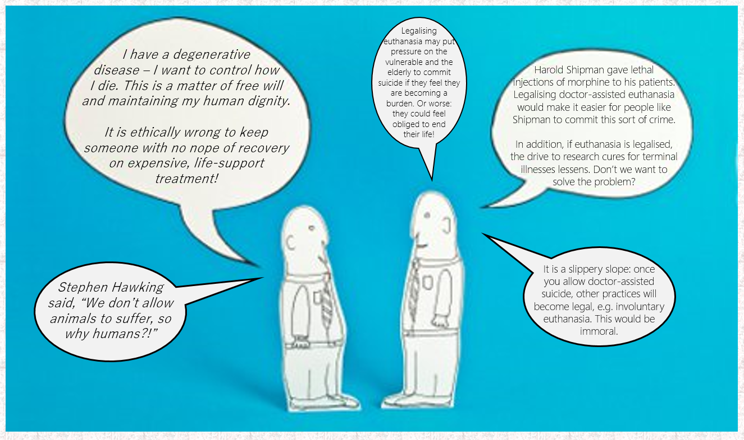

Euthanasia is not the only option:
- A hospice is a place where people with terminal illnesses can go to die with dignity
- A hospice focuses on relieving the symptoms and pain of the terminal illness, it does not try to cure the illness
- Hospices also provide a type of pastoral care
- Palliative care focuses on relieving the pain of the sufferer
- Hospices may be religious in ethos because of the clear connection with religious ideas and practices, e.g. to act with kindness and compassion
- Hospices fulfil the Christian desire to support the suffering of both patients and family in the final moments of life
- Patients and believers can preserve their sanctity of life and can still benefit from a quality of life. For some Christians, palliative care and hospices provide the best of both sides of the argument
Hospices in Britain
- There are over 260 hospices in Britain
- Some are dedicated to the care of children and infants; others focus on adult end-of-life care
- Patients do not only go to hospices to die – some patients are admitted for short periods of time to help manage pain and relieve other symptoms of their illness
- Around 4% of deaths occur in a hospice setting, with many more patients and their families benefiting from time spent in a hospice before their death

Christian Attitudes to Euthanasia:
Liberal Christians | Literal Christians
Euthanasia may be acceptable because:  - The person might be brain dead. In such circumstances, turning off the life support is OK  - It might be the most loving and compassionate thing to do, for example withholding treatment that prolongs a painful illness. Instead, the patient suffers for a reduced amount of time  - Jesus taught compassion for others | Euthanasia is not acceptable because:  - All life is sacred (sanctity of life)  - Those who assist are involved in murder (‘Do no kill’)  - Life is a gift from God and is, therefore, precious  - Suffering can have a purpose and should be endured as God will not give us more suffering than we are able to cope with  - Hospices also offer an alternative where care and support can be given. Patients can die with dignity and their pain is  managed.

Humanist Attitudes to Euthanasia:
Humanists uphold the right to life but don’t believe that life should be prolonged in the face of pointless suffering. Being able to die, with dignity, in a manner of our choosing must be understood to be a fundamental human right.
Humanists have supported attempts to legalise assisted dying, assisted suicide and voluntary euthanasia across the UK. They believe that assistance should not be limited to terminally ill people alone and want to see reform (change) in the law.
This ‘reform’ would consider the needs of other people who are ‘permanently and incurably suffering’, for example people who are paralysed.

Christian Views about Euthanasia: Questions
- What is the meaning of ‘euthanasia’?
………………………………………………………………………………………………………………
- Why might a person choose euthanasia?
………………………………………………………………………………………………………………
- What are the four different types of euthanasia and what do they mean?
………………………………………………………………………………………………………………
………………………………………………………………………………………………………………
………………………………………………………………………………………………………………
………………………………………………………………………………………………………………
- What is a ‘living will’?
………………………………………………………………………………………………………………
- Is euthanasia and assisted suicide legal in UK?
………………………………………………………………………………………………………………
- Why might someone not be prosecuted for assisting in someone’s suicide?
………………………………………………………………………………………………………………
- What is an argument for euthanasia being made legal?
………………………………………………………………………………………………………………
………………………………………………………………………………………………………………
- What is an argument against euthanasia being made legal?
………………………………………………………………………………………………………………
- What is a hospice and what service do they provide?
………………………………………………………………………………………………………………
- What do liberal Christians believe about euthanasia? Why?
………………………………………………………………………………………………………………
………………………………………………………………………………………………………………
- What do literal Christians believe about euthanasia? Why?
………………………………………………………………………………………………………………
………………………………………………………………………………………………………………
- What do Humanists believe about euthanasia?
………………………………………………………………………………………………………………
………………………………………………………………………………………………………………
Muslim Views about Euthanasia Islam

In Islam human life through euthanasia is seen as holy and blessed and by Allah so the taking of human life is frowned upon. In the Qur’an, Chapter (Surah) 6 states:
"Take not life which Allah made sacred otherwise than in the course of justice." (Surah 6:151)

There is no right in Islam to suicide. Islam believes that since we did not create ourselves we do not own our own bodies. Allah is the owner and giver of life and His rights in giving and in taking are not to be changed.
The Prophet Muhammad (pbuh) is reported to have said:
"Whoever kills himself with an iron instrument will be carrying it forever in hell. Whoever takes poison and kills himself will forever keep sipping that poison in hell. Whoever jumps off a mountain and kills himself will forever keep failing down in the depths of hell." Hadith (Saying of the Prophet Muhammad pbuh)

There is no place for mercy killing in Islam. The pain should be born with patience, Muhammad (pbuh) taught:
"When the believer is afflicted with pain, even that of a prick of a thorn or more, Allah forgives his sins, and his wrongdoings are discarded as a tree sheds off its leaves." Hadith (Saying of the Prophet Muhammad pbuh)

It is taught that accepting and withstanding pain will be to the sufferer's credit in heaven.

A person should seek medical treatment in Islam, but when the treatment holds no promise it ceases to be mandatory. This applies to surgical, pharmaceutical and artificial measures that prolong life. Therefore, passive euthanasia would be acceptable in the last resort.
Christian Views about Euthanasia: Questions
- Why do Muslim object to euthanasia?
………………………………………………………………………………………………………………
- What is the Islamic attitudes to suicide? Explain your answer.
………………………………………………………………………………………………………………………………………………………………………………………………………………………………………………………………………………………………………………………………………………………………………………………………………………………………………………………………
- What is Muhammad’s belief on suicide/euthanasia?
………………………………………………………………………………………………………………
………………………………………………………………………………………………………………
………………………………………………………………………………………………………………
………………………………………………………………………………………………………………
- In what circumstances might euthanasia be acceptable to some Muslims? Explain your answer.
…………………………………………………………………………………………………………………………………………………………………………………………………………………………………………………………………………………………………………………………………………………………………………………………………………………………………………………………………………………………………………………………………………………………………………………………....

Christian Views of the Soul and Life after Death
Soul: The spiritual aspect of a being; that which connect someone to God. The soul is often regarded as non-physical and as living on after the physical death, in an afterlife.
Christians believe that only humans have a soul, which is immortal, and lives on after the body has died.
Humanists deny the existence of a soul
There are two views about the soul and its relationship with the physical body:
- Dualism: the belief that we are made of two separate parts: a physical body and a spiritual soul. The soul lives in the physical body and is the true, inner part of us and it will live on after death.
- Materialism: the beliefs that nothing else exists apart from matter. All we have, as human beings, is a spiritual body. There is no soul or spirit.
Are humans born sinners?
- People are born with ‘original sin’ – the sin inherited from Adam and Eve in the Garden of Eden, when they ate from the Tree of Knowledge of Good and Evil
How do we get to heaven?
- We must be reconciled with God for this sin. We must be ‘saved’ and forgiven. This can only happen through believing that Jesus died on the cross to cleanse us from our sins.
What happens when we die?
There are 2 main types of belief that we study about what happens after death:
- Christians: believe in resurrection, heaven and hell. After death, we will rise up from the dead to be judges by God. Those who God judges to be good will be raised to eternal life. Those who have lived sinful lives or caused harm to others will either cease to exist or will face torment in hell
- Atheists and humanists: believe that nothing survives death. There is no ‘soul’. We are just physical, material beings, so when we die that is the end. Nothing exists beyond the grave.
Afterlife
Life after death; the belief that existence continues after physical death.
Judgement, Heaven and Hell
Christians believe in resurrection and eternal life. Death is not the end, but a gateway to a perfect existence. Heaven is our true home and our lives on earth are the testing ground for life in eternity.
Jesus rose again after death – so we will too. God is the Divine Judge and on Judgement Day God will decide who will be rewarded and who will be punished.
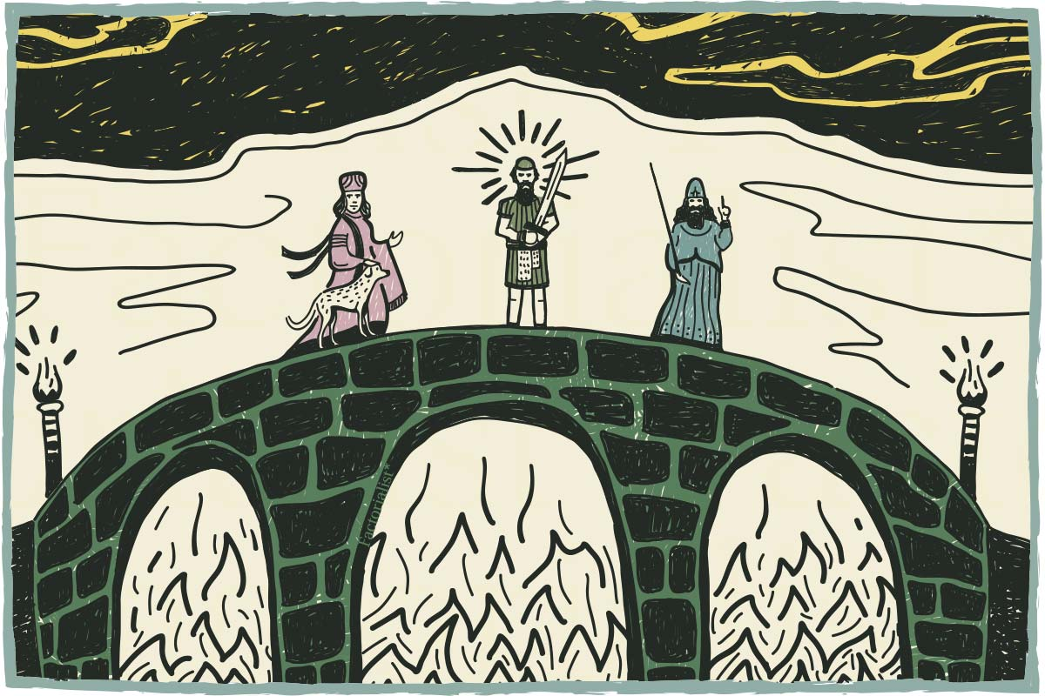
Other Christians say that we will experience a ‘bodily resurrection’, like Jesus, who came back in a physical form. St. Paul writes that we will be raised as spiritual bodied, not just disembodied souls: “So will it be with the resurrection of the dead… raised a spiritual body.” (1 Corinthians 15:42-44)
Christians believe that to be in heaven is to be in God’s presence, existing in a state of pure beauty and kindness. To be in hell is to be in constant torment, cut off from all that is good and loving.
Evangelical Christians refer to heaven and hell as if they are real places. Liberal Christians say these ideas are symbolic. They remind us that there are consequences to our choices.
Humanist Attitudes to Judgement, Heaven and Hell
Most Humanists are materialists. They believe that we are nothing more than matter. There is no spiritual or supernatural aspect to life. Humanists believe that, as far as we know, we are unlike any other creatures in that we are able to reflect on our own lives.
The humanist answer to, ‘What happens after we die?’ is: nothing; we only live once and there is no second chance. There is no soul or immortal consciousness, no cosmic judge, divine paradise or fiery hell. Because of this, we should make the most out of our existence while we can, living moral lives because it shows respect for others and for ourselves.

Christian Views of Life after Death: Questions
- What is the meaning of ‘soul’?
………………………………………………………………………………………………………………
- What is the difference between Christian and Humanist beliefs about the soul?
………………………………………………………………………………………………………………
………………………………………………………………………………………………………………
………………………………………………………………………………………………………………
- What is Dualism?
………………………………………………………………………………………………………………
- What is Materialism?
………………………………………………………………………………………………………………
- How do Christians believe they get to heaven?
………………………………………………………………………………………………………………
………………………………………………………………………………………………………………
- What do Christians believe happens when they die?
………………………………………………………………………………………………………………
………………………………………………………………………………………………………………
- What do Humanists believe happens when they die?
………………………………………………………………………………………………………………
………………………………………………………………………………………………………………
- Why do Christians think that they will rise again from the dead?
………………………………………………………………………………………………………………
- If being in heaven is being in God’s presence, what is hell?
………………………………………………………………………………………………………………
………………………………………………………………………………………………………………
- What do Humanists believe about judgement, heaven and hell?
………………………………………………………………………………………………………………
………………………………………………………………………………………………………………
………………………………………………………………………………………………………………
………………………………………………………………………………………………………………
Muslim Views of the Soul and Life after Death

Akhirah (Muslim beliefs about Life after death)
Akhirah is the Muslim belief in life after death. It is similar to the Christian belief. However, the time between death and resurrection is slightly different. When life is over it is too late to do anything to alter Allah’s judgement on us. Those who did not believe in Allah will beg for a second chance. They will ask if they can go back to warn those that they loved- but they will get no second chance. The souls of those who die before the Day of Judgement are taken by Azra’il, the angel of death, to a waiting place. This is called Barzakh.

On the Last (Judgement) Day, all graves will be opened. The dead will be brought back to life. Two angels will question them about the lives they have led. The deeds of everyone are weighed in Allah’s balance. Judgement is passed by Allah handing a book over. If it is placed in the right hand, the person passes into paradise. If it is placed in the left hand, they pass into hell.

Those who believe in Allah go to heaven. The Qur’an tells us that it is like a garden with green plants, the sound of running water and birds singing. Both men and women will be taken up with its beauty. It will be a place of great happiness.
His shall be a blissful state in a lofty garden, with clusters of fruit within his reach. We shall say to him: ‘Eat and drink to your heart’s content: your reward for what you did in days gone by.’ Surah (Chapter) 69:19

All unbelievers go to hell. This is a place of scorching fire under the earth’s crust. Those in hell are chained up with hot winds, boiling water and black smoke around them. They stay in hell forever.

Garments of fire have been prepared for the unbelievers. Scalding water shall be poured upon their heads, melting their skins and that which is in their bellies. They shall be lashed with rods of iron.
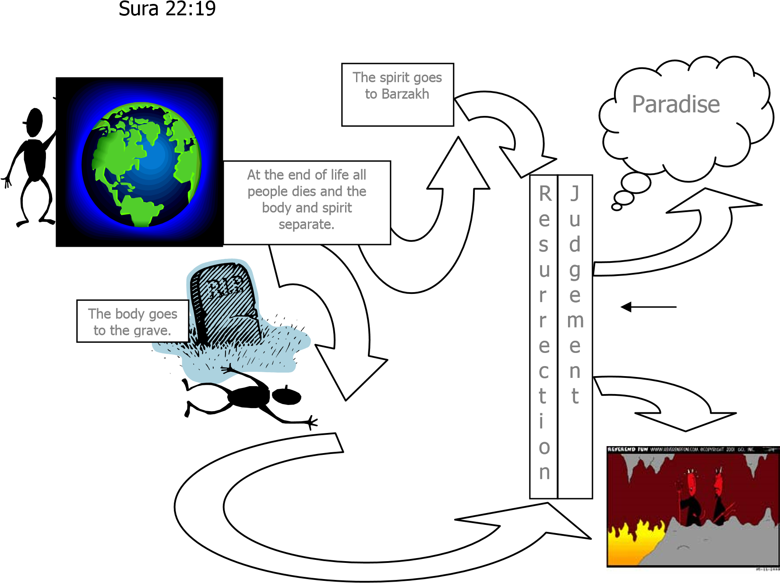

Why do people believe in a life after death? | Why do people not believe in a life after death?
Their religion teaches them so | There is no proof
It gives them hope and comfort | Science has proved that paranormal is false.
It gives them a purpose to life | People have made the afterlife up to provide comfort, because they can’t deal with death.
There is evidence from the scriptures | There are so many different religious views, they can’t all be right.
Near Death experiences
The Paranormal

Christian Views of Life after Death: Questions
- What do Muslims think happens to the soul?
………………………………………………………………………………………………………………………………………………………………………………………………………………………………………………………………………………………………………………………………………………………………………………………………………………………………………………………………
- What do Muslims think will happen on the Day of Judgement?
………………………………………………………………………………………………………………
………………………………………………………………………………………………………………
………………………………………………………………………………………………………………
- How does the Qur’an describe Heaven?
………………………………………………………………………………………………………………………………………………………………………………………………………………………………………………………………………………………………………………………………………………………………………………………………………………………………………………………………………………………………………………………………………………………………………………
- What are Muslims beliefs about Heaven?
………………………………………………………………………………………………………………………………………………………………………………………………………………………………………………………………………………………………………………………………………………………………………………………………………………………………………………………………
- What are Muslims beliefs about Hell?
………………………………………………………………………………………………………………………………………………………………………………………………………………………………………………………………………………………………………………………………………………………………………………………………………………………………………………………………………….
- Is a belief in life after death convincing? Explain your answer.
………………………………………………………………………………………………………………
……………………………………………………………………………………………………………………………………………………………………………………………………………………………………………………………………………………………………………………………………………………………………………………………………………………………………………………………………………………………………………………………………………………………………………………………..

Christian Symbolism in Funerals
How do funeral rites reflect beliefs about the afterlife?
Christians:
- When a person is close to death, a priest or a minister is called to say the ‘last rites’. Prayers are said for the dying person and they can ask God for forgiveness of their sins. The last rites is more commonly a Roman Catholic practice, which might involve the priest giving Holy Communion.
- The ‘last rites’ are important because it helps to ease the dying person into the afterlife, enabling them to die at peace, having asked for God’s forgiveness
- A Christian funeral is usually held in a church. The coffin is carried to the front of the church and a service is held in honour of the dead person. Flowers are displayed, prayers said and candles lit.
- “I am the resurrection and the life.” (John 11:25) This reminds the congregation that those who believe in Jesus will be resurrected, to spend eternity with God.
- The candles represent Jesus as the ‘light of the world’ because he guides a path into heaven.
- Psalm 23. ‘The Lord is my shepherd’, is often read at funerals. It says that even when I am ‘in the valley of the shadow of death’, God is still by my side. This means that we are not forgotten by God; he will comfort those who mourn and accompany those who have died
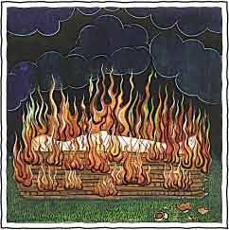
- Roman Catholics may hold a mass (communion service) with bread and wine at a funeral
- A person is buried with the words, “ashes to ashes, dust to dust.” Today, many Christians prefer to be cremated.
- A person may choose to be buried because they believe in a bodily resurrection to be with God in heaven
- A person may choose cremation because the soul goes to heaven, not the body, so it is acceptable to cremate the body. There is also an environmental
argument for cremation: if the world is for the living,
why is so much land taken up with graves?
Non-Religious Funeral Services
- Informal, personal ceremony
- Songs and readings are considered important to the person who has died or the family and friends of the person, and therefore have a more special meaning
- At a humanist funeral, those present remember the life of the person who has died, reflection on their contribution to the world and to others
- The service will be held by a humanist celebrant
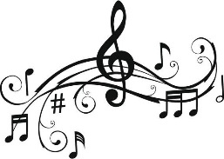
- The service will try to show respect for the dead person without suggesting that they are going to a better place. They will be remembered for their special, unique qualities, the life they led and the achievements they made.
- The service may include:
  - Music
  - Non-religious refection on death
  - Readings of poetry
  - Reminiscences about the person (memories)
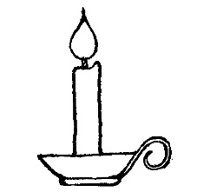
  - A eulogy (a description of why they were special)
  - Lighting candles
  - Moments of quiet reflection

Christian Symbolism and Funerals: Questions
- Which denomination more commonly says ‘last rites’ when a person is close to death?
………………………………………………………………………………………………………………
………………………………………………………………………………………………………………
- Why are the ‘last rites’ important?
………………………………………………………………………………………………………………
………………………………………………………………………………………………………………
- Where is a Christian funeral usually held?
………………………………………………………………………………………………………………
- What does John 11:25 say and what does it remind Christians of?
………………………………………………………………………………………………………………
………………………………………………………………………………………………………………
………………………………………………………………………………………………………………
- What do the candles represent?
………………………………………………………………………………………………………………
………………………………………………………………………………………………………………
………………………………………………………………………………………………………………
- What does Psalm 23 say and what does it mean?
………………………………………………………………………………………………………………
………………………………………………………………………………………………………………
………………………………………………………………………………………………………………
- What do Roman Catholics hold at a funeral?
………………………………………………………………………………………………………………
………………………………………………………………………………………………………………
- Which words is the person buried with?
………………………………………………………………………………………………………………
………………………………………………………………………………………………………………
- What is an alternative to cremation?
………………………………………………………………………………………………………………
………………………………………………………………………………………………………………
- Why might someone choose burial over cremation?
………………………………………………………………………………………………………………
………………………………………………………………………………………………………………
- State five features of a non-religious funeral service.
………………………………………………………………………………………………………………
………………………………………………………………………………………………………………
………………………………………………………………………………………………………………
………………………………………………………………………………………………………………

Muslim Funerals

At Death of a Muslim
Upon death, those people with the deceased are encouraged to remain calm, pray for the departed, and begin preparations for burial. The eyes of the deceased should be closed, and the body covered temporarily with a clean sheet. It is forbidden for those in mourning to excessively wail, scream, or thrash about. Grief is normal when one has lost a loved one, and it is natural and permitted to cry. When the Prophet Muhammad's own son died, he said: "The eyes shed tears and the heart is grieved, but we will not say anything except which pleases our Lord." One should strive to be patient, and remember that Allah is the One who gives life and takes it away, at a time appointed by Him. It is not for us to question Allah’s wisdom.

Washing and Shrouding the Body
In preparation for burial, the family or other members of the community will wash and shroud the body, this is usually done by family members. (If the deceased was killed as a martyr (they died to defend the Islamic faith or save others), this step is not performed; martyrs are buried in the clothes they died in.) The body will be washed respectfully, with clean and scented water, in a manner similar to how Muslims perform wudu (wash) for prayer. The body will then be wrapped in sheets of clean, white cloth (called the kafan).

Funeral Prayers
At death the body is transported to the site of the funeral prayers (salat-l-janazah). These prayers are commonly held outdoors, in a courtyard or public square, not inside the mosque. The community gathers, and the imam (leader of the prayer) stands in front of the deceased, facing away from the worshippers. The funeral prayer is similar in structure to the five daily prayers, with a few variations. (For example, there is no bowing or prostration, and the entire prayer is said silently but for a few words.)

Burial
The deceased is then taken to the cemetery for burial (al-dafin). While all members of the community attend the funeral prayers, only the men of the community accompany the body to the gravesite. It is preferred for a Muslim to be buried where he or she died, and not be transported to another location or country (which may cause delays or require embalming the body). If available, a cemetery (or section of one) set aside for Muslims is preferred. The deceased is laid in the grave (without a coffin if permitted by local law) on his or her right side, facing Mecca. At the gravesite, it is discouraged for people to erect tombstones, elaborate markers, or put flowers or other mementos. Rather, one should humbly remember Allah and His mercy, and pray for the deceased.
Mourning
Loved ones and relatives are to observe a 3 day mourning period. Mourning is observed in Islam by increased devotion, receiving visitors and condolences, and avoiding decorative clothing and jewellery. Widows observe an extended mourning period (iddah), 4 months and 10 days long, in accordance with the Qur'an 2:234. During this time, she is not to remarry, move from her home, or wear decorative clothing or jewellery.
When a Muslim dies, everything in this earthly life is left behind, and there are no more opportunities to perform acts of righteousness and faith. The Prophet Muhammad once said that there are three things, however, which may continue to benefit a person after death: charity given during life which continues to help others, knowledge from which people continue to benefit, and their religious offspring or any other religious child or who prays for him or her.

Muslim Funerals: Questions
- How are relatives of somebody who has died expected to behave at the death of a loved one?
………………………………………………………………………………………………………………
………………………………………………………………………………………………………………………………………………………………………………………………………………………………………………………………………………………………………………………………………………
- How is the body prepared after death?
………………………………………………………………………………………………………………………………………………………………………………………………………………………………………………………………………………………………………………………………………………………………………………………………………………………………………………………………………………………………………………………………………………………………………………
- Explain what happens during a Muslim funeral in your own words.
………………………………………………………………………………………………………………
………………………………………………………………………………………………………………
……………………………………………………………………………………………………………………………………………………………………………………………………………………………………………………………………………………………………………………………………………………………………………………………………………………………………………………………....
- Explain how Muslims are buried? What are mourners are encouraged to do? What is discouraged at the graveside?
………………………………………………………………………………………………………………
………………………………………………………………………………………………………………
………………………………………………………………………………………………………………
- How are Muslims expected to mourn?
………………………………………………………………………………………………………………
………………………………………………………………………………………………………………
………………………………………………………………………………………………………………
- What might continue to benefit a Muslim after their death?
………………………………………………………………………………………………………………
………………………………………………………………………………………………………………
………………………………………………………………………………………………………………

You!
Well Done!

