eduqas

GCSE Religious Studies
Relationships

Name:

Key Concepts in
Philosophy and Ethics:
Relationships

Adultery: Voluntary sexual intercourse between a married person and a person who is not their ………………………….... The commandments say, ‘thou shalt not commit adultery.’ Christians believe that adultery is a sin because it goes against God’s …………………………... .
Divorce: To legally end a marriage …………………………... In some circumstances, divorce is preferable where reconciliation and counselling have been tried and have …………………………...
Cohabitation: Living together in a sexual relationship without being …………………………... or in a civil partnership. Some Roman Catholics believe that this can lead to breaking the vow of ………………………….. made to God.
Commitment: Dedication and …………………………... to someone or something. For example, the wedding vows state, ‘til ………………………….. us do part.’
Contraception: The deliberate use of ………………………….. methods to prevent pregnancy. Some Church of England Christians allow contraception within a
………………………….. relationship, if both partners agree.
Word Box
contract
death
loving
chastity
spouse
teaching
failed
church
married
artificial
obligation
genders
commandments
opportunities
duties
society
Gender Equality: Equal rights between the …………………………... Christians
believe that we are all ‘created in God’s image,’ meaning that we all deserve
equal rights and ………………………….. .
Responsibilities: ………………………….. we must carry out. For example, looking
after others is a responsibility within Christianity because of Jesus’
………………………….. to, ‘love on another’.
Roles: Position, status or function of a person in …………………………..., as well
as characteristics and social behaviour expected of them. Each person can
have different roles within a family or a ………………………….., for example a
priest has a role to look after his congregation.
Diversity Within Religion and Society
Some religions believe that the teachings in sacred texts, such as the Bible, need to be adapted or changed because of changing views in society.
In addition, Britain is becoming an increasingly secular society. This means that more and more people are claiming not to belong to any religion or belief. These people would describe themselves as atheist (believing that there is no God), agnostic (unsure if there is a God) or humanist, (believing that we need to live an ethical existence for humanity alone).
There is an increasing pluralism of belief in Britain, meaning that there are becoming many more different religious groups within society.
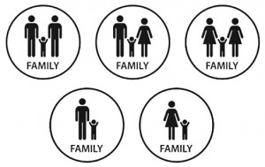
These changing statistics in Britain means that there are ever-changing attitudes towards relationships.
What is a family?
- Foundation for all human activity
- Where human relationships begin and develop
- Where the norms and values of society are lived out and practiced
- Where new generations are brought up into adulthood
Types of Family
Nuclear
Two parents and one or more

Single Parent Family
One parent raising one or more children alone. Increased rates of divorce has led to more single-parent families.

Nuclear
Two parents and one or more

Extended Family
Number of adults and children who are related living in the same home, e.g. aunts, cousins etc.

Nuclear
Two parents and one or more

Reconstituted Family
Divorced adults remarried or cohabiting and may include children from the new relationship.

Nuclear
Two parents and one or more

Nuclear
Two parents and one or more children living in the same house

Nuclear
Two parents and one or more

Childless Family
Married or cohabiting couple without children due to choice or inability to conceive.

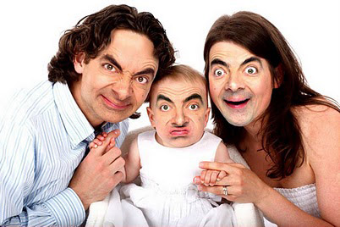
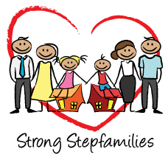
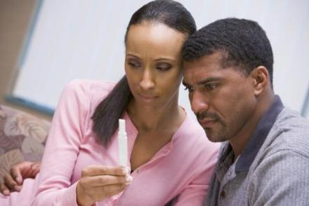

Diversity Questions
- Why do some people believe that sacred texts, e.g. the Bible, need to be adapted?
………………………………………………………………………………………………………………………...
………………………………………………………………………………………………………………………...
- What does ‘secular’ mean?
………………………………………………………………………………………………………………………...
………………………………………………………………………………………………………………………...
- What is the meaning of ‘atheist’?
………………………………………………………………………………………………………………………...
………………………………………………………………………………………………………………………...
- What is the meaning of ‘agnostic’?
………………………………………………………………………………………………………………………...
………………………………………………………………………………………………………………………...
- What is a ‘Humanist’?
………………………………………………………………………………………………………………………...
………………………………………………………………………………………………………………………...
- What does ‘pluralism’ mean?
………………………………………………………………………………………………………………………...
………………………………………………………………………………………………………………………...
- What is a family?
………………………………………………………………………………………………………………………...
………………………………………………………………………………………………………………………...
- What are the five different types of family?
………………………………………………………………………………………………………………………...
………………………………………………………………………………………………………………………...
………………………………………………………………………………………………………………………...
………………………………………………………………………………………………………………………...

Roles of Men and Women in the Family
Roles: Position, status or function of a person in society, as well as the characteristics and social behaviour expected of them.
Responsibilities: Actions/duties you are expected to carry out

Family members can have the following roles:
- Caring for children
- Caring for other family members, e.g. elderly relatives
- Maintaining the family home
- Earning money to support the family
- Men and women both have important roles within the family, e.g. showing mutual respect and being role models for the children
Traditional Views
- Traditionally in Christianity, the man was responsible for providing for the family through work
- The mother was traditionally responsible for domestic life (everything to do with the home)
- The man used to be seen as the leader of the family. This is called patriarchy, which means a family or a society controlled by men
Changing Views
- Women and men are now seen as in a partnership in family life, with shared responsibilities
- Women sometimes choose to stay on at work and there might be a ‘house-husband’ nowadays. The number of ‘stay-at-home’ dads has doubled since 1993. The law is also changing to reflect this – in 2015 it became possible for men and women to share parental leave. Parents can decide who takes leave to look after the baby, rather than it automatically being the mother
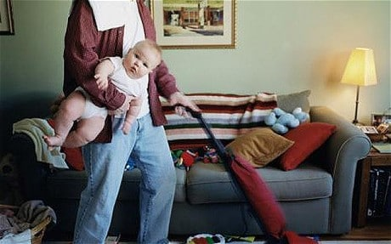

Families and Religion
- Religious belief is taught and learned in the home. Religious beliefs, practices and teachings are lived out in the home and young children learn by example
- It is a religious duty for parents to bring children up in faith and teach the values of the religion
- The Ten Commandments, and other basic values, are shared by all Christians (including Muslims and Jews). These values include: respect your parents, no murder, no adultery, etc
- Parents are expected to:
  - Take their children to church
  - Teach children how to read and understand the Bible
  - Teach children how and when to pray
  - Join in the celebration of festivals, e.g. Christmas and Easter
  - Understand the importance of rites of passage, e.g. baptism and the Eucharist
Many people today, e.g. Humanists, think that children should make up their own ideas about religion or that parents should not share their religious beliefs and faith with their children. Humanists believe all people should be able to make a free choice about accepting or rejecting religious beliefs
Worldwide Family
- Everyone in the Christian faith is regarded as part of the worldwide family
- Christians use the phrase ‘people of God’ for all Christians
- Pope Francis said:
  - The family is the basis of human society
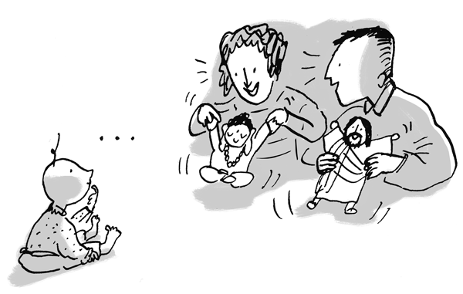
  - The role of the mother in passing on religious faith is fundamental

What does Islam say about family life?
Families are considered to be at the heart of every Muslim community. Family life was created by Allah to keep society together and Muslims should follow the example of the Prophet Muhammad, who was married and raised a family. The traditional Muslim family is an extended family. It usually includes parents, children, grandparents and elderly relatives. Most Muslims believe that extended families mean greater stability, continuity, love and support for each other.

Roles of men and women
Islamic law and practice recognise the differences between the sexes, resulting in different roles and obligations for men and women. However, many Muslims believe that men and women complement each other, and the Qur'an states:
O mankind! We have created you from a male and a female, and made you into nations and tribes, that you may know one another.Qur'an 49:13
In many Islamic societies, the woman's role is in the home and the man's role is in the public realm of the working world.
The Qur'an and the Hadith refer to the biological differences that mean men are generally physically stronger than women. Men, therefore, are regarded as protectors of women and families, and providers of financial support. Women are expected to have children and to fulfil the role of wife and mother.

Protection and nurturing
Many Muslims believe that family life is the foundation of human society providing a secure, healthy and nurturing environment for parents and growing children. The best place to pass on and develop human virtues such as love, kindness, mercy and compassion is in a family.
The family unit should encourage the individual to see themselves as part of a wider community and should discourage anti-social behaviour. Many Muslims believe that these values are not just for the benefit of individual families, but also the worldwide Islamic community, the Ummah.

Caring for the elderly
Muslims treat the elderly with dignity. Many consider it to be an honour and a blessing from Allah to be able to look after their elderly relatives and give them care with kindness, patience and respect. It is also a duty.

Parenting and children
Muslim parents have a responsibility to care for their children physically and emotionally. Their goal is for their children to grow into self-disciplined, independent adults. Parents are expected to teach their children right from wrong.
Children are expected to respect their parents. The child's duties to its parents are second only to its duties to Allah. Commandments from the Qur'an, and also the sayings of the Prophet Muhammad, talk about the respect children should have for their parents.
Your Lord has commanded that you worship none but Him and that you be kind to your parents. If one of them or both of them reach old age with you, do not say to them a word of disrespect… and act humbly to them in mercy. Qur'an 17:23-24

Children and spiritual development
The mother is at the heart of the Muslim family and is responsible for teaching children about halal and haram in the home. The father is responsible for taking the children to the mosque.
Muslim children are born into a state of fitrah, meaning purity and awareness of God. The parents have the responsibility of developing their spirituality. This may be achieved through teachings and daily life, but also by enrolling a child at a madrasah

Roles of Men and Women Questions
- What the meaning of ‘roles’?
………………………………………………………………………………………………………………………...
………………………………………………………………………………………………………………………...
- What is the meaning of ‘responsibilities’?
………………………………………………………………………………………………………………………...
………………………………………………………………………………………………………………………...
- What roles can family members have?
………………………………………………………………………………………………………………………...
………………………………………………………………………………………………………………………...
- What are the traditional views surrounding a ‘family’?
………………………………………………………………………………………………………………………...
………………………………………………………………………………………………………………………...
- What are the changing views surrounding families?
………………………………………………………………………………………………………………………...
………………………………………………………………………………………………………………………...
- Where is religious belief learned and taught?
………………………………………………………………………………………………………………………...
………………………………………………………………………………………………………………………...
- List some of the duties that religious parents are expected to perform:
………………………………………………………………………………………………………………………...
………………………………………………………………………………………………………………………...
- How does the nature of the family differ between traditional Muslim families and traditional Christian ones? How are they similar?
………………………………………………………………………………………………………………………...
………………………………………………………………………………………………………………………...
- What do Humanists believe about passing on religious beliefs?
………………………………………………………………………………………………………………………...
………………………………………………………………………………………………………………………...
- What is the ‘Worldwide Family’?
………………………………………………………………………………………………………………………...
………………………………………………………………………………………………………………………...

The Nature and Purpose of Marriage
Commitment: A sense of dedication and obligation to someone or something

Humanist Attitudes to Marriage
Humanists view marriage as a significant part of human life and understand why a couple may want to show their commitment. Such a ceremony may reflect the important nature of marriage and the significance for a couple and society but would include no religious aspect.
Christian Attitudes to Marriage
Marriage is the basis of family life. It is regarded as:
- God-given
- The best basis for creating an environment into which children should be born
- A lifelong commitment
A wedding ceremony is an important rite of passage in many religious traditions. It is a celebration that recognises the importance of marriage and it includes rituals and symbolism, which often reflect the purpose of marriage.
For Christians, marriage is:
- A gift given to humanity by God
- A Sacrament – an important rite of passage
- ‘Ordained by God’, as stated in the Christian marriage service, meaning ‘set aside’ for a particular job or role. In this case, married couples believe that their role is to now live in a partnership with God. The vows exchanged between a bride and groom in a Christian wedding service reflect this.
In the Gospels, Jesus teaches about the importance of marriage. This refers back to the idea in Genesis that, as part of God’s creation, God made man and woman. Jesus uses powerful language to express the meaning that marriage is the complete joining together of two people in a very special way. It is implied that the relationship becomes the most important human relationship for the couple who are married.
“At the beginning of creation God made them male and female. For this reason a man will leave his father and mother and be united to his wide, and the two will become one flesh. So they are no longer two, but one flesh.”
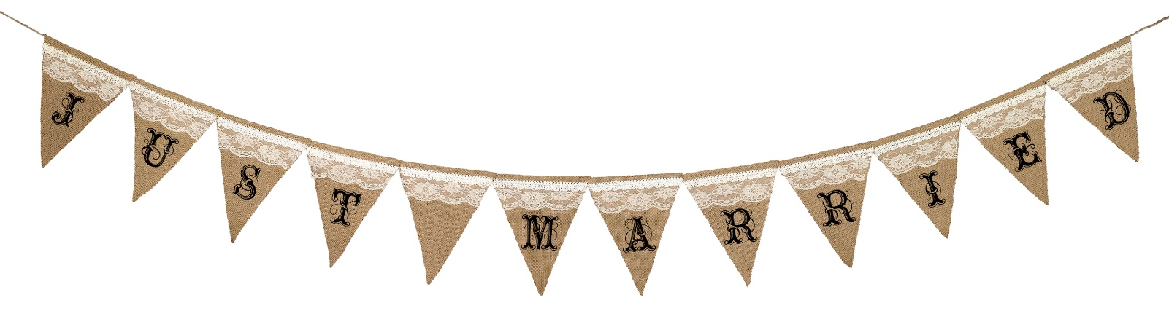
The marriage service says, ‘what man has joined together, let no man put asunder,’ meaning that marriage should be a lifelong union.

Islam and Marriage

For Muslims, marriage was created by God not only as the foundation of family life, but also as the foundation of society. Most Muslims believe marriage is a fundamental building block of life. Marriage is a contract between a man and woman to live together as husband and wife. The marriage contract is called a nikah.
For most Muslims the purpose of marriage is to:
- keep faithful to each other for the rest of their lives
- have children and bring them up in the Muslim faith

Marriage is mentioned many times in the Qur'an:
And among His signs is this, that He created for you mates from among yourselves, that you may dwell in peace and tranquility with them, and He has put love and mercy between your (hearts).
Qur'an 30:21
Muslims also regard the teachings and actions of the Prophet Muhammad as a source of authority. In the Qur'an it says that the Prophet was married, and therefore most Muslims look to follow his example.
In the Qur'an, Muslim men are allowed up to four wives, as long as they can treat each one equally. This practice is known as polygamy. However, if they cannot treat their wives equally, Muslim men are advised to have just one wife, and this is the practice in most modern Islamic societies. Polygamy is not allowed in the UK.
Marry women of your choice, two, or three, or four; but if ye fear that ye shall not be able to deal justly (with them), then marry only one.
Qur'an 4:3
Muslim women are only allowed one husband

Nature and Purpose of Marriage Questions
Nature and Purpose of Marriage Questions
- What is the meaning of ‘commitment’?

- What are the Humanist attitudes to marriage?

- What is a covenant?

- According to the quote from Genesis, what will the married couple become?

5. Christians believe that marriage should be a lifelong commitment. Do you agree? Explain your response IN DETAIL (at least four lines!)

6. In Christianity, marriage is a covenant between a man, a woman and God. How does this differ to the nature of marriage in Islam?

7. What is a Nikah?

Christian Wedding Ceremonies
Christians believe that marriage is a gift from God and traditionally Christian marriage ceremonies have taken place in a chapel or a church to reflect this belief. A typical wedding ceremony in the Church of England is performed by a vicar and would include:
- The vicar welcomes everyone
- The vicar gives a short sermon on the nature and purpose of marriage
- An exchange of vows, which reflect the main Christian beliefs about marriage:
To have and to hold
From this day forward
For better or worse
For richer for poorer
In sickness and in health
To love and to cherish
Til death do us part
According to God’s holy law
And this is my solemn vow
Vows:
The couple exchange rings as a sign of a commitment and say:

With my body I honour you
All that I am I give to you
And all that I have I share with you
Within the love of God,
Father, Son and Holy Spirit

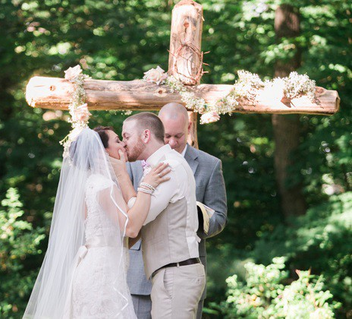
- The vicar declares the couple married
- There are prayers and Bible readings; the priest gives a sermon
- There may be hymns with an appropriate theme
- The legal requirement in Britain is for the newly married couple to sign the register, witnessed by a registrar and witnesses, which makes the marriage ceremony legal
- In an Anglican church the couple always marry in front of the altar

Christian Wedding Ceremonies: Questions
- Who do Christians believe marriage is a gift from?
………………………………………………………………………………………………………………………
- What would a typical Church of England wedding ceremony include? (Name three)
………………………………………………………………………………………………………………………
………………………………………………………………………………………………………………………
………………………………………………………………………………………………………………………
- State two lines from the Christian wedding vows.
………………………………………………………………………………………………………………………
………………………………………………………………………………………………………………………
- When the couple exchange rings, what do they say?
………………………………………………………………………………………………………………………
………………………………………………………………………………………………………………………
………………………………………………………………………………………………………………………
- What happens after the vicar declares the couple married?
………………………………………………………………………………………………………………………
………………………………………………………………………………………………………………………
………………………………………………………………………………………………………………………
- Which part of the ceremony makes the union legal?
………………………………………………………………………………………………………………………
- What might a couple do at an Anglican ceremony?
………………………………………………………………………………………………………………………

Islamic weddings
Although mosques are obviously places of worship, the majority of them in the UK, including Wales, have not yet been officially registered as such, and so any Islamic wedding that merely takes place at a mosque has to be registered legally with the UK law as well, in order to be seen as valid in the UK.
For many Muslims, it is the Islamic marriage ceremony that counts as the actual wedding, and not the legal confirmation of that wedding in a registry office. For this reason, Muslims in Wales will have a Muslim ceremony first, and then marry legally in a registry office.
A Muslim wedding ceremony is known as a nikah, and is usually a simple ceremony. The bride does not have to be present as long as she sends two witnesses to the drawn-up agreement. Normally, the ceremony consists of readings from the Qur'an, and the exchange of vows in front of witnesses for both partners. No special religious official is necessary, but often the imam is present and performs the ceremony and gives a short sermon.
There are certain things which are basic to all Muslim marriages:
- marriages have to be declared publicly
- they should never be undertaken in secret
- the publicity is usually achieved by having a large feast, or walimah - a party specifically for the purpose of announcing publicly that the couple are married and entitled to each other

Questions:
1. State three things that might typically happen during a Muslim wedding ceremony:

2. Why do you think that it’s important that marriages must be declared publicly and not undertaken in secret?

Marriage Outside of Religious Traditions
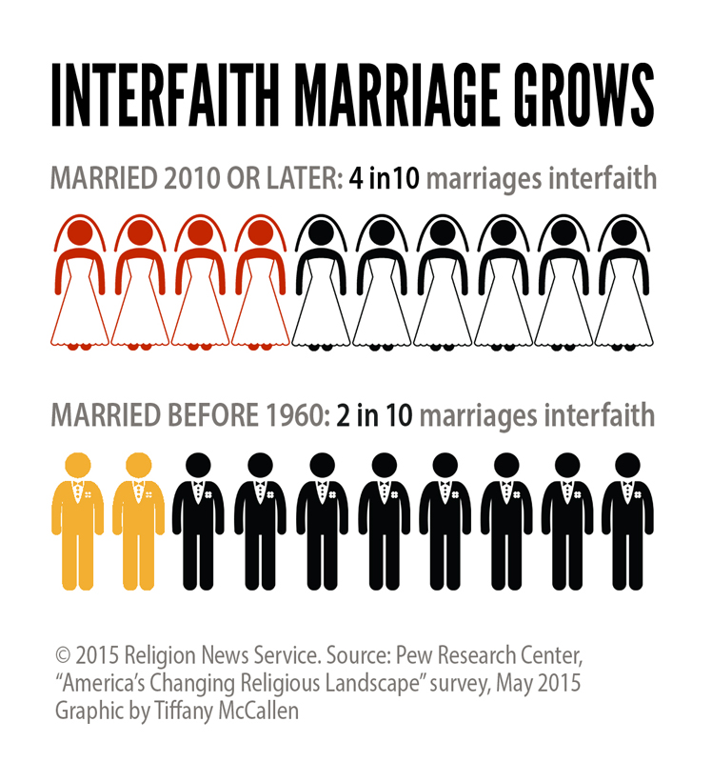
In a pluralist (multi-faith) society, inter-faith marriage – where two people of different faiths marry – is an issue that religions must respond to. Examples of issues raised by inter-faith marriage are:
- In the Orthodox tradition, marriage can only take place if the Christians have been baptised
- In RC, the partner who is not Catholic must agree to any children of the marriage being allowed to follow the Catholic faith
- Where there is an issue about a couple marrying in a place of worship, a civil ceremony can happen with a religious blessing
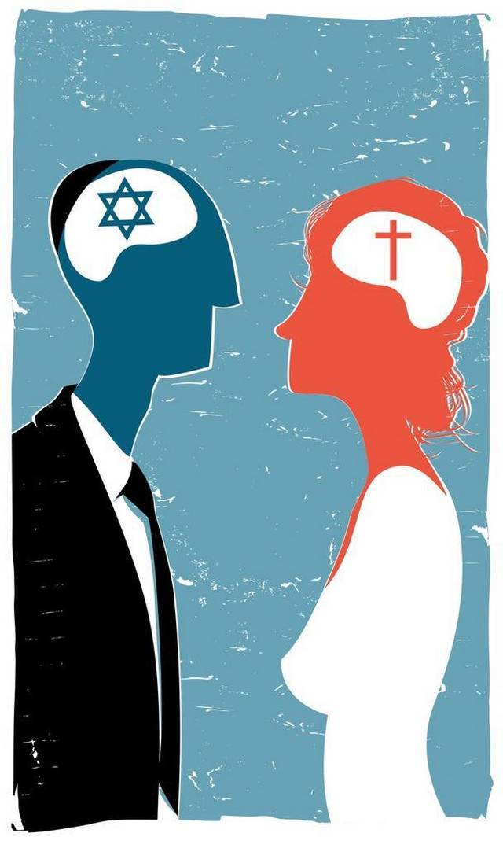
Issues faced by inter-faith marriage:
- Following religious dietary rules in the home (e.g. if one partner follows kosher laws)
- There might be different expectations about gender roles
- Religious communities might refuse to accept the inter-faith marriage
- Different beliefs about moral issues, e.g. the use of contraception
- Children might be told different things about death and the afterlife
- Parents might be torn between religions that children are raised in
- Families might want to celebrate different religious festivals

Marriage Outside Religious Traditions: Questions
- What is an interfaith marriage?
………………………………………………………………………………………………………………………
- What is needed in Orthodox traditions, in order for the couple to marry?
………………………………………………………………………………………………………………………
- What must be agreed if there is an interfaith marriage in the RC tradition?
………………………………………………………………………………………………………………………
- What else can happen, instead of marriage in a church?
………………………………………………………………………………………………………………………
- What are three issues faced by inter-faith marriage?
………………………………………………………………………………………………………………………
………………………………………………………………………………………………………………………
………………………………………………………………………………………………………………………

Cohabitation
Cohabitation: to live together in a sexual relationship, without being married or in a civil partnership

Some couples choose to cohabit rather than marry, whilst some couples will marry after a period of cohabitation. In 2012, there was 5.9 million people cohabiting in the UK and it was the fastest growing family type.
Attitudes to Cohabitation
Christianity has become increasingly more tolerant of cohabitation. Liberal Christians, such as some Church of England Christians, accept cohabitation where it is part of a committed relationship, although they still believe that marriage would be the ideal.
Some denominations, e.g. Roman Catholic, disagree with cohabitation as they believe is devalues the special and sacred nature of sex, which would only take place within marriage. The Catholic Church do not accept cohabitation and expect a couple to not have sex before marriage. Some Baptist Churches may refuse to marry a couple who are cohabiting.
In Islam, cohabitation is forbidden as living together in a sexual relationship should not take place until after marriage. Cohabitation does not provide families with security, as marriage does. Fornication (sex) outside of marriage is literally a crime in Islam. The Qur’an says: "The woman and the man guilty of zināʾ (for fornication or adultery),- flog each of them with a hundred stripes: Let not compassion move you in their case, in a matter prescribed by Allah, if ye believe in Allah and the Last Day: and let a party of the Believers witness their punishment."
— Qur'an, Sura 24

Cohabitation: Questions
- What is the meaning of ‘cohabitation’?
………………………………………………………………………………………………………………………...
- Finish the sentence: Cohabiting families are the fastest growing….
………………………………………………………………………………………………………………………...
- What do liberal Christians believe about cohabitation?
………………………………………………………………………………………………………………………...
- Which denomination disagrees with cohabitation?
………………………………………………………………………………………………………………………...
- Why disagree with cohabitation?
………………………………………………………………………………………………………………………...

Adultery
Adultery: voluntary sexual intercourse between a married person and a person who is not their spouse

Extra marital sex (or adultery) is generally frowned upon in Britain. The majority of people in UK disapprove of adultery on moral and social grounds and the law recognises adultery as a justifiable reason for the granting of a divorce.
Christian Attitudes to Adultery
Christianity considers adultery as a sin. The Ten Commandments forbid adultery: “do not commit adultery.”
Christianity teaches that adultery is wrong for the following reasons:
- Marriage is sexually exclusive and should not be shared with anyone else
- The Ten Commandments forbid adultery: “You shall not commit adultery” (Exodus 20:14)
- Marriage is a sacrament – a gift from God – and adultery goes against this
- Committing adultery destroys the special relationships between a husband and wife
- Committing adultery can harm the family unit and cause the partner to feel cheated and betrayed
Islam and Adultery
Adultery is a crime in Islam. The Qur’an says "The woman and the man guilty of zināʾ (for fornication or adultery),- flog each of them with a hundred stripes: Let not compassion move you in their case, in a matter prescribed by Allah, if ye believe in Allah and the Last Day: and let a party of the Believers witness their punishment."
— Qur'an, Sura 24
Why do some marriages fail?
- Lack of communication
- Lack of appreciation
- Unemployment
- Alcohol/drug problems
- Financial problems
- Affairs (adultery)
- Sexual problems
- Religious differences
- Unacceptable behaviour
- Interference from in-laws
- Too little time together
- Pregnancy/children
- Separation
- False hopes
- Work or career
- Different interests
- Personality difficulties
When people argues or are in conflict, making up is essential and is known as ‘reconciliation’. Religious communities can help those who are having relationship problems to reconcile. The religious leader might offer counselling and guidance to the couple, or the wider community might offer support and prayers.
However, sometimes the couple cannot reconcile, in which case, they might want to end the relationships. This could involve:
- Divorce – the legal ending of a marriage
- Separation = deciding to live separately
- Annulment – a legal way of cancelling a marriage in the Catholic Church
Eventually, a person who has been married and divorced, might want to marry someone else. This is known as remarriage.

Adultery: Questions
- What is the meaning of ‘adultery’?
………………………………………………………………………………………………………………………...
- Why do the majority of people in Britain object to adultery?
………………………………………………………………………………………………………………………...
- What does the law recognise adultery as?
………………………………………………………………………………………………………………………...
- What do the Ten Commandments say about adultery?
………………………………………………………………………………………………………………………...
- Why is adultery wrong for Christians? (name three reasons)
………………………………………………………………………………………………………………………...
………………………………………………………………………………………………………………………...
………………………………………………………………………………………………………………………...
- Why do some marriages fail? (Name three reasons)
………………………………………………………………………………………………………………………...
………………………………………………………………………………………………………………………...
………………………………………………………………………………………………………………………...
- What is reconciliation?
………………………………………………………………………………………………………………………...
- How might a religious community help couples who are in conflict?
………………………………………………………………………………………………………………………...
………………………………………………………………………………………………………………………...
………………………………………………………………………………………………………………………...
- What three options do a couple who cannot reconcile have?
………………………………………………………………………………………………………………………...
………………………………………………………………………………………………………………………...
………………………………………………………………………………………………………………………...
- What is remarriage?
………………………………………………………………………………………………………………………...
- What is the Islamic view of adultery?
………………………………………………………………………………………………………………………………………………………………………………………………………………………………………………………………………………………………………………………………………………………………………

Divorce, Separation and Remarriage
Divorce: To legally end a marriage

Marriages break down, which can result in separation or divorce. The RC Church does not permit divorce, so some Catholics will choose to remain separated rather than to divorce. However, divorce is necessary if someone wants to marry someone else. Otherwise it is known as bigamy and it is illegal.
Bigamy is entering into a marriage with someone whilst still being legally married to another person. Couples can apply for a divorce via the court system.
Christian Attitudes to Divorce and Separation
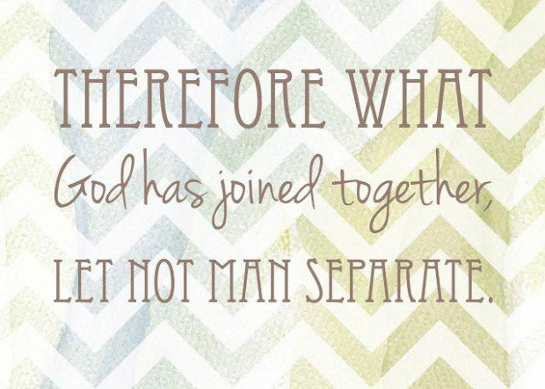
Roman Catholic
- Do not recognise divorce
- Marriage is a lifelong commitment that cannot be broken
- In some cases, annulment is given, which is where the marriage is declared as having never happened
- Jesus said, “Anyone who divorces his wife, except for sexual immorality, and marries another woman commits adultery.”
- The Bible says, “Therefore what God has joined together, let no one separate.”
- Catholics who separate are expected not to cohabit with anyone else and if they do this, then they are not allowed to receive Holy Communion during Mass
- Catholics who do divorce can apply through the courts, just like everyone else. However, the Catholic Church do not recognise couples who are legally divorced. They believe that, in God’s eyes, you are still married
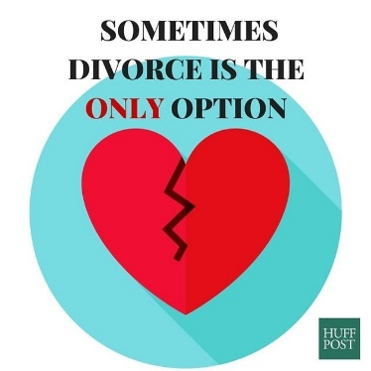
- Annulment is when a court says that your marriage is not legally valid. This might be in the case that there is no consummation of the marriage (the couple haven’t had sex) or when it is proved that the marriage should never have taken place, e.g. because it was forced
Church of England
- Divorce is recognised by the Church of England as it is legal (allowed by the law)
- Issues arise when it comes to remarriage. Remarriage is okay if the minister allows it – but it is up to their own discretion

Is divorce acceptable?
Maybe
No
It is not God’s intention
It is breaking the solemn promises made before God and the Christian family
Catholics do not recognise divorce
Marriage is a sacrament and it cannot be dissolved (unless for special reasons, e.g. it was a forced marriage)
Some marriages can be annulled for special reasons, e.g. the marriage has not been consummated
If a Catholic remarries without annulments then they can attend Mass but cannot receive Holy Communion (bread and wine)
Anglicans/Church of England
Divorce is best avoided. However UK law accepts divorce, therefore it is OK in some circumstances, e.g. abuse
Remarriage is discouraged but if chosen then a non-church wedding is preferred
Remarriage permitted if it seems suitable and acceptable to all concerned
No minister can be forced to conduct a remarriage service against their will

Islam and divorce
Although it is not encouraged, most Muslims agree that divorce is permitted if a marriage has broken down, and generally Muslims are permitted to re-marry if they so wish. Divorce is the legal ending of a marriage.
However, there are differences between Muslims about the procedures for divorce and remarriage:
- Sunni Muslims do not require witnesses. The husband must express his desire for a divorce on three separate occasions with a waiting period of three months.
- Shi'ah Muslims require two witnesses, followed by a waiting period before a marriage can end.
- If a woman initiates a divorce it is called khula. There must be a waiting period to ensure the woman is not pregnant.
Although Shariah Law permits divorce, in the Hadith, Abdullah ibn Umar reported that the Prophet Muhammad said, “Of all things permitted, divorce is most hated by Allah”. So although divorce is allowed, Muslims should try to avoid it, if possible.
This means that many Muslims who experience marital difficulties will try to resolve their issues.

What does this mean in practice?
A couple can go to their mosque for advice and support from the imam if they are experiencing marital problems. Extended families also play a vital role in trying to help the couple sort out any issues. However, in some situations a couple might feel divorce is their only option.

Divorce, Separation and Remarriage: Questions
- What is the meaning of ‘divorce’?
………………………………………………………………………………………………………………………...
………………………………………………………………………………………………………………………...
- What is bigamy?
………………………………………………………………………………………………………………………...
………………………………………………………………………………………………………………………...
- What is an annulment?
………………………………………………………………………………………………………………………...
………………………………………………………………………………………………………………………...
- What did Jesus say about divorce and adultery?
………………………………………………………………………………………………………………………...
………………………………………………………………………………………………………………………...
- What does the Bible say about separation?
………………………………………………………………………………………………………………………...
………………………………………………………………………………………………………………………...
- What might happen to Roman Catholics who divorce, but live (cohabit) with another partner?
………………………………………………………………………………………………………………………...
………………………………………………………………………………………………………………………...
- Why do Roman Catholics not recognise a couple who are legally divorced?
………………………………………………………………………………………………………………………...
………………………………………………………………………………………………………………………...
- Why might a marriage get annulled?
………………………………………………………………………………………………………………………...
………………………………………………………………………………………………………………………...
- Why does the Church of England allow divorce?
………………………………………………………………………………………………………………………...
………………………………………………………………………………………………………………………...
- When might remarriage be allowed?
………………………………………………………………………………………………………………………...
………………………………………………………………………………………………………………………...
- What did Prophet Muhammad say about divorce?

- Explain the difference between Sunni and Shi’a divorce procedures:

Sexual Relationships
Sexual relationships are an important part of being human. Sex is a gift from God and part of God’s creation. It allows for the continuation of the human race and is an important part of human identity. It is also a physical expression of love for others.
Promiscuity (having a number of casual sexual relationships) is regarded as wrong or a sin in Christianity, because sex should be part of a committed relationship between two people who have deep feelings for each other. As sex can result in children, fidelity in sexual relationships is really important for the upbringing of children by two parents.

The Purpose of Sex
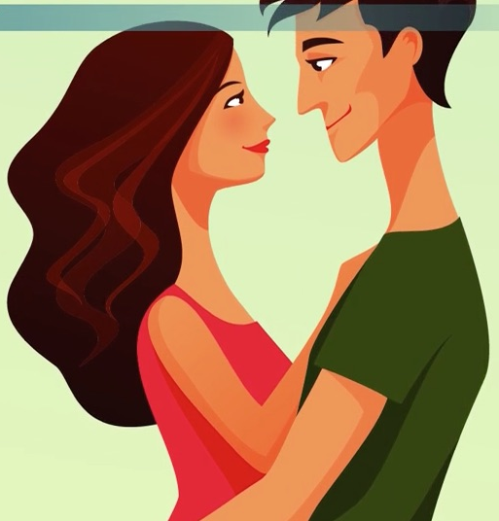
Sex is a powerful human instinct and drive. It is linked with procreation, but the development of successful and widely available contraception, e.g. the contraceptive pill, has allowed the act of sex to be divorced from the act of procreation. Therefore people are able to have sex without becoming pregnant. This has significantly changes attitudes towards sexual activity.
Christian and Muslim Attitudes to Sex
- Promiscuity is not acceptable
- Sex should take place within a marriage
- Sex is a gift from God. It is holy and sacred
- Sex should only be done with the person you love
- Casual sex devalues people and devalues the sex itself (it becomes meaningless)
- Christians and Muslims are very concerned about children being born outside of a stable home environment
Chastity
- The promise to not have sex until marriage
- Traditionally in Christianity and Islam, a person would remain chaste (a virgin) until marriage
- In America, Christians wear a ring on their wedding finger as part of the ‘Silver Ring Thing’ or ‘True Love Waits’ movement, which highlights a person’s choice to not have sex until marriage. When married, the person will replace this silver ring with their wedding ring
Celibacy
- The decision to never have a sexual relationship
- In the RC faith, priests, monks and nuns take a vow of celibacy. It is made as a positive choice of lifestyle in order to dedicate one’s life to the service of God

Purpose of Sex: Questions
- Finish the sentence: Sex is a gift from God and part of…
………………………………………………………………………………………………………………………...
- What does sex allow for?
………………………………………………………………………………………………………………………...
- What is promiscuity and why is it seen to be a sin?
………………………………………………………………………………………………………………………...
………………………………………………………………………………………………………………………...
………………………………………………………………………………………………………………………...
- What do Christians and Muslims believe about sex? (Name three)
………………………………………………………………………………………………………………………...
………………………………………………………………………………………………………………………...
………………………………………………………………………………………………………………………...
- What is chastity?
………………………………………………………………………………………………………………………...
………………………………………………………………………………………………………………………...
- What is the ‘Silver Ring Thing’ movement?
………………………………………………………………………………………………………………………...
………………………………………………………………………………………………………………………...
- What is celibacy?
………………………………………………………………………………………………………………………...
………………………………………………………………………………………………………………………...

Contraception and Family Planning
Contraception: Methods used to prevent a woman from becoming pregnant during or following sexual intercourse

There are two types of contraception:
- Natural contraception: This can include Natural Family Planning. This is when a person doesn’t have sex during the time of the month when they are most likely to become pregnant. Natural contraception also includes the Withdrawal Method, where the man ‘pulls-out’ before he ejaculates. However this is an extremely unreliable method of contraception.
- Artificial contraception: These methods include the pill, injection or condom to prevent contraception.

Christian Attitudes to Contraception
Roman Catholic:
The Roman Catholic Church opposes artificial contraception. However, population growth is currently a debate throughout the planet, so some Catholics will consult their consciences when making a decision about using contraception
Many Catholics also want to enjoy sex without the worry of having more children that they can’t look after or afford.
St. Thomas Aquinas developed a theory on Natural Law, which many Catholics consult when making moral decisions. Aquinas said there are some fundamental laws laid down by God and are the basis of how human should live and carry out their lives. There are five primary precepts:
- Self-preservation/preservation of the innocent
- Continuation of the species through reproduction
- Education of children
- To live in society
- To worship God
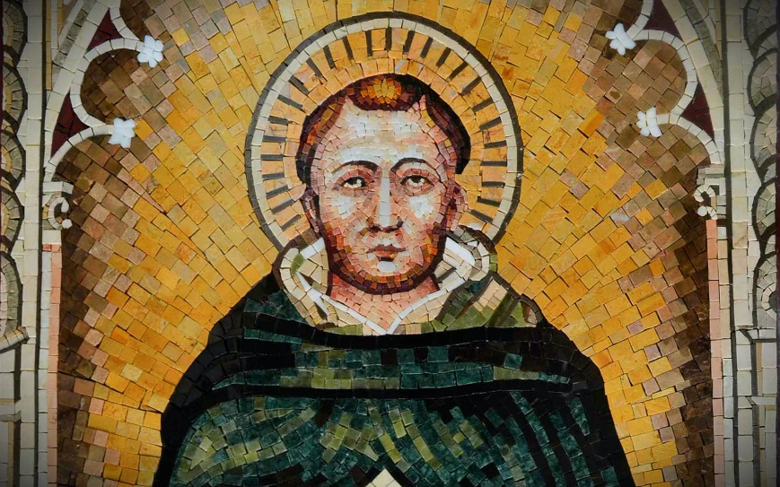
From these primary precepts, Aquinas set out secondary precepts that fulfil and maintain the primary precepts. For example, the second precept says that we should reproduce, therefore contraception is wrong as it would prevent reproduction.
Natural Law should always be followed. If Natural Law states that we should continue the species, then contraception is going against that! - Aquinas
The Catholic Church takes an absolutist view of Aquinas’s Natural Law, meaning that the rules Aquinas laid down should always be followed. Therefore, contraception should not be used as it goes against Natural Law.
Church of England
Natural Law is not an absolute set of laws, but a relative set of laws. God gave humans intelligence and creativity so that they can use their consciences to decide what is right in any given situation. There might be some situations where using contraception is the moral and responsible thing to do, e.g. where the parents already have children and cannot afford any more, or when considering global over-population.
In addition, contraception doesn’t just prevent pregnancy, but the spread of STIs/STDs, so it is a good thing for this reason.

Islam
The Qur'an does not refer to contraception explicitly, but Muslims opposed to birth control often quote the Qur'an as saying "You should not kill your children for fear of want" (17:31, 6:151) and interpret this as including a ban on contraception as well as infanticide. Supporters of birth control argue that this interpretation is wrong.
In practice most Muslim authorities permit contraception to preserve the health of the mother or the well-being of the family.

Hadith
There are a number of hadith which indicate that the Prophet knew of birth control and approved of it in appropriate circumstances.

Humanism
Contraception is allowed so that people can enjoy their lives and limit the size of families. Sex is regarded as an expression of human affection and love between two people and it has no religious or sacred aspect.
Science should be used to improve the quality of life for human beings, therefore is the use of contraception limits the size of families and leads to an improvement in the quality of life it should be used.

Contraception and Family Planning: Questions
- What is the meaning of ‘contraception’?
………………………………………………………………………………………………………………………...
………………………………………………………………………………………………………………………...
- What is artificial contraception?
………………………………………………………………………………………………………………………...
………………………………………………………………………………………………………………………...
- What is natural contraception?
………………………………………………………………………………………………………………………...
………………………………………………………………………………………………………………………...
- What do Roman Catholics believe about contraception?
………………………………………………………………………………………………………………………...
………………………………………………………………………………………………………………………...
- What are Muslim attitudes towards contraception?
………………………………………………………………………………………………………………………………………………………………………………………………………………………………………………………………………………………………
- What is ‘Natural Law’?
………………………………………………………………………………………………………………………...
………………………………………………………………………………………………………………………...
- What does Natural Law suggest about the use of contraception?
………………………………………………………………………………………………………………………...
………………………………………………………………………………………………………………………...
- What do the Church of England believe about the use of contraception?
………………………………………………………………………………………………………………………...
………………………………………………………………………………………………………………………...
- What other benefit is there of using contraception?
………………………………………………………………………………………………………………………...
………………………………………………………………………………………………………………………...
- What do Humanists believe about the use of contraception?
………………………………………………………………………………………………………………………...
………………………………………………………………………………………………………………………...
- What is the purpose of science, according to Humanists?
………………………………………………………………………………………………………………………...
………………………………………………………………………………………………………………………...

Same-Sex Relationships
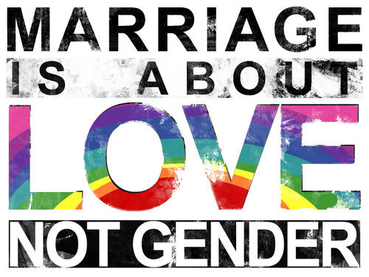
- Traditionally, relationships were between one man and one woman
- In 1967, homosexuality was decriminalised in UK
- British attitudes to same-sex relationships have changed over time
- The Civil Partnership Act of 2004 enabled same-sex partners to have essentially the same legal rights and responsibilities as married couples. This was followed by the Marriage Act in 2013, which legalised same-sex marriage in England and Wales. So now couples who wish to be legally joined have two routes they can take: Civil Partnership or Marriage

Christian Attitudes to Same-Sex Marriage
- Traditionally, same-sex marriage was seen as wrong
- Many Christians oppose same-sex marriage on Biblical grounds:
  - “If a man has sexual relations with a man as he does a woman, both of them has done what is detestable. They are to be put to death.” (Leviticus 20:13 – Old Testament)
  - “The law is made for lawbreakers and rebels…for those practicing homosexuality” (Timothy 1: 8-10)
- However, other Christians believe that the above quotes reflect the cultural and social values of the time they were written in and that they don’t apply in today’s society
- Liberal Christians point out that there are a lot of things that are condemned in the Bible that are seen as perfectly acceptable today, e.g. eating snails, consulting psychics or mediums, wearing provocative clothing, having tattoos or wearing polyester – or any other fabric blends!

Roman Catholics
- RC Church is against same-sex marriage as it believes that sexual relationships should only exist between a man and a woman in marriage
- Pope Francis wrote in 2010, “A marriage made up of a man and a woman is not the same as the union of two people of the same sex... a father is not the same as a mother.”

Other Christian Churches
- Some Anglicans believe that same-sex marriages should not happen in a church
- Others believe that same-sex couples can receive a blessing in a church
- Quakers conduct same-sex services but the couple will also need a Civil Ceremony in order to be legally married
- The United Reform Church has recently decided to allow same-sex marriages to take place
Humanist Attitudes to Same-Sex Marriage
- Humans should find personal happiness in this lifetime
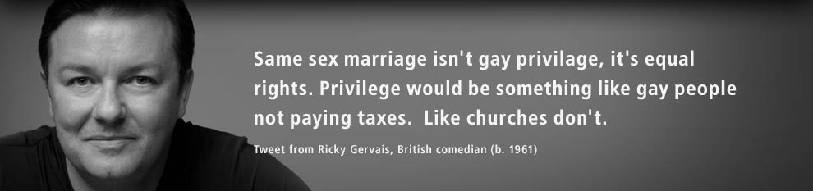
- Same-sex marriages are a positive expression of finding personal happiness and a quality of life that only a stable, loving relationship can provide
Same-Sex Marriage: Questions
- When was homosexuality decriminalised in UK?
………………………………………………………………………………………………………………………...
- What did the Civil Partnership Act of 2004 enable?
………………………………………………………………………………………………………………………...
- What did the Marriage Act of 2013 allow?
………………………………………………………………………………………………………………………...
- What does Leviticus say about same-sex marriage?
………………………………………………………………………………………………………………………...
………………………………………………………………………………………………………………………...
- What does Timothy say about same-sex marriage?
………………………………………………………………………………………………………………………...
………………………………………………………………………………………………………………………...
- What do some Christians believe that the above two quotes reflect?
………………………………………………………………………………………………………………………...
- What do Liberal Christians believe?
………………………………………………………………………………………………………………………...
………………………………………………………………………………………………………………………...
- What else is said in the Bible to be forbidden that we ignore as a rule now?
………………………………………………………………………………………………………………………...
- What do Roman Catholics believe about same-sex marriage?
………………………………………………………………………………………………………………………...
- What did Pope Francis write in 2010?
………………………………………………………………………………………………………………………...
………………………………………………………………………………………………………………………...
- Other than a marriage, what else can happen for a same-sex couple?
………………………………………………………………………………………………………………………...
- What do Humanists believe about same-sex marriage?
………………………………………………………………………………………………………………………...
………………………………………………………………………………………………………………………...
………………………………………………………………………………………………………………………...
Issues of Equality: Gender Prejudice and Discrinimation
Gender Equality: People of all genders enjoying the same rights and opportunities in all aspects of their lives

Gender equality and the changing relationships between men and women is one of the most significant changes in society in recent times and across the world.
In UK law, men and women have equal rights in employment. Discrimination on the basis of gender is illegal. The 2010 Equality Act simplified previous laws to protect people from discrimination.
However, traditionally woman and men had different roles in religions, particularly in relation to their role in authority (leadership) and worship. These traditional roles have been debated in recent years as the role of women has changed in society to become more equal to that of men.
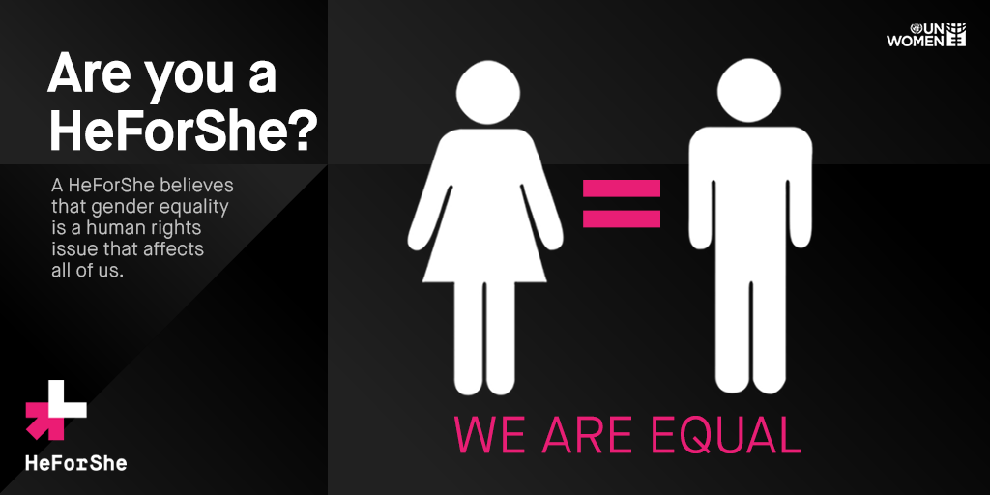

Christian Attitudes to the Roles of Women and Men in Worship and Authority
Arguments for Gender Equality in Christianity:
- In Jesus’ time it was normal for men to take up positions of authority. Society is different now and women are more equal
- Jesus’ actions showed that he respected women and he had women amongst his closest followers, which would have been very unusual at the time
- In the Parable of the Good Samaritan, Jesus taught that you should not discriminate
- Humans are all “Created in the image of God”, so each human life is sacred and equal
- Gender is irrelevant, as long as you have faith in Jesus:
  - “There is neither Jew nor Gentile, neither slave nor free, nor is there male and female, for you are all one in Christ Jesus.” (Galatians 3:27-29)
Arguments against Gender Equality in Christianity:
- In the early Christian Church, the original disciples were all men
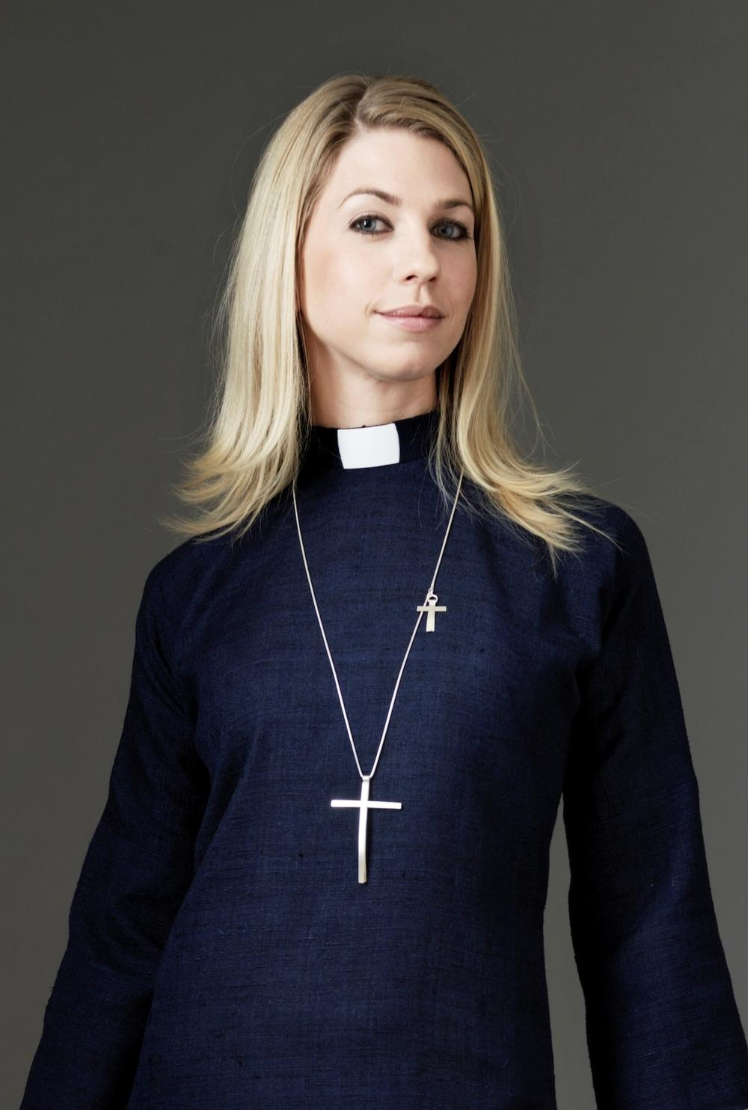
- Women are different to men and should not have authority over men: “A woman should learn in quietness and full submission. I do not permit a woman to teach or to assume authority over a man; she must be quiet.”
The Church of England
- Men and women can take up equal roles within leadership and worship
- 32 female ministers were ordained in 1994 and the first female bishop was ordained in 2014. Therefore women can become ministers and lead Christian congregations in worship
- The Archbishop of Canterbury said that the Church was “entering a completely new phase of our existence” when the first female bishop was ordained
- However, there is still a huge imbalance between male and female bishops
The Roman Catholic Church
- Women can take up active roles in worship. They can become a nun or a ‘sister’, taking vows to dedicate their lives to God
- Women are equal members of the Church congregation, supporting the church in a number of ways, e.g. serving on church committees or helping ministers to lead worship
- However, women cannot be ordained (process of being given religious authority). Therefore, women cannot become priests in the RC Church
- Men and women are equal but they have different strengths and contributions to make to society. Men take more religious leadership roles, whilst women have an equally important role to play in their families and communities

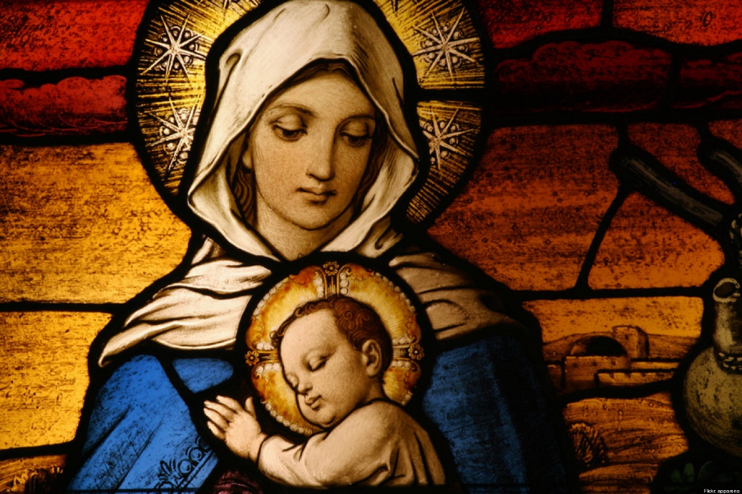
Virgin Mary, mother of Jesus, is one of the most iconic figures in the Catholic Church. She, above all others, was chosen by God: “Blessed are you amongst women.”
Mary did her duty for her faith and bore God’s son, Jesus. She is portrayed as a caring mother: a role model for women everywhere.
Mary is believed to be chosen, holy and pure (without sin). She is one of the only other Bible characters who was also assumed (bodily raised) into heaven.

Equality, Gender Prejudice and Discrimination: Questions
- What is the meaning of ‘gender equality’?
………………………………………………………………………………………………………………………...
- What does UK law say about gender equality?
………………………………………………………………………………………………………………………...
- State three arguments for gender equality in the Christian Church:
………………………………………………………………………………………………………………………...
………………………………………………………………………………………………………………………...
………………………………………………………………………………………………………………………...
- State two arguments against gender equality in the Christian Church:
………………………………………………………………………………………………………………………...
………………………………………………………………………………………………………………………...
………………………………………………………………………………………………………………………...
- When was the first female bishop ordained in the Church of England?
………………………………………………………………………………………………………………………...
- What is there an imbalance between in the Church of England?
………………………………………………………………………………………………………………………...
- What roles can women take up in the Roman Catholic Church?
………………………………………………………………………………………………………………………...
- In which Church can women not become priests in?
………………………………………………………………………………………………………………………...
- Finish the sentence: Men and women are equal but they have different strengths and…
………………………………………………………………………………………………………………………...
- Why is the Virgin Mary important in the Roman Catholic Church?
………………………………………………………………………………………………………………………...
………………………………………………………………………………………………………………………...
- How is Mary portrayed?
………………………………………………………………………………………………………………………...
………………………………………………………………………………………………………………………...
- Finish the sentence: Mary is one of the only other Bible characters who was also…
………………………………………………………………………………………………………………………...

