GCSE Religious Studies
Islam: Beliefs & Teachings
Workbook

Name:

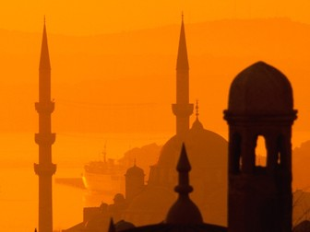

Diversity of Beliefs
within Islam
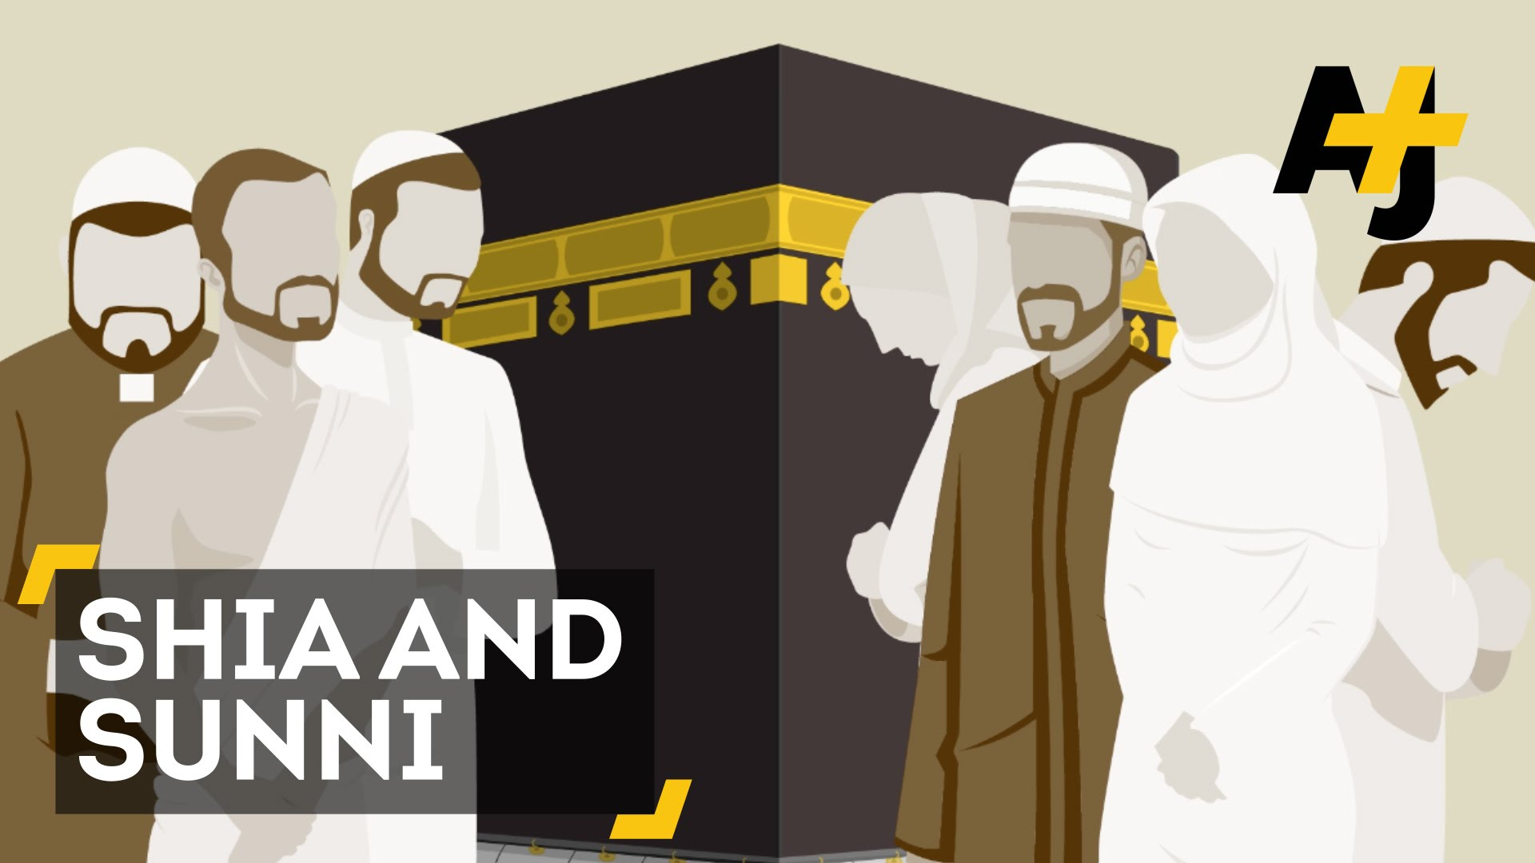
Islam has two main sects: Sunni and Shi’a.
Sunni
Sunni form the majority of the Muslim community. Four successors, called caliphs, were appointed to lead the Muslim community after the death of Muhammad (PBUH) in 632CE: Abu Bakr, Umar, Uthman and Ali. These men were chosen in turn and known as the ‘four rightly guided caliphs’, led the community for the next 24 years.
Sunni Muslims believe in the authority of the Qur’an and Hadiths, interpreted by leading Muslim scholars.
Sunni comes from the word Sunnah, which means ‘custom’ or ‘way’. Sunni believe they are the true followers of the way of the Prophet Muhammad (PBUH). They believe that as Prophet Muhammad (PBUH) did not choose his successor, election is the right way. About 90% of all Muslims are Sunni.
Shi’a
Shi’a is the second largest branch of Islam. Shi’a refer to their chosen leader as the ‘imam’ and they believe that each imam must be chosen by the previous imam. All Shi’a believe that Prophet Muhammad (PBUH) appointed Ali as his successor. They claim the first three caliphs ignored the Prophet’s choice, so they are only seen as companions. Shi’a believe the imams have authority from Allah and can interpret the Qur’an and the Laws of Islam. They believe the last imam disappeared or went to the sky without dying. The hidden imam, Mehdi, is present in the world, yet is unseen. He helps those in need and tries to convert all humankind to Islam. They believe he will appear again at the end of the world and establish Allah’s kingdom.
After Ali’s death, Shi’as believed his son, Hasan, should be the next leader, but there was disagreement. Ali himself had been opposed by Muawiya (Uthman’s cousin) and Hasan agreed that his family would lead the caliphate only after Muawiya died. Unfortunately, Hasan died and Muawiya made his son, Yazid, the leader. Hasan’s brother, Husayn, refused to accept Yazid and war broke out.
Although there are many Shi’a subsects, modern Shi’a Islam has been divided into three main groupings with Twelver Shi’a being the largest and most influential group, and the one this course focuses on.
These differences caused a split amongst the Muslim community, which we still see today. There are some within each Muslim group who believe no government can be accepted if it is not based on the Laws of Islam and the rule of Allah alone.
There is still much hatred between Sunni and Shi’a countries like in Syria where Sunni righters are fighting the Shi’a government. Also we see attacks on shrines and mosques by each group, especially in the Middle East, pointing to a continuing hatred rooted in history.
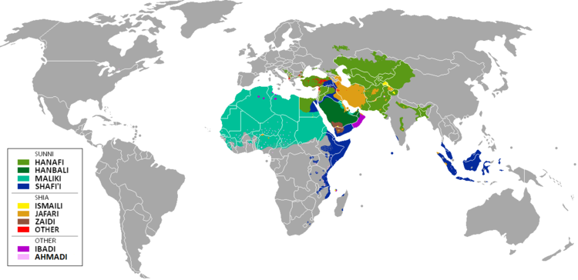
Questions
- Who was appointed after Muhammad’s (PBUH) death?
………………………………………………………………………………………………………………………...
………………………………………………………………………………………………………………………...
- Where does Sunni authority come from?
………………………………………………………………………………………………………………………...
………………………………………………………………………………………………………………………...
- Where does ‘Sunnah’ come from and what does it mean?
………………………………………………………………………………………………………………………...
………………………………………………………………………………………………………………………...
- What percentage of all Muslims are Sunni?
………………………………………………………………………………………………………………………...
………………………………………………………………………………………………………………………...
- What is the second largest branch of Islam?
………………………………………………………………………………………………………………………...
………………………………………………………………………………………………………………………...
- What do Shi’a Muslims believe?
………………………………………………………………………………………………………………………...
………………………………………………………………………………………………………………………...
- How many main groupings is modern Shi’a Islam?
………………………………………………………………………………………………………………………...
………………………………………………………………………………………………………………………...
- What evidence is there of conflict between Sunni and Shi’a Muslims?
………………………………………………………………………………………………………………………...
………………………………………………………………………………………………………………………...

The Six Articles of Faith in Sunni Islam
The Oneness of Allah is the concept of tawhid meaning ‘oneness, absolute, alone. Surah 112:1-4 says: “He is Allah, the One, Allah is Eternal and Absolute. None is born of Him, He is unborn. There is none like unto Him.”
This means that Allah is the creator and sustainer of life. He is beyond any human limitations like age and death because He was not born and cannot die. He has no partners or children and nothing is like him.
Angels do the work of Allah. They deliver revelations via the prophets so that Muslims know what Allah wants them to do. They record the words and actions of each individual person so that they have a book to account for their lives. They receive souls at death. Angels do not have free will like humans and they obey Allah’s commands.
Five sources of authority are the books: the Torah of Moses; the Psalms of David; the Gospels; the Scrolls of Abraham; the Qur’an. According to Muslims, the first four books have been lost in their original form or changes. The Qur’an is the only revealed scripture still in its original form. It is the direct Word of Allah as given through Angel Jibril.
Muslims believe in the supremacy of Allah’s will. Sunni believe that Allah known everything. ‘Qadr’ means everything is ordered by Allah; nothing is random or by chance. Humans do have free will though, but as Allah knows the past, present and future their choices are already known to Him, but not to them.
Muslims believe that there will be a day (the Day of Judgement) when all Muslims and others stand alone in front of Allah, who decides whether they go to heaven or hell based on their deeds. Everyone must answer for themselves and must accept the consequences of their thoughts and actions on earth. Human life acts as a test for the eternal life to come.
Prophets and messengers are chosen by Allah to deliver His message to humankind. Muslims believe that Allah has revealed messages throughout time to guide humanity and that Prophet Muhammad (PHUH) was the last (Seal) of the prophets; he was given the ultimate guidance in the Qur’an. As a result of this, there is no need for any more prophets. “Muhammad (PBUH) is not the father of any of your men, but the messenger of Allah and the Seal of the Prophets.” (Qur’an 33:40)

Questions
- What is ‘tawhid’?
………………………………………………………………………………………………………………………...
………………………………………………………………………………………………………………………...
- What is the purpose of angels?
………………………………………………………………………………………………………………………...
………………………………………………………………………………………………………………………...
- What are the five sources of authority?
………………………………………………………………………………………………………………………...
………………………………………………………………………………………………………………………...
- Which scripture is still in its original form?
………………………………………………………………………………………………………………………...
………………………………………………………………………………………………………………………...
- What is ‘Qadr’?
………………………………………………………………………………………………………………………...
………………………………………………………………………………………………………………………...
- What is the belief in the Day of Judgement?
………………………………………………………………………………………………………………………...
………………………………………………………………………………………………………………………...
- According to Muslims, what is human life?
………………………………………………………………………………………………………………………...
………………………………………………………………………………………………………………………...
- What is the purpose of prophets and messengers?
………………………………………………………………………………………………………………………...
………………………………………………………………………………………………………………………...

Why are the six articles important?
These six articles underpin religious life for Muslims. They influence all aspect of life. If Muslims believe in the absolute power of Allah, then they will live their lives according to His will. The angels are writing up all thoughts and actions, and people will have to justify them, do this makes Muslims think about how they approach life and the people around them. This shows that life here is a test for the afterlife and dew have a guaranteed place in paradise because it has to be earned.
To know what is the right thing to do, Muslims have the teachings of the prophets, along with the examples of the lives of the prophets, such as Muhammad (PBUH) and Ibrahim, and the ultimate guide in the Qur’an. If they are to live according to how Allah wants, then paradise is on offer to them. Muslims know that they can easily follow the wrong path and that they have to make the right choices with the free will they have been given. Allah knows our actions before we even think about what we do.

Question:
Explain in detail the importance of the Six Articles of Faith in Islam.
………………………………………………………………………………………………………………………...
………………………………………………………………………………………………………………………...
………………………………………………………………………………………………………………………...
………………………………………………………………………………………………………………………...
………………………………………………………………………………………………………………………...
………………………………………………………………………………………………………………………...
………………………………………………………………………………………………………………………...
………………………………………………………………………………………………………………………...

The Five Roots of Usul ad-Din in Shi’a Islam
Usual as-Din means ‘the foundations of the faith’. These are the principles underpinning Shi’a belief, and from them come the Ten Obligatory Acts. The Twelver Shi’a (the largest group within Shi’a Islam) who follow this, are encouraged to be able to explain them; what they mean, why they are the five key roots to belief and to understand how they link to their own religious practice in all its elements. Of the five roots, tawhid, prophethood and resurrection are key to all Muslim belief. To be a Muslim means to accept them completely and without question. If a Muslim rejects the other two (imamate and justice) – then they are still Muslim, just not a Shi’a Muslim.
Tawhid – ‘oneness’
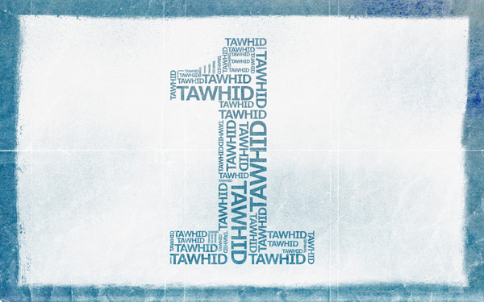
This means the same as in Sunni beliefs, that Allah is One. Allah is the Almighty and unique in his Oneness. Shi’a use Qur’an Surah 112 to explain why they believe Allah is One. Allah cannot be associated with anything as ‘none is like Him’; to do so is to commit the greatest sin, called ‘shirk’. This means ‘association’ in Arabic and therefore nothing can be compared to Allah. Allah is the creator of all, pre-existent, beyond time and space and beyond all human understanding.
Justice of Allah – Adalat
Alla is ‘The Just’ and ‘The Wise’ which means He does no wrong. The Shi’a believe they need to be aware there is good and evil in everything, but that Allah commands them to do good. Surah 16.19 says, “Indeed Allah commands them to do justice.” Humans will be held responsible for their actions, good and bad. Allah acts with a purpose that humans cannot understand. Sometimes justice can be hard to see but the Shi’a should try to understand as much as they can.
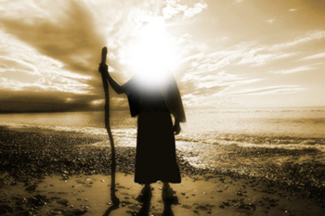
Nubuwwah – Prophethood
Shi’as believe that Allah sent messengers to guide people to the right path and Prophet Muhammad (PBUH) was the last of them. The ‘right path’ means a peaceful way of life, lived in total submission to Allah. Prophets deliver the messages to spread the religion. The imam protects the messages so that people do not forget and leave the faith in the absence of prophets.
Al-Ma’ad – Resurrection
The Shi’a believe that there will be a Day of Judgement (Yawm al-Qiyyamah). Every Muslim and non-Muslim will be judged by Allah. Humans will be physically resurrected to stand to be judged and they will be asked to account for the words and actions of their lives on earth. The events of this day are described in both the Qur’an and Hadith.
Imamate – Leadership
Some believe that Prophet Muhammad (PBUH) aid that twelve imams from his own tribe (the Quraysh) would succeed him as leaders. Shi’as believe that the first eleven led the community, some were killed, but that the twelfth disappeared after his father’s death. This imam will appear again when Allah decides at the end of time. Currently he is alive and in hiding. All imams are seen as infallible (can do no wrong) and must be obeyed. They are protectors of the faith, ensuring that the teachings so not become corrupted or spoiled.
How the five roots influence a Muslim’s life:
- Belief in Allah as One governs a Muslim’s life
- Following Allah’s path means doing the right thing
- Prophethood means that a Muslim is not alone in life. Guidance is there throughout history and in the present in the Qur’an.
- The imamate is important to Muslims as without the prophets, we need leaders as we might go off track when living in the modern world
- They know that the Day of Judgement will happen – they cannot hide from Allah and so need to do the best they can in terms of intentions. This life is short in comparison to the next.
- Belief in justice means that Muslims have faith that Allah always has a purpose and his actions are based on wisdom.

Questions
- What does ‘Usul as-Din’ mean?
………………………………………………………………………………………………………………………...
………………………………………………………………………………………………………………………...
- What is ‘Tawhid’?
………………………………………………………………………………………………………………………...
………………………………………………………………………………………………………………………...
- What is ‘Adalat’?
………………………………………………………………………………………………………………………...
………………………………………………………………………………………………………………………...
- What is ‘Nubuwwah’?
………………………………………………………………………………………………………………………...
………………………………………………………………………………………………………………………...
- What do Muslims believe about resurrection?
………………………………………………………………………………………………………………………...
………………………………………………………………………………………………………………………...
- What do Muslims believe about leadership?
………………………………………………………………………………………………………………………...
………………………………………………………………………………………………………………………...
- Explain how the five roots influence a Muslim’s life.
………………………………………………………………………………………………………………………...
………………………………………………………………………………………………………………………...
………………………………………………………………………………………………………………………...
………………………………………………………………………………………………………………………...
………………………………………………………………………………………………………………………...

The Nature of Allah – Oneness and Omnipotence
Oneness (tawhid)
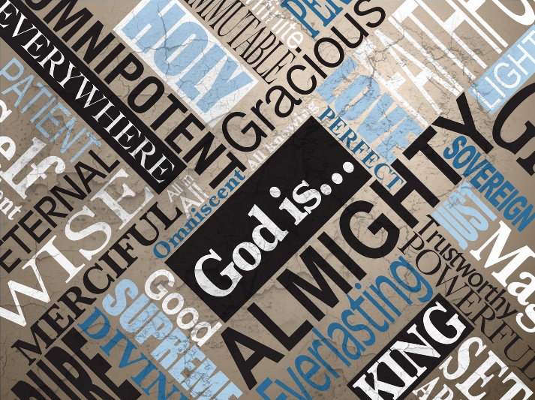
Muslims believe that Allah is One God, indivisible and absolute; nothing comes close to Him as the ultimate source of power and creation. He is totally supreme. There is nothing that can be likened to Him. He is beyond understanding. Everything belongs to Allah; everything humans have is on loan from Allah. Humans only exist because Allah wills them to. Muslims are what Allah makes them. They believe any talents come from Allah, so it is wrong to be arrogant. Nothing happens without Allah allowing it. Allah has absolute compassion, so even suffering is Allah’s will and for a reason. Muslims should not question this and should never forget His power. Humans cannot obstruct Allah or indeed try to fool Allah as He knows their every thought and intention. Anything that goes against these beliefs breaks tawhid.
If Muslims liken themselves to Allah or to His qualities, then they commit the sin of shirk. For example, Muslims believe that Jesus could not have been the Son of God, as he could not have had God’s qualities (which also means that there is no Holy Trinity). The Christian belief in the Trinity divides Christianity and Islam in the modern world.
Many positives can come from belief in tawhid. Having total faith, humility and modesty should mean a Muslim cannot be jealous of what does not belong to them. They can trust in Allah and know everything happens for a reason. If they dedicate themselves to Him, they will be courageous and determined in their lives to please Him.
Omnipotent
Allah is Al-Qadeer (all-powerful). The idea that ‘He is able to do all things’ ensures a Muslim’s submission to Him. Humankind will always need Him and there is a reason for everything that happens. Muslims can be secure in knowing that Allah knowns what is happening in the world. He sees their every action and knows their innermost thoughts and desires and He hears when they call Him. There are hidden blessings to everything that happens.

Questions
- Give five things that Muslims believe about God/Allah:
………………………………………………………………………………………………………………………...
………………………………………………………………………………………………………………………...
………………………………………………………………………………………………………………………...
………………………………………………………………………………………………………………………...
………………………………………………………………………………………………………………………...
- What should Muslims not question?
………………………………………………………………………………………………………………………...
………………………………………………………………………………………………………………………...
- What is the sin of shirk?
………………………………………………………………………………………………………………………...
………………………………………………………………………………………………………………………...
- What is a positive of believing in tawhid?
………………………………………………………………………………………………………………………...
………………………………………………………………………………………………………………………...
- What is the idea that Allah is all-powerful?
………………………………………………………………………………………………………………………...
………………………………………………………………………………………………………………………...
- What can Muslims be secure in the knowledge of?
………………………………………………………………………………………………………………………...
………………………………………………………………………………………………………………………...
- What does Allah see?
………………………………………………………………………………………………………………………...
………………………………………………………………………………………………………………………...

The Nature of Allah – Immanence and Transcendence
Immanence
“We are closer to human than his jugular vein” (50:16)
“And He is with you wherever you may be.” (57:4)
These quotes from the Qur’an show Allah is vital to human existence. If the jugular vein is cut, humans die, so trying to live without Allah is worse than death.
Allah knows humans so well that, for example, He knows what someone will say even before they say it.
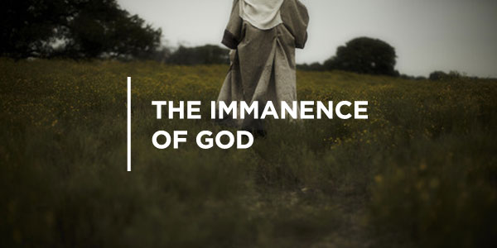
Muslims believe Allah must be in this world to help and guide, to give people the purpose and ability to live this life. This is what immanence means; that Allah is very active in the world.

Transcendence
“No vision can grasp Him…He is above all comprehension.” (6:103)
“Nothing there is like him.” (42:11)
He is outside this world, outside everything that He created. Allah is outside time, whereas humans are subject to time. Allah has no beginning or end, so He cannot be part of time. Allah is beyond human understanding, limitless and therefore He is not part of this world. Transcendence is being separate to the world, beyond it, which allows Allah to control and act in the world, but not be affected by it.
The Nature of Allah – Beneficence and Mercy
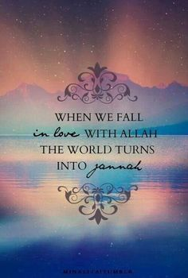
In Islam, Allah is known as the Beneficent (Al-Rahman) and the Merciful (Al-Rahim), so Allah is kind, compassionate and forgiving. Allah shows these by being just and fair.
In the Qur’an, Allah is referred to 57 times as Beneficent and over 160 times as the Merciful. In daily prayer the names are recited seventeen times. So how is Allah beneficent and merciful in a world full of suffering and evil?
- He sent prophets as guides to the right path, so He is compassionate and humans have free will to follow His path
- The mercy of Allah is reflected in the rules within the Qur’an
- Making mistakes is part of being human, but Allah always forgives those who repent. Out of mercy Allah forgives and even repeated sin is forgiven. Muslims have the chance to make up for bad deeds.
- Allah’s mercy allows humans to exist, to live, to love and to care. Muslims are never alone. Allah’s compassion surrounds them and mercy helps them deal with being humans.
- Suffering clearly exists, but it is a test of faith to see how humans respond even where it seems beyond comprehension.
- Humans should focus on the good (charity, loving kindness, family, togetherness, selflessness) of which there is much. They should not think only of the bad, for example, war, crime, poverty, disease.

Questions
- What is ‘immanence’?
………………………………………………………………………………………………………………………...
………………………………………………………………………………………………………………………...
- Give a quote to support the view that Allah is immanent.
………………………………………………………………………………………………………………………...
………………………………………………………………………………………………………………………...
- What is ‘transcendent’?
………………………………………………………………………………………………………………………...
………………………………………………………………………………………………………………………...
- Give a quote to support the view that Allah is transcendent.
………………………………………………………………………………………………………………………...
………………………………………………………………………………………………………………………...
- How many times is Allah referred to as being ‘Beneficent’?
………………………………………………………………………………………………………………………...
………………………………………………………………………………………………………………………...
- Give three examples of Allah’s beneficence:
………………………………………………………………………………………………………………………...
………………………………………………………………………………………………………………………...
………………………………………………………………………………………………………………………...
………………………………………………………………………………………………………………………...
………………………………………………………………………………………………………………………...
………………………………………………………………………………………………………………………...
………………………………………………………………………………………………………………………...
………………………………………………………………………………………………………………………...

The Nature of Allah – Fairness and Justice
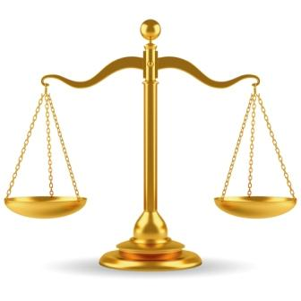
Justice (Adalat) means fairness, that is, to do what is right. Allah is absolute, so always does what is right. Muslims must accept this and try to act in a fair way to others. Humans cannot always see justice being served, because they are incapable of fully understanding how Allah acts. Allah is just in His creation, in His laws and in all His actions. Allah created all things perfectly through His true wisdom. Allah rewards a good act with a good act and an evil act with consequences. Allah’s divine justice rules the universe.
Humans are commanded to be just and fair in their actions: “Be steadfast witnesses for Allah in equity and let not hatred of any people seduce you that you deal not justly” (Surah 5:8) and also, “We have made you a moderate nation.” (Surah 2:143) The Five Pillars are all just to help in life.
This belief should influence Muslims in their lives to never be extreme, to deal with people in the right way, to be fair to others and to do good deeds. So a Muslims must never be too angry or too calm, too courageous or too weak, too clever or too foolish. All Muslims should strive to live their lives in a balanced way. Extreme actions cannot be justified.
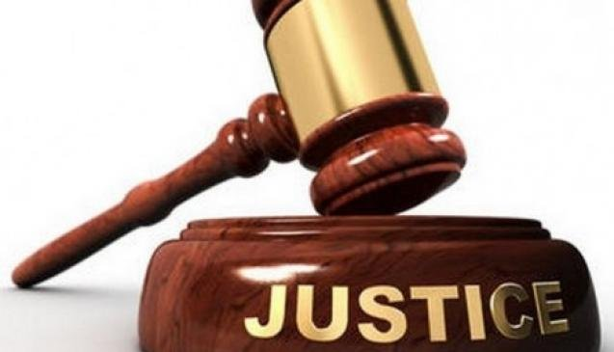
Shi’s Muslims believe that the justice of Allah is absolute. Everything belongs to Allah, so humans can never lose anything. Humans only have things by the grace of Allah. Allah punishes humans for any bad deed. Any situation which seems negative is actually for our own good as Allah would never be cruel or carry out injustice. At least 40 verses of the Qur’an discuss the justice of Allah and on the Day of Judgement, each individual will face justice for their own actions.

Questions
- What is ‘adalat’?
………………………………………………………………………………………………………………………...
………………………………………………………………………………………………………………………...
- How must Muslims act?
………………………………………………………………………………………………………………………...
………………………………………………………………………………………………………………………...
- What does Allah reward good acts with?
………………………………………………………………………………………………………………………...
………………………………………………………………………………………………………………………...
- What are humans commanded to be fair and just in?
………………………………………………………………………………………………………………………...
………………………………………………………………………………………………………………………...
- How must a Muslim strive to live their life?
………………………………………………………………………………………………………………………...
………………………………………………………………………………………………………………………...
- What do Shi’a Muslims believe about Allah’s justice?
………………………………………………………………………………………………………………………...
………………………………………………………………………………………………………………………...
- What does Allah do to humans for bad deeds?
………………………………………………………………………………………………………………………...
………………………………………………………………………………………………………………………...
- How many verses in the Qur’an discuss the justice of Allah?
………………………………………………………………………………………………………………………...
………………………………………………………………………………………………………………………...

How does the nature of Allah influence Muslims today?
Muslims:
- Will try to be as good a Muslim as they can
- Believe that talents were given by Allah in his beneficence
- know that it is up to them to make the most of their chances
- Know that Allah is always with them (immanent) and that they cannot succeed without Him
- Believe that struggling is a test of determination
- Believe that Allah only acts in a way that is best for the person
- Accept that they cannot know Allah’s plan
- Will help others who are suffering. This is Allah working through them
- Believe that evil people will suffer the consequences of their actions
- May spend their time helping and educating Muslims who could be vulnerable to extreme action or the lies of others
- Want to make the world a better, calm, peaceful place
- Believe that extremism never works as it is not Allah’s plan

Explain in detail how the nature of Allah influences Muslims today.
………………………………………………………………………………………………………………………...
………………………………………………………………………………………………………………………...
………………………………………………………………………………………………………………………...
………………………………………………………………………………………………………………………...
………………………………………………………………………………………………………………………...
………………………………………………………………………………………………………………………...
………………………………………………………………………………………………………………………...
Authority – the Concept of Risalah
What is risalah?
Risalah flows through the whole of life. Humans are born, go through the stages of life listening to Allah’s guidance from the prophets and reading the holy books and finally die to be resurrected in the afterlife to paradise.
Muslims believe that Allah is the ultimate creator of the world, but why did He create this world? The Qur’an tells us that Allah told the angels that He was going to put man on earth. The angels questioned this, as they believed that man would simply cause chaos. Allah told them that He knew best and asked them to bow down before Adam. All the angels obeyed except Azazil, believing he was better than Adam. Allah then sent Azazil, now named Iblis, to earth to test humanity. What was He testing though? Human action? How can humans be tested without knowing the rules? Allah had a duty to give people a code to live by. If it is a duty to love, serve and submit to Allah, then humans have to know how to achieve this to be reunited with Allah at death. Allah is just, so it must be the case that He has revealed what He wants from humans.
Adam was the first prophet appointed by Allah. Prophets are guided in the truth and understand it. Their love of Allah prevents them from sinning. They deliver the messages Allah sends as guidance. Muslims believe that there were 124,000 prophets who developed the religion over time. Some prophets are also messengers ‘rasul’ (given divine revelation to deliver everywhere), whilst others as ‘nabi’ (given revelation of news of an important nature, immediately concerning themselves with their communities).

Muhammad (PBUH), the last of the prophets, known as ‘The Seal’. Muslims believe that over time previous messages had become lost or changed. Judaism and Christianity contain some truths, but they are not the original messages. Allah then decided to call Muhammad (PBUH) and gave him revelations which became the Qur’an. Being written down they could not be changed so not more prophets would be needed. The Qur’an is the direct Word of Allah, containing everything humankind needs to do to pass the test for the next life.
Angels have no physical form. They are messengers of Allah. They are known as bodies of light, which are in constant contact with the world. They are there when we pray. Angels have been seen by specifically chosen individuals in human form, for example, Angel Jibril to Muhammad (PBUH), but they are not human. Muslims believe that we all have two guardian angels who record our actions, which is why they turn to the left and right at the end of daily prayers as if to greet the angels on both shoulders.
Throughout time there have been books to guide Muslims in the right way. Holy books include the Suhuf of Ibrahim, Tawrat of Musa, Zabur of Dawud (David) and Injil or the Gospels of Jesus. Muslims believe that these books contain some true guidance but have been altered and are incomplete. The Qur’an is the directly dictated Word of Allah in its original form; it is absolute.
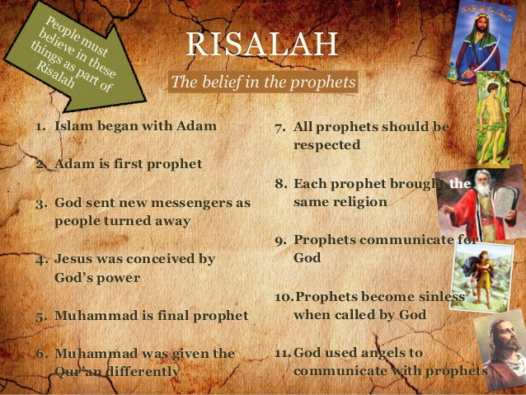

Questions
- What does risalah flow through?
………………………………………………………………………………………………………………………...
- What did the angels question?
………………………………………………………………………………………………………………………...
- What was Azazil (Iblis) sent to do?
………………………………………………………………………………………………………………………...
- Who was the first prophet?
………………………………………………………………………………………………………………………...
- How many prophets are there in total?
………………………………………………………………………………………………………………………...
- What are ‘rasul’?
………………………………………………………………………………………………………………………...
- What are ‘nabi’?
………………………………………………………………………………………………………………………...
- Who is known as ‘The Seal’?
………………………………………………………………………………………………………………………...
- What did writing down the Qur’an mean?
………………………………………………………………………………………………………………………...
- What are angels known as?
………………………………………………………………………………………………………………………...
- What is the role of our guardian angels?
………………………………………………………………………………………………………………………...
- What are the Muslim holy books?
………………………………………………………………………………………………………………………...

Prophet Adam
“I indeed am going to set a vicegerent (earthly representative of Allah) on the earth” (Qur’an 2:30)
“…I am going to create a human out of clay…so when I have made him, and breathed life into him…” (Qur’an 38: 71-72)
The angels collected soil, red, white, brown and block, smooth and gritty, soft and hard. It came from mountains and valleys, from dry deserts and green fertile lands.
Allah honoured Adam. He blew light into his soul. He ordered his angels to bow down before Adam as a sign of respect and honour. His descendants were to be as diverse as the clay he was created from.
So what do we know about Adam?
Everything was created for Adam and his descendants so to be able to worship and know Allah. Adam was to be the caretaker of the Earth. Adam was taught everything by Allah, given the ability to identify and give names, language and the ability to communicate. Allah gave him a thirst for learning, the ability to reason, evaluate and make choices.
To prevent loneliness, Adam was given Hawwa (Eve), a woman for company. Allah told Adam and Hawwa to enjoy all the things made for them, but not to eat from one tree. Iblis (a jinn, or supernatural creature) managed to tempt them to taste the fruit, hence disobeying Allah. They also became aware of their nakedness and covered themselves. As punishment, Allah banished them to Earth, but He forgave them because they asked for mercy. They became ordinary people living on Earth instead of in the Garden of Bliss (Eden). On Earth, Allah sent guidance to Adam, so he could teach people about Allah.
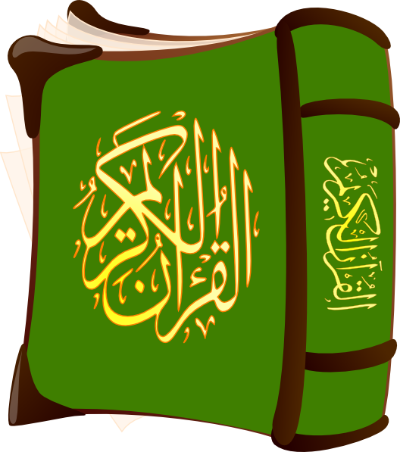
Adam and Hawaa had many children, the most famous being Qabeel (Cain) and Habeel (Abel). The brothers continued the evil side of humankind when Qabeel killed Habeel, fulfilling the prophecy in the Qur’an. When Adam died, he named his son Seth as successor but over time his descendants spilt up and moved apart.
Why is Adam important in Islam?
- He is the father of all humankind
- He was a prophet until his death
- He taught the revelations to his sons
- He taught about the work of Iblis and how to protect themselves from jinn
- He taught life on earth was temporary, eternal life was in the next life
- He built the Ka’aba as the first place of worship, with the help of the angels after he was sent to earth
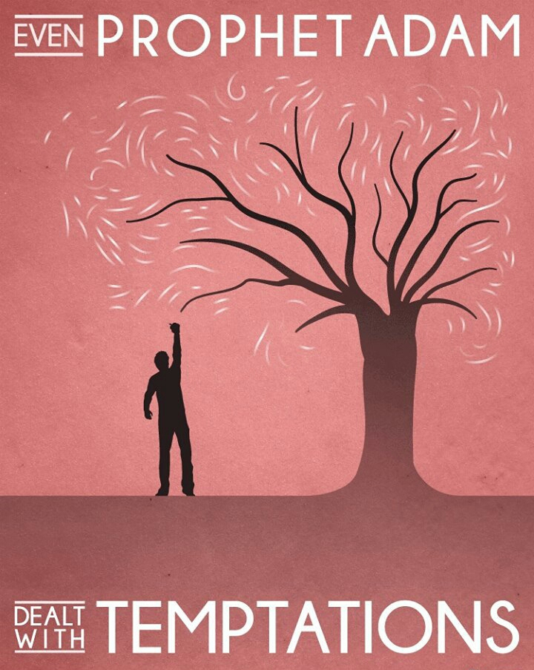
What can Muslims learn from Adam?
Iblis and Adam disobeyed Allah. However, Adam repented his sins straight away and regretted it all his life, so finding salvation. He openly criticised himself for falling into Iblis’ trap but he hopes he could make amends and receive Allah’s mercy. Iblis did not show repentance or regret. He lost all hope and was forever tormented.
Questions
- How was Adam made?
………………………………………………………………………………………………………………………...
- How did Allah treat Adam?
………………………………………………………………………………………………………………………...
- What were Adam’s descendants to be as diverse as?
………………………………………………………………………………………………………………………...
- What was Adam to be on the earth?
………………………………………………………………………………………………………………………...
- What did Allah give Adam a thirst for?
………………………………………………………………………………………………………………………...
- What did Allah do to prevent Adam from becoming lonely?
………………………………………………………………………………………………………………………...
- What sort of creature was Iblis?
………………………………………………………………………………………………………………………...
- What did Iblis tempt Adam and Hawwa to do?
………………………………………………………………………………………………………………………...
- Explain why Adam is important in Islam.
………………………………………………………………………………………………………………………...
………………………………………………………………………………………………………………………...
………………………………………………………………………………………………………………………...
………………………………………………………………………………………………………………………...
- What can Muslims learn from Adam?
………………………………………………………………………………………………………………………...
………………………………………………………………………………………………………………………...
………………………………………………………………………………………………………………………...
Prophet Ibrahim
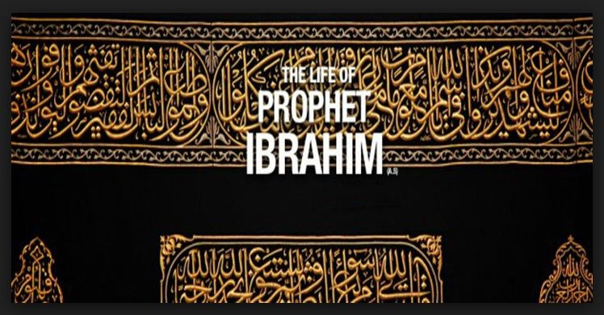
Ibrahim lived in Ur in Mesopotamia about 1900 BCE. He sold small statues (idol gods) for his father, Azar, who was a sculptor. One day, he decided to test the power of the idols. He threw them into the river to show they did not have any power to save themselves – they sank, proving his point. He realised that there was no power in these statues. He began to search for the truth, and looking at the sun, moon and stars, but became convinced that there was just one true power: a single One God. Allah called him to be a prophet and Ibrahim submitted to Him. “For me, I have set my face towards the One who created the skies and the earth. I will never make partners with Allah” (Qur’an 6:79). He then tried to convert his father and save him, but his father threatened to kill him and sent him away.
Ibrahim preached in public but people did not listen. They ridiculed him. He went into their temples and destroyed all the idols except one. The people were angry and questioned him. Ibrahim told them to ask the remaining idol for answers, which of course did not answer. Ibrahim asked them why they worshipped useless idols. Furious, the people shouted for him to be burned. A fire was built and Ibrahim was chained up and then catapulted into it. An angel spoke to him in the fire asking what he wanted most, but Ibrahim said he only wanted to please Allah. As a result, Allah commanded the fire to be cool. People were amazed: the chains were burned but Ibrahim was untouched. Ibrahim continued to receive revelations and wrote them on scrolls called the Suhuf. People including his nephew, Lut, began to follow him. After a disagreement with Minrud, the King of Ur, Ibrahim realised that he would have to leave. With his family, he set off to the Promised Land (Qur’an 21:71). On the journey, quarrels led the group to split. Lut went to the plains east of the Dead Sea and Ibrahim carried on to the Promised Land.
Ibrahim married Sarah and later took on Hajar as a second wife because Sarah was barren. Hajar had a son, Ismail, whom Ibrahim loved greatly. He dreamt he was told to sacrifice Ismail, and when he told Ismail of the dream, both agreed to do what Allah had commanded. As both were willing, the test was passed and a ram was sacrificed instead. Clearly, Ibrahim was willing to give up everything for Allah. Allah then granted Sarah with a son, Ishaq. It has been said that Hajar and Sarah were jealous of each other, so Hajar and Ismail left to live elsewhere. They were on their own, but they never gave up hope and when they ran out of water, Allah gave them a well, which Hajar names Zamzam. In thanks to Allah for the lives on his families, Ibrahim built (or rebuilt) the Ka’aba with Ismail.
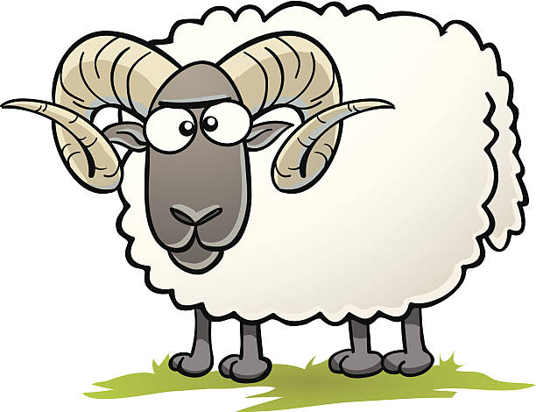
Later, Ismail took his father’s place as a prophet and led the first community in the valley of Makkah.
Questions
- How did Ibrahim prove the statues had no power?
………………………………………………………………………………………………………………………...
- What did Ibrahim become convinced of?
………………………………………………………………………………………………………………………...
- What did Ibrahim destroy that angered people?
………………………………………………………………………………………………………………………...
- What did the angel ask Ibrahim in the fire?
………………………………………………………………………………………………………………………...
- What did Ibrahim say he wanted?
………………………………………………………………………………………………………………………...
- What was the miracle of the fire?
………………………………………………………………………………………………………………………...
………………………………………………………………………………………………………………………...
………………………………………………………………………………………………………………………...
- What is the Suhuf?
………………………………………………………………………………………………………………………...
- What was Ibrahim’s dream?
………………………………………………………………………………………………………………………...
- Why did Ibrahim pass the test?
………………………………………………………………………………………………………………………...
- What was the miracle of the well?
………………………………………………………………………………………………………………………...
………………………………………………………………………………………………………………………...
………………………………………………………………………………………………………………………...

Prophet Muhammad (PBUH)
Why Muhammad (PBUH) was chosen to be the Prophet of Allah
Muhammad (PBUH) is important for Islam at the time and Islam today. In 610CE, at the age of 40, Muhammad (PBUH), was called to serve Allah. Why Muhammad (PBUH) though, and why at this point? Muhammad (PBUH) had a tough life, he never knew his father because he had died before Muhammad (PBUH) was born. He became an orphan at age 6 when his mother died, and he had to grow up very quickly, earning his keep by looking after his grandfather’s sheep and then working as a merchant for his uncle Abu Talib. Many boys might have struggled with this. For Muhammad (PBUH), it made him stronger, developing characteristics in him such as responsibility, determination, patience, courage, honesty, trustworthiness and self-discipline. By age 40, he was married to Khadijah, had children, had his own successful business and was highly respected in the community.
This was all part of Allah’s plan; Muhammad’s (PBUH) role would now be as Prophet to deliver a message that was never going to be changed or corrupted. Prophet Muhammad (PBUH) had the task of converting the people of Makkah and beyond to the ways of One God and laying down the basic structures for a religion.
What did Muhammad (PBUH) do as a prophet?
The conversion of Makkah was not straightforward, and Muhammad (PBUH) had to escape to Madinah (the Hijrah) after his religious message was rejected and his life came under threat. In Madinah, he became the rules of the city both spiritually and politically. This was the first Islamic community to be set up. He later did fulfil his task of converting the people of Makkah to Islam.
The call of Muhammad (PBUH) to Prophethood
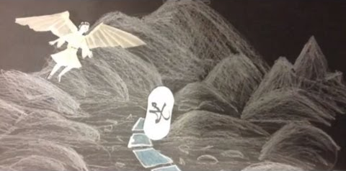
Muhammad (PBUH) was a wealthy merchant, but was disillusioned with life in Makkah; people behaved in an immoral way, cheated people out of money, gambled, prostitution was rife and idol worship was the normal thing. Muhammad (PBUH) began to spend time along outside the city, meditating in a cave to find peace of mind and the right path to follow. Most scholars agree on the account that on Allah’s command, Angel Jibril appeared beside Muhammad (PBUH) commanding him to ‘Recite!’ Muhammad (PBUH) said he could not read. The Angel squeezed him tight three times before he said the words. When the angel left, Muhammad (PBUH) left the cave, trembling from what had happened. He returned to Khadijah to tell her the story. (In the Shi’a tradition they believe that Muhammad (PBUH) was not terrified and they he was in fact expecting it). After reassurances from Khadijah and her Christian cousin, three years passed with Muhammad (PBUH) spending more time in meditation and spiritual contemplation. The revelations continued. Allah commanded him to preach to close family friends and then the people of Makkah about Islam and One God.
Why was it important for Muhammad’s Prophethood to happen at that point?
- It was all part of Allah’s plan for it to happen
- People were becoming more distanced from the ways of Allah, earlier revelations were being ignored; Makkah was become a centre for idol worship as it grew as a trade centre
- Previous holy books had been lost or changed
- The religion now needed structure in its organisation in the same way that Judaism and Christianity had
- Muhammad (PBUH) was a role model that people could follow and tryst in. it is said he stood for the truth when truth was lost, was gracious to those who persecuted him, always compassionate and respectful, was concerned with the welfare of others (human or animal), loved children, taught equality, lived humbly and was the model husband, father and friend.

Questions
- What happened in Muhammad’s (PBUH) early life?
………………………………………………………………………………………………………………………...
………………………………………………………………………………………………………………………...
………………………………………………………………………………………………………………………...
………………………………………………………………………………………………………………………...
………………………………………………………………………………………………………………………...
- What was Muhammad’s (PBUH) task?
………………………………………………………………………………………………………………………...
- What did Muhammad (PBUH) do as a prophet?
………………………………………………………………………………………………………………………...
………………………………………………………………………………………………………………………...
………………………………………………………………………………………………………………………...
………………………………………………………………………………………………………………………...
- How were people acting immorally in Makah?
………………………………………………………………………………………………………………………...
- How did Muhammad (PBUH) learn to read?
………………………………………………………………………………………………………………………...
………………………………………………………………………………………………………………………...
………………………………………………………………………………………………………………………...
………………………………………………………………………………………………………………………...
- What did Allah command Muhammad (PBUH) to di?
………………………………………………………………………………………………………………………...
- Explain why it was important for Muhammad’s prophethood to happen.
………………………………………………………………………………………………………………………...
………………………………………………………………………………………………………………………...
………………………………………………………………………………………………………………………...
………………………………………………………………………………………………………………………...
………………………………………………………………………………………………………………………...
………………………………………………………………………………………………………………………...
………………………………………………………………………………………………………………………...
………………………………………………………………………………………………………………………...
Muhammad’s (PBUH) Sunnah and Hadith
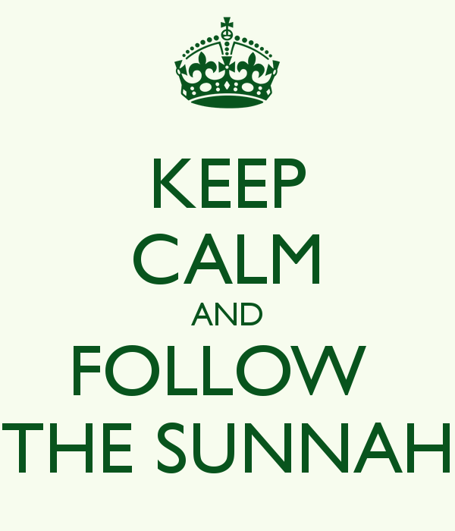
The second most important source of authority for Muslims is the Sunnah. The Sunnah are the practices, customs and traditions of Prophet Muhammad (PBUH). These give the perfect example for Muslims to follow. They are found in the Hadith (sayings of the prophet) and other texts. Different groups of Muslims accept different collections of Hadith as reliable sources of authority. Reading the Hadiths helps Muslims learn how Muhammad (PBUH) explained the teachings from the Qur’an. The language and style of the Qur’an do not lend themselves to easy interpretation, so Hadiths are helpful. The Shi’a, in addition to using the Hadith narrated by Muhammad (PBUH), also refer to the teachings of the ‘Imams’. Sunni Muslims believe that the Hadith are important because the Qur’an says: “A similar (favour you have already received) in that We have sent among you a Messenger of your own…and instructing you in Scripture and Wisdom, and in new knowledge.” (2:151)
Also:
“You have in the Messenger of Allah a beautiful pattern for anyone whose hope is in Allah and the Final Day.” (33:21)
The role of Muhammad (PBUH) was to teach and live by the Qur’an so that humankind could understand it and live by it. Muhammad (PBUH) should never be worshipped (as Jesus is by Christians, for example.)
What does the Sunnah tell Muslims?
The Sunnah covers many areas of life, including:
- Sunnah for marriage
- Sunnah for rituals for the birth of children
- Sunnah towards animals
- Sunnah to have good sense of humour
- Sunnah for helping the poor and needy
- Sunnah to always remember Allah
The Sunnah is the guideline for Muslim life and there is a Sunnah for everything.
Questions
- What are the Sunnah?
………………………………………………………………………………………………………………………...
- Where are the Sunnah found?
………………………………………………………………………………………………………………………...
- What does reading the Hadiths help Muslims to do?
………………………………………………………………………………………………………………………...
- Why do Muslims believe that the Hadith are important?
………………………………………………………………………………………………………………………...
………………………………………………………………………………………………………………………...
………………………………………………………………………………………………………………………...
………………………………………………………………………………………………………………………...
………………………………………………………………………………………………………………………...
………………………………………………………………………………………………………………………...

- What does the Sunnah tell Muslims?
………………………………………………………………………………………………………………………...
………………………………………………………………………………………………………………………...
………………………………………………………………………………………………………………………...
………………………………………………………………………………………………………………………...
………………………………………………………………………………………………………………………...
………………………………………………………………………………………………………………………...
………………………………………………………………………………………………………………………...

What impact does Prophet Muhammad (PBUH) have on Muslims today?
Muhammad (PBUH) the individual
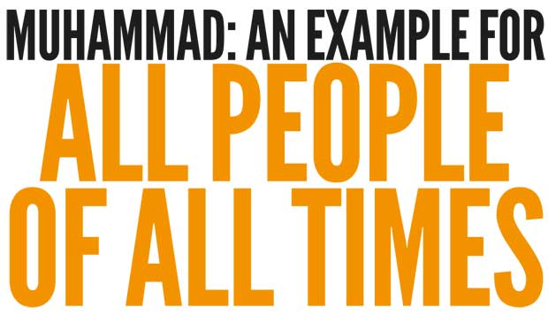
Muslims believe he is the perfect example of a man serving Allah without question. Firstly, that he was a man without godlike qualities, means there is no reason why they themselves cannot aim to live as good a life as Muhammad (PBUH) did. He did not have it easy; he had to be determined to succeed all his life. He had to have patience in his Prophethood before it brought results. He rejected the immorality he saw around him. He always focused on Allah. He was humble, modest, caring, prayed and knew Allah would help when difficult times arose. He is the best example to follow for all those reasons. He was a better human being because of his sense of morality, of duty and his belief in the importance of his community. Regardless of a person’s position in society, Muslims believe everyone could learn from him, then and now.
Muhammad (PBUH) the leader
Muslims claim that Muhammad (PHUB) was the greatest political and religious leader of all time, managing to combine the two roles perfectly. He set up a community where individuals were respected. He allowed religious freedom, gave women rights, looked after the elderly and sick, welcomed strangers and created rules which allowed the best possible outcomes for everyone. He had charisma as a leader so that people followed him in religion, in ordinary life and militarily. Ten thousand men went into battle for him in Makkah. The Islamic Empire spread from southern Europe to northern Africa and across Asia, in his name and the name of Islam. Today, 13 centuries later, 1.3 billion Muslim followers repeat his name daily and many people study his life worldwide.
Muhammad (PBUH) the family man
Muhammad (PBUH) was the ultimate family man, carrying on from other prophets. In the Qur’an there is a theme of good fathers: Adam, Noah, Lut, Jacob, Ibrahim and them Muhammad (PBUH). Islam sees the family as the basic unit for the well-being of society. If family works well, society works well. Muhammad (PBUH) said: “The best of you is he who is best to his family” (Hadith). Muhammad (PBUH) led a strong family unit. He loved his wife, and still cared for the extended family after she died. He was as caring to his other wives, spending time with them, was never harsh with them and did his duties around the house. He kept all his wives happy, dealing with any issues justly. He had four daughters whom he educated (not the tradition at the time), marrying them to decent men, and he was a good grandfather. He also suffered the loss of his own sons and needed his faith in Allah to help him through this. As a loving father, he never forgot his sons.
Muhammad (PBUH) the teacher
He was the greatest teacher because of what he said. He lived every aspect of Islamic life, so others could learn and follow. He spoke with authority, but made it easy for others to learn. He spoke clearly and precisely, making learning easier. He spend thirteen years in Makkah teaching people the Word of Allah. Many initially rejected his teachings and though he faced hatred and violence he carried on. Muhammad (PBUH) realised that everyone can learn with the right method and patience to succeed. His determination to teach Allah’s way meant he had the patience he needed
Questions
- Explain the idea of Muhammad (PBUH) as an individual.
………………………………………………………………………………………………………………………...
………………………………………………………………………………………………………………………...
………………………………………………………………………………………………………………………...
………………………………………………………………………………………………………………………...
………………………………………………………………………………………………………………………...
- Explain the idea of Muhammad (PBUH) as a leader.
………………………………………………………………………………………………………………………...
………………………………………………………………………………………………………………………...
………………………………………………………………………………………………………………………...
………………………………………………………………………………………………………………………...
………………………………………………………………………………………………………………………...
- Explain the idea of Muhammad (PBUH) as a family man.
………………………………………………………………………………………………………………………...
………………………………………………………………………………………………………………………...
………………………………………………………………………………………………………………………...
………………………………………………………………………………………………………………………...
………………………………………………………………………………………………………………………...
- Explain the idea of Muhammad (PBUH) as a teacher.
………………………………………………………………………………………………………………………...
………………………………………………………………………………………………………………………...
………………………………………………………………………………………………………………………...
………………………………………………………………………………………………………………………...
………………………………………………………………………………………………………………………...

The Qur’an – Its Revelation and Compilation
Revelation of the Qur’an
The Qur’an has 114 chapters (Surah) which contain 6,237 ayahs (verses). During his thirteen years in Makkah, 86 Surahs were revealed to Muhammad (PHUB), the remaining 28 were revealed in his ten years in Madinah. The original first revelation happened on the Night of Power. It is believed that the first revealed message was ‘Recite! In the name of your Lord, who created all that exists.’ It was the direct message from Allah through Angel Jibril with no change or alteration. In Surah 10:15 it states that whilst Muhammad (PHUB) received the revelations, he had to authority to change them. What was revealed was the will of Allah, Allah himself was not seen. Muhammad (PHUB) received the revelations like the ringing of a bell, but also that some were painful, as if his soul was being ripped from him. Once received, he recited them in public, instructing one of his scribes to write them down. He appointed Zayd ibn Thabit as his lead scribe to record, organise and keep the messages.
Each Surah begins ‘In the Name of Allah, the Most Merciful, The Most Compassionate.’ Zayd and 48 other scholars recorded the Qur’an in written form, though it was only later that this was as one book. Sunni and Shi’a believe the revelations were complete by the time Muhammad (PHUB) had died.
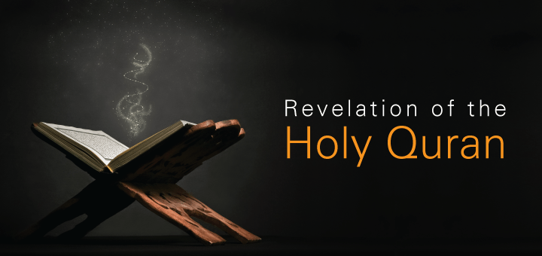
Compilation of the Qur’an
Some Hadith say that Muhammad (PHUB) left behind two examples: the Qur’an and the Sunnah. The word used in Al Kitab, meaning a compiled book. As Muhammad (PBUH) put so much importance by the Qur’an he would have had it written down in full. Others disagree; they believe the Qur’an was collected and ordered as the Prophet had recited, but not in one book. Shi’a believes that Imam Ali had all the Surahs in the right order six months after Muhammad’s (PHUB) death, but not as a complete book. Other Muslims claim Ali’s version had non-authentic verses in it, so rejected this copy.
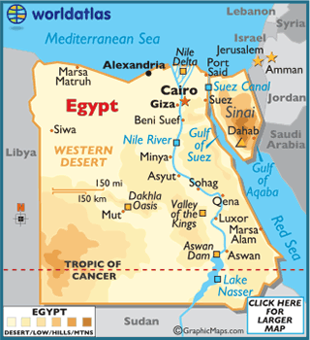
The majority of Sunni Muslims believe that Umar insisted Abu Bakr (the first caliph) have one copy completed. Certainly, the need for one single volume was urgent, because many scholars and many hafiz (those who memorised the Qur’an word for word) had died in the battle of Yamama; including Salim – a teacher of the Qur’an. The Qur’an was compiled, passed onto Umar, who became the second Caliph. He then handed it over to Hafsa, his daughter and wife of Muhammad (PHUB). The next Caliph, Othman, made sure that as Islam spread, copies of Hafsa’s version were sent out, so that everyone was reading the same book.
Since the 7th century CE, there have been many forms of the Qur’an from different scholars using different calligraphy and bindings, but the teachings remained the same. The first mass-printed version did not appear until the 1920s, produced in Cairo, Egypt. This version very quickly became accepted by Sunni and Shi’a alike as the ‘official’ Qur’an.

Questions
- How many chapters does the Qur’an have?
………………………………………………………………………………………………………………………...
- How many verses does the Qur’an have?
………………………………………………………………………………………………………………………...
- When did the first revelation happen?
………………………………………………………………………………………………………………………...
- How did Muhammad (PBUH) receive the revelations?
………………………………………………………………………………………………………………………...
- What role did Zayd and Thabit have?
………………………………………………………………………………………………………………………...
- What does each Surah begin with?
………………………………………………………………………………………………………………………...
………………………………………………………………………………………………………………………...
- Explain in detail how the Qur’an was compiled (put together):
………………………………………………………………………………………………………………………...
………………………………………………………………………………………………………………………...
………………………………………………………………………………………………………………………...
………………………………………………………………………………………………………………………...
………………………………………………………………………………………………………………………...
………………………………………………………………………………………………………………………...
………………………………………………………………………………………………………………………...
………………………………………………………………………………………………………………………...
………………………………………………………………………………………………………………………...
………………………………………………………………………………………………………………………...
………………………………………………………………………………………………………………………...
………………………………………………………………………………………………………………………...
The Qur’an and its Authority
Belief and Origins
- The Qur’an is the direct Word of Allah and therefore has authority. It is infallible (without error) and remains in its original form:
- “Falsehood shall never come to it” (Qur’an 41:42)
- It supersedes other books like the Torah and Injil.
- The Qur’an was revealed to the Seal of the Prophet (Muhammad PBUH) and because no man would be capable of writing such a book, it made him even more important.
- “If all mean and jinn should combine to bring about the likes of the Qur’an, they could not bring the like of it, even if they helped one another.” (Surah 17:88)
- Muhammad (PBUH) was illiterate, making the Qur’an the first great miracle.
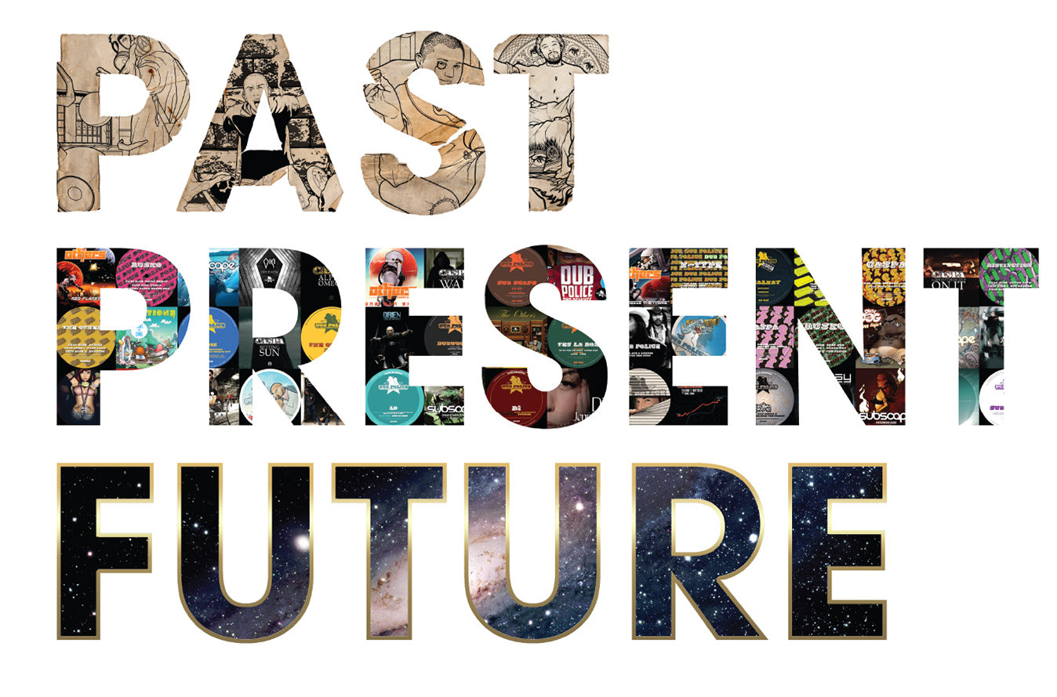
- A written book (the Qur’an) was needed to formalise the religion.
What the religion contains
- The Qur’an has authority because it covers every aspect of life: past, present and future
- It influences a person throughout their lives: birth, ceremony, marriage, death and in daily prayers
- It contains the basics of worship which Muhammad (PBUH) developed
- It contains the legal (Shari’ah Law) and social systems
- It explains the creation and other ultimate questions like why we are here and what happens when we die
- It has been suggested by some that science and the Qur’an go together; they are compatible and the Qur’an reveals ideas that scientists did not even know at the time
- It provides personal and spiritual guidance for all life’s situations and challenges
If Muslims combine all these ideas there is no reason to not believe that the Qur’an has supreme authority. It is a timeless book. Equally though, other religions also believe that their holy books are as important to them and have as much authority. Christians, for example, may say that where the Bible comes from is a secondary issues, what is far more important is how it speaks to people when they read it. In other words, God speaks to them individually in their hearts when the Bible is read. Other books have been translated, but in general the meaning still exists. What is more important is that people can read it in their own language and it is available to all. The Qur’an is only infallible in its original language (Arabic) and translation is exactly that; a translation and not the Word of Allah.
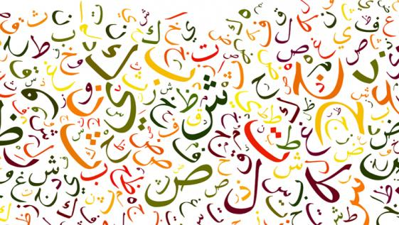

Questions
- What is the Qur’an?
………………………………………………………………………………………………………………………...
- What does the Qur’an supersede?
………………………………………………………………………………………………………………………...
- Why was the Qur’an the first miracle?
………………………………………………………………………………………………………………………...
- What was needed to formalise Islam?
………………………………………………………………………………………………………………………...
- Why does the Qur’an hold authority?
………………………………………………………………………………………………………………………...
- What does the Qur’an contain?
………………………………………………………………………………………………………………………...
- What does the Qur’an explain?
………………………………………………………………………………………………………………………...
- How are science and the Qur’an compatible?
………………………………………………………………………………………………………………………...
- What does the Qur’an provide?
………………………………………………………………………………………………………………………...
- Explain the idea that the Qur’an is a ‘timeless’ book.
………………………………………………………………………………………………………………………...
………………………………………………………………………………………………………………………...
………………………………………………………………………………………………………………………...
………………………………………………………………………………………………………………………...
………………………………………………………………………………………………………………………...
………………………………………………………………………………………………………………………...
The Qur’an as the basis for Shari’ah
“It is not for a believing man or a believing woman, when Allah and His messenger have decided a matter, that they should (thereafter) have any choice about their affair. And whoever disobeys Allah and His messenger have certainly strayed into a clear error.” (Surah 33:36)
What makes up the Shari’ah?
Shari’ah (Islamic) law means ‘a path to life-giving water’ and goes back to Ibrahim. Shari’ah considered:
- The Qur’an – containing direct guidance from Allah
- the Sunnah – many of the prophets teachings and actions putting the Qur’an into practice
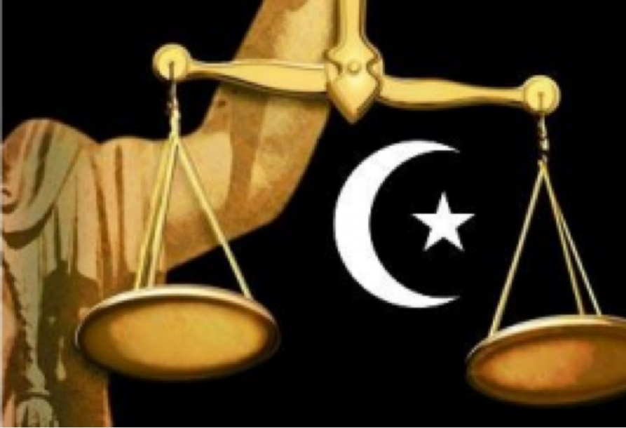
Leading scholars use these to make decisions (ijma’, which means consensus). Muslims believe that any devout Muslim has the right to make judgements in keeping with the Qur’an and Sunnah where there is no guidance. The opinions of the Prophet’s companions such as Abu Bakr and Qatadah, are like laws, late ijma’ are only seen as guidelines. There is the belief
that these can be changed as time moves on.
Why is there a need for Shari’ah?
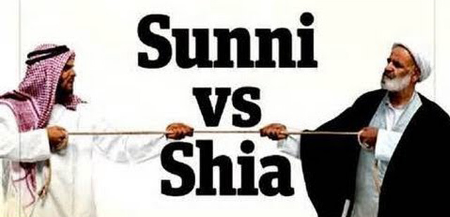
Allah’s laws are always superior to human-made laws, because He knows and understands the world humans live in far better than they ever could. Also, Allah is without prejudice and favour, so is absolutely objective, whereas humans are biased. Laws are needed for society to function properly and fairly. Shari’ah Law covers five main areas: behaviour and manners; ritual worship; beliefs; transactions and punishments. If the laws in a country are not based on absolute justice, then Shari’ah Law is more important to follow. Muslims are taught to obey the laws of the country they live in, but some Muslims do want Shari’ah to be used alongside government law in dealing with matters of religion. This subject has been debated in Britain as radical Muslims called for Shari’ah Law to be the law of the UK. However, Shari’ah is not meant to be imposed on people, it must be part of the consensus. Some parts of Shari’ah are used in Britain, for example, in relation to marriage.
Sunni and Shi’a Diversity
For Sunni Muslims, there are four schools of thought within Islamic Shari’ah Law (each known as madh’hab): the Hanafi, Maliki, Shafi’I and Hanbali schools. Some Sunni also accept the Shi’a Ja’fari school of thought. Shi’a Muslims only accept the Ja’fari school, which is made up of learned individuals called mujtahids (living religious scholars or ayatollahs representing the twelve imams). Their opinions must still be based on the Qur’an and Sunnah though.
Categories of Behaviour
- Fard or Wajib: Compulsory actions, for example, prayers
- Mustahab and Mandoob: Things that are recommended for Muslims, for example, nafil prayers
- Mubah: Things that are allowed, but neither recommended or forbidden
- Makruh: Allowed actions which are dislikes or disapproved of, for example, divorce
- Haram: forbidden actions, for example, adultery
How does Shari’ah fit in a modern world?
Shari’ah Law comes from 1400 years ago. How can they apply today? Are our lives too complex today? Should religion really govern our actions, for example, telling me whether I can drink alcohol? Muslims see all the rules as Allah looking after us, helping us tick to the right path, rather than them being seen as restricting us.
Questions
- What makes up the Shari’ah?
………………………………………………………………………………………………………………………...
………………………………………………………………………………………………………………………...
………………………………………………………………………………………………………………………...
- Explain in detail why there is a need for Shari’ah?
………………………………………………………………………………………………………………………...
………………………………………………………………………………………………………………………...
………………………………………………………………………………………………………………………...
- Explain the diversity between Sunni and Shi’a.
………………………………………………………………………………………………………………………...
………………………………………………………………………………………………………………………...
………………………………………………………………………………………………………………………...
- What are the five categories of behaviour?
………………………………………………………………………………………………………………………...
………………………………………………………………………………………………………………………...
………………………………………………………………………………………………………………………...
………………………………………………………………………………………………………………………...
………………………………………………………………………………………………………………………...
………………………………………………………………………………………………………………………...
- Explain how Shari’ah fits into a modern world.
………………………………………………………………………………………………………………………...
………………………………………………………………………………………………………………………...
………………………………………………………………………………………………………………………...
………………………………………………………………………………………………………………………...
………………………………………………………………………………………………………………………...
………………………………………………………………………………………………………………………..
The Torah (Tawrat) and the Scrolls of Ibrahim
The Tawrat
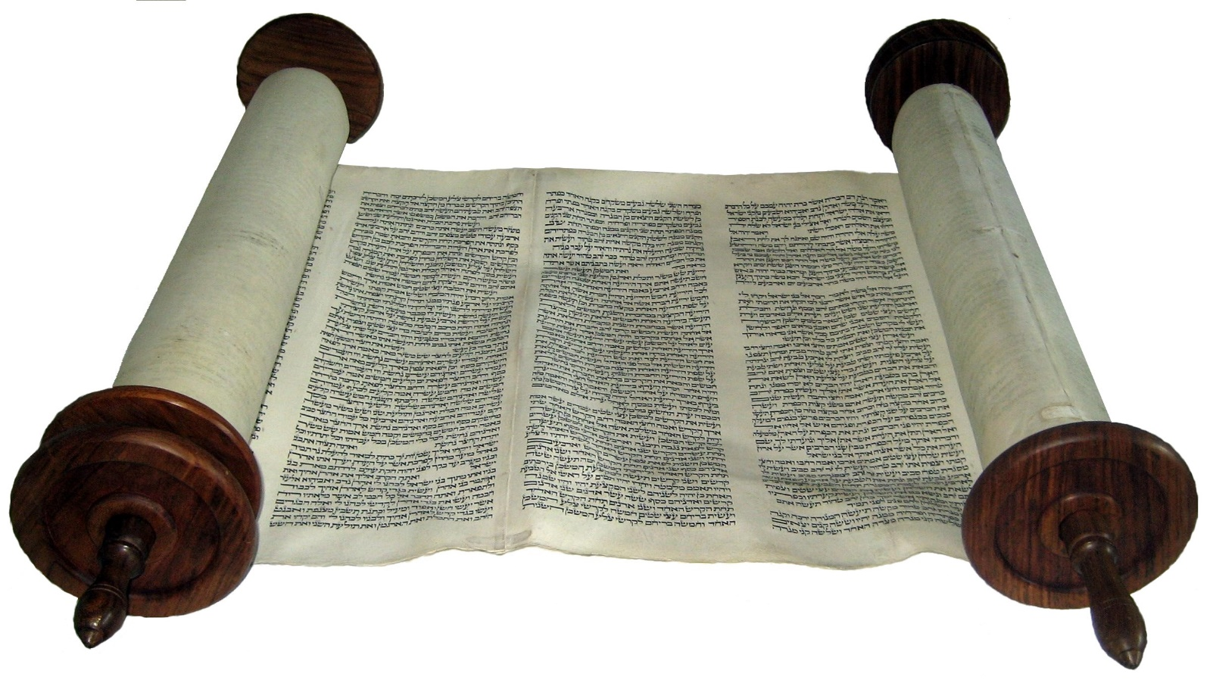
The Tawrat is the Arabic word for the Torah, which are the revelations given to Musa (Moses) by Allah on Mount Sinai. Some say that the Tawrat is the first five books of the Bible (the Pentateuch). Other Muslim scholar say the Tawrat is equal to all of the Old Testament. The Qur’an states that it confirms what was before, that is, the Torah and the Gospels, although those texts have themselves become corrupted. Some scholars believe these earlier books to be ‘lost’ and no longer existing in any form.
The Tawrat does not exist in its original language or its original text. It was put together by the followers of Moses a long time after his death. The compilers changed the text, so some is the Word of Allah and some is human addition.
That being said, some believe that Allah preserves the books, so they have not been lost or added to. This view is supported by these teachings:
- Allah is all-powerful and His Word cannot be changed
- A proverb given to Prophet Sulayman says: “Do not add to His words or He will rebuke you.”
- Deuteronomy 4:2 says: “Do not add to what I command and do not subtract from it…”
- The fact that Muhammad (PBUH) was told is he was ever unsure to search out meaning from those who had received scripture, suggests that the original scriptures were still believed to be reliable at the time the Qur’an was written
Whatever the case, the Qur’an refers to the Tawrat as ‘guidance and light’, revealed by Allah, and clearly very important. On retiring to bed at night, Muhammad’s (PBUH) prayer put his life into Allah’s hands (the creator and lord of everything, the source of the Tawrat, the Gospels and the Qur’an) and asked for protection from Shaytan (the Devil). The Qur’an also seems to suggest that the Torah was not only taught by Musa, buy by all prophets and priests.
The Scrolls of Ibrahim
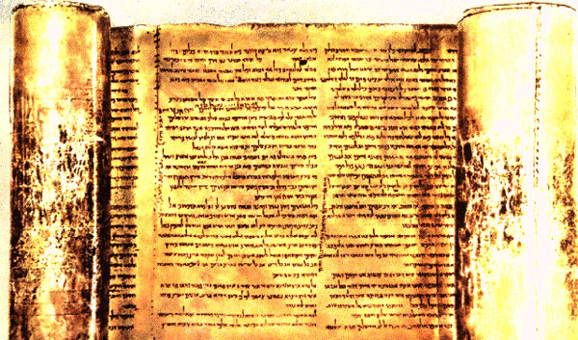
Very little is actually known about these scrolls (often called Suhuf). The revelations were said to have been received by Ibrahim on the first day of Ramadan and contained parable-like stories about worship, reflections and building a livelihood. Ibrahim is termed ‘the upright one’, always faithful to Allah. The scrolls were written on parchment but perished over time. It is generally agreed that they were not ‘a book’, rather they were individual revelations.

Questions
- What is the Tawrat?
………………………………………………………………………………………………………………………...
………………………………………………………………………………………………………………………...
- When was the Tawrat put together?
………………………………………………………………………………………………………………………...
………………………………………………………………………………………………………………………...
- What did the compilers do to the text?
………………………………………………………………………………………………………………………...
………………………………………………………………………………………………………………………...
- What evidence is there for the Tawrat still being Allah’s Word?
………………………………………………………………………………………………………………………...
………………………………………………………………………………………………………………………...
- What does the Qur’an refer to the Tawrat as?
………………………………………………………………………………………………………………………...
………………………………………………………………………………………………………………………...
- What is ‘Suhuf’?
………………………………………………………………………………………………………………………...
………………………………………………………………………………………………………………………...
- What does the Suhuf supposedly contain?
………………………………………………………………………………………………………………………...
………………………………………………………………………………………………………………………...
………………………………………………………………………………………………………………………...
………………………………………………………………………………………………………………………...
………………………………………………………………………………………………………………………...
………………………………………………………………………………………………………………………...

The Psalms (Zabur) and the Gospels (Injil)
Psalms - Zabur
One of the other two holy scriptures of Islam, the Zabur (Psalms) of Dawud are a collection of prayers to Allah (some refer to them as poems). Dawud was a great king, whose people were God-fearing and righteous. In Surah 4:163 it says, “We gave Dawud the Zabur.” They contain lessons of guidance for the people and he recited them in song version. A fragment of an Arabic translation of Psalm 78 from the second century CE was found in Damascus, Syria.
One important message in the Zabur is the idea of the Masih (Messiah). The Masih was to be a symbol of hope for the future in a world where many had failed to obey Allah’s commands. Isa (Jesus) also referred to what had been said aout the Masih in the Gospel of Luke, “Everything must be fulfilled that is written about me in the Law of Moses, the Prophets and the Psalms (Zabur)” He taught in a way which allowed people to understand the scriptures. For Muslims, Jesus was the Messiah and will return.

Gospel – Injil
This is the good news about Isa (Jesus) written by his disciples. Muslims highly respect Isa because there are revelations in the Qur’an about him. Muslims believe:
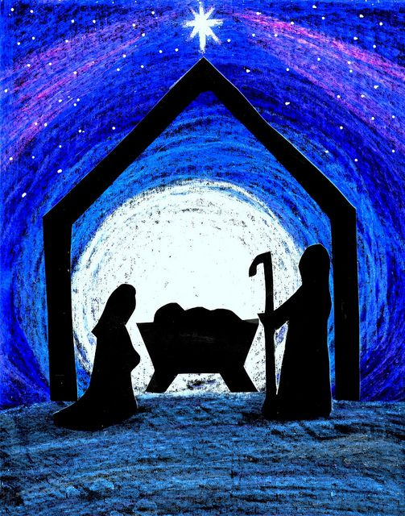
- He was born of a virgin mother
- He was the Masih
- He was no the son of Allah (as Allah can have no partners)
- He followed Allah
- He was not crucified (but did not die, rather he ascended to heaven)
- He did not die to save sins (Allah is all-compassionate, so He will forgive sins, so this sacrifice would have been unnecessary)
- The gospels in their current form contain mistakes because they were written by disciples many years after the death of Isa, having had only weak understanding of his teachings in the first place
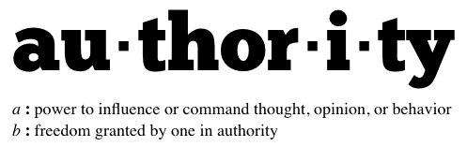
Authority of the Four Books
- All four books are referred to in the Qur’an, so they are important
- Muhammad (PHUB) learned from them and referred to them, therefore giving them authority
- They were associated with key prophets and their revelations which gives them importance
However:
- Some are lost and no one knows what they said
- It is alleged that they have been changes, so do they still have some authority?
- Why were they not preserved like the Qur’an if they were important?
- Having been so changed, Muslims cannot use them, so they have no impact/authority today
Questions
- Explain the importance of the Psalms (Zabur) to Muslims.
………………………………………………………………………………………………………………………...
………………………………………………………………………………………………………………………...
………………………………………………………………………………………………………………………...
………………………………………………………………………………………………………………………...
………………………………………………………………………………………………………………………...
- Explain the importance of the Gospel (Injil) to Muslims.
………………………………………………………………………………………………………………………...
………………………………………………………………………………………………………………………...
………………………………………………………………………………………………………………………...
………………………………………………………………………………………………………………………...
………………………………………………………………………………………………………………………...
- What authority do the four books have?
………………………………………………………………………………………………………………………...
………………………………………………………………………………………………………………………...
………………………………………………………………………………………………………………………...
………………………………………………………………………………………………………………………...
………………………………………………………………………………………………………………………...
- Why is there some doubt about the authority of these books?
………………………………………………………………………………………………………………………...
………………………………………………………………………………………………………………………...
………………………………………………………………………………………………………………………...
………………………………………………………………………………………………………………………...
………………………………………………………………………………………………………………………...

All About Angels
What are angels?
Believing in angels is one of the six articles of faith. The Qur’an tells us that humans are made from clay; jinn are made more smokeless fire; angels are made of elements of light. Angels are said to have wings and can move at the speed of light. They can appear in human form, but dazzle so are not like humans. They have no gender and are part of the unseen world. What they do we cannot see and they always complete what Allah asks. Their purpose is to obey Allah as they have no free will. Surah 19.64 says: “We don’t descend except for the command of our Lord.”
What do angels do?
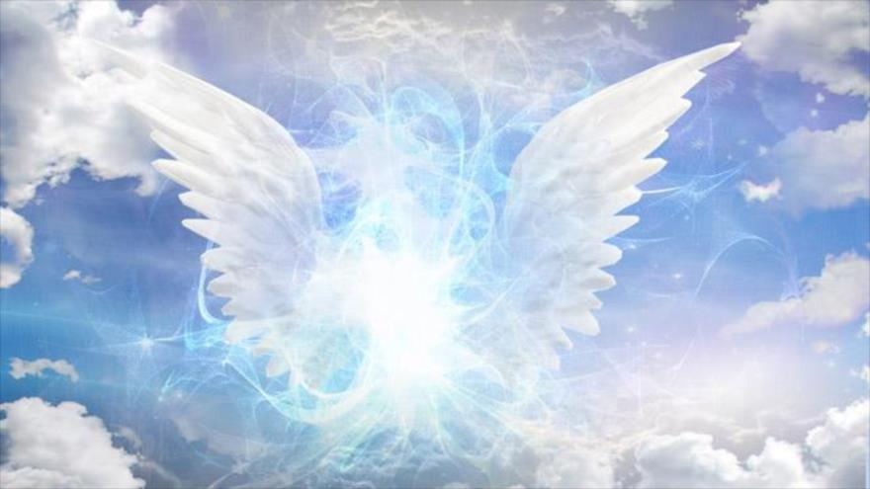
Angels watch over humans, bringing peace to believers and instilling fear in unbelievers. They record every thought and actions to report on Judgement Day. One angel delivers all Allah’s messages to humans and has appeared to all the prophets. Angels can cause natural disasters when Allah commands them to. There is the Angel of Death who takes the soul at death (it is taken gently or with extreme pain depending upon a person’s life). There are angels who question each soul, either punishing or soothing it as it waits for Judgement Day. Angels greet those who enter paradise, two stand at each gate to wish peace upon those entering. In hell there are angels who throw people into the pits of hell and do not let people escape. On Judgement Day, one angel will blow the horn at Allah’s command to signify the end of the world.
Famous Angels
- Nakir and Munkir
- Mallik
- Israfil
- Kiraman and Katibeen

Questions
- What is one of the six articles of faith?
………………………………………………………………………………………………………………………...
………………………………………………………………………………………………………………………...
- What are humans and angels made from?
………………………………………………………………………………………………………………………...
………………………………………………………………………………………………………………………...
- What is are angels said to be like?
………………………………………………………………………………………………………………………...
………………………………………………………………………………………………………………………...
- What is the purpose of angels?
………………………………………………………………………………………………………………………...
………………………………………………………………………………………………………………………...
- What so angels do? Explain in detail.
………………………………………………………………………………………………………………………...
………………………………………………………………………………………………………………………...
………………………………………………………………………………………………………………………...
………………………………………………………………………………………………………………………...
………………………………………………………………………………………………………………………...
………………………………………………………………………………………………………………………...
………………………………………………………………………………………………………………………...
………………………………………………………………………………………………………………………...
………………………………………………………………………………………………………………………...
………………………………………………………………………………………………………………………...
………………………………………………………………………………………………………………………...
………………………………………………………………………………………………………………………...

Jibril – the ‘Angel of Holiness’
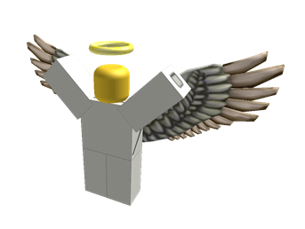
Jibril is the most famous angel, and in Islam, the most important. Jibril (also known as Gabriel) visited Maryam – mother of Prophet Isa. ‘Jibril’ is said to mean ‘God is my strength’. So what do we know about him?
Jibril is known as the ‘spirit of holiness’ as he always brings good news. In the Hadith, Muhammad (PBUH) was said to have described Jibril as having 600 wings. Each wing filled the horizon as far as the eye could see. Jibril was the first thing to be given life by Allah and he was sent to look at paradise. On seeing it, he claimed that no one would every stray away from its beauty and wonder. He was send a second time to look at it when it was surrounded by a barrier of difficulties and hardship. His reaction then was that no one would ever reach it. He was then sent to look at hell; he said that no one would want to go there. So Allah surrounded hell with desires and lusts, at which Jibril said that no one would ever be able to avoid it.
Jibril spoke with many prophets who received revelations from Allah. He is mentioned five times in the Qur’an but also in the Hadith. These include:
- He helped Ibrahim when he was thrown into the fire
- He opened up the Zamzam well so that Hajar could give her dying son water
- When Yusef (Joseph) was thrown into a well by his brothers, Jibril caught him and was his protector
- He told Zakariyya (Zechariah) about a son he was to have in his old age, Yahya (John)
- Jibril told Maryam she would have a son, Isa (Jesus)
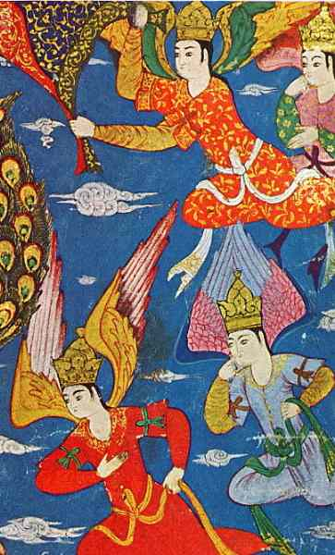
- Jibril spoke to Muhammad (PBUH) in Cave Hira, over 23 years dictated the Qur’an directly from Allah, and taught him the Sunnah and the Five Pillars, teaching him that faith meant believing in Allah, angels, books and messengers
The Angel Mika’il
Most of what is known about Mika’il is from the Islamic tradition rather than the Qur’an. He is mentioned as one of the most important angels. Angel Mika’il not only associated with Muhammad (PBUH) with his spiritual mission, but still does that for people today. He is often know as the giver of rain and sustenance. He was one of the first to bow to Adam and he was put in charge of the plants and rain. Muslim teachers think this is symbolic to mean that Mika’il provides spiritual help to the soul and material help to the body. Mika’il had to prepare Muhammad (PBUH) by providing water that Jibril used to purify him, before Jibril took to the seven heaven and the throne of Allah.
Some Islamic traditions say that Mika’il lives in heaven, has wings of dark green colour and hairs of saffron. Each hair has a million faces and mouths that can communicate in all languages, all asking for Allah’s mercy for humankind. He is mentioned as helping Muhammad (PBUH) at the Battle of Badr, which was fought for Makkah.
On Judgement Day both Jibril and Mika’il will help with the weighing of a person’s actions. Mika’il has seen hell and how easy it is to get there, as opposed to how hard it is to get to paradise, so it is believed that he does not smile. He is the friend of humankind as he knows that awaits; the path to paradise being thinner than a human hair.
Angels of the Seven Heavens
Islam believes in other angels, who have specific jobs, and some whom are names:
Hafaza is the guardian angel, whilst Jundullah (the army of Allah) helped Muhammad (PBUH) in battle. There are angels whose job it is to maintain order, angels who protect people from death until the given time, angels who carry Allah’s throne, angels who bestow blessings from Allah, animals who ensoul each foetus and angels who travel the earth finding those who worship Allah.

Questions
- Who is Jibril?
………………………………………………………………………………………………………………………...
………………………………………………………………………………………………………………………...
- What is Jibril known as?
………………………………………………………………………………………………………………………...
………………………………………………………………………………………………………………………...
- How is Jibril described?
………………………………………………………………………………………………………………………...
………………………………………………………………………………………………………………………...
- Why does Jibril think humans will never enter paradise?
………………………………………………………………………………………………………………………...
………………………………………………………………………………………………………………………...
- Who did Jibril speak with?
………………………………………………………………………………………………………………………...
………………………………………………………………………………………………………………………...
- State some things that Jibril has done / was involved in.
………………………………………………………………………………………………………………………...
………………………………………………………………………………………………………………………...
- What is Jibril known as?
………………………………………………………………………………………………………………………...
………………………………………………………………………………………………………………………...
- Explain the role of the Angel Mika’il.
………………………………………………………………………………………………………………………...
………………………………………………………………………………………………………………………...
………………………………………………………………………………………………………………………...
………………………………………………………………………………………………………………………...
Akhirah – Belief in Life After Death
How does Islam explain life after death for its followers?
- Akhirah definitely exists., The Qur’an says it does as the Word of Allah is right
- Life after death makes sense of our short existence on earth – why we are here at all
- On earth, Muslims’ lives are tested by Allah and the end result is akhirah in one form or another
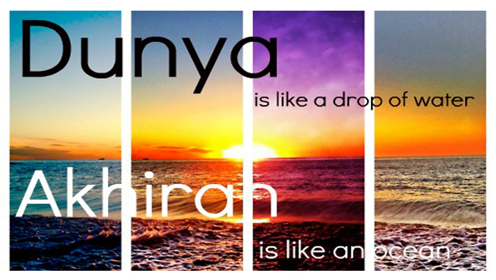
- Most of the prophets state that Muslims were created deliberately, people will be accountable for their actions in order to complete the journey back to Allah

The Angel of Death – The Grave and Barzakh
When a person dies, their soul is taken by the Angel of Death, called Azra’il. The soul hovers around the corpse, seeing everything but unable to communicate. It watches the burial, as it is no longer a part of the body. Two angels visit to ask three questions:
- Who is your Lord?
- What was your life like?
- Who is your prophet?
If these three questions are answered correctly, it is believed that the soul is made comfortable to sleep until the Day of Judgement. If not, it is tormented by angels. This is known as the punishment of the grave. After this stage, waiting for the Day of Judgement is called Barzakh. Barzakh means ‘barrier’. This is not governed by time and there is no return to life, even to warn or help others.

Questions
- Explain what Islam believes about life after death.
………………………………………………………………………………………………………………………...
………………………………………………………………………………………………………………………...
………………………………………………………………………………………………………………………...
………………………………………………………………………………………………………………………...
- What happens when a person dies?
………………………………………………………………………………………………………………………...
………………………………………………………………………………………………………………………...
- What three questions will a soul be asked?
………………………………………………………………………………………………………………………...
………………………………………………………………………………………………………………………...
- What heppens if the questions are answered corrrectly?
………………………………………………………………………………………………………………………...
………………………………………………………………………………………………………………………...
- What heppens if the questions are not answered corrrectly?
………………………………………………………………………………………………………………………...
………………………………………………………………………………………………………………………...
- What is Barzakh?
………………………………………………………………………………………………………………………...
………………………………………………………………………………………………………………………...

Akhirah – the End of the World
“Every soul shall have a taste of death.” (Qur’an 3:185)
For Muslims, this world is not all there is. Our human existence will continue after death; our earthy life is just a preparation for the eternal life to come (Akhirah). Our mortal lives are a test and we will be judged according to how we have lived. As humans, we have been given free will, so we are able to make choices about what to believe and how to treat others. We will be held responsible for these thoughts and actions when God comes to judge us on the last day.
The Angel Israfil will blow a trumpet to announce the Day of Judgement. The trumpet is constantly on his limps, awaiting the command from God.
Signs of the end of the world
Many signs will mark the end of the world, but the most importance will be the appearance of the Mahdi. His return will coincide with the second coming of Isa (Jesus). A false messiah will also attempt to deceive the people. Other signs include: abundance of earthquakes, the spreading of killing, rejection of Islam, increase in dishonesty, drunkenness, obscenity, nakedness and fornication. Society will be full of terrible corruption and chaos.
Day of Judgement: the test
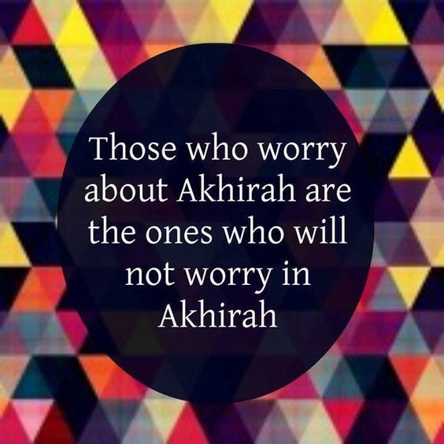
On the Day of Judgement, the dead will be raised from their graves and all people will stand before God to be sentences according to the way they have lived their lives. A book which represents everything an individual has done, is presented to each of them. If the person’s good deeds outweigh the bad, then they will receive the book in their right hand and pass into heaven. If it is placed into their left hand, they will be among the damned.
On the Day of Judgement, the Book of Deeds will be read, in which ‘every small and great thing is recorded.’ (Qur’an 54:52)
How are people judged?
The Qur’an gives many warnings about the Day of Judgement and Muslims are encouraged to question themselves: Am I ready to face death? What have I done to prepare for that day?

Questions
- What is our earthly life a preparation for?
………………………………………………………………………………………………………………………...
………………………………………………………………………………………………………………………...
- What is Akhirah?
………………………………………………………………………………………………………………………...
- What role will the Angel Israfil play?
………………………………………………………………………………………………………………………...
………………………………………………………………………………………………………………………...
- State at least three signs of the end of the world.
………………………………………………………………………………………………………………………...
………………………………………………………………………………………………………………………...
………………………………………………………………………………………………………………………...
- What will happen on the Day of Judgement?
………………………………………………………………………………………………………………………...
………………………………………………………………………………………………………………………...
………………………………………………………………………………………………………………………...
- On the Day of Judgement, a book is placed in your hand. What is its importance?
………………………………………………………………………………………………………………………...
………………………………………………………………………………………………………………………...
- What is in the book?
………………………………………………………………………………………………………………………...
- How are people judged?
………………………………………………………………………………………………………………………...
………………………………………………………………………………………………………………………...

Judgement: heaven and hell
God weighs our deeds
God judges each person’s actions, but intentions (niyyah) are also taken into consideration.
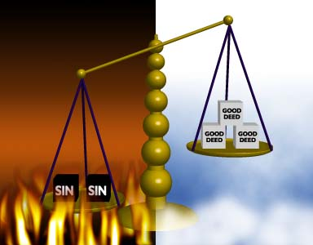
- If the person has the intention to do a good deed, but was unable to carry it out, this is counted as a good deed
- If they intended and carried out a good deed, this is counted as ten good deeds
- If the person intended a bad deed, but did not do it, that is counted as a good deed
- If they intended and carried out a bad deed, God records that as one bad deed
God tests people’s faith
The two terrifying judging angels, Munkar and Nakir, will question each person, testing their faith. In order to give the correct answer to their questions, it is not enough to just learn to recite the Shahadah. If the person has not truly lived a life of submission to God, following the Five Pillars, they will be incapable of giving the right response on the day.
Barzakh
Only God knows when the Day of Judgement will come. Muslims believe that, for those who die before that day, the angel of death, Azrail, will come to take their souls to await the day. They will be kept in a state of barzakh (waiting) until the sound of the final trumpet is heard.
Life beyond death
Islam provides the most graphic descriptions of what awaits after death. Heaven and hell are described as very real places, but some Muslims interpret these descriptions symbolically, since what exists beyond death must exist in a different dimension from our own world.
Heaven (Janna) is a state of joy, happiness and peace. After judgement, people will pass over the very narrow bridge of As-Sirat. Those who have been blessed by God will successfully cross to heaven (Janna) on the other side. This will include those who have lived faithful and moral lives, those who have been persecuted for their faith in God and those who have fought for God. Muslims believe that heaven is a reward for living a good life, so everything that one longs for on earth will be found in paradise: beautiful gardens, delicious food, gently flowing rivers, lovely serving maidens and reclining couches.
Hell (Jahannam) is a state of torment and suffering. The wicked, those whom God has damned, will fail to pass over the As-Sirat bridge. In trying to cross they will fall into hell, which is a place of terror, where the damned will face boiling water, scorching fire and black smoke. As well as experiencing the physical torment, those condemned to hell will suffer because they are separated from God, without hope of return.
Questions
- Which action will be written down by God as a bad deed?
………………………………………………………………………………………………………………………...
………………………………………………………………………………………………………………………...
………………………………………………………………………………………………………………………...
- How does God test people’s faith?
………………………………………………………………………………………………………………………...
………………………………………………………………………………………………………………………...
………………………………………………………………………………………………………………………...
- What is Barzakh?
………………………………………………………………………………………………………………………...
………………………………………………………………………………………………………………………...
………………………………………………………………………………………………………………………...
- Explain the Muslim idea of heaven (Janna).
………………………………………………………………………………………………………………………...
………………………………………………………………………………………………………………………...
………………………………………………………………………………………………………………………...
………………………………………………………………………………………………………………………...
- Explain the Muslim idea of hell (Jahannam).
………………………………………………………………………………………………………………………...
………………………………………………………………………………………………………………………...
………………………………………………………………………………………………………………………...
………………………………………………………………………………………………………………………...

Al-Qadr, God’s Divine Plan
God has eternal foreknowledge
Islam teaches that God is responsible for all things and that he has a divine plan for all of us (al-Qadr). God has a masterplan; everything that happens is predestined to take place; it is all part of his design. He is the cause of all things and the whole of creation is under his control. God knows all things in the greatest detail, with accuracy that we, as human, could never imagine.
Everything is part of a larger plan
Muslims believe that we can never know the reasons behind the universe, but that it is all part of a larger picture. God is the all-knowing one; his knowledge is complete and perfect. He even knows the secrets of our hearts.
“He knows what is within the heavens and the earth and knows what you conceal and what you declare. And God is Knowing of that within the breasts.” (Qur’an 64:4)
Insha’Allah, if God is willing
Insha’Allah: ‘if God allows it’ – comes from joining the Arabic words ‘Allah’ and ‘his will’. It is a very common phrase, for example: “I will get to school on time, Insha’Allah!”
Muslims believe that things which some people might call coincidences are, in fact, part of God’s plan. The word ‘insha’Allah’ expresses the belief that all events are outside of our own control; they are in the hands of God. When a Muslim says insha’Allah they are acknowledging that they are in submission to God. They will only succeed in their plans if God is also willing to make it happen.
Can good come out of suffering?
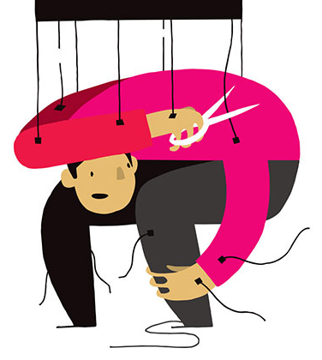
If all things are part of the will of God, then that must include suffering, pain, disease and disasters. It is easy to see how good can come out of things which cause suffering, like training to run a marathon, but harder to understand how hurricanes and wars can be seen in a positive way. Islam teaches that painful experiences need to be viewed as opportunities for our own growth as human beings.
Free Will
Islam teaches that we all have free will and God will hold us accountable for our decisions on the Day of Judgement. Humans are not puppets or robots; we have the ability to choose right from wrong. God wants us to follow the ‘straight path’, but it is up to us to make the right choices. Central to Islamic thought is the idea that life is a test and we need to learn how to turn away from evil.
“He may let them taste part of [the consequence of] what they have done that perhaps they will return [to righteousness].” (Qur’an 30:41)

Questions
- What is al-Qadr?
………………………………………………………………………………………………………………………...
………………………………………………………………………………………………………………………...
- What does the Qur’an tell us about God’s knowledge?
………………………………………………………………………………………………………………………...
………………………………………………………………………………………………………………………...
- What does ‘Insha’Allah’ mean?
………………………………………………………………………………………………………………………...
………………………………………………………………………………………………………………………...
- What does saying ‘Insha’Allah’ express belief in?
………………………………………………………………………………………………………………………...
………………………………………………………………………………………………………………………...
- According to Islam, how can good things come out of suffering?
………………………………………………………………………………………………………………………...
………………………………………………………………………………………………………………………...
- What are we accountable for?
………………………………………………………………………………………………………………………...
………………………………………………………………………………………………………………………...
- What does God want us to follow?
………………………………………………………………………………………………………………………...
………………………………………………………………………………………………………………………...
- What is central to Islamic thought?
………………………………………………………………………………………………………………………...
………………………………………………………………………………………………………………………...

Exam-style questions
- What is meant by ‘tawhid’? (1 mark)
…………………………………………………………………………………………………………
…………………………………………………………………………………………………………

- What is Shari’ah? (1 mark)
…………………………………………………………………………………………………………
…………………………………………………………………………………………………………

- Who were the Zabur (Psalms) written by? (1 mark)
…………………………………………………………………………………………………………
…………………………………………………………………………………………………………

- What are the Injil? (1 mark)
…………………………………………………………………………………………………………
…………………………………………………………………………………………………………

- What is Al-Qadr? (1 mark)
…………………………………………………………………………………………………………
…………………………………………………………………………………………………………

- What are angels made of? (1 mark)
…………………………………………………………………………………………………………
…………………………………………………………………………………………………………

- Who was asked by Allah to sacrifice his son? (1 mark)
……………………………………………………………………………………………………………………………………………………………………………………………………………………
- Who is known as the father of humanity? (1 mark)
……………………………………………………………………………………………………………………………………………………………………………………………………………………
- What is Akhirah? (1 mark)
……………………………………………………………………………………………………………………………………………………………………………………………………………………

- Give two Muslim beliefs about akhirah. (2 marks)
………………………………………………………………………………………………………………………………………………………………………………………………………………………………………………
- Name two prophets of Islam. (2 marks)
………………………………………………………………………………………………………………………………………………………………………………………………………………………………………………
- Give two reasons why the Qur’an is important. (2 marks)
………………………………………………………………………………………………………………………………………………………………………………………………………………………………………………
- Name two of the books of authority for Islam.(2 marks)
………………………………………………………………………………………………………………………………………………………………………………………………………………………………………………
- Give two of the roles of angels in Islam. (2 marks)
………………………………………………………………………………………………………………………………………………………………………………………………………………………………………………
- State two destinations for Muslim afterlife. (2 marks)
………………………………………………………………………………………………………………………………………………………………………………………………………………………………………………
- Name two of Islam’s angels. (2 marks)
………………………………………………………………………………………………………………………………………………………………………………………………………………………………………………

- Explain two ways in which belief in angels influences Muslims today. (4 marks)
………………………………………………………………………………………………………………………………………………………………………………………………………………………………………………………………………………………………………………………………………………………………………………………………………………………………………………………………………………………………
- Explain two ways in which belief in the Qur’an influences Muslims today. (4 marks)
………………………………………………………………………………………………………………………………………………………………………………………………………………………………………………………………………………………………………………………………………………………………………………………………………………………………………………………………………………………………
- Explain two ways in which belief in the afterlife influences Muslims today.. (4 marks) ……………………………………………………………………………………………………………………………………………………………………………………………………………………………………………………………………………………………………………………………………………………………………………………………………………………………………………………………………………………
- Explain two ways in which belief in risalah influences Muslims today. (4 marks)
………………………………………………………………………………………………………………………………………………………………………………………………………………………………………………………………………………………………………………………………………………………………………………………………………………………………………………………………………………………………
- Explain two ways in which learning about Allah influences Muslims today. (4 marks)
………………………………………………………………………………………………………………………………………………………………………………………………………………………………………………………………………………………………………………………………………………………………………………………………………………………………………………………………………………………………
- Explain two ways in which learning about the prophets influences Muslims today. (4 marks)
………………………………………………………………………………………………………………………………………………………………………………………………………………………………………………………………………………………………………………………………………………………………………………………………………………………………………………………………………………………………

- Explain two Muslim teachings about angels. (5 marks)
………………………………………………………………………………………………………………………………………………………………………………………………………………………………………………………………………………………………………………………………………………………………………………………………………………………………………………………………………………………………………………………………………………………………………………………………………………………………………………………………………………………………………………………………………………………………………………………………………………………………………………………………………………………………………………………………………………………………………………………………
- Explain two Muslim teachings about the authority of sacred texts. (5 marks)
………………………………………………………………………………………………………………………………………………………………………………………………………………………………………………………………………………………………………………………………………………………………………………………………………………………………………………………………………………………………………………………………………………………………………………………………………………………………………………………………………………………………………………………………………………………………………………………………………………………………………………………………………………………………………………………………………………………………………………………………
- Explain two Muslim teachings about Prophethood. (5 marks)
………………………………………………………………………………………………………………………………………………………………………………………………………………………………………………………………………………………………………………………………………………………………………………………………………………………………………………………………………………………………………………………………………………………………………………………………………………………………………………………………………………………………………………………………………………………………………………………………………………………………………………………………………………………………………………………………………………………………………………………………
- Explain two Muslim teachings about the afterlife. (5 marks)
………………………………………………………………………………………………………………………………………………………………………………………………………………………………………………………………………………………………………………………………………………………………………………………………………………………………………………………………………………………………………………………………………………………………………………………………………………………………………………………………………………………………………………………………………………………………………………………………………………………………………………………………………………………………………………………………………………………………………………………………
- Explain two Muslim teachings about paradise. (5 marks)
………………………………………………………………………………………………………………………………………………………………………………………………………………………………………………………………………………………………………………………………………………………………………………………………………………………………………………………………………………………………………………………………………………………………………………………………………………………………………………………………………………………………………………………………………………………………………………………………………………………………………………………………………………………………………………………………………………………………………………………………
- Explain two Muslim teachings about tawhid. (5 marks)
………………………………………………………………………………………………………………………………………………………………………………………………………………………………………………………………………………………………………………………………………………………………………………………………………………………………………………………………………………………………………………………………………………………………………………………………………………………………………………………………………………………………………………………………………………………………………………………………………………………………………………………………………………………………………………………………………………………………………………………………
- Explain two Muslim teachings about Allah’s omnipotence. (5 marks)
………………………………………………………………………………………………………………………………………………………………………………………………………………………………………………………………………………………………………………………………………………………………………………………………………………………………………………………………………………………………………………………………………………………………………………………………………………………………………………………………………………………………………………………………………………………………………………………………………………………………………………………………………………………………………………………………………………………………………………………………
Explain two Muslim teachings about justice. (5 marks)
………………………………………………………………………………………………………………………………………………………………………………………………………………………………………………………………………………………………………………………………………………………………………………………………………………………………………………………………………………………………………………………………………………………………………………………………………………………………………………………………………………………………………………………………………………………………………………………………………………………………………………………………………………………………………………………………………………………………………………………………

- “Muslims should be more concerned with this life than the next.”
Evaluate this statement. You should:

  - Refer to Muslim teaching
  - Give developed arguments to support this statement
  - Give developed arguments to support a different point of view
  - Reach a justified conclusion
……………………………………………………………………………………………………………………………………………………………………………………………………………………………………………………………………………………………………………………………………………………………………………………………………………………………………………………………………………………………………………………………………………………………………………………………………………………………………………………………………………………………………………………………………………………………………………………………………………………………………………………………………………………………………………………………………………………………………………………………………………………………………………………………………………………………………………………………………………………………………………………………………………………………………………………………………………………………………………………………………………………………………………………………………………………………………………………………………………………………………………………………………………………………………………………………………………………………………………………………………………………………………………………………………………………………………………………………………………………………………………………………………………………………………………………………………………………………………………………………………………………………………………………………………………………………………………………………………………………………………………………………………………………………………………………………………………………………………………………………………………………………………………………………………………………………………………………………………………………………………………………………………………………………………………………………………………………………………………………………………………………………………………………………………………………………………………………………………………………………………………………………………………………………………………………………………………………………………………………………………………………………………………………………………………………………………………………………………………………………………………………………………………………………………………………………………………………………………………………………………………………………………………………………………………………………………………………………………………………………………………………………………………………………………………………………………………………………………………………………………………………………………………………………………………………………………………………………………………………………………………………………………………………………………………………………………………………………………………………………………………………………………………………………………………………………………………………………………………………………………………………………………………………………………………………………………………………………………………………………………………………………………………………………………………………………………………………………………………………………………………………………………………………………………………………………………………………………………………………………………………………………………………………………………………………………………………………………………………………………
- “The Sunnah is more important than the Qur’an as a guide to life for Muslims today.”
Evaluate this statement. You should:

  - Refer to Muslim teaching
  - Give developed arguments to support this statement
  - Give developed arguments to support a different point of view
  - Reach a justified conclusion
……………………………………………………………………………………………………………………………………………………………………………………………………………………………………………………………………………………………………………………………………………………………………………………………………………………………………………………………………………………………………………………………………………………………………………………………………………………………………………………………………………………………………………………………………………………………………………………………………………………………………………………………………………………………………………………………………………………………………………………………………………………………………………………………………………………………………………………………………………………………………………………………………………………………………………………………………………………………………………………………………………………………………………………………………………………………………………………………………………………………………………………………………………………………………………………………………………………………………………………………………………………………………………………………………………………………………………………………………………………………………………………………………………………………………………………………………………………………………………………………………………………………………………………………………………………………………………………………………………………………………………………………………………………………………………………………………………………………………………………………………………………………………………………………………………………………………………………………………………………………………………………………………………………………………………………………………………………………………………………………………………………………………………………………………………………………………………………………………………………………………………………………………………………………………………………………………………………………………………………………………………………………………………………………………………………………………………………………………………………………………………………………………………………………………………………………………………………………………………………………………………………………………………………………………………………………………………………………………………………………………………………………………………………………………………………………………………………………………………………………………………………………………………………………………………………………………………………………………………………………………………………………………………………………………………………………………………………………………………………………………………………………………………………………………………………………………………………………………………………………………………………………………………………………………………………………………………………………………………………………………………………………………………………………………………………………………………………………………………………………………………………………………………………………………………………………………………………………………………………………………………………………………………………………………………………………………………………………………………………………
- “There is no proof for the Muslim belief in angels.”
Evaluate this statement. You should:

  - Refer to Muslim teaching
  - Give developed arguments to support this statement
  - Give developed arguments to support a different point of view
  - Reach a justified conclusion
……………………………………………………………………………………………………………………………………………………………………………………………………………………………………………………………………………………………………………………………………………………………………………………………………………………………………………………………………………………………………………………………………………………………………………………………………………………………………………………………………………………………………………………………………………………………………………………………………………………………………………………………………………………………………………………………………………………………………………………………………………………………………………………………………………………………………………………………………………………………………………………………………………………………………………………………………………………………………………………………………………………………………………………………………………………………………………………………………………………………………………………………………………………………………………………………………………………………………………………………………………………………………………………………………………………………………………………………………………………………………………………………………………………………………………………………………………………………………………………………………………………………………………………………………………………………………………………………………………………………………………………………………………………………………………………………………………………………………………………………………………………………………………………………………………………………………………………………………………………………………………………………………………………………………………………………………………………………………………………………………………………………………………………………………………………………………………………………………………………………………………………………………………………………………………………………………………………………………………………………………………………………………………………………………………………………………………………………………………………………………………………………………………………………………………………………………………………………………………………………………………………………………………………………………………………………………………………………………………………………………………………………………………………………………………………………………………………………………………………………………………………………………………………………………………………………………………………………………………………………………………………………………………………………………………………………………………………………………………………………………………………………………………………………………………………………………………………………………………………………………………………………………………………………………………………………………………………………………………………………………………………………………………………………………………………………………………………………………………………………………………………………………………………………………………………………………………………………………………………………………………………………………………………………………………………………………………………………………………………………
- “The Qur’an is the only source of authority in Islam.”
Evaluate this statement. You should:

  - Refer to Muslim teaching
  - Give developed arguments to support this statement
  - Give developed arguments to support a different point of view
  - Reach a justified conclusion
………………………………………………………………………………………………………………………………………………………………………………………………………………………………………………………………………………………………………………………………………………………………………………………………………………………………………………………………………………………………………………………………………………………………………………………………………………………………………………………………………………………………………………………………………………………………………………………………………………………………………………………………………………………………………………………………………………………………………………………………………………………………………………………………………………………………………………………………………………………………………………………………………………………………………………………………………………………………………………………………………………………………………………………………………………………………………………………………………………………………………………………………………………………………………………………………………………………………………………………………………………………………………………………………………………………………………………………………………………………………………………………………………………………………………………………………………………………………………………………………………………………………………………………………………………………………………………………………………………………………………………………………………………………………………………………………………………………………………………………………………………………………………………………………………………………………………………………………………………………………………………………………………………………………………………………………………………………………………………………………………………………………………………………………………………………………………………………………………………………………………………………………………………………………………………………………………………………………………………………………………………………………………………………………………………………………………………………………………………………………………………………………………………………………………………………………………………………………………………………………………………………………………………………………………………………………………………………………………………………………………………………………………………………………………………………………………………………………………………………………………………………………………………………………………………………………………………………………………………………………………………………………………………………………………………………………………………………………………………………………………………………………………………………………………………………………………………………………………………………………………………………………………………………………………………………………………………………………………………………………………………………………………………………………………………………………………………………………………………………………………………………………………………………………………………………………………………………………………………………………………………………………
- “Allah is just.”
Evaluate this statement. You should:

  - Refer to Muslim teaching
  - Give developed arguments to support this statement
  - Give developed arguments to support a different point of view
  - Reach a justified conclusion
……………………………………………………………………………………………………………………………………………………………………………………………………………………………………………………………………………………………………………………………………………………………………………………………………………………………………………………………………………………………………………………………………………………………………………………………………………………………………………………………………………………………………………………………………………………………………………………………………………………………………………………………………………………………………………………………………………………………………………………………………………………………………………………………………………………………………………………………………………………………………………………………………………………………………………………………………………………………………………………………………………………………………………………………………………………………………………………………………………………………………………………………………………………………………………………………………………………………………………………………………………………………………………………………………………………………………………………………………………………………………………………………………………………………………………………………………………………………………………………………………………………………………………………………………………………………………………………………………………………………………………………………………………………………………………………………………………………………………………………………………………………………………………………………………………………………………………………………………………………………………………………………………………………………………………………………………………………………………………………………………………………………………………………………………………………………………………………………………………………………………………………………………………………………………………………………………………………………………………………………………………………………………………………………………………………………………………………………………………………………………………………………………………………………………………………………………………………………………………………………………………………………………………………………………………………………………………………………………………………………………………………………………………………………………………………………………………………………………………………………………………………………………………………………………………………………………………………………………………………………………………………………………………………………………………………………………………………………………………………………………………………………………………………………………………………………………………………………………………………………………………………………………………………………………………………………………………………………………………………………………………………………………………………………………………………………………………………………………………………………………………………………………………………………………………………………………………………………………………………………………………………………………………………………………………………………………………………………………………………………

- “The prophets are not important in modern Islam.”
Evaluate this statement. You should:

  - Refer to Muslim teaching
  - Give developed arguments to support this statement
  - Give developed arguments to support a different point of view
  - Reach a justified conclusion
……………………………………………………………………………………………………………………………………………………………………………………………………………………………………………………………………………………………………………………………………………………………………………………………………………………………………………………………………………………………………………………………………………………………………………………………………………………………………………………………………………………………………………………………………………………………………………………………………………………………………………………………………………………………………………………………………………………………………………………………………………………………………………………………………………………………………………………………………………………………………………………………………………………………………………………………………………………………………………………………………………………………………………………………………………………………………………………………………………………………………………………………………………………………………………………………………………………………………………………………………………………………………………………………………………………………………………………………………………………………………………………………………………………………………………………………………………………………………………………………………………………………………………………………………………………………………………………………………………………………………………………………………………………………………………………………………………………………………………………………………………………………………………………………………………………………………………………………………………………………………………………………………………………………………………………………………………………………………………………………………………………………………………………………………………………………………………………………………………………………………………………………………………………………………………………………………………………………………………………………………………………………………………………………………………………………………………………………………………………………………………………………………………………………………………………………………………………………………………………………………………………………………………………………………………………………………………………………………………………………………………………………………………………………………………………………………………………………………………………………………………………………………………………………………………………………………………………………………………………………………………………………………………………………………………………………………………………………………………………………………………………………………………………………………………………………………………………………………………………………………………………………………………………………………………………………………………………………………………………………………………………………………………………………………………………………………………………………………………………………………………………………………………………………………………………………………………………………………………………………………………………………………………………………………………………………………………………………………………………………

