GCSE (9-1)
Combined
Physics 2

Topics for Paper 2

Topic 8 – Energy – forces doing work

Students should: |  | Maths skills
8.1 | Describe the changes involved in the way energy is stored when systems change – eg Gravitational potential energy in to kinetic energy or electrical energy into light energy.
8.2 | Draw and interpret diagrams to represent energy transfers  Electricity -> Heat + Light | 1c, 2c
8.3 | Explain that where there are energy transfers in a closed system there is no net change to the total energy in that system  1000J -> 350J + 650J For the example above in 8.2
8.4 | Identify the different ways that the energy of a system can be changed  a through work done by forces  b in electrical equipment  c in heating  Examples include: Fricition -> Electrostatic, Kinetic energy -> electrical energy and Friction -> Heat
8.5 | Describe how to measure the work done by a force and understand that energy transferred (joule, J) is equal to work done (joule, J)  Work done is the same as Energy and both are measured in Joules
8.6 | Recall and use the equation:  work done (joule, J) = force (newton, N) × distance moved in the direction of the force (metre, m)  E = F × d  e.g A force of 50N acting for 2m gives 50 x 2 = 100J | 1a, 1b, 1c, 1d 2a  3a, 3b, 3c, 3d  4f
8.7 | Describe and calculate the changes in energy involved when a system is changed by work done by forces  I can use the equation in 2.6
8.8 | Recall and use the equation to calculate the change in gravitational PE when an object is raised above the ground:  change in gravitational potential energy (joule, J) = mass (kilogram, kg) × gravitational field strength (newton per kilogram, N/kg) × change in vertical height (metre, m)  ΔGPE = m (kg)× g(N/kg) × Δh(m) . Δ=change | 1a, 1c, 1d 2a  3a, 3b, 3c, 3d
8.9 | Recall and use the equation to calculate the amounts of energy associated with a moving object:  kinetic energy (joule, J) = 1/2× mass (kilogram, kg) ×  (speed)2 ((metre/second)2, (m/s)2)  KE = 1 × m × v 2  2  e.g A 5kg mass at 3m/s Energy = ½ X5 X3² = 22.5J | 1a, 1c, 1d 2a  3a, 3b, 3c, 3d
8.10 | Explain, using examples, how in all system changes energy is dissipated so that it is stored in less useful ways.  Dissipated means spread out, like heat lost through friction ion the brakes of a bike.
Students should: |  | Maths skills
8.11 | Explain that mechanical processes become wasteful when they cause a rise in temperature so dissipating energy in heating the surroundings (See 8.10)
8.12 | Define power as the rate at which energy is transferred and use examples to explain this definition  The faster you transfer energy, the more powerful you are | 1c
8.13 | Recall and use the equation:  power (watt, W) = work done (joule, J) ÷ time taken (second, s)  P = E  t  e.g. 3000J are transferred in 20sec.  Power (W) = 3000J / 20sec = 150W | 1a, 1c, 1d 2a  3a, 3b, 3c, 3d
8.14 | Recall that one watt is equal to one joule per second, J/s | 1c
8.15 | Recall and use the equation:  (useful energy transferred by the device)  efficiency = (total energy sup plied to the device)  e.g A kettle used 3MJ of electrical energy and 2.5MJ went into the hot water.  Efficiency = 2.5MJ/3.0MJ = 0.83  There are no units and it has to be less than 1.0 | 1a, 1c, 1d 2a  3a, 3b, 3c, 3d

Topic 9 – Forces and their effects

Students should: |  | Maths skills
9.1 | Describe, with examples, how objects can interact  - at a distance without contact, linking these to the gravitational, electrostatic and magnetic fields involved  - by contact, including normal contact force and friction c producing pairs of forces which can be represented as  vectors  - Falling to the ground, brushing your hair and a compass facing North/South  - Push a car, pull a rope, slow down on a rough road  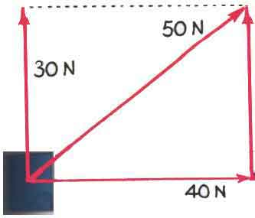
9.2 | Explain the difference between vector and scalar quantities using examples  Vectors like velocity have magnitude (size) and direction and scalers like speed have just magnitude
9.3 | Use vector diagrams to illustrate resolution of forces, a net force, and equilibrium situations (scale drawings only)  Resultant force = zero  Resultant force is to the right | 4a, 5a, 5b
9.4 | Draw and use free body force diagrams  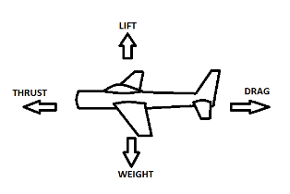 | 4a, 5a, 5b
9.5 | Explain examples of the forces acting on an isolated solid object or a system where several forces lead to a resultant force on an object and the special case of balanced forces when the resultant force is zero  Like the diagrams in 9.3 | 5a
9.10 | Explain ways of reducing unwanted energy transfer through lubrication  Oil on a hinge reduces friction which will reduce heat lost to the environment

Topic 10 – Electricity and circuits

Students should: | Maths skills
10.1 Describe the structure of the atom, limited to the position, mass and charge of protons, neutrons and electrons.  Particle Mass Charge Position  Proton 1 +1 Nucleus  Neutron 1 0 Nucleus  Electron 1/2000 -1 Shells | 5b
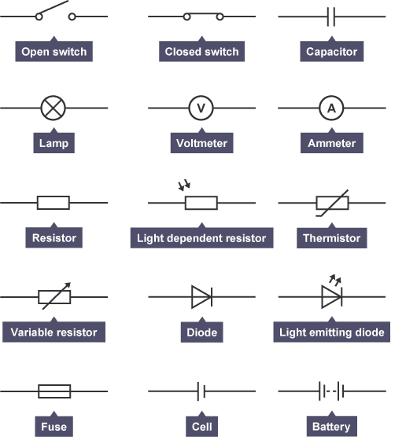  10.2 Draw and use electric circuit diagrams representing them with the conventions of positive and negative terminals, and the symbols that represent cells, including batteries, switches, voltmeters, ammeters, resistors, variable resistors, lamps, motors, diodes, thermistors, LDRs and LEDs. | 5b
10.3 Describe the differences between series and parallel circuits.
Series have 1 loop and parallel have more than 1 loop.
10.4 Recall that a voltmeter is connected in parallel with a component to measure the potential difference (voltage), in volt, across it
10.5 Explain that potential difference (voltage) is the energy transferred per unit charge passed and hence that the volt is a joule per coulomb. 1 Amp means 1C of charge flows in 1 second | 1a, 1c  3c
10.6 Recall and use the equation:  energy transferred (joule, J) = charge moved (coulomb, C) × potential difference (volt, V)  E = Q ×V  e.g What charge flows with 6V and 2400J of energy  coulomb = 2400J / 6V = 400C | 1a, 1b, 1c, 1d 2a  3a, 3b, 3c, 3d
10.7 Recall that an ammeter is connected in series with a component to measure the current, in amp, in the component
10.8 Explain that an electric current as the rate of flow of charge and the current in metals is a flow of electrons ( see 10.5)
10.9 Recall and use the equation:  charge (coulomb, C) = current (ampere, A) × time (second, s)  Q = I × t  e.g. 3Amps flowing for 60secs = 3A X 60s = 180C | 1a, 1b, 1c, 1d 2a  3a, 3b, 3c, 3d
10.10 Describe that when a closed circuit includes a source of potential difference there will be a current in the circuit. Source = cell. Closed = A complete circuit.
10.11 Recall that current is conserved at a junction in a circuit
10.12 Explain how changing the resistance in a circuit changes the current and how this can be achieved using a variable resistor.
More resistance means less current can flow

10.13 Recall and use the equation:  potential difference (volt, V) = current (ampere, A) × resistance (ohm, Ω)  V = I × R  What current flows through a 200Ω resistor from a 6V cell?  I = V/R 6/200 = 0.03A | 1a, 1d 2a  3a, 3c, 3d
10.14 Explain why, if two resistors are in series, the net resistance is increased, whereas with two in parallel the net resistance is decreased
Two 30Ω resistors in series = 30 Ω +30 Ω = 60Ω
Two 30Ω resistors in parallel. There are two paths so twice the current flows so the resistance is 15 Ω

Students should: | Maths skills
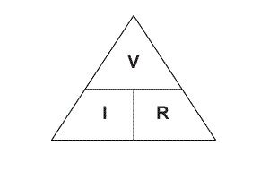  10.15 Calculate the currents, potential differences and resistances in series circuits. Make sure that you can use the equation. | 1a, 1d 2a  3a, 3c, 3d
10.16 Explain the design and construction of series circuits for testing and measuring. By using a variable resistor to control the current and then measuring the potential difference across a component using a voltmeter.
- Core Practical: Construct electrical circuits to:  - investigate the relationship between potential difference, current and resistance for a resistor and a filament lamp  - test series and parallel circuits using resistors and filament lamps | 1a, 1c, 1d 2a, 2b, 2f  3a, 3b, 3c, 3d  4a, 4b, 4c, 4d, 4e
10.18 Explain how current varies with potential difference for the following devices and how this relates to resistance  a filament lamps - more current gives heat so resistance increases. More p.d. doesn’t give the same increase in current.  b diodes – Only allows current to flow in one direction  c fixed resistors – Directly proportional. More p.d.=more current | 2g  4a, 4b, 4c, 4d, 4e
10.19 Describe how the resistance of a light-dependent resistor (LDR) varies with light intensity  More light = less resistance so more current flows | 4c, 4d
10.20 Describe how the resistance of a thermistor varies with change of temperature (negative temperature coefficient thermistors only)  More heat = less resistance so more current flows | 4c, 4d
10.21 Explain how the design and use of circuits can be used to explore the variation of resistance in the following devices  a filament lamps b diodes  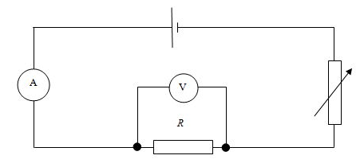  - thermistors  - LDRs | 5b
10.22 Recall that, when there is an electric current in a resistor, there is an energy transfer which heats the resistor
Electricity -> Heat
10.23 Explain that electrical energy is dissipated as thermal energy in the surroundings when an electrical current does work against electrical resistance – the heat is lost, but can be used in a kettle or a toaster
10.24 Explain the energy transfer (in 10.22 above) as the result of collisions between electrons and the ions in the lattice – more collisions between + ions in the metal and electrons causes an increase in resistance
10.25 Explain ways of reducing unwanted energy transfer through low resistance wires - make wires shorter or have a bigger diameter so more current flows for the same p.d.
10.26 Describe the advantages and disadvantages of the heating effect of an electric current – PRO – you can use the heat energy for cooking or keeping warm. CON – lose energy from the circuit into the surroundings which will increase the cost of running the appliance.

Students should: | Maths skills
10.27 Use the equation:  energy transferred (joule, J) = current (ampere, A) × potential difference (volt, V) × time (second, s)  E = I ×V × t  e.g. How much energy does a 12A kettle at 230V use in 300sec?  E = 12 x 230 x 300 = 828,000J or 828kJ | 1a, 1b, 1c, 1d 2a  3a, 3b, 3c, 3d
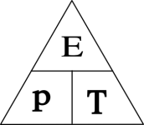  10.28 Describe power as the energy transferred per second and recall that it is measured in watt | 1c
10.29 Recall and use the equation:  power (watt, W) = energy transferred (joule, J) ÷ time taken (second, s)  e.g. A 3Kw kettle for 2 min  Energy J = 3000 x 120 = 360,000J | 1a, 1b, 1c, 1d 2a  3a, 3b, 3c, 3d
10.30 Explain how the power transfer in any circuit device is related to the potential difference across it and the current in it  Increasing p.d. or current increase the energy flow | 1a, 1c, 1d 2a  3a, 3b, 3c, 3d
10.31 Recall and use the equations:  electrical power (watt, W) = current (ampere, A) × potential difference (volt, V)  P = I ×V e.g. Power W = 5A x 230V = 1150W  electrical power (watt, W) = current squared (ampere2, A2) × resistance (ohm, Ω)  P = I 2 × R e.g. Power = 5A x 5A x 50Ω = 1250W | 1a, 1b, 1c, 1d 2a  3a, 3b, 3c, 3d
10.32 Describe how, in different domestic devices, energy is transferred from batteries (electrons flow to the motor/heater giving up their energy before going back to the battery to collect more) and the a.c. mains (electrons vibrate and pass on energy) to the energy of motors and heating devices
10.33 Explain the difference between direct and alternating voltage | 4c
10.34 Describe direct current (d.c.) as movement of charge in one direction only and recall that cells and batteries supply direct current (d.c.) – Go from the –ve to the +ve terminals of the cell
10.35 Describe that in alternating current (a.c.) the movement of charge changes direction - They vibrate back and forth in the wire
10.36 Recall that in the UK the domestic supply is a.c., at a frequency of 50 Hz and a voltage of about 230 V
10.37 Explain the difference in function between the live and the neutral mains input wires– LIVE varies between +230V and -230V at 50 times each second, 50Hz. NEUTRAL kept at 0V
10.38 Explain the function of an earth wire and of fuses or circuit breakers in ensuring safety – If the live touches a metal case which is earthed, a large current flows to earth. This current goes through the fuse which melts, breaking the circuit. Circuit breakers detect high currents and open a switch. They can be reset later.
10.39 Explain why switches and fuses should be connected in the live wire of a domestic circuit - The earth and neutral are at 0V so no energy. Live is at 230V, so lots of energy.

Students should: | Maths skills
10.40 Recall the potential differences between the live, neutral and earth mains wires
LIVE – EARTH = 230V
LIVE – NEUTRAL = 230V
EARTH – NEUTRAL = 0V
10.41 Explain the dangers of providing any connection between the live wire and earth – this can cause a large current to flow
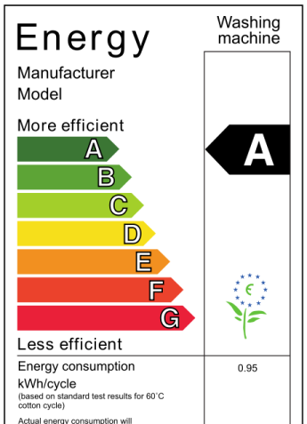  10.42 Describe, with examples, the relationship between the power ratings for domestic electrical appliances and the changes in stored energy when they are in use  Washing machine -  Electrical -> Heat + Kinetic energy + sound  An efficient washing machine converts the electrical energy into useful energy like heat and movement and not a lot of sound. | 1c 2c

Topic 12 – Magnetism and the motor effect

Students should: | Maths skills
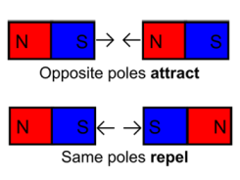
12.1 Recall that unlike magnetic poles attract and like magnetic poles repel
12.2 Describe the uses of permanent and temporary magnetic materials including cobalt, steel, iron and nickel – can separate Al and Fe cans, move cars in a scrapyard and make speakers in a hifi work.
12.3 Explain the difference between permanent and induced magnets - permanent are there all the time and induced only last when a current is flowing through a coil of wire.
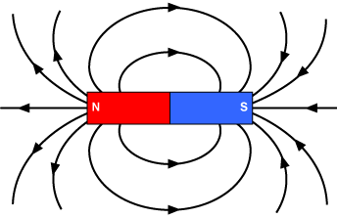  12.4 Describe the shape and direction of the magnetic field around bar magnets and for a uniform field, and relate the strength of the field to the concentration of lines | 5b
12.5 Describe the use of plotting compasses to show the shape and direction of the field of a magnet and the Earth’s magnetic field - plotting compass is a tiny magnet | 5b
12.6 Explain how the behaviour of a magnetic compass is related to evidence that the core of the Earth must be magnetic - always points in a North South direction | 5b
12.7 Describe how to show that a current can create a magnetic effect around a long straight conductor, describing the shape of the magnetic field produced and relating the direction of the magnetic field to the direction of the current – circles of a force field go around the wire. RH rule, thumb = current direction and fingers show field rotation. | 5b
12.8 Recall that the strength of the field depends on the size of the current and the distance from the long straight conductor – increased current = larger field strength and the field gets weaker further away from the wire
- Explain how inside a solenoid (an example of an electromagnet) the fields from individual coils  - add together to form a very strong almost uniform field along the centre of the solenoid – strong through the core  - cancel to give a weaker field outside the solenoid – weak on the outside because the fields cancel each other out | 5b
- Recall that a current carrying conductor placed near a magnet experiences a force and that an equal and opposite force acts on the magnet  – This causes a force on the wire and the magnet, but wires are light so they move and the magnet stays still | 5b
  - Explain that magnetic forces are due to interactions between magnetic fields
– repulsion or attraction
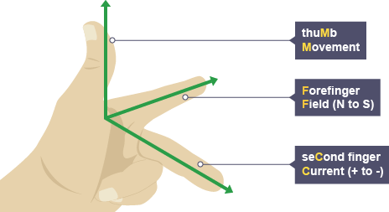  12.12 Recall and use Fleming’s left-hand rule to represent the relative directions of the force, the current and the magnetic field for cases where they are mutually perpendicular | 5b

Students should: | Maths skills
12.13 Use the equation:  force on a conductor at right angles to a magnetic field carrying a current (newton, N) = magnetic flux density (tesla, T or newton per ampere metre, N/A m) × current (ampere, A) × length (metre, m)  F = B × I × l  e.g. What force acts a wire 0.5m long carrying 3A in a field of strength 0.2T?  Force N = 0.2T x 3A x 0.5m = 0.3N | 1a, 1c, 1d 2a  3a, 3b, 3c, 3d

Topic 13 – Electromagnetic induction

Students should: | Maths skills
13.2 Recall the factors that affect the size and direction of an induced potential difference, and describe how the magnetic field produced opposes the original change - 4 factors  – magnetic field strength, direction of field, number of turns on the coil and the current through the coil | 5b
13.5 Explain how an alternating current in one circuit can induce a current in another circuit in a transformer
- two circuits connected by an iron core ( ring )
13.6 Recall that a transformer can change the size of an alternating voltage
- different numbers of turns on each coil
13.8 Explain why, in the national grid, electrical energy is transferred at high voltages from power stations, and then transferred at lower voltages in each locality for domestic uses as it improves the efficiency by reducing heat loss in transmission lines
– High voltage means low current. Energy loss through heat relates to the square of the current so ½ current means ¼ less heat produced ( ½ x ½ = ¼)
13.9 Explain where and why step-up and step-down transformers are used in the transmission of electricity in the national grid
– Step down near homes and factories to lower the voltage to make them safer and less chance of large shocks
Students should: | Maths skills
13.10 Use the power equation (for transformers with 100% efficiency):  potential difference across primary coil (volt, V) × current in primary coil (ampere, A) = potential difference across secondary coil (volt, V) × current in secondary coil (ampere, A)  VP × IP = VS × IS  Current on secondary coil? Vp = 2,000V, Ip = 30A and Vs = 12,000V  2000 x 30 = 12000 x Is  Is = 2000 x 30 = 5A  12000 | 1a, 1c, 1d 2a  3a, 3b, 3c, 3d

Topic 14 – Particle model

Students should: | Maths skills
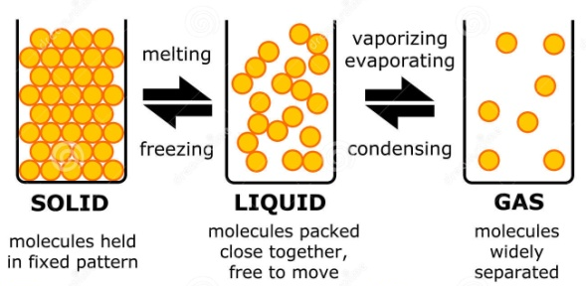
14.1 Use a simple kinetic theory model to explain the different states of matter (solids, liquids and gases) in terms of the movement and arrangement of particles
14.2 Recall and use the equation:  density (kilogram per cubic metre, kg/m3) = mass (kilogram, kg) ÷ volume (cubic metre, m3)  ρ = m  V  What is the density of a 0.5m³ block of ice of mass 478kg?  ρ = 478/0.5 = 956 kg/m3 | 1a, 1b, 1c, 1d 2a  3a, 3b, 3c, 3d 5c
14.3 Core Practical: Investigate the densities of solid and liquids | 1a, 1b, 1c, 1d 2a, 2c, 2f  3a, 3b, 3c, 3d 4a, 4c  5c
14.4 Explain the differences in density between the different states of matter in terms of the arrangements of the atoms or molecules  – When you melt a solid the particles spread out into a larger volume so are less dense and when they turn into a gas, they are widely spaced so have a really large volume and a very low density. | 5b
14.5 Describe that when substances melt, freeze, evaporate, boil, condense or sublimate (goes from a solid to a gas) mass is conserved and that these physical changes differ from some chemical changes because the material recovers its original properties if the change is reversed
– You have the same number of particles, but they are arranged differently, more spread out
14.6 Explain how heating a system will change the energy stored within the system and raise its temperature or produce changes of state – Gives particles more energy so they break the bonds between them and then change state
14.7 Define the terms specific heat capacity ( Energy needed to raise the temperature of 1kg by 1ºC ) and specific latent heat and explain the differences between them
– energy needed to change the state of 1kg of substance
14.8 Use the equation:  change in thermal energy (joule, J) = mass (kilogram, kg) × specific heat capacity (joule per kilogram degree Celsius, J/kg °C) × change in temperature (degree Celsius, °C)  ΔQ = m × c × Δθ  Energy needed to heat 2kg of water (SHC = 4200 J/kg °C) by 30°C?  E = 2 x 4200 x 30 = 252,000J or 252kJ | 1a, 1b, 1c, 1d 2a  3a, 3b, 3c, 3d
14.9 Use the equation:  thermal energy for a change of state (joule , J) = mass (kilogram, kg) × specific latent heat (joule per kilogram, J/kg)  Q = m × L  Energy needed to turn 4kg of water into steam (SLH of water is 2.26 x 10⁶ J/kg)  E = 4 x 2.26 x 10⁶ = 9.04 x 10⁶ J | 1a, 1b, 1c, 1d 2a  3a, 3b, 3c, 3d
14.10 Explain ways of reducing unwanted energy transfer through thermal insulation - A barrier stops the heat transfer to the surroundings. E.g. a wooly jumper keeps you warm in winter.

Students should: | Maths skills
14.11 Core Practical: Investigate the properties of water by determining the specific heat capacity of water and obtaining a temperature-time graph for melting ice | 1a, 1b, 1c, 1d 2a, 2b, 2f  3a, 3b, 3c, 3d  4a, 4c, 4e
14.12 Explain the pressure of a gas in terms of the motion of its particles - Gas particles collide with the walls of a container creating a force – this leads to pressure | 5b
14.13 Explain the effect of changing the temperature of a gas on the velocity of its particles and hence on the pressure produced by a fixed mass of gas at constant volume (qualitative only) – High temperature means particles move faster with more collisions so increased pressure | 5b
14.14 Describe the term absolute zero, −273 °C, in terms of the lack of movement of particles – The particles stop vibrating so have no energy
14.15 Convert between the kelvin and Celsius scales  K = C – 273º C = K +273º | 1a  2a

Topic 15 – Forces and matter

Students should: | Maths skills
15.1 Explain, using springs and other elastic objects, that stretching, bending or compressing an object requires more than one force - To compress or stretch a spring you need to push or pull at BOTH ends
15.2 Describe the difference between elastic ( goes back to shape ) and inelastic distortion (changes shapes)
15.3 Recall and use the equation for linear elastic distortion including calculating the spring constant:  force exerted on a spring (newton, N) = spring constant (newton per metre, N/m) × extension (metre, m)  F = k × x  Force needed to extend a wire by 0.025m whose spring constant is 6x10⁶ N/m?  Force = 6x10⁶ x 0.025 = 150,000N | 1a, 1c, 1d 2a  3a, 3b, 3c, 3d
15.4 Use the equation to calculate the work done in stretching a spring:  energy transferred in stretching (joules, J) = 0.5 × spring constant (newton per metre, N/m) × (extension (metre, m))2  E = 1 × k × x 2  2  The energy for the above example is  E = 0.5 x 6x10⁶ x 0.025 x 0.025 = 1,875J | 1a, 1c, 1d 2a  3a, 3b, 3c, 3d 4c, 4e, 4f
15.5 Describe the difference between linear ( a straight line going through the origin of a force / extension graph) and non-linear ( curved line) relationships between force and extension | 4c, 4e
15.6 Core Practical: Investigate the extension and work done when applying forces to a spring | 1a, 1c, 1d 2a, 2b, 2c, 2f 3a, 3b, 3c, 3d  4a, 4b, 4c, 4d

