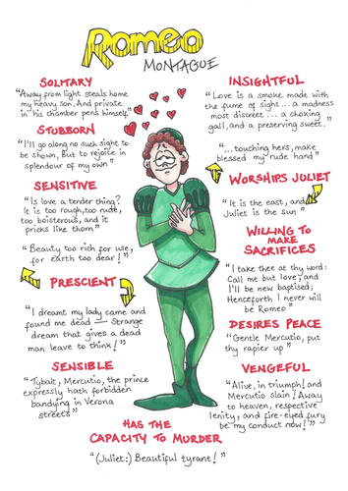
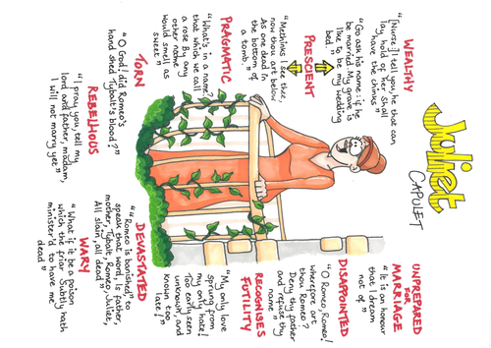
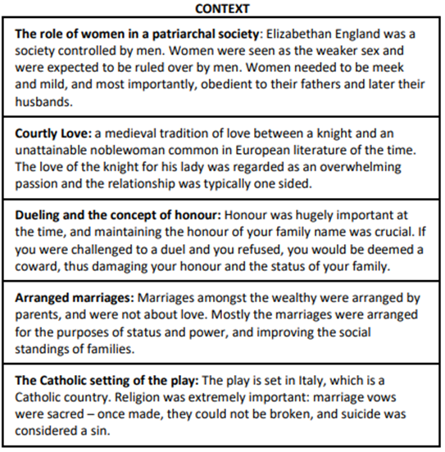
Astrology the Supernatural – At the time of Shakespeare, the belief in both astronomy and the supernatural was far more preeminent than in society today. The reference to ‘star-cross’d lovers demonstrates the large role of astrology in being used to predict fate – an interest of Queen Elizabeth I. Also, Romeo and Juliet make reference to the fact that they feel they are being guided by a supernatural force (e.g. ‘fortune’s fool).
Title: Shakespeare’s Romeo and Juliet SOW: AQA GCSE English Literature Paper 1 Section A Date: Summer Y10/Autumn Y11
Themes
LOVE: relationships. friendships, family, loyalty, attraction, (un)requited
CONFLICT: violence, hatred, feud, fighting, disagreements, to disobey, internal-conflict, disorder, chaos, opposites
DEATH: revenge, accidental, by choice, threats, finality
FAMILY: parents, close friends, confidantes, secrets, duty to obey, parental figures,
OLD vs YOUNG: traditional attitudes, immaturity, quick to anger, wisdom
RELIGION: rules, expectations, traditions, standards, respect
FATE: destiny, higher power, status
FATE: pre-determined path, no control, inevitability,

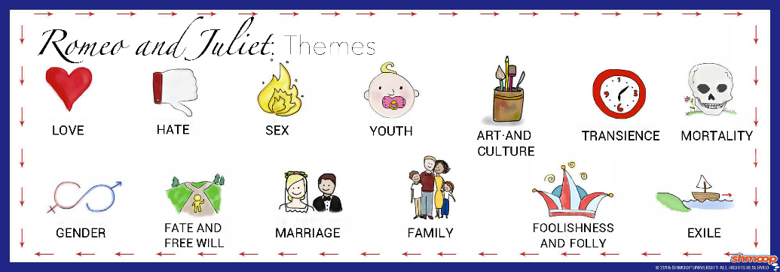
Tier 3 Vocabulary
Term | Definition
Dramatic Irony | When the audience has awareness of a situation which the characters do not.
Soliloquy | Passage in a drama in which a character expresses his thoughts or feelings aloud while alone upon the stage
Climax | The point at which the highest level of interest and emotional response is achieved. The peak of the drama.
Iambic Pentameter | A rhythm structure that combines five unstressed syllables and stressed syllables (an iamb) in one line of verse
Shakespearean Sonnet | A 14 line poem consisting of the rhyme scheme ABABCDCDEFEFGG
Oxymoron | Two words with opposite meaning, next to each other
Tragedy | These types of plays end on a tragic note and most likely a character’s death.
Masculinity | Qualities or attributes regarded as characteristic of men.
Femininity | Qualities or attributes regarded as characteristic of women.
Elizabethan Chain of Being | A hierarchical structure thought to have been decreed by God. The chain begins with God and descends through angels, humans, animals and plants to minerals.
Overzealous | Too eager/too excited
Fickle | Quick to change your mind, therefore unreliable
Patriarchy | A system whereby the male gender has power and rule over society
Hierarchy | A ranking order, with the most powerful at the top
Dominant | Stronger (superior) and more powerful than those below
Subordinate | Weaker (inferior) and less powerful than those above
Key Characters
Romeo Montague: Tragic Hero, Romantic, Hubristic, Fickle, Hyperbolic, Impulsive, Melancholic, Ardent, Obsessive, Foolish, Intense
Juliet Capulet: Idealistic, Innocent, Naïve, Victim, Rebellious, Unworldly, Resolute, Obsessive.
Benvolio: The Voice of Reason, Appeasing, Sincere, Loyal, Rational, Reliable
Mercutio: Comedic, Anarchic, Misogynistic, Chaotic, Precocious, Immature, Victim
Tybalt: Volatile, Tempestuous, Righteous, Aggressive, Challenging, Stubborn, Amoral
Nurse: Maternal, Submissive, Uncouth, Caring, Honest, Brave, Betrays Juliet
Capulet: Aggressive, Powerful, Controlling, Traditional, Foolish, Immature, Proud
Lady Capulet: Unmaternal, Traditional, Ruthless, Obedient, Disappointing
Friar Lawrence: Creative, Wise (to a degree), Foolish (to a degree), Sympathetic
Prince Escalus: Powerful, Intolerant (to a degree), Victim, Guilty, Ineffective, Proud

Title: Shakespeare’s Romeo and Juliet SOW: AQA GCSE English Literature Paper 1 Section A Date: Summer Y10/Autumn Y11
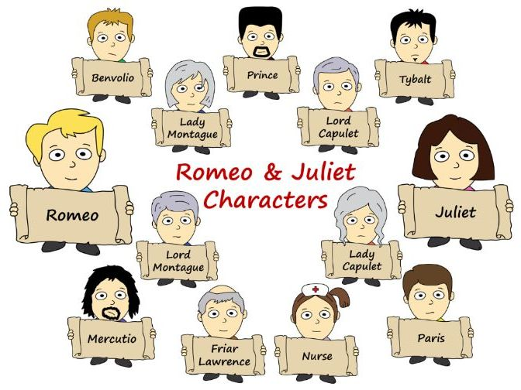
Features of Tragedy in Romeo and Juliet
Tragic Hero: A character in a dramatic tragedy who has virtuous and sympathetic traits but ultimately meets with suffering or defeat.
Fatal Flaw (Hamartia): a fault that leads to deadly consequences – Romeo’s fatal flaw is his impulsiveness.
Hubris: God-like arrogance, excessive pride.
Catharsis: the release of the audience’s emotions through empathy with the characters.
Internal Conflict: the struggle the hero engages in with his fatal flaw.
Chaos - disorder ensues when the Tragic Hero has succumbed to their fatal flaw (hamartia) – impacts plot, character and setting.

