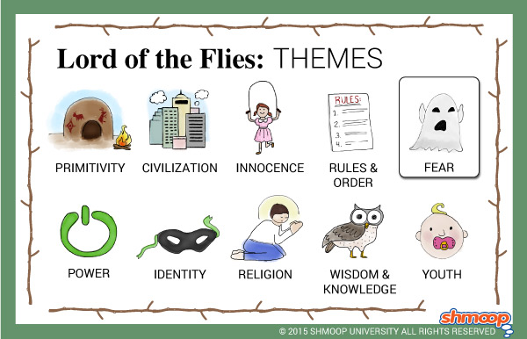

**Powerful knowledge**

**Human nature:** The arrival of the boys marks the destruction of the island, representing the destructive quality of human nature. The plane leaves a “scar” and in the final chapter the “island is scorched up like deadwood”.

**Regression:** the boys’ descent into savagery represents how civilisation is a veneer for what mankind’s true desires are/ vulnerability to corruption.

**Freud’s Personality Theory**: Golding uses the characters to personify each element that is within us all. Ralph=ego, Piggy=superego and Jack=id.

**Symbolism: The conch**—civilisation, democracy, order. **The glasses**—intelligence, insight.**The fire**—represents hope, chaos, power and rescue. **The beast**—represents the boys’ irrational fear and explores the ideas of the “beast within” us all.**The island**—like the Garden of Eden before it was ruined by man. It’s a microcosm of the way adults are destroying the outside world. **Simon** – Jesus Christ. **The Lord of the Flies** – the power of evil.

**Context:** Writing in an era following WW2 known as the ‘atomic age’ and at the time of the ‘**Cold War’** and where also, the horrors of the holocaust were being uncovered, Golding tapped into a widespread cultural panic over nuclear destruction and man’s capacity for warfare. Golding’s experience in the Navy in WW2 had directly informed his view of man’s capacity for cruelty.

**Irony**: the irony is that the boys are playing out the bigger war going on in the adult world. The out of control fire at the end leading to rescue. Piggy has poor eyesight, but his insight and intelligence are so strong. The boys are evacuated from a war zone, only to then create one themselves.

**Violence/Brutality:** the boys (except Piggy) enjoy violence and Golding purposefully creates uncomfortable gore to highlight immorality.

**Dictatorship:** Jack takes away freedom of speech, leads a fascist regime, rules through fear, uses violence to control, manipulates the truth to suit his own agenda, represents himself as an idol and embarks upon mutually assured destruction.

**Title: *Lord of the Flies*** by William Golding **SOW:** AQA GCSE English Literature Paper 2 Section A  **Date:** Autumn Y10

**Key skills**

**Point** – use keyword vocabulary, be detailed and specific.

**Evidence** – quotation from the text – ideally select the key part. You can use a very specific reference.

**Explain and explore**– how does this prove your point/link to the question?

**Word or methods analysis** – Golding’s use of ……. Is effective because… This conveys…

**Evaluate and Link** – explore the significance of your ideas and explore the context and Golding’s message. Connect back to the question’s focus.

**Key Questions**

Who, or what, truly is the beast?

Is Ralph a fool or is he blameless?

Is civilisation a vulnerable façade?

Are we all capable of terrible cruelty?

Why are some people not in support of a Democracy?

Is Piggy guilty of not using his intelligence to a greater effect?

How do the boys’ identities impact upon their behaviours?

How does Golding highlight mankind’s doom in the novel?

How do the boys lose their innocence?

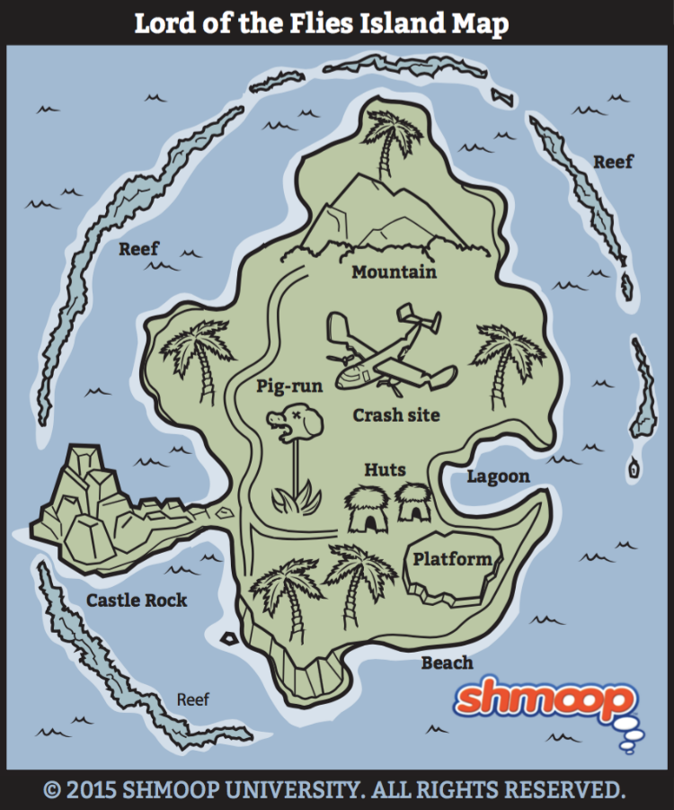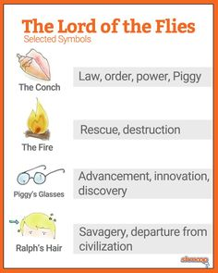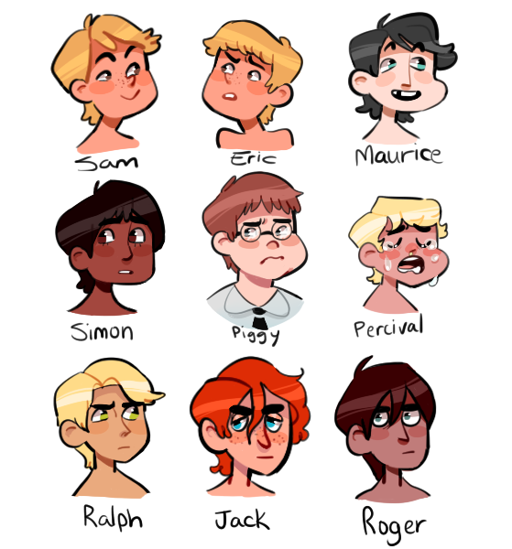

|  |  |
| --- | --- |
| **Tier 3 Vocabulary** | |
| **Allegory** | A story, poem, or picture that can be interpreted to reveal a hidden meaning, typically a moral or political one. |
| **Microcosm** | A community, place, or situation regarded as encapsulating in miniature the characteristics of something much larger. |
| **Dystopia** | An imagined state or society in which there is great suffering or injustice, typically one that is totalitarian or post-apocalyptic. |
| **Persecution** | Hostility and ill-treatment, especially because of race or political or religious beliefs; oppression. |
| **Primitive** | Being the first or earliest of the kind or in existence |
| **Themes**  **Rules and Order**  **Loss of innocence**  **Savagery, primitivity and animalism**  **Civilisation and its vulnerability**  **Evil**  **Conflict, violence and war**  **Identity** | |
| **Character**  **Ralph –** leader, ineffective, confident, protagonist, immature, democratic, passive  **Piggy –** victim, intelligence, guide, caring, lower class,unchanged,  **Jack –** violent, bully, leader, antagonist, irresponsible,dictator,active, animalistic  **Simon –** sacrifice, perceptive, weak, appreciative of the natural world  **Sam and Eric –** Sam’n’Eric, samneric, identity, hopelessness,  **Roger**­ – sadistic, reckless, brutal, irresponsible | |

**Title: *Lord of the Flies*** by William Golding **SOW:** AQA GCSE English Literature Paper 2 Section A  **Date:** Autumn Y10

|  |  |
| --- | --- |
| **Tier 3 Vocabulary** | |
| **Omniscient narrator** | All-seeing voice, narrating the story. |
| **Sadistic** | Deriving pleasure from inflicting pain, suffering, or humiliation on others |
| **Civilisation** | The process by which a society reaches an advanced stage of social, moral and cultural development and organisation. |
| **Regression** | A return to a former or less developed state |
| **Pathos** | A quality that evokes pity or sadness. |
| **Dualistic Society** | The coexistence of two different types of economies or societies within one nation |
| **Veneer** | Fragile cover |
| **Savagery** | The quality of being fierce or cruel, primitive or uncivilised. |
| **Chaos** | Complete disorder and confusion. |
| **Democracy** | Democracy is a form of government in which the people have the authority to deliberate and decide legislation, or to choose governing officials to do so |
| **Morality** | Principles concerning the distinction between right and wrong or good and bad behaviour. |
| **Inherent** | Existing in something as a permanent, essential, |
| **Naïve** | Showing a lack of experience, wisdom, or judgement. |
| **Mutually Assured Destruction** | The understanding that your own demise is a certainty if you unleash your most powerful weapon on your enemy (Nuclear weapons). |
| **Dictator** | A ruler with total power. |