**Powerful Knowledge Organiser: Writer’s Viewpoints and Perspectives SOW: AQA English Language Paper 2 Section B Date: Y10 Summer/ Autumn 1**

**Powerful knowledge – Structure**

**P**owerful image connected to question

**A**ngle of your viewpoint

**R**eason 1

**R**eason 2

**R**eason 3

**R**eason 4+

**O**n the other hand – disprove counterargument

**T**ie back to your powerful image

**Powerful knowledge – Paragraphing**

* New idea/ different focus = **new paragraph**
* Paragraphs should mostly be **4/5 sentences in length**
* Use the structure of **WHAT HOW WHY** or **PROBLEM SOLUTION BENEFITS** to layer the depth of the reasons/ideas in your paragraph
* Engaging paragraph **opening sentences** – grab your reader
* Use **connectives** to create cohesion in your paragraphing
* **Avoid** ‘The’ or ‘I’ or ‘A’ as a paragraph start
* Use a **one sentence paragraph** to make a bold, important statement once
* It should be easy to **summarise your paragraph** into a few keywords. E.g if the question was about holidays then one paragraph might be defined as ‘cost of holidays’
* Use **a variety of sentence types** (vary syntax) within a paragraph

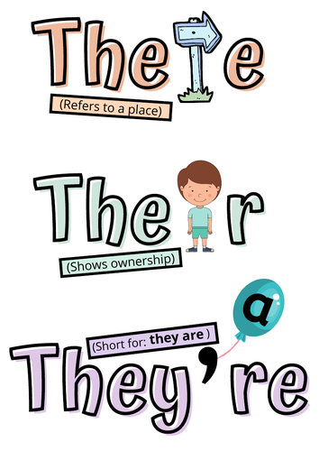



**Powerful knowledge – Methods**

* Strategically use a **semantic field** that will emphasise your idea/ key message.
* Use a **cyclical structure** to create a clear conclusion and create emphasis for key points. You might link explicitly or implicitly – choose for effect.
* Create a tone for a purpose – this tone could change at different points to create your desired effect. **Tone= attitude**
* Can you create a motif or use **symbolism** to further highlight your ideas.
* Use **persuasive and rhetorical devices** for effect- do not use as a checklist and ‘shoehorn’ into your writing, only employ these methods when it fulfils your purpose!
* Can you create an extended metaphor to emphasise a key idea or convince your reader to agree with your opinion?
* An anecdote or expert opinion can be used strategically for effect but only if well planned and is cohesive within your writing.

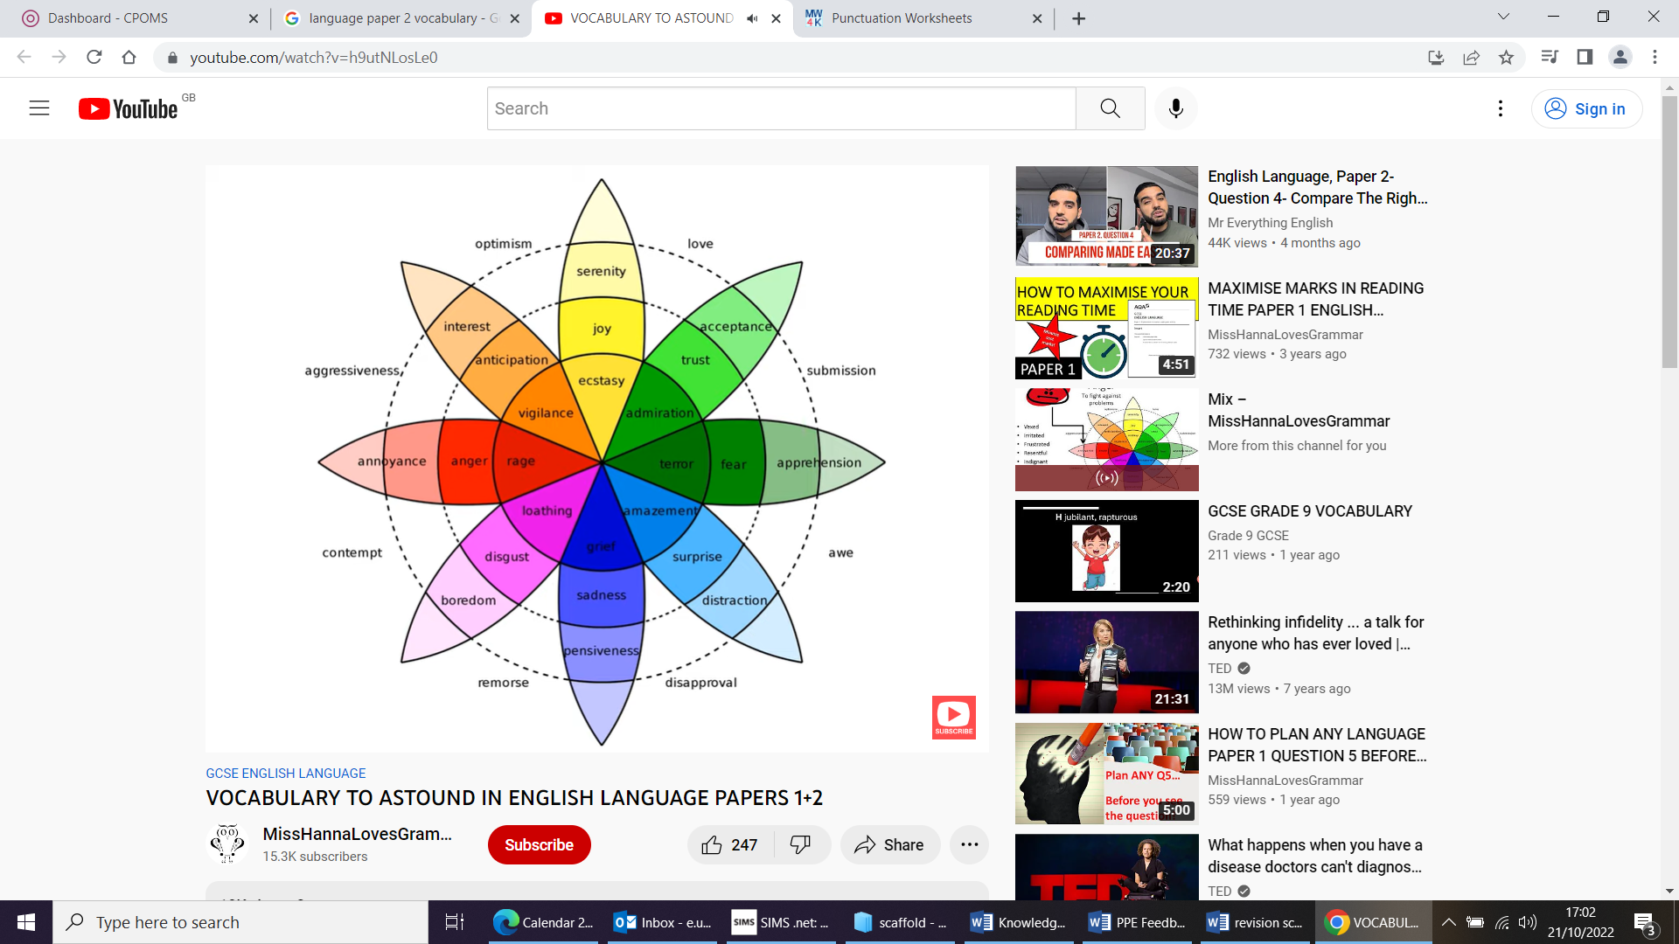

**ALWAYS spend 5 minutes planning at the start, 35 minutes writing and leave 5 minutes at the end to proof read!**

**Powerful knowledge – Tier 3 Vocabulary**

* Argument
* Viewpoint
* Perspective
* Hypothesis
* Reasons
* Bias
* Manipulation
* Counterargument
* Emotive language
* Rhetoric
* Persuasive
* Cohesion
* Quintessentially
* Unequivocally
* Fundamentally
* Significantly
* Paramount

**Powerful knowledge – Avoid vague language:**

* ~~Good~~
* ~~Bad~~
* ~~Happy~~
* ~~Sad~~
* ~~Light~~
* ~~Dark~~
* ~~Exciting~~
* ~~Amazing~~
* ~~Boring~~
* ~~Rubbish~~
* ~~Emotional~~

**Powerful knowledge – Punctuation**

* **Commas ,** used to separate clauses or when listing ideas or for an intentional pause.
* **Semi colon ;** connects two independent clauses that are closely related. **TOP TIP** – a semi colon can replace ‘so’ when it is used as a connective.
* **Colon :** introduces a list or can introduce a closely related idea to what has been written before it. **TOP TIP** a colon can be used in the same way as a hash tag online.
* **Exclamation mark !** creates emphasis/attention after a point or suggests strong feelings towards an idea.
* **Dash and hyphen –** a dash is used to create a dramatic pause between ideas or can show a connection between related ideas. A hyphen joins two words together.
* **Ellipsis …** is used to create a dramatic pause, build tension or can link ideas together.
* **Parenthesis ( )** inserting extra information within a sentence.
* **Asterix \*** signifies that further information relating to an idea will be included at the bottom of a page to provide clarification.
* **Stroke or Slash /** suggests a close connection between the two words either side.

**Focus on the argument and shape your writing around this.**

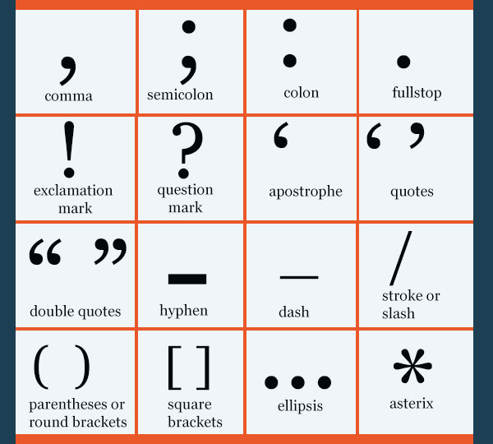

**Powerful knowledge –**

**Sentence Types (syntax)**

* Complex and compound sentences
* Embedded clauses
* Sentences that begin with the verb
* Sentence that begin with an adverb (adverbial fronted)
* One word sentence
* Repeated sentence for impact
* Rhetorical question

