**Powerful knowledge –Question 1**

* 5 mins to answer 4 questions
* Select the 4 true statements using the specified line numbers
* Double check that you have read the statement carefully
* Fill the box in when you are sure

**Powerful knowledge – Reading**

* 10 minutes to read both sources.
* Read the context boxes carefully, they will give you clues and help you decode some of the text.
* After reading the first source, draw a stickman and label with keywords to describe the writer’s feelings, attitude and experience.
* After reading the second source, draw a stickman and label with keywords to describe the writer’s feelings, attitude and experience.

**Title: Writer’s Viewpoints and Perspectives SOW: AQA English Language Paper 2 Section A Date: Y11 Autumn 1**

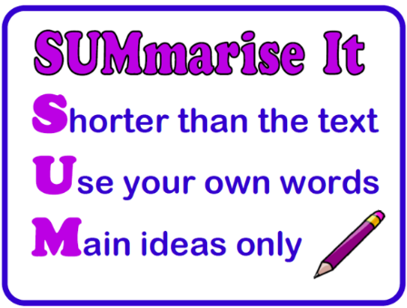

**Powerful Knowledge Question 2**

**Inference and Summary**

8 marks = 10 minutes

***This question asks you to write a SUMMARY COMPARISON of a particular aspect of the two texts (Source A and B.) e.g. ‘Write a summary of the different / similar ways people are affected by the weather’.***

***You must write about both Sources.***

***DO NOT refer to writers’ methods***

**P -** In source A the writer present...

**E -** This is shown when…

**I -**From this I can infer…

**C -** This conveys/ this could suggest…

**S -**This is significant because….

**X -** Similarly/however in source B the writer presents…

**E -** This is shown when…

**I -** From this I can infer…

**C -** This conveys/ this could suggest…

**S -** This is significant because…

**Stretch it!** Can you develop your inferences to explore abstract ideas? What is the writer revealing? What alternative interpretations can you explore?

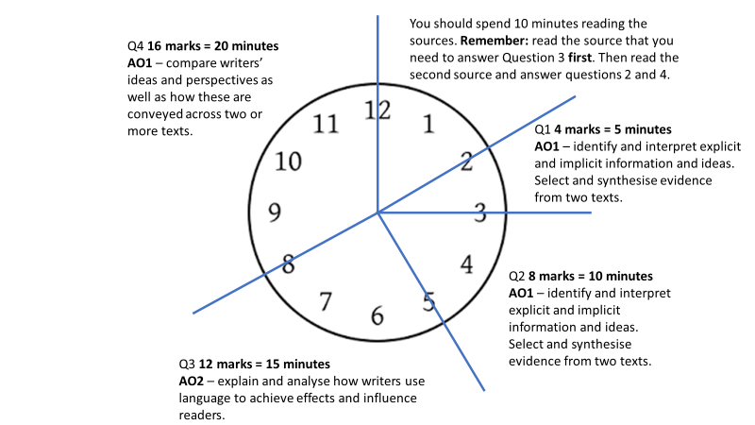

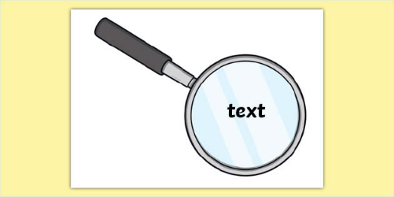

**Powerful Knowledge Question 4**

***Compare the viewpoints of both writers on…***

16 marks = 20 minutes

Using the whole of Source A and Source B to compare:

a) The writers’ perspectives, viewpoints and attitudes

b) The methods they use to convey these perspectives, viewpoints and attitudes (e.g. language techniques, structure etc.)

Structure is a useful method to look out for- especially if the tone changes through the progression of the text, e.g. an optimistic tone changing to a despondent tone.

Look to find opportunities to compare ‘like with like’

Focus on the writers’ choices and their intended effect on the reader

Introduce your comparison then create 3 comparison paragraphs using this structure…

* P - In Source A the writer presents their perspective as…
* E - This is shown when…
* E - This conveys…
* A - The writer’s use of ….. is effective because…
* L - This is significant because (link back to the question)
* X -Whereas/Similarly the writer of Source B presents their perspective as…
* E - This is shown when…
* E - This conveys…
* A - The writer’s use of ….. is effective because…
* L - This is significant because (link back to the question)

**Stretch it!** Zoom in on subtle areas to compare and be perceptive!

Conclusion

Ultimately, whose perspective do you connect with or agree with more? Why?

**Powerful Knowledge Question 3**

***How does the writer use language to*…**

12 marks = 15 minutes

Aim for 3 analytical paragraphs, exploring the effects of language.

**P**oint/statement *‘The writer has used…’*

**E**vidence – be sharp and precise with your selection *‘This is presented…’*

**A**nalyse the effects on the reader *‘The writer’s use of [method] is effective because…’*

* How has the writer’s choice of methods been effective?
* What is the writer conveying?
* Why is this significant?
* What do the word choices connote when you zoom in?

**L**ink your idea by connecting back to the question *‘Therefore the writer has…’*

**Stretch it!** Can you explore alternative ideas? Can you explore how the author reinforces their ideas through repeated imagery, extended metaphors, semantic fields or sensory language?

**Tier 3 Vocabulary**

Tone

Attitude

Perspective

Viewpoint

Anchored

Bias

Manipulation

Context

Era

Overall

However

In contrast

Conversely

Similarly

Additionally

Nevertheless

Furthermore

Moreover

Suggests

Emphasises

Conveys

Portrays

Illustrates

Presents

Represents

Implies

Evokes

Displays

Demonstrates

Indicates

Reveals

HighlightsSymbolises

**Title: Writer’s Viewpoints and Perspectives SOW: AQA English Language Paper 2 Section A Date: Y11 Autumn 1**