**Powerful knowledge – Reading**

* 15 minutes to read the extract.
* Read the context box carefully, this will give you clues and help you decode some of the text.
* Read the extract once for pleasure and comprehension.
* On the second reading you are securing your comprehension.
* You have time to read for a third time if you are still not 100% secure in your understanding of the extract.
* Focus on what you learn about the character throughout – do you change your opinion of them? When? Why? What do you learn about the setting and how it is described? When does the author change the focus? What kind of genre do you think this is? If it’s not the opening page, what might have happened before the extract? What might happen after it?

**Title: Explorations in Reading and Creative Writing SOW: AQA English Language Paper 1 Section A Date: Y10 Autumn 1**

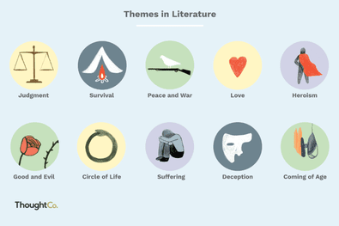



**Powerful knowledge –Question 1**

* 5 mins to answer 4 questions
* You do not need to write in full sentences – just select the 4 pieces of information from the extract
* If the question is about a character, write the character’s name or their pronoun at the beginning of each answer to focus your response

**Powerful Knowledge Question 2**

***How does the writer use language to*…**

8 marks = 10 minutes

Aim for 3 analytical paragraphs, exploring the effects of language.

Point/statement *‘The writer has used…’*

Evidence – be sharp and precise with your selection *‘This is presented…’*

Analyse the effects on the reader *‘The writer’s use of [method] is effective because…’*

* How has the writer’s choice of methods been effective?
* What is the writer conveying?
* Why is this significant?
* What do the word choices connote when you zoom in?

Link your idea by connecting back to the question *‘Therefore the writer has…’*

**Stretch it!** Can you explore alternative ideas? Can you explore how the author reinforces their ideas through repeated imagery, extended metaphors, semantic fields or sensory language?

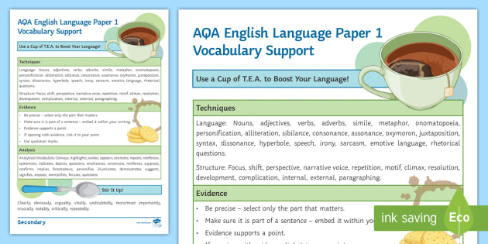

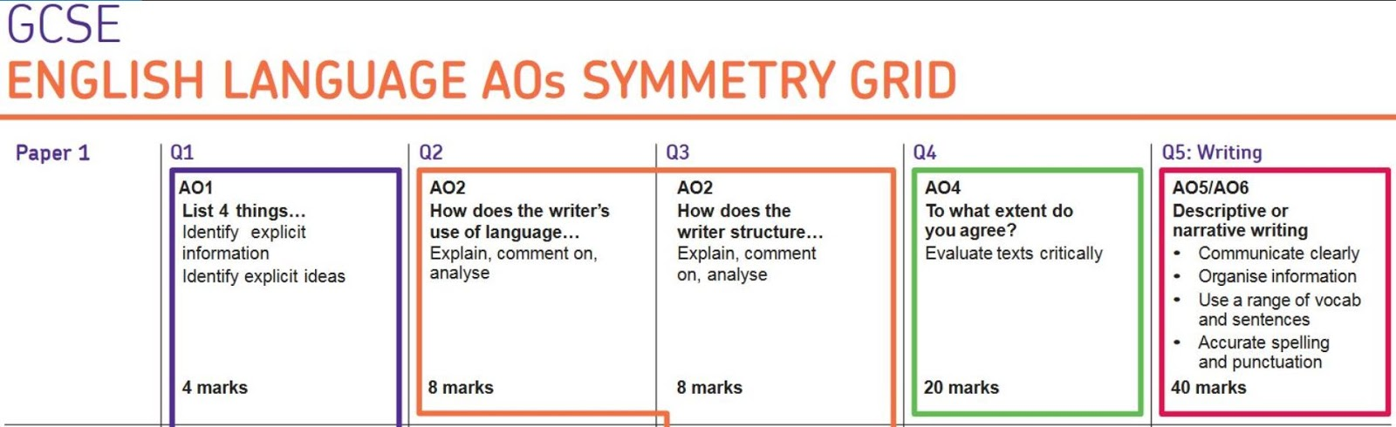

**Title: Explorations in Reading and Creative Writing SOW: AQA English Language Paper 1 Section A Date: Y10 Autumn 1**

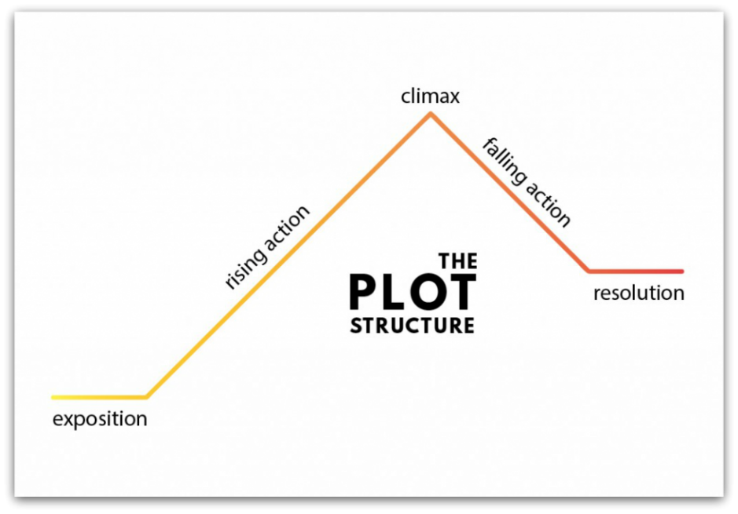

**Powerful Knowledge Question 3**

***How has the writer structure the text to interest you as the reader?***

8 marks = 10 minutes

You must imagine the creative process of the writer here – you are only focusing on their structural choices, not language!

**Focus=Setting/Character/Description/Speech**

* What is the focus in the opening? How does this interest the reader?
* What is the tone in the opening? How does this interest the reader? **Any questions?**
* Where does the focus change? Why has the writer made this choice?
* How has the tone changed now? Why is this effective? **Any questions answered or raised?**
* What is the focus in the closing of the extract and how is an interesting choice by the writer?
* Why does the tone change here? Why is this interesting to the reader? **Any questions?**
* **Stretch it! Cyclical structure** - do the opening and closing link? Why does the writer create this effect? What’s reinforced? Are we hooked?

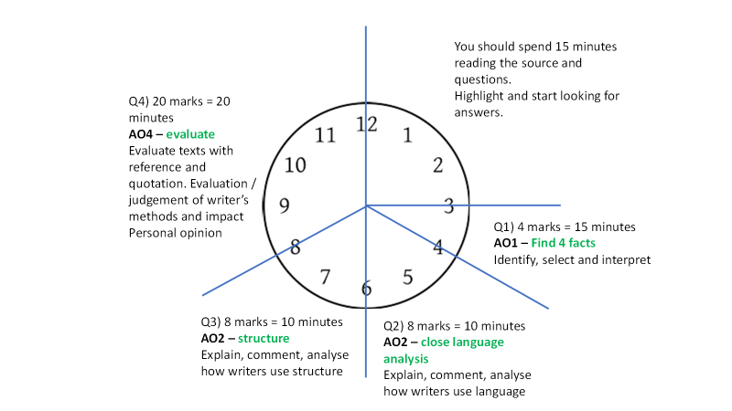

**Powerful Knowledge Question 4**

***To what extent do you agree with the statement?***

20 marks = 20 minutes

Only refer to the lines specified in the question.

You are being assessed on how well you can **EVALUATE** the text that the writer has created and their choices.

State if you agree, disagree or partially agree/disagree…

Explain your **reasons**, IN YOUR OWN WORDS, for your opinion. You may have 2 or 3 reasons.

Select evidence to support your reasons – this is your paragraph plan e.g. 4 paragraphs 2/2 split or 1/3 split

In each paragraph, **evaluate:**

* How your reason shows you agree or disagree
* Give your evidence to prove your reason
* Explain clearly how this supports your opinion
* Explore how effective the writer is here
* Explore how the writer’s use of a method creates a significant effect on the reader
* Develop your evaluation with a clear connection back to the focus of the question to fully prove your point

**Stretch it!** Focus on the writer’s purpose and how their choices are effective. Analyse the connotations of language and how this is of significance. Explore what the writer is conveying and the effects on the reader