Paper 1 Core Practical Revision
Core Practical: Using a light microscope (page 13 + 14 in revision guide)
Label the microscope
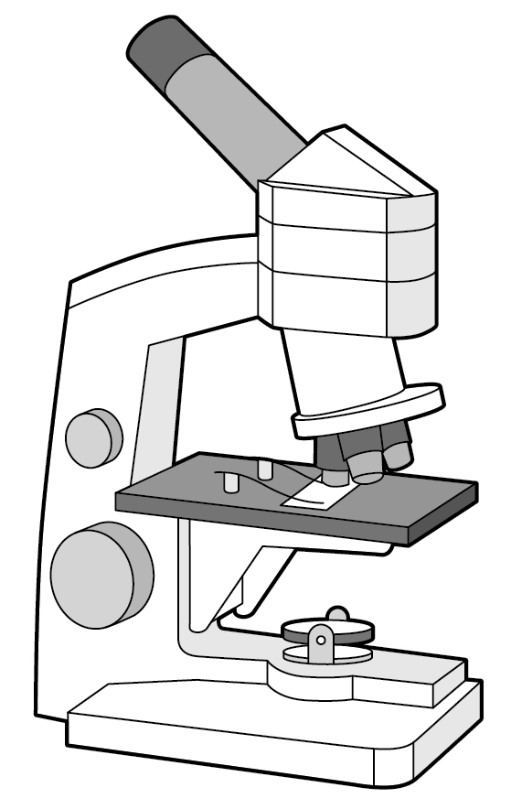
State two parts of the microscope which magnify the image
- ……………………………………………………………………………………………….
- ……………………………………………………………………………………………….

Label the items shown in the diagram

State the equation that links image size, real size and magnification (1 mark)
………………………………………………………………………………………………………………………………………………………………………………………….

State what can be done during slide preparation to make the cells more visible (1 mark)
………………………………………………………………………………………………………………………………………………………………………………………….
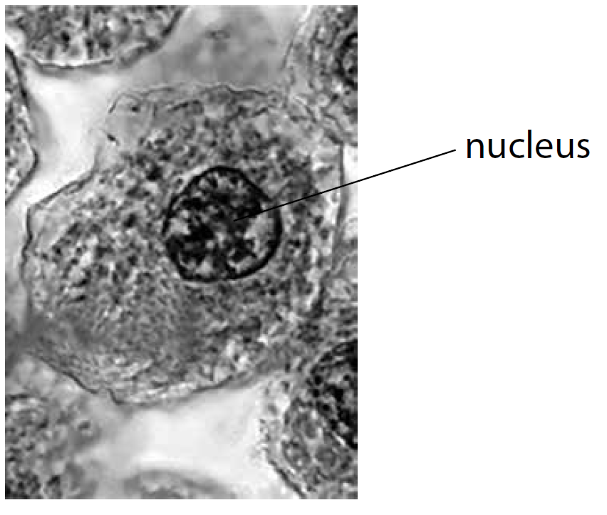
The diameter of the cell is 15um.
Convert 15um into mm (1 mark)
…………………………………………………………………………………………..

Calculate the magnification (3 marks)

…………………………………………………………………………………….

Core Practical: Investigation of how pH affects enzyme action (page 16 in revision guide)
Identify the independent, dependent and control variables for the core practical investigation
Independent : …………………………………………………………………………………………………………………………
Dependent : …………………………………………………………………………………………………………………………
Controls: ……………………………………………………………………………………………………………………………………………………………………………………………………………………………………………………………………………………………………………………………………………………………………………………
Calculate the rate of reaction using the following data
Hint: Rate is calculated by 1/time
pH | 2 | 4 | 6 | 8 | 10
Time (mins) | 20 | 7.5 | 3.6 | 1.2 | 8.3
Rate (min⁻¹)

Describe the effect of pH on the rate of reaction
Hint: Use values in your description
………………………………………………………………………………………………………………………………………………………………………………………………………………………………………………………………………………………………………………………………………………………………………………………………………………………………………………………………………………………………………………………………………………………………………………
Explain why the rate of reaction decreased at pH 10
…………………………………………………………………………………………………………………………………………………………………………………………………………………………………………………………………………………………………………………………………………………………………………………………………………………………………………………………………………………………………………………………………………………………………………………………………………………………………………………………………………………………………………………………………………………………………………
State one way the student could increase data collection to find the optimum pH
…………………………………………………………………………………………………………………………………………………………………………………………
Suggest an alternative method to investigate a different factor such as temperature or substrate concentration that affects enzyme action
Hints: Write a step by step method for one of these factors. Use amylase and starch
……………………………………………………………………………………………………………………………………………………………………………………………………………………………………………………………………………………………………………………………………………………………………………………………………………………………………………………………………………………………………………………………………………………………………………………………………………………………………………………………………………………………………………………………………………………………………………………………………………………………………………………………………………………………………………………………………………………………………………………………………………………………………………………………………………………………………………………………………………………………………………………………………………………………………………………………………………………………………………………………………………………………………………………………………………………………………………………………………………………………………………………………………………………

Core Practical: Osmosis in potato slices (page 19 in revision guide)
You were provided with different concentrations of solution and investigated osmosis in potato slices
Describe the process of osmosis (2 marks)
……………………………………………………………………………………………………………………………………………………………………………………………………………………………………………………………………………………………………………………………………………………………………………………
Describe what will happen in the following situations when an animal cell is placed in:
Hints: Where will water move? What will happen to the cell as a result?
Hypotonic solution ……………………………………………………………………………………………………………………………...........................
…………………………………………………………………………………………………………………………………………………………………………………………
Isotonic solution ……………………………………………………………………………………………………………………………..............................
…………………………………………………………………………………………………………………………………………………………………………………………
Hypertonic solution …………………………………………………………………………………………………………………………….........................
…………………………………………………………………………………………………………………………………………………………………………………………

Variables:
State the independent variable: ……………………………………………………………………………………………………………………………
State the dependent variable: …………………………………………………………………………………………………………………………………
State which variables needed to be controlled in this investigation:
…………………………………………………………………………………………………………………………………………………………………………………………
…………………………………………………………………………………………………………………………………………………………………………………………
Results:
Hint: Percentage change in mass = Change in mass/Initial mass x 100
Concentration (moldm⁻³) | Initial mass (g) | Final mass (g) | Change in mass (g) | Percentage change in mass (g)
0.0 | 19.15 | 21.60 | 2.45
0.2 | 18.30 | 19.25 | 0.95
0.4 | 15.32 | 14.85 | -0.47
0.6 | 16.30 | 14.40 | -1.90
0.8 | 18.25 | 16.00 | -2.25
1.0 | 19.50 | 17.20 | -2.30

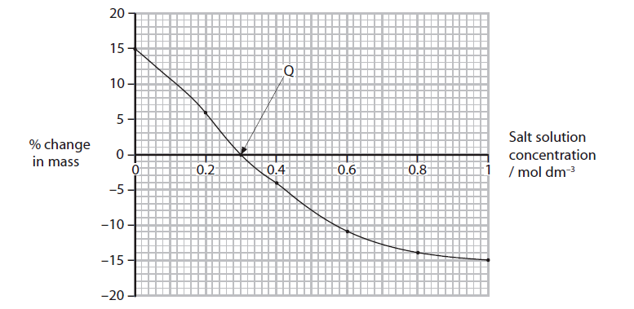
Explain the conclusion that can be made at point Q (2 marks)
…………………………………………………………………………………………………………………………………………………………………………………………
…………………………………………………………………………………………………………………………………………………………………………………………
Give one way the student could obtain more data to increase the accuracy of point Q (1 mark)
…………………………………………………………………………………………………………………………………………………………………………………………

Core Practical: Investigate the composition of inks using simple distillation and paper chromatography (pages 100 & 102 in revision guide)

Chromatography
Identify the mobile phase
………………………………………………………………………………………………………………………………………………………………………………………….
Identify the stationary phase
………………………………………………………………………………………………………………………………………………………………………………………….
Explain why the base line is drawn in pencil (1 mark)
………………………………………………………………………………………………………………………………………………………………………………………….
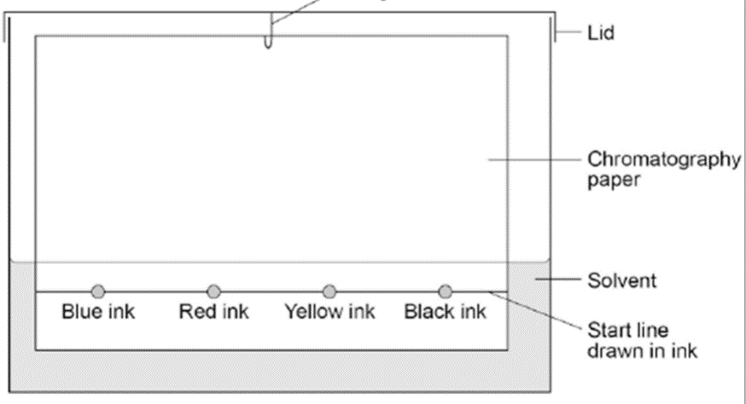
Identify the mistakes and explain what will happen (4 marks)
Mistake 1: ……………………………………………………………
……………………………………………………………………………….
……………………………………………………………………………….
Mistake 2: …………………………………………………………..
……………………………………………………………………………….
…………………………………………………………………………………………………………………………………………………………………………………………

State the formula to calculate the Rf value
…………………………………………………………………………………………………………………………………………………………………………………………
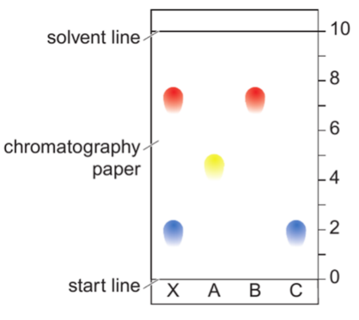
Calculate the Rf value for the blue ink
……………………………………………………………………………………………………………………………………..

Identify and explain which ink is the most soluble (2 marks)
…………………………………………………………………………………………………………………………………………………………………………………………
…………………………………………………………………………………………………………………………………………………………………………………………
…………………………………………………………………………………………………………………………………………………………………………………………

Simple Distillation
Label the equipment needed to carry out simple distillation
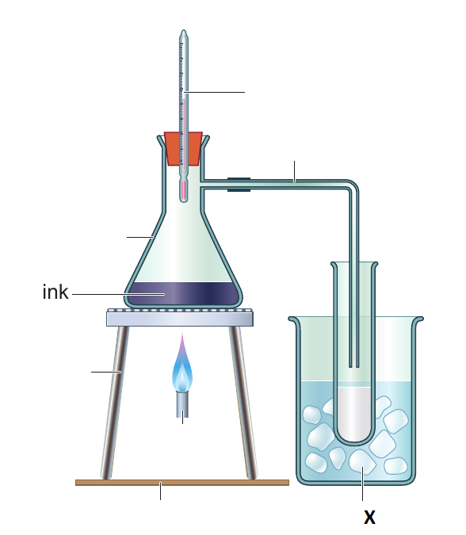
Explain why X is needed in simple distillation (1 mark)
…………………………………………………………………………………………………………………………………………………………………………………………
Explain how simple distillation allows a pure solvent to be separated from a solution (3 marks)
…………………………………………………………………………………………………………………………………………………………………………………………
…………………………………………………………………………………………………………………………………………………………………………………………
…………………………………………………………………………………………………………………………………………………………………………………………
Pure ethanol boils at 78.5oC. Explain how fractional distillation can be used to separate a mixture of ethanol and water (3 marks)
………………………………………………………………………………………………
………………………………………………………………………………………………
………………………………………………………………………………………………
………………………………………………………………………………………………
………………………………………………………………………………………………
………………………………………………………………………………………………
………………………………………………………………………………………………

Core practical: Preparing an insoluble salt (page 101 in revision guide)
Identify the equipment needed from the diagram:
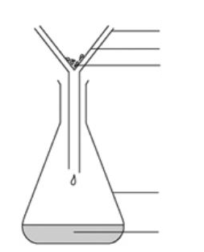
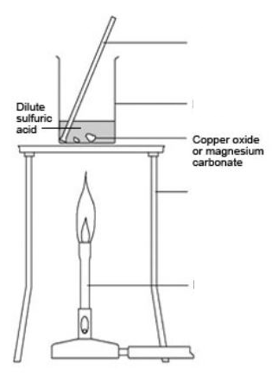

Describe what the final step would be to prepare a pure, dry sample of the salt crystals …………………………………………………………………………………………………………………………………………………………………………………………
…………………………………………………………………………………………………………………………………………………………………………………………

Write a word equation for the reaction of copper oxide and sulphuric acid (2 marks)
…………………………………………………………………………………………………………………………………………………………………………………………

Write a balanced symbol equation including state symbols for the above reaction (3 marks)
…………………………………………………………………………………………………………………………………………………………………………………………

Plan an experiment to prepare pure, dry crystals of calcium nitrate by reacting calcium carbonate with a suitable acid (6 marks)
Hints: Include a word equation in your answer and symbol equation in your answer (AO2)
Describe how to carry out the practical in a logical order
…………………………………………………………………………………………………………………………………………………………………………………………
…………………………………………………………………………………………………………………………………………………………………………………………
…………………………………………………………………………………………………………………………………………………………………………………………
…………………………………………………………………………………………………………………………………………………………………………………………
…………………………………………………………………………………………………………………………………………………………………………………………
…………………………………………………………………………………………………………………………………………………………………………………………
…………………………………………………………………………………………………………………………………………………………………………………………
…………………………………………………………………………………………………………………………………………………………………………………………
…………………………………………………………………………………………………………………………………………………………………………………………
…………………………………………………………………………………………………………………………………………………………………………………………
…………………………………………………………………………………………………………………………………………………………………………………………
…………………………………………………………………………………………………………………………………………………………………………………………
…………………………………………………………………………………………………………………………………………………………………………………………
Core Practical: Investigating Neutralisation (page 105 in revision guide)
You investigated the change in pH when powdered calcium hydroxide was added to a fixed volume of hydrochloric acid
Variables: Identify the following
Independent variable: ………………………………………………………………………………………………………………………………………………..
Dependent variable: ……………………………………………………………………………………………………………………………………………………
Control variables: …………………………………………………………………………………………………………………………………………………….....
………………………………………………………………………………………………………………….....…………………………………………………………………

Write a word equation for the reaction between calcium hydroxide and hydrochloric acid (2 marks)
………………………………………………………………………………………………………………….....…………………………………………………………………
Write a balanced symbol equation, including state symbols for the reaction between powdered calcium hydroxide and hydrochloric acid (3 marks)
………………………………………………………………………………………………………………….....…………………………………………………………………

State how the pH of the mixture was measured (1 mark)
………………………………………………………………………………………………………………….....…………………………………………………………………
Mass of calcium hydroxide | pH of the mixture
0.3 | 2.0
0.6 | 2.5
0.9 | 3.5
1.2 | 5.0
1.5 | 6.0
1.8 | 6.5
2.1 | 7.5

Draw a graph of your results
Use your graph to determine the mass of calcium hydroxide needed to neutralise the hydrochloric acid (1 mark)
……………………………………………………………………………………………………………………………………………………………………………………..

Explain why pH meters must be calibrated (1 mark)
……………………………………………………………………………………………………………………………………………………………………………………..
Give a reason why adding hydroxide ions to an acid solution leads to an increase in pH (1 mark)
……………………………………………………………………………………………………………………………………………………………………………………..
Core Practical: Electrolysis (page 112 in revision guide)
Define electrolysis (2 marks)
……………………………………………………………………………………………………………………………………………………………………………………………………………………………………………………………………………………………………………………………………………………………………………………
State the electrode that is positive (1 mark) ……………………………………………………………………………………………………
State the electrode that is negative (1 mark) ……………………………………………………………………………………………………
State the material electrodes are usually made of (1 mark) …………………………………………………………………………..

Oxygen is produced in the electrolysis of copper sulfate solution using graphite electrodes.
Explain at which electrode will oxygen be produced (2 marks)
…………………………………………………………………………………………………………………………
…………………………………………………………………………………………………………………………
…………………………………………………………………………………………………………………………
…………………………………………………………………………………………………………………………

Identify the electrode which will gain mass (1 mark)
………………………………………………………………………………………………………………………

Explain why this electrode gains mass (2 marks)
………………………………………………………………………………………………………………………
………………………………………………………………………………………………………………………
………………………………………………………………………………………………………………………
………………………………………………………………………………………………………………………
………………………………………………………………………………………………………………………

Write a half equation for what is happening at the anode for the electrolysis of copper sulfate using copper electrodes (2 marks)
…………………………………………………………………………………………………………………………………………………………………………………………
Write a half equation for what is happening at the cathode for the electrolysis of copper sulfate using copper electrodes (2 marks)
…………………………………………………………………………………………………………………………………………………………………………………………
Identify from your half equations which product is oxidised and which is reduced (2 marks)
Oxidised: …………………………………………………………………….
Reduced: ……………………………………………………………………..

Molten potassium bromide is electrolysed.
Predict the products at the anode and cathode (2 marks)
Anode: …………………………………………………………………………
Cathode: ………………………………………………………………………

Physics Core practical 1: Investigation on the effect of mass on the acceleration of the trolley (page 151 in revision guide)
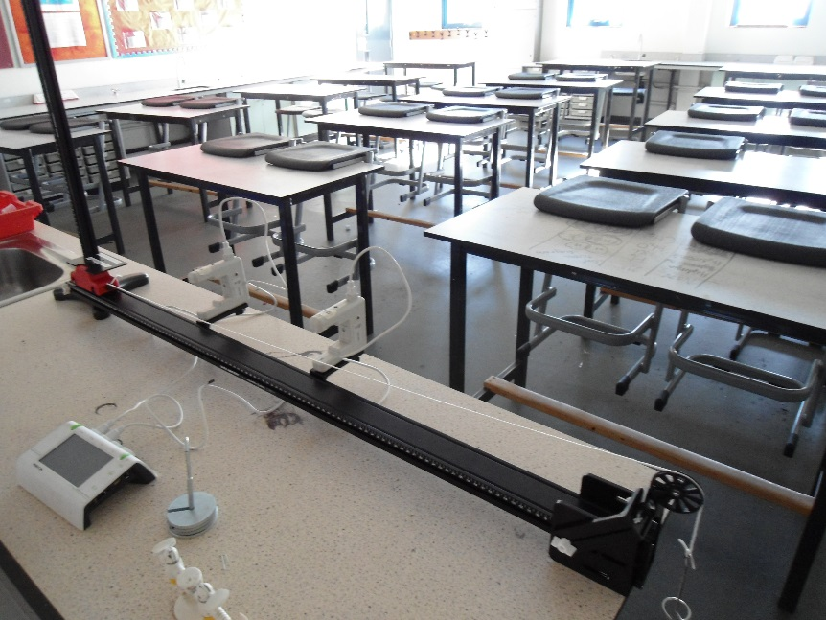
Results: Complete the table calculating the acceleration
Mass (g) | Change in velocity (m/s) | Time taken (s) | Acceleration (m/s²)
200 | 7.0 | 2.2
400 | 6.7 | 2.4
600 | 6.8 | 2.8
800 | 6.9 | 3.0

Describe the conclusion that can be drawn from this experiment
………………………………………………………………………………………………………………………………………………………………………………………………………………………………………………………………………………………………………………………………………………………………………………………………………………………………………………………………………………………………………………………………………………………………………………

Identify Newton’s law that can be referred to in verifying results for this experiment
…………………………………………………………………………………………………………………………………………………………………………………………

Explain why it was necessary to use two light gates when measuring acceleration in this experiment
………………………………………………………………………………………………………………………………………………………………………………………………………………………………………………………………………………………………………………………………………………………………………………………………………………………………………………………………………………………………………………………………………………………………………………

Design an experiment to investigate how the gradient of the slope affects acceleration
………………………………………………………………………………………………………………………………………………………………………………………………………………………………………………………………………………………………………………………………………………………………………………………………………………………………………………………………………………………………………………………………………………………………………………………………………………………………………………………………………………………………………………………………………………………………………………………………………………………………………………………………………………………………………………………………………………………………………………………………………………………………………………………………………………………………………………………………………………………………
Core Practical: Investigating waves in fluids (page 165 in revision guide)
Identify two equations to calculate speed

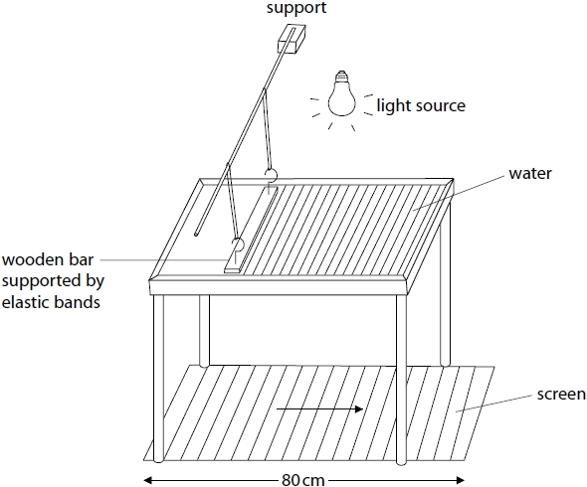
Identify a control when using a ripple tank (1 mark)
…………………………………………………………………………………………………………………………………………………………………………………………
Describe how you can calculate the frequency of waves using a ripple tank (2 marks)
……………………………………………………………………………………………………………………………………………………………………………………………………………………………………………………………………………………………………………………………………………………………………………………
Describe how you can work out the wavelength of a wave (2 marks)
……………………………………………………………………………………………………………………………………………………………………………………………………………………………………………………………………………………………………………………………………………………………………………………
Explain how the investigation can be improved (2 marks)
……………………………………………………………………………………………………………………………………………………………………………………………………………………………………………………………………………………………………………………………………………………………………………………
Describe a method to calculate the speed of sound of an echo (3 marks)
…………………………………………………………………………………………………………………………………………………………………………………………………………………………………………………………………………………………………………………………………………………………………………………………………………………………………………………………………………………………………………………………………………………………………………………………………………………………………………………………………………………………………………………………………………………………………………
The frequency of a sound wave is 2kHz and travels in air at 330m/s. Calculate the wavelength (3marks)

…………………………………………………………………………………………………………………………………………………………………………………………
Core Practical: Investigating refraction (page 167 in revision guide)
Define refraction (1 mark)
……………………………………………………………………………………………………………………………………………………………………………………………………………………………………………………………………………………………………………………………………………………………………………………
Describe a method to investigate refraction using a glass block, raybox and a protractor (4 marks)
……………………………………………………………………………………………………………………………………………………………………………………………………………………………………………………………………………………………………………………………………………………………………………………………………………………………………………………………………………………………………………………………………………………………………………………………………………………………………………………………………………………………………………………………………………………………………………………………………………………………………………………………………………………………………………………………………………………………………………………………………………………………………………………………………………………………………………………………………………………………………………………………………………………………………………………………………………………………………………………………………………………………………………………………………………………………………………………………………………………………………………………………………………………

Using the data in the table describe the results (2 marks)
……………………………………………………………………………………………………………………………………………………………………………………………………………………………………………………………………………………………………………………………………………………………………………………

Angle of incidence | Angle of refraction
5 | 3
10 | 7
15 | 10
20 | 15

Explain what conclusion you can make from the data in the table (2 marks)
……………………………………………………………………………………………………………………………………………………………………………………………………………………………………………………………………………………………………………………………………………………………………………………

