Paper 2 Core Practical Revision
Core Practical: Light Intensity and Photosynthesis (page 47 in revision guide)
You used algae balls to investigate photosynthesis at different distances from the lamp. Hydrogen carbonate indicator was used to measure the pH of the solution.
Hydrogen carbonate indicator is a red colour. In high concentrations of carbon dioxide it turns red and in low concentrations of carbon dioxide it turns purple.
Write the word equation for photosynthesis
…………………………………………………………………………………………………………………………………………………………………………………………
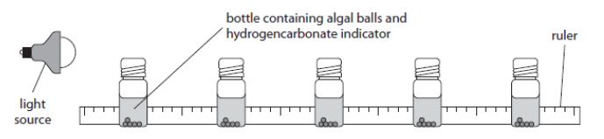
Identify the independent variable
…………………………………………………………………………………………………………………………………………………………………………………………
Identify the dependent variable
…………………………………………………………………………………………………………………………………………………………………………………………
Identify the control variables in the investigation
…………………………………………………………………………………………………………………………………………………………………………………………
…………………………………………………………………………………………………………………………………………………………………………………………
Describe using the diagram what you would expect the results to show
…………………………………………………………………………………………………………………………………………………………………………………………
…………………………………………………………………………………………………………………………………………………………………………………………
State the colour you would expect the hydrogen carbonate indicator to be nearest the lamp
…………………………………………………………………………………………………………………………………………………………………………………………
Explain why the solution has turned this colour
…………………………………………………………………………………………………………………………………………………………………………………………
…………………………………………………………………………………………………………………………………………………………………………………………
Describe how you would investigate how temperature affects the rate of photosynthesis
…………………………………………………………………………………………………………………………………………………………………………………………
…………………………………………………………………………………………………………………………………………………………………………………………
…………………………………………………………………………………………………………………………………………………………………………………………
Core Practical Biology: Respiration rates (page 65 in revision guide)
You investigated how temperature affected the rate of respiration
Write the word equation for aerobic respiration
…………………………………………………………………………………………………………………………………………………………………………………………
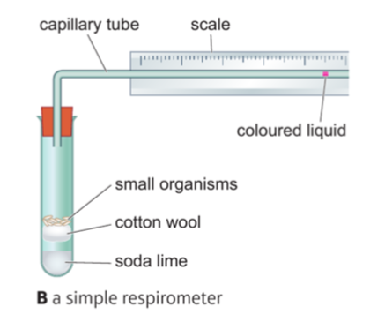
Identify the independent variable
………………………………………………………………………………………………………….

Identify the dependent variable
………………………………………………………………………………………………………….

Identify two control variables
………………………………………………………………………………………………………….
………………………………………………………………………………………………………….

Explain why one of your control variables needs to be controlled
…………………………………………………………………………………………………………………………………………………………………………………………
…………………………………………………………………………………………………………………………………………………………………………………………
Explain the role of soda lime in your investigation (2 marks)
…………………………………………………………………………………………………………………………………………………………………………………………
…………………………………………………………………………………………………………………………………………………………………………………………
State an appropriate control in your investigation (1 mark)
…………………………………………………………………………………………………………………………………………………………………………………………
Explain the need for controls in the investigation (1 mark)
…………………………………………………………………………………………………………………………………………………………………………………………
…………………………………………………………………………………………………………………………………………………………………………………………

Temperature (ºC) | Distant moved by coloured liquid in 5 minutes (mm)
20 | 18
25 | 28
30 | 36

Describe what the results show from the investigation
…………………………………………………………………………………………………………………………………………………………………………………………
…………………………………………………………………………………………………………………………………………………………………………………………

Explain the results of the investigation
…………………………………………………………………………………………………………………………………………………………………………………………
…………………………………………………………………………………………………………………………………………………………………………………………

Calculate the rate at 25ºC (Hint: Look at the units)

………………………………………………………………………………………………………………………………………………………………mm min⁻¹

Explain how the student’s results from above can be improved
…………………………………………………………………………………………………………………………………………………………………………………………
…………………………………………………………………………………………………………………………………………………………………………………………
…………………………………………………………………………………………………………………………………………………………………………………………
…………………………………………………………………………………………………………………………………………………………………………………………

Core practical Biology: Quadrats and Transects (page 68 in revision guide)
Name 3 abiotic factors
…………………………………………………………………………………………………………………………………………………………………………………………
…………………………………………………………………………………………………………………………………………………………………………………………
Describe how to carry out a belt transect
…………………………………………………………………………………………………………………………………………………………………………………………
…………………………………………………………………………………………………………………………………………………………………………………………
…………………………………………………………………………………………………………………………………………………………………………………………
…………………………………………………………………………………………………………………………………………………………………………………………
Results are from a belt transect carried out by a student.
Distance from tree (m) | Number of daisies
0 | 1
1 | 4
2 | 6
3 | 10
4 | 15

Describe the effect of distance from the tree on the number of daisies
…………………………………………………………………………………………………………………………………………………………………………………………
…………………………………………………………………………………………………………………………………………………………………………………………
Suggest an explanation for this effect
…………………………………………………………………………………………………………………………………………………………………………………………
…………………………………………………………………………………………………………………………………………………………………………………………

Explain how the student could improve their investigation
…………………………………………………………………………………………………………………………………………………………………………………………
…………………………………………………………………………………………………………………………………………………………………………………………
…………………………………………………………………………………………………………………………………………………………………………………………
…………………………………………………………………………………………………………………………………………………………………………………………
In a 1m² quadrat there are 25 limpets. The total area of the shore is 500m². Extimate the total population size of limpets.

…………………………………………………………………………………………………………………………………………………………………………………………

Core Practical Chemistry: Investigating Reaction Rates (page 129 + 130 in revision guide)
State 4 factors that affect the rate of a reaction

Part 1: Investigating the reaction rates measuring the production of a gas
Write the word equation when calcium carbonate reacts with hydrochloric acid
…………………………………………………………………………………………………………………………………………………………………………………………
A student filled a beaker to 50cm³ line and added it to a conical flask. He then added 4 large pieces of marble chips and added a bung on. He measured the gas produced every 20 seconds in an inverted measuring cylinder. He then repeated the experiment using 4 small pieces of marble chips
State and explain 2 ways the student could improve the method
- …………………………………………………………………………………………………………………………………………………………………………………………………………………………………………………………………………………………………………………………………………………………
- ………………………………………………………………………………………………………………………………………………………………………………………………………………………………………………………………………………………………………………………………………………………..
The students results are shown below. Sketch what the graph would look like with the smaller chips.
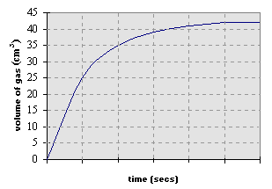
Describe how you would calculate the reaction rate in cm³/second using the graph
…………………………………………………………………………………………………………………………………………………………………………………………
…………………………………………………………………………………………………………………………………………………………………………………………

Explain how surface area affects the rate of a reaction
…………………………………………………………………………………………………………………………………………………………………………………………
…………………………………………………………………………………………………………………………………………………………………………………………
…………………………………………………………………………………………………………………………………………………………………………………………

Explain how and weighing scale could be used to investigate the rate of reaction between calcium carbonate and hydrochloric acid
…………………………………………………………………………………………………………………………………………………………………………………………
…………………………………………………………………………………………………………………………………………………………………………………………
…………………………………………………………………………………………………………………………………………………………………………………………

Describe a method to investigate how concentration affects the rate of reaction between calcium carbonate and hydrochloric acid
…………………………………………………………………………………………………………………………………………………………………………………………
…………………………………………………………………………………………………………………………………………………………………………………………
…………………………………………………………………………………………………………………………………………………………………………………………
…………………………………………………………………………………………………………………………………………………………………………………………
…………………………………………………………………………………………………………………………………………………………………………………………
…………………………………………………………………………………………………………………………………………………………………………………………

Explain how concentration affects the rate of a reaction
…………………………………………………………………………………………………………………………………………………………………………………………
…………………………………………………………………………………………………………………………………………………………………………………………
…………………………………………………………………………………………………………………………………………………………………………………………

Part 2: Investigating reaction rates observing a colour change
Na₂S₂O_{3 (aq)} + 2HCl _{(aq)} 2NaCl _{(aq)} + H2O _{(l)} + S _{(s)}
Explain which product causes the colour change
…………………………………………………………………………………………………………………………………………………………………………………………
…………………………………………………………………………………………………………………………………………………………………………………………

Explain how temperature affects the rate of a reaction

………………………………………………………………………………………………………………………………………………………………………………………………………………………………………………………………………………………………………………………………………………………………………………………………………………………………………………………………………………………………………………………………………………………………………………

Core practical Physics: Investigating resistance (page 186 + 189 in revision guide)
Part 1: Investigating resistance in a filament lamp and a resistor
Describe how to measure current and potential difference in a circuit. You may use a labelled diagram (4 marks).
…………………………………………………………………………………………………………………………………………………………………………………………
…………………………………………………………………………………………………………………………………………………………………………………………
…………………………………………………………………………………………………………………………………………………………………………………………
…………………………………………………………………………………………………………………………………………………………………………………………
State the equation that links current, potential difference and resistance
…………………………………………………………………………………………………………………………………………………………………………………………
Sketch a diagram on how you would measure the current and potential difference in a resistor.

Results below show the potential difference and current through a resistor
Potential difference (V) | Current flowing through resistor (A)
0 | 0
1 | 0.3
2 | 0.6
3 | 0.9
4 | 1.2

Calculate the resistance of the resistor

…………………………………………………………………………………………………………………………………………………………………………………………
Describe the relationship between potential difference and current in a fixed resistor
…………………………………………………………………………………………………………………………………………………………………………………………

Core practical Physics: Investigating resistance
Part 2: Investigating resistance of a filament lamp in a series and parallel circuit
Describe how current flows in a series circuit
…………………………………………………………………………………………………………………………………………………………………………………………
…………………………………………………………………………………………………………………………………………………………………………………………
Describe how current flows in a parallel circuit
…………………………………………………………………………………………………………………………………………………………………………………………
…………………………………………………………………………………………………………………………………………………………………………………………

The potential difference across the battery was 6V. If the potential difference across bulb 1 was 3.5V, state the potential difference across bulb 2.
……………………………………………………………………………………………………………………………….
Describe what would happen to the current if another filament lamp is added to this circuit
………………………………………………………………………………………………………………………………

The potential difference across the battery in circuit E was 9V. If the potential difference across bulb 1 was 9V, state the potential difference across bulb 2.
………………………………………………………………………………………………………………………………
In circuit E the current leaving the battery is 0.82A. The bulbs in the circuit are identical. State the ammeter reading of bulb 1 and 2.
Bulb 1: ……………………………. Bulb 2: …………………………………

Explain which circuit would have the lowest resistance
…………………………………………………………………………………………………………………………………………………………………………………………
…………………………………………………………………………………………………………………………………………………………………………………………
…………………………………………………………………………………………………………………………………………………………………………………………

Core practical Physics: Investigating densities (page 200 in revision guide)

State the equation to calculate density

………………………………………………………………………………………………………………………………………………………………............................

Explain in terms of particles why a solid is more dense than a liquid
………………………………………………………………………………………………………………………………………………………………............................
………………………………………………………………………………………………………………………………………………………………............................

Method:
Describe how to calculate the density of a cube | Describe how to calculate the density of an object with an irregular shape
………………………………………………………………………………………  ………………………………………………………………………………………  ………………………………………………………………………………………  ………………………………………………………………………………………  ………………………………………………………………………………………  ………………………………………………………………………………………  ………………………………………………………………………………………  ………………………………………………………………………………………  ………………………………………………………………………………………  ………………………………………………………………………………………  ……………………………………………………………………………………… | ………………………………………………………………………………………  ………………………………………………………………………………………  ………………………………………………………………………………………  ………………………………………………………………………………………  ………………………………………………………………………………………  ………………………………………………………………………………………  ………………………………………………………………………………………  ………………………………………………………………………………………  ………………………………………………………………………………………  ………………………………………………………………………………………  ………………………………………………………………………………………

Describe how calculating the density of a liquid would differ from calculating the density of a solid
………………………………………………………………………………………………………………………………………………………………............................………………………………………………………………………………………………………………………………………………………………............................………………………………………………………………………………………………………………………………………………………………............................
0.5kg of water fills a 500cm³ flask. Calculate the density in g/cm³.
………………………………………………………………………………………………………………………………………………………………............................
A piece of wood is 1m long, 20cm wide and 5cm thick. It has a mass of 7kg. Calculate the density in kg/m³
………………………………………………………………………………………………………………………………………………………………............................
Core Practical: Investigating water (page 202 + 203 in revision guide)

Define specific heat capacity
………………………………………………………………………………………………………………………………………………………………............................
………………………………………………………………………………………………………………………………………………………………............................

State the equation that links specific heat capacity, mass, temperature change and thermal energy
………………………………………………………………………………………………………………………………………………………………............................

Describe an experiment on how the specific heat capacity of water could be measured
Think about the equation and what measurements you would need for it
………………………………………………………………………………………………………………………………………………………………............................
………………………………………………………………………………………………………………………………………………………………............................
………………………………………………………………………………………………………………………………………………………………............................
………………………………………………………………………………………………………………………………………………………………............................
………………………………………………………………………………………………………………………………………………………………............................
………………………………………………………………………………………………………………………………………………………………............................
………………………………………………………………………………………………………………………………………………………………............................

Describe why a polystyrene cup is used
………………………………………………………………………………………………………………………………………………………………............................
………………………………………………………………………………………………………………………………………………………………............................

Calculate the specific heat capacity of water when a student heated 500g of water. The joulemeter reading was 22kJ and the temperature change went from 20 to 30ºC.

………………………………………………………………………………………………………………………………………………………………………………………….

The specific heat capacity of water is 4181 J/kg/ºC. Explain why results obtained from this experiment are likely to be higher than this value.
………………………………………………………………………………………………………………………………………………………………………………………….
………………………………………………………………………………………………………………………………………………………………………………………….
………………………………………………………………………………………………………………………………………………………………………………………….

Define specific latent heat
………………………………………………………………………………………………………………………………………………………………............................
………………………………………………………………………………………………………………………………………………………………............................

State the equation that links change in thermal energy, mass and specific latent heat.
………………………………………………………………………………………………………………………………………………………………............................

Sketch a graph to show the temperature changes when ice melts
Core practical Physics: Investigating springs (page 206 in revision guide)
State the equation that links extension, spring constant and force.
………………………………………………………………………………………………………………………………………………………………............................
Describe how to set equipment up to investigate the effect of force on the extension of a spring
………………………………………………………………………………………………………………………………………………………………............................
………………………………………………………………………………………………………………………………………………………………............................
………………………………………………………………………………………………………………………………………………………………............................
………………………………………………………………………………………………………………………………………………………………............................
………………………………………………………………………………………………………………………………………………………………............................

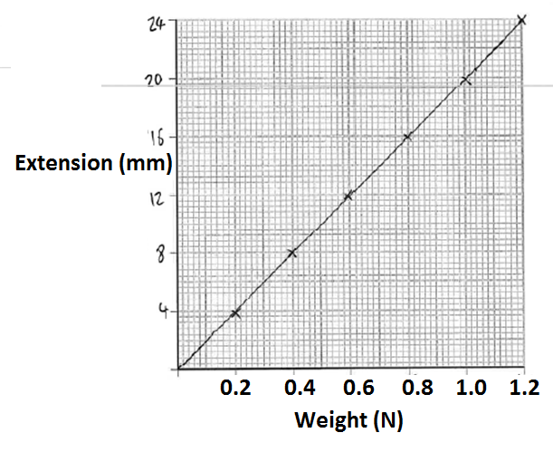
Describe the relationship shown from the data collected
……………………………………………………………………………………….
……………………………………………………………………………………….

Calculate the spring constant of the spring in the graph (Hint: Think about units)

……………………………………………………………………………………….

Sketch on the graph the results of a spring with a higher spring constant

Explain the difference between the length of a spring and the extension
………………………………………………………………………………………………………………………………………………………………………………………….
………………………………………………………………………………………………………………………………………………………………………………………….
Calculate the spring constant when a spring is stretch 50cm with 5N of force.

………………………………………………………………………………………………………………………………………………………………………………………….
Calculate the energy stored in a spring of spring constant 0.9N/m when it is extended by 63cm.

………………………………………………………………………………………………………………………………………………………………............................

