CP9 Electricity and Energy

Current, Charge and Energy

State the equation that links charge, current and time.

…………………………………………………………………………………………

State the unit of charge ………………………………………….

Calculate the charge when an object is on for 2 minutes and uses 13A

………………………………………………………………………………………….

Current and Potential Difference

Describe what happens to the current if the potential difference is increased.

………………………………………………………………………………………

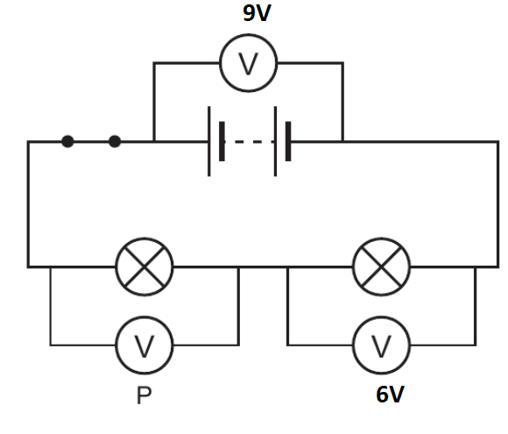

State the voltmeter reading on voltmeter P …………………………………………………………………………………………

Current and Potential Difference

Draw a series circuit with a cell, bulb, ammeter and a voltmeter to measure the potential difference across the bulb.

Describe how to measure current and potential difference in a circuit

……………………………………………………………………………………………………………………………………………………………………………………………………………………………………………………………………………….

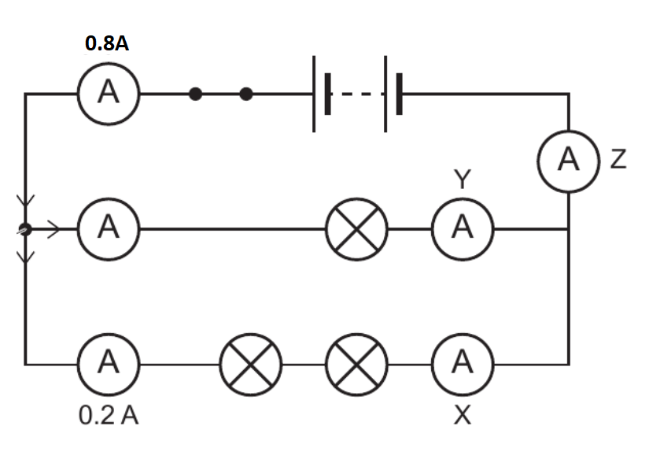

Identify the ammeter reading on

X ……………………………………………………..

Y ………………………………………………………

Z ……………………………………………………..

Electric Circuits

Draw a labelled diagram of an atom to identify the protons, electrons and neutrons.

Draw a series circuit containing a battery, 2 bulbs and an ammeter

Draw a parallel circuit containing a battery and 2 bulbs.

Describe how current flows in a series circuit

……………………………………………………………………………………………………………………………………………………………………………………

Describe how current flows in a parallel circuit

……………………………………………………………………………………………………………………………………………………………………………………

More about resistance

Describe how resistance of an LDR changes with an increasing light intensity.

…………………………………………………………………………………………..

…………………………………………………………………………………………..

…………………………………………………………………………………………..

…………………………………………………………………………………………..

Sketch graphs of potential difference (X axis) against current (Y axis) for the following components

Diode:

Fixed resistor

Filament lamp

Explain what happens to the resistance of the filament lamp when the temperature increases

…………………………………………………………………………………………..

…………………………………………………………………………………………..

More about resistance

Draw circuit symbols for the following components:

Diode Variable resistor

Filament lamp Thermistor

LDR

Resistance

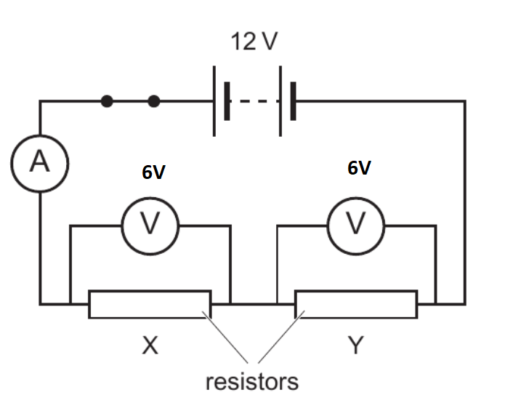

1. Calculate the current flowing through resistor X which has a resistance of 10Ώ.

…………………………………………………………………………………………..

1. Calculate the resistance of resistor Y

…………………………………………………………………………………………..

Describe what happens to the total resistance when the resistors in the diagram above are placed in parallel

…………………………………………………………………………………………..

…………………………………………………………………………………………..

Resistance

State the equation that links resistance, current and potential difference

………………………………………………………………………………………….

State the unit of resistance ……………………………………..

Current, Charge and Energy

Calculate the time taken for 33C of charge and a current of 6A.

…………………………………………………………………………………………..

State the equation that links potential difference, charge and energy transferred.

…………………………………………………………………………………………..

Calculate how much energy is transferred when 10C of charge flows through a potential difference of 5V

…………………………………………………………………………………………..

Calculate the energy transferred when an appliance is used for 5 minutes from the mains (230V) with a current of 5A.

…………………………………………………………………………………………..

Electrical Safety

Label the three wires in a plug

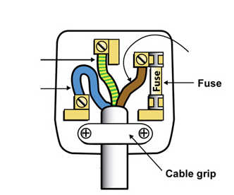

Identify the potential difference between:

Earth and Live wire …………………….

Live and neutral wire …………………..

Neutral and earth ………………………..

Transferring energy by electricity

Describe the difference between direct and alternating current

…………………………………………………………………………………………..…………………………………………………………………………………………..…………………………………………………………………………………………..…………………………………………………………………………………………..

State the frequency of mains supply ………………………

State the potential difference of the mains supply ………………………………………………………………………………

Transferring Energy

Explain why a resistor gets hot when current flows through it

…………………………………………………………………………………………..

…………………………………………………………………………………………..…………………………………………………………………………………………..

…………………………………………………………………………………………...

Explain how resistance can be reduced in wires

…………………………………………………………………………………………..

…………………………………………………………………………………………..

…………………………………………………………………………………………..

…………………………………………………………………………………………..

***Equation given in exam:***

***Energy transferred = Current x Potential difference x time***

Calculate the energy transferred when a 9V battery supplies 0.2A of current to an appliance for 5 minutes.

…………………………………………………………………………………………..

Calculate the time taken to transfer 3000J to a lamp with a current of 0.8A when it is connected to a 230V supply

…………………………………………………………………………………………..

Transferring energy by electricity

Describe the energy transfers in a mains operated hairdryer

…………………………………………………………………………………………..

Describe the energy transfer of a battery operated heated gloves

…………………………………………………………………………………………..

Power

State the three equations to calculate power



Calculate the power of a kettle connected to a 230V supply and 13A of current is required.

…………………………………………………………………………………………..

Calculate the resistance when 3A flows through and 8kW of power is transferred

…………………………………………………………………………………………..

Electrical Safety

Describe why earth wires are needed in plugs

…………………………………………………………………………………………..…………………………………………………………………………………………..

Explain how fuses make circuits safe

…………………………………………………………………………………………..…………………………………………………………………………………………..

Explain the advantage of circuit breakers over fuses

…………………………………………………………………………………………..…………………………………………………………………………………………..