CP6 Radioactivity

Electrons and Orbits

Describe what happens when an atom absorbs electromagnetic radiation

……………………………………………………………………………………………………………………………………………………………………………………

Describe what happens when an atom emits electromagnetic radiation

……………………………………………………………………………………………………………………………………………………………………………………

What is the difference between emission and absorption spectra

………………………………………………………………………………………………………………………………………………………………………………………………………………………………………………………………………………

How is Niels Bohr model of the atom different to Rutherfords?

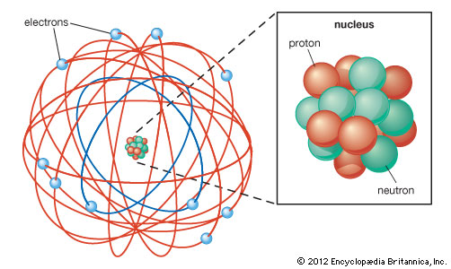[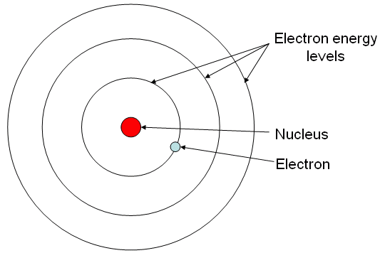](http://www.google.co.uk/url?sa=i&rct=j&q=&esrc=s&source=images&cd=&cad=rja&uact=8&ved=0ahUKEwj6j9vZ5ezUAhVEkRQKHRJ5AwoQjRwIBw&url=http://science.babson.edu/winrich/semiconductors/bonding.htm&psig=AFQjCNGElAcAmqVOhfHPjPL_fZzMzRuqkg&ust=1499160355046835)

………………………………………………………………………………………………………………………………………………………………………………………………………………………………………………………………………………

Lithium has an atomic number of 3 and loses an electron to form an ion. How many protons and electrons are there?

……………………………………………………………………………………………………………………………………………………………………………………

Electrons and Orbits

Define an ion

…………………………………………………………………………………………………………………………………………………………………………………….

Describe how a magnesium atom becomes a magnesium ion

…………………………………………………………………………………………..

Inside Atoms

Draw a labelled diagram of the modern day structure of an atom

|  |  |  |
| --- | --- | --- |
|  | Mass | Charge |
| Proton |  |  |
| Neutron |  |  |
| Electron |  |  |

Complete the table

|  |  |  |  |  |
| --- | --- | --- | --- | --- |
|  | C | N | Mg | Ca |
| Mass number |  |  |  |  |
| Atomic number |  |  |  |  |
| Protons |  |  |  |  |
| Neutrons |  |  |  |  |
| Electrons |  |  |  |  |

Define an isotope

…………………………………………………………………………………………………………………………………………………………………………………….

Atomic Models

Draw a labelled diagram of the Plum Pudding Model

Draw a labelled diagram of Rutherford’s model

Describe the experiment Rutherford carried out which allowed him to come up with his model.

…………………………………………………………………………………………………………………………………………………………………………………………………………………………………………………………………………………………………………………………………………………………………………………………………………………………………………………………………….

What is the radius of a nucleus? ……………………………..

What is the radius of an atom? ………………………………..

How is Rutherford’s model of the atom similar to today’s model?

…………………………………………………………………………………………………………………………………………………………………………………….

Radioactive decay

Describe what happens during ß+ decay and the effect on the nucleus

…………………………………………………………………………………………………………………………………………………………………………………….

Describe what happens during ß- decay and the effect on the nucleus

…………………………………………………………………………………………………………………………………………………………………………………….

Complete the table summarising what happens to the mass and atomic number during radioactive decay

|  |  |  |
| --- | --- | --- |
|  | Mass number | Atomic number |
| Alpha |  |  |
| ß+ |  |  |
| ß- |  | Increases by 1 |

**Radium has a mass number of 226 and an atomic number of 88.**

Write a nuclear equation when this nucleus emits an alpha particle

Write a nuclear equation if Iodine-131 undergoes ß- decay.

Write a nuclear equation if Potassium-37 undergoes ß+ decay.

Radioactive decay

Complete the table

|  |  |  |
| --- | --- | --- |
| Particle | Symbol | |
| Alpha |  |  |
| Beta | ß- |  |
| Positron |  |  |
| Neutron |  | n |

What happens to the atomic and mass number when a neutron is emitted? ………………………………………. …………………………………………………………………………………………..…………………………………………………………………………………………..

Types of radiation

Describe the structure of a gamma ray

…………………………………………………………………………………………………………………………………………………………………………………….

What does unstable mean?

…………………………………………………………………………………………………………………………………………………………………………………….

|  |  |  |  |
| --- | --- | --- | --- |
|  | Alpha | Beta | Gamma |
| Ionising |  |  | Weak |
| Penetrating |  |  |  |
| Stopped by |  |  |  |

Explain why alpha particles are more ionising than beta particles

…………………………………………………………………………………………………………………………………………………………………………………….

Types of radiation

Describe the structure of an alpha particle

…………………………………………………………………………………………………………………………………………………………………………………….

What is the charge on an alpha particle? ……………….

Describe the structure of a beta particle

…………………………………………………………………………………………………………………………………………………………………………………….

What is the charge on a beta particle? …………………

Background Radiation

What is meant by background radiation?

…………………………………………………………………………………………………………………………………………………………………………………….

State 2 sources of **natural** background radiation:

…………………………………………………………………………………………………………………………………………………………………………………….

State 2 sources of background radiation that does not occur naturally

…………………………………………………………………………………………………………………………………………………………………………………….

How can radiation be measured and describe how the equipment works.

…………………………………………………………………………………………………………………………………………………………………………………….

…………………………………………………………………………………………………………………………………………………………………………………….

Dangers of radioactivity

What happens to the intensity of radiation with increasing distance?

…………………………………………………………………………………………

Explain other precautions people should take when handling radioactive sources

………………………………………………………………………………………….

…………………………………………………………………………………………..

Explain how medical staff working with radioactive sources minimise exposure

………………………………………………………………………………………….

…………………………………………………………………………………………..

………………………………………………………………………………………….

Describe the difference between contamination and irradiation

………………………………………………………………………………………….

…………………………………………………………………………………………..

………………………………………………………………………………………….

…………………………………………………………………………………………..

Dangers of radioactivity

What are the dangers of exposure to ionising radiation?

…………………………………………………………………………………………………………………………………………………………………………………….

…………………………………………………………………………………………………………………………………………………………………………………….

…………………………………………………………………………………………………………………………………………………………………………………….

Half-life

Define half life

…………………………………………………………………………………………………………………………………………………………………………………….

What is the unit of activity of a radioactive substance? …………………………………………………………………….

Strontium has a half life of 29 years. How many half-lives is 58 years? ………………………………………………..

Calculate the half-life of both sources

Source A: ………………………………………………….

Source B: ………………………………………………….

