[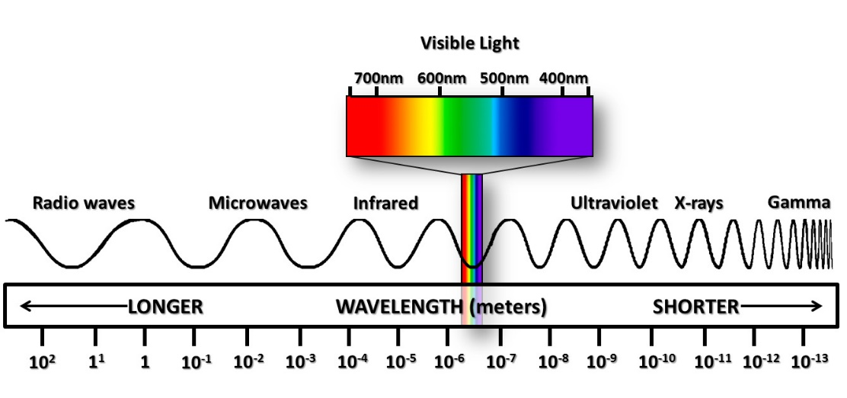](http://www.google.com/url?sa=i&rct=j&q=&esrc=s&source=images&cd=&cad=rja&uact=8&ved=0ahUKEwjh8OaD2-fRAhXEnBoKHXrrASUQjRwIBw&url=http%3A%2F%2Fwww.ces.fau.edu%2Fnasa%2Fmodule-2%2Fradiation-sun.php&bvm=bv.145822982,d.ZGg&psig=AFQjCNHR8-uMR2oxW1abMOASj10I-8UnrA&ust=1485791557425315)**CP5 Revision Mat:**

**EM Waves:**

What type of wave are all EM waves?

…………………………………………………………………………………………

What is the speed of all EM waves in a vacuum?

…………………………………………………………………………………………

What can be used to split white light?

…………………………………………………………………………………………How was infrared discovered?

…………………………………………………………………………………………………………………………………………………………………………………………………………………………………………………………………………………………………………………………………………………………………………

What happens to the frequency and energy as the wavelength becomes shorter on the EM spectrum?

…………………………………………………………………………………………

How are radiowaves produced and detected? (*Higher)*

………………………………………………………………………………………………………………………………………………………………………………………………………………………………………………………………………………

Explain why some telescopes are placed outside the Earth’s atmosphere

………………………………………………………………………………………………………………………………………………………………………………………………………………………………………………………………………………

**EM Spectrum**

|  |  |  |
| --- | --- | --- |
| **Part of EM Spectrum** | **Uses** | **Dangers** |
| **R** |  |  |
| **M** |  |  |
| **I** |  |  |
| **V** |  |  |
| **U** |  |  |
| **X** |  |  |
| **G** |  |  |