**CP4 Revision Mat:**

**Waves:**

Label amplitude and wavelength on the diagram

[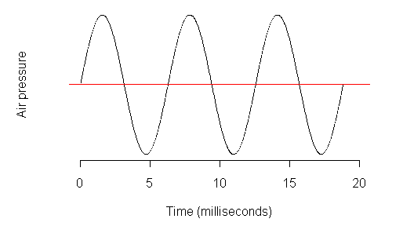](https://www.google.com/url?sa=i&rct=j&q=&esrc=s&source=images&cd=&cad=rja&uact=8&ved=0ahUKEwjc0KmC2OfRAhWHqxoKHe_nClkQjRwIBw&url=https%3A%2F%2Fhome.cc.umanitoba.ca%2F~krussll%2Fphonetics%2Facoustic%2Fsine-properties.html&psig=AFQjCNFSh3b-H12AT7d8bJJOJg__xB9a6g&ust=1485790740419310)

Define frequency and state the unit

……………………………………………………………………………………………………………………………………………………………………………………

Describe how longitudinal waves travel

………………………………………………………………………………………………………………………………………………………………………………………………………………………………………………………………………………

State an example of a longitudinal wave

…………………………………………………………………………………………

Describe how transverse waves travel

………………………………………………………………………………………………………………………………………………………………………………………………………………………………………………………………………………

State examples of transverse waves

…………………………………………………………………………………………

**Refraction:**

Define refraction

……………………………………………………………………………………………………………………………………………………………………………………

What is the normal?

……………………………………………………………………………………………………………………………………………………………………………………

[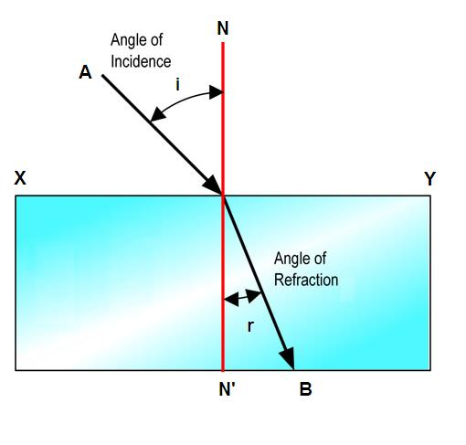](http://www.google.com/url?sa=i&rct=j&q=&esrc=s&source=images&cd=&cad=rja&uact=8&ved=0ahUKEwi_1OmA2ufRAhVBVRoKHZc1AyQQjRwIBw&url=http%3A%2F%2Fphysics.stackexchange.com%2Fquestions%2F37731%2Frefraction-reflection-and-what-is-total-reflection&bvm=bv.145822982,d.ZGg&psig=AFQjCNFcc40RGvnSJZ8F21xT3RXG3S5adg&ust=1485791247980956)

*Complete the diagram to show what happens to light when it leaves the glass block*

Describe what happens when a light travels from air to glass

……………………………………………………………………………………………………………………………………………………………………………………

Describe what happens when a light travels from glass to air

……………………………………………………………………………………………………………………………………………………………………………………

**Calculating wave speeds**

What are the two equations that can be used to calculate wave speeds:

1)

2)

Draw triangles to help you rearrange to get the subject

A wave travels 10m in 2 seconds. Calculate the speed.

…………………………………………………………………………………………

A wave has a speed of 330m/s and a wavelength of 16m. Calculate the frequency.

…………………………………………………………………………………………

Describe how you could measure the speed of water waves between two buoys floating in the sea

………………………………………………………………………………………………………………………………………………………………………………………………………………………………………………………………………………