**CP2 Revision Mat**

**Mass and Weight cont.**

Calculate the weight of an object on Earth (10N/kg) if the mass is 1000g

…………………………………………………………………………………..

**Forces on falling bodies:**

1. Label the forces in each diagram
2. Explain what happens in each diagram

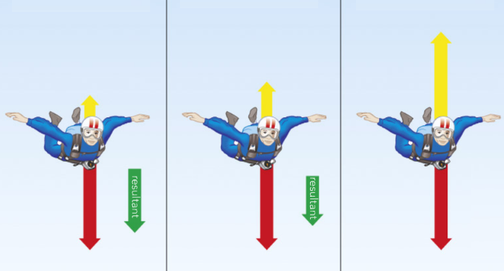

Diagram 1:

……………………………………………………………………………………………………………………………………………………………………

…………………………………………………………………………………

Diagram 2:

…………………………………………………………………………………

……………………………………………………………………………………………………………………………………………………………………

Diagram 3:

……………………………………………………………………………………………………………………………………………………………………

……………………………………………………………………………………………………………………………………………………………………

**Mass and Weight**

What equation links weight, mass and gravitational field strength?

*Don’t forget the units*

Draw a triangle to help you change the subject.

**Resultant Forces**

Calculating resultant forces:

* If the forces are in the same direction you need to ……………………………………………....
* If the forces are in opposite directions you need to ……………………………

Add arrows to the diagram to show the following forces

* 1000N of upthrust
* 1000N of weight
* 700N thrust
* 300N water resistance
* 100N air resistance

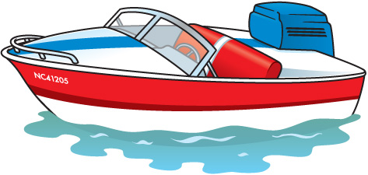

Calculate the resultant force and state the direction.

…………………………………………………………………………………..

What forces on the boat are balanced?

…………………………………………………………………………………..

**Newton’s First Law**

What are the two possible outcomes if an object has a resultant force of 0 N?

1. ………………………………………………………………….
2. ………………………………………………………………….

*Higher:*

What is the force labelled Fc in the diagram?

………………………………………………………………………………….

[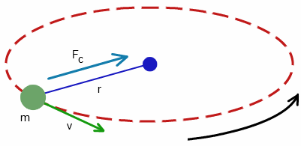](http://www.google.co.uk/url?sa=i&rct=j&q=&esrc=s&source=images&cd=&cad=rja&uact=8&ved=0ahUKEwjhzJmUv-fRAhWCCBoKHeHyD1IQjRwIBw&url=http%3A%2F%2Fwww.tutorvista.com%2Fphysics%2Fcentripetal-velocity&bvm=bv.145822982,d.ZGg&psig=AFQjCNFfR9TQbZf5zYoN3jPiHLZt6ovVSg&ust=1485784076007972)

How can an object moving in a circle have different velocities but travel at the same speed?

……………………………………………………………………………………………………………………………………………………………………

**Crash Hazards**

What safety features in cars reduce the large deceleration in crashes?



**Stopping distances**

Stopping distance =

Name factors that affect the thinking distance

…………………………………………………………………………………………………………………………………………………………………………………………

…………………………………………………………………………………………………………………………………………………………………………………………

Name factors that increase braking distance and explain why

…………………………………………………………………………………………………………………………………………………………………………………………

…………………………………………………………………………………………………………………………………………………………………………………………

**Momentum and collisions**

What is meant by the term conservation of momentum?

…………………………………………………………………………………………………………………………………………………………………………………………

**Momentum**

What equation links mass, momentum and velocity?

*Don’t forget the units*

Draw a triangle to help you change the subject

A car has a mass of 1000kg and travels at 4m/s. Calculate the momentum.

What equation links change in momentum, force and time?

A 2000kg car accelerates from 10m/s to 25m/s in 10 seconds. What force is needed to produce this acceleration?

**Newton’s Third Law**

*Higher:*

Explain why in a collision between a footballer’s head and the ball the action-reaction forces are the same size but the effects are different.

……………………………………………………………………………………………

**Newton’s Third Law**

What is the difference between action reaction forces and balanced forces?

…………………………………………………………………………………………………………………………………………………………………………………………

Action reaction forces act in ……………………………… directions and are the ……………….. size

**Newton’s Second Law:**

What equation links mass, acceleration and force. *Don’t forget the units.*

Draw a triangle to help you change the subject.

What can be said about the forces needed to accelerate a lorry and a car by 5m/s2?

…………………………………………………………………………………………………………………………………………………………………………………………

A car accelerates at 2m/s2. The resultant force is 3000N. Calculate the mass of the car.

Define inertial mass.

……………………………………………………………………………………………

Describe how you could measure the acceleration of a toy car ***(Practical Skills)***

…………………………………………………………………………………………………………………………………………………………………………………………