CP12-13 Revision Mat

Energy and Changes of State

Describe what happens to particles in a solid when they gain thermal energy

………………………………………………………………………………………….

State 3 factors which affect the amount of thermal energy stored in an object

1. ……………………………………………………………………………
2. …………………………………………………………………………….
3. …………………………………………………………………………….

State what is meant by specific heat capacity

………………………………………………………………………………………….

………………………………………………………………………………………….

State what is meant by specific latent heat

………………………………………………………………………………………….………………………………………………………………………………………….

Sketch a heating curve to show the state changes of a pure substance

*Identify the three states of matter*

*Identify the melting and boiling point*

*Practical Skills:*

List the equipment needed to investigate densities of objects

………………………………………………………………………………………….………………………………………………………………………………………….………………………………………………………………………………………….

Describe one way of increasing the accuracy of measuring the density

………………………………………………………………………………………….………………………………………………………………………………………….

Describe the difference between chemical and physical changes

………………………………………………………………………………………….

………………………………………………………………………………………….

………………………………………………………………………………………….

………………………………………………………………………………………….

State the equation that links mass, density and volume

………………………………………………………………………………………….

A 400kg block of steel has a volume of 10m3. Calculate the density

………………………………………………………………………………………….

If the density of an object is 3500kg/m3. Calculate the volume if the object has a mass of 400kg.

………………………………………………………………………………………….

Particles and density

What does the kinetic theory state?

………………………………………………………………………………………….

………………………………………………………………………………………….

Draw particle diagrams for solid, liquid and gases

|  |  |  |
| --- | --- | --- |
|  |  |  |
| Solid | Liquid | Gas |

Describe how particles are arranged in solids

………………………………………………………………………………………….

………………………………………………………………………………………….

………………………………………………………………………………………….

Describe how particles are arranged in liquids

………………………………………………………………………………………….

………………………………………………………………………………………….

………………………………………………………………………………………….

Describe how particles are arranged in gases

………………………………………………………………………………………….

………………………………………………………………………………………….

………………………………………………………………………………………….

Explain why gases are compressible

………………………………………………………………………………………….

………………………………………………………………………………………….

………………………………………………………………………………………….

Gas Temperature and Pressure

Describe the effect of temperature of the average kinetic energy

………………………………………………………………………………………….

………………………………………………………………………………………….

Describe what causes pressure

………………………………………………………………………………………….

………………………………………………………………………………………….

State the units of pressure

………………………………………………………………………………………….

Explain what happens to the pressure when a gas in a sealed container is heated

………………………………………………………………………………………….

………………………………………………………………………………………….

………………………………………………………………………………………….

………………………………………………………………………………………….

**Convert the following:**

0K into oC …………………………………….

10K into oC …………………………………..

500K into oC ………………………………..

0oC into K …………………………………..

30oC into K ………………………………..

100oC into K ………………………………..

Describe the relationship between average kinetic energy and kelvin temperature of a gas

………………………………………………………………………………………….

Energy Calculations

**Equation given in exam:**

**Q = m x L**

*Q = Thermal energy (J)*

*m= mass (kg)*

*L = specific latent heat J/kg)*

When a kettle boils, 180g of water changes to steam. Calculate the amount of energy required for this change.

Specific latent heat of vapourisation = 2.3 x 106 J/kg

………………………………………………………………………………………….

Calculate the energy released when 0.025kg of condensation form.

The specific latent heat of vapourisation of water = 2.3 x 106 J/kg

………………………………………………………………………………………….

Energy Calculations

**Equation given in exam:**

[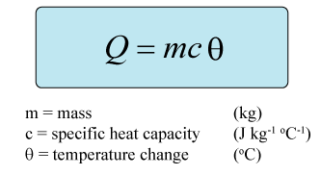](https://www.google.co.uk/url?sa=i&rct=j&q=&esrc=s&source=images&cd=&cad=rja&uact=8&ved=0ahUKEwjvv-qgo5TYAhVQKFAKHZcKBsMQjRwIBw&url=https%3A%2F%2Fwww.pinterest.com%2Fpin%2F207236020326354168%2F&psig=AOvVaw1dVArJEyYUFS1jVyfvIIW8&ust=1513711050382718)

The specific heat capacity of water is 4182 J/kgoC. Calculate the energy needed to heat 4kg of water from 20 to 80oC

………………………………………………………………………………………….

Calculate the temperature change when 30000J of energy is transferred to a 3kg brick if the specific heat capacity is 840 J/kgoC.

………………………………………………………………………………………….

Calculate the mass of bricks if 50000J of energy is transferred raising the temperature from 20 to 40oC.

Specific heat capacity is 840 J/kgoC.

………………………………………………………………………………………….

Describe what the spring constant is of a spring

………………………………………………………………………………………….

………………………………………………………………………………………….

………………………………………………………………………………………….

Sketch a graph to show a spring which has a higher spring constant

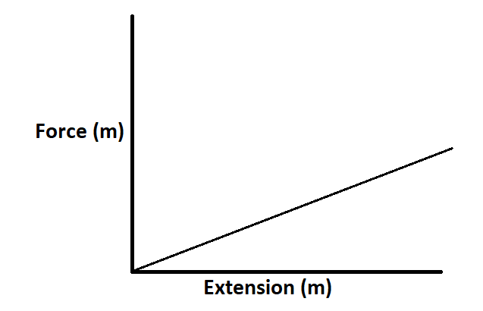

**Equation given in exam**

**E = ½ x k x X2**

Calculate the energy transferred when a spring with a spring constant of 200N/m is stretched by 30cm

Bending and Stretching

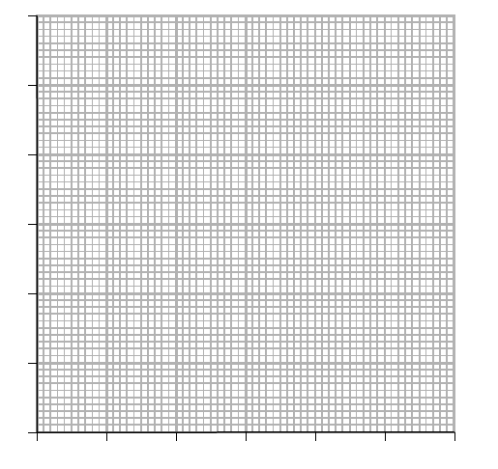

Describe the conclusions that can be made from the graph

………………………………………………………………………………………….………………………………………………………………………………………….

………………………………………………………………………………………….

State the equation that links spring constant, extension and force

………………………………………………………………………………………….

Calculate the force needed to make a spring extend by 10cm if the spring constant is 200N/m

………………………………………………………………………………………….………………………………………………………………………………………….

………………………………………………………………………………………….

Bending and Stretching

Describe the difference between elastic and inelastic objects

………………………………………………………………………………………….………………………………………………………………………………………….

………………………………………………………………………………………….

Identify force A which is acting on the bungee jumper …………………………………………………………………………….

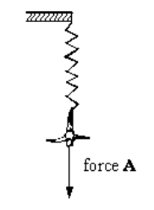

Plot the following data on the graph paper provided

