**CP1 Revision Mat:**

**Vectors and Scalars:**

Define scalar:

…………………………………………………………………………………………………………………………………………………………………………

Give 2 examples of scalar quantities:

…………………………………………………………………………………………………………………………………………………………………………

Define vector:

…………………………………………………………………………………………………………………………………………………………………………

Give 2 examples of vector quantities

…………………………………………………………………………………………………………………………………………………………………………

Give a pair of quantities where one is a vector and the other a scalar

……………………………………………………………………………………

What is meant by the term ‘displacement’

…………………………………………………………………………………………………………………………………………………………………………

Draw a diagram to show an example of displacement.

**Acceleration:**

What is the equation that links the change in velocity, acceleration and time?

What are the units of acceleration?...................

An object accelerates from 10m/s to 20m/s in 5 seconds. Calculate the acceleration.

……………………………………………………………………………………

A car slows down from 30m/s to 10m/s in 4 seconds. Calculate the acceleration.

……………………………………………………………………………………

Acceleration can be linked to initial velocity, final velocity and distance:

**v2-u2 = 2 x a x *x***

Rearrange the equation to calculate distance (*x*)

What is the acceleration due to gravity?

……………………………………………………………………………………

**Distance-Time Graphs**

What is the equation that links time, speed and distance?

What are the units of speed? ……………………………..

|  |  |
| --- | --- |
|  | Estimate of speed |
| Walking |  |
| Cycling |  |

An object travels 10m in 2 seconds. Calculate the speed.

………………………………………………………………………………………

How far would ThrustSSC travel in 5 seconds if the speed was 341m/s?

……………………………………………………………………………………….

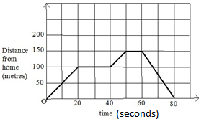

What does a horizontal line represent on a distance time graph?

……………………………………………………………………………………….

Calculate the speed in the first 20 seconds.

……………………………………………………………………………………….

**Velocity-Time Graphs**

[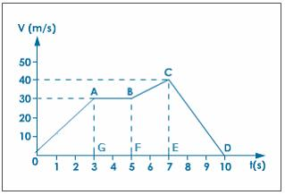](http://www.google.com/url?sa=i&rct=j&q=&esrc=s&source=images&cd=&cad=rja&uact=8&ved=0ahUKEwje-OWa78jPAhXD1hoKHQ8yD6cQjRwIBw&url=http%3A%2F%2Fwww.tutorvista.com%2Fcontent%2Fscience%2Fscience-i%2Fmotion%2Fquestion-answers-2.php&psig=AFQjCNGpBzIAVotxfgFycw2eN1TIBryWzw&ust=1475935720152733)

Calculate the distance travelled:

**Part A**

………………………………………………………………………………………

**Part A-B**

………………………………………………………………………………………

**Part B-C**

………………………………………………………………………………………

**Velocity-Time Graphs**

What does a sloping line represent on a velocity-time graph?

………………………………………………………………………………………

What does a horizontal line represent on a velocity-time graph?

………………………………………………………………………………………

How do you calculate the distance travelled on a sloped part of the graph?

………………………………………………………………………………………

How do you calculate the distance travelled on a horizontal part of the graph?

………………………………………………………………………………………