**CC9 Revision Mat**

**Calculating the empirical formula of magnesium oxide.**

Label A-F

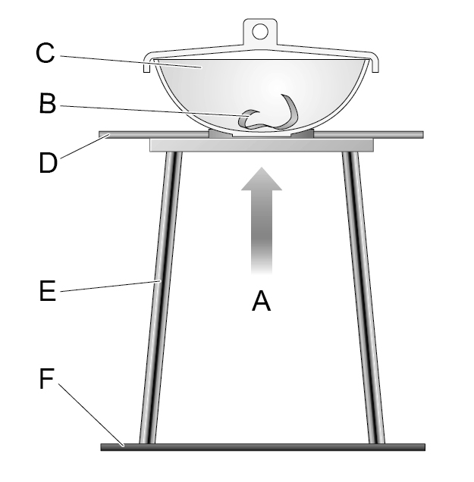

Describe how this apparatus can be used to find the empirical formula of magnesium oxide

……………………………………………………………………………………..

……………………………………………………………………………………..

……………………………………………………………………………………..

……………………………………………………………………………………..

……………………………………………………………………………………..

……………………………………………………………………………………..

……………………………………………………………………………………..

……………………………………………………………………………………..

……………………………………………………………………………………..

……………………………………………………………………………………..

**Masses and empirical formulae continued**

Rules:

1. Divide the mass of each element by the relative atomic mass
2. Divide the answers by the smallest number to find the simplest ratio
3. Empirical formula

Calculate the empirical formula of a compound that contains 4.6g of sodium (Na) and 7.1g of chlorine (Cl)

Calculate the empirical formula of a compound that contains 3.6g magnesium and 10.65g of chlorine

**Masses and empirical formulae**

Relative formula mass is the sum of the relative atomic masses of all the atoms/ions in its formula.

Define relative atomic mass

……………………………………………………………………………………..

……………………………………………………………………………………..

Calculate the relative formula mass of:

1. N2 …………………………………………..
2. NaI …………………………………………..
3. NH3 …………………………………………..
4. CO2 …………………………………………..
5. (NH4)2SO4 …………………………………

Define empirical formula

……………………………………………………………………………………..

……………………………………………………………………………………..

Deduce the empirical formula:

1. H2O2 ……………………..
2. C3H6 ……………………..
3. N2H4 ……………………..

**Conservation of mass continued**

1.34g of copper was heated in air and formed 1.76g of copper oxide. Calculate the mass of oxygen formed

**Calculating masses of reactants or products**

Rules:

1. Write a balanced equation
2. Calculate relative formula masses of substances needed
3. Calculate the ratio of masses (multiply Mr values by balancing numbers in equation if needed)
4. Work out the mass for 1g of reactant/product
5. Scale up or down

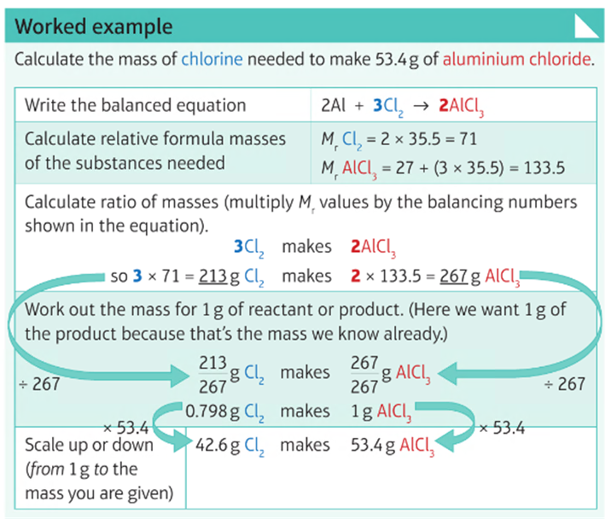

**Conservation of mass**

Write the formula for calculating concentration and state the units

Calculate the concentrations in gdm-3 of 10g of sodium chloride in 1dm3

Calculate the concentration in gdm-3 of 1.2g potassium chloride in 50cm3.

**Conservation of mass in reactions:**

What is the difference between a closed and a non-enclosed system?

…………………………………………………………………………………

…………………………………………………………………………………

…………………………………………………………………………………

…………………………………………………………………………………

Give examples of non-enclosed systems

………………………………………………………………………………………………………….………………………………………………………………………………..

**Conservation of mass continued**

Calculate the mass of oxygen that combines with 20.4g of magnesium to form 34.0g of magnesium oxide

2Mg + O2 🡪 2MgO

Calculate the mass of oxygen that combines with 5.4g of aluminium to form 10.2g of aluminium oxide

4Al + 3O2 🡪 2Al2O3

**Moles (*Higher*)**

Calculate the maximum mass of magnesium oxide that can be made from 2.4g of magnesium and 2.4g of oxygen

**Working out balanced equations from masses of reactants and/or products**

Rules:

1. Calculate the number of moles (Mass/Ar or Mr)
2. Divide by smaller
3. Simplest whole number ratio

15g of hydrogen gas reacts with 70g of nitrogen gas to produce ammonia, NH3 – deduce the balanced equation for the reaction.

**Moles (*Higher*)**

Write the formula triangle for calculating moles.

Write Avogadro’s constant in standard form: 602 204 500 000 000 000 000 000

Calculate the number of moles in 88g of carbon dioxide molecules

Calculate the number of moles in 3.2g of methane.

What is meant by limiting reactant?

………………………………………………………………………………………………………….…………………………………………………………………..