**CC8 Revision Mat**

Describe what happens to the acidity and pH of a solution as more hydrogen ions are added

……………………………………………………………………………………..

……………………………………………………………………………………..

Describe what happens to the alkalinity and pH of a solution as more hydroxide ions are added

……………………………………………………………………………………..

……………………………………………………………………………………..

What can be said about the concentration of ions in a neutral solution?

……………………………………………………………………………………..

|  |  |
| --- | --- |
| Ion | Formula |
| Chloride |  |
| Oxide |  |
| Hydroxide |  |
| Nitrate |  |
| Sulfate |  |

|  |  |
| --- | --- |
| Common acid | Formula |
|  | HCl |
| Sulfuric acid |  |
| Nitric acid |  |

|  |  |
| --- | --- |
| Common alkali | Formula |
|  | NaOH |
| Potassium hydroxide |  |
| Calcium hydroxide |  |

Looking at acids: (Higher)

Calculate the concentration if 5g is dissolved in 50cm3

……………………………………………………………………………………..

What is a concentrated solution?

……………………………………………………………………………………..

……………………………………………………………………………………..

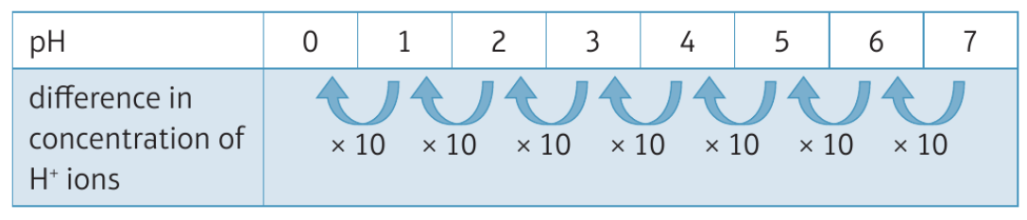

How many more times concentrated is a solution of pH 0 compared with a solution of pH 3? …………………………………………………………………………

Explain the difference between a strong and a weak acid.

……………………………………………………………………………………..

……………………………………………………………………………………..

……………………………………………………………………………………..

Explain how a concentrated solution of a weak acid could have the same pH and similar reactions to a dilute solution of a weak acid

……………………………………………………………………………………..………

……………………………………………………………………………………..………

…………………………………………………………………………………….…………………………………………………………………………………..…………………

Acids, Alkalis and indicators

|  |  |
| --- | --- |
| Type of solution | pH |
| Acid |  |
| Alkali |  |
| Neutral |  |

What hazard symbols would you find on an acid/alkali?

1. …………………………………………………….
2. …………………………………………………….

Indicators:

|  |  |  |
| --- | --- | --- |
| Indicator | Colour in acidic solutions | Colour in alkaline solutions |
| Litmus |  |  |
| Methyl orange |  |  |
| Phenolphthalein |  |  |

Ions in acids and alkalis:

What is an ion?

……………………………………………………………………………………..

……………………………………………………………………………………..

What ion is in excess in acids? …………………………..

What ion is in excess in alkalis? …………………………

Alkalis and Neutralisation

Write a symbol equation to show the dissociation of ions for hydrochloric acid:

…………………………………………………………………………………

Write a symbol equation to show the dissociation of ions for sodium hydroxide

…………………………………………………………………………………

Write a symbol equation to show how water forms in a neutralisation reaction

…………………………………………………………………………………

Alkalis and Balancing Equations

Write balanced symbol equations for the following reactions: Include state symbols.

Lithium hydroxide + Hydrochloric acid 🡪

…………………………………………………………………………………

Calcium hydroxide + nitric acid 🡪

…………………………………………………………………………………

Sodium hydroxide + Sulfuric acid 🡪

…………………………………………………………………………………

Sodium hydroxide + Hydrochloric acid 🡪

…………………………………………………………………………………

Alkalis and Balancing Equations

Complete the general equation:

Metal hydroxide + Acid 🡪 ______________ + ________________

Complete word equations for the following reactions:

Lithium hydroxide + Hydrochloric acid 🡪

……………………………………………………………………………………..

Calcium hydroxide + nitric acid 🡪

……………………………………………………………………………………..

Sodium hydroxide + Sulfuric acid 🡪

……………………………………………………………………………………..

Sodium hydroxide + Hydrochloric acid 🡪

……………………………………………………………………………………..

Bases and Salts

Explain why excess base is used in making a soluble salt.

……………………………………………………………………………………..……………………………………………………………………………………..

Write a word equation when insoluble nickel oxide with hydrochloric acid

……………………………………………………………………………………..……………………………………………………………………………………..

Bases and Salts

Complete the general equation:

Metal oxide + Acid 🡪 _________ + ________

|  |  |
| --- | --- |
| Acid | Salt Formed |
| Hydrochloric acid |  |
| Nitric acid |  |
| Sulfuric acid |  |

Complete the word equations:

Magnesium oxide + Sulfuric acid 🡪

……………………………………………………………………………………..

Write a balanced symbol equation for the above reaction

……………………………………………………………………………………..

During a neutralisation reaction what two ions combine to form water?

……………………………………………………………………………………..

Describe how to prepare a **soluble** salt from copper oxide and sulphuric acid

……………………………………………………………………………………..……………………………………………………………………………………..……………………………………………………………………………………..……………………………………………………………………………………..……………………………………………………………………………………..

Solubility

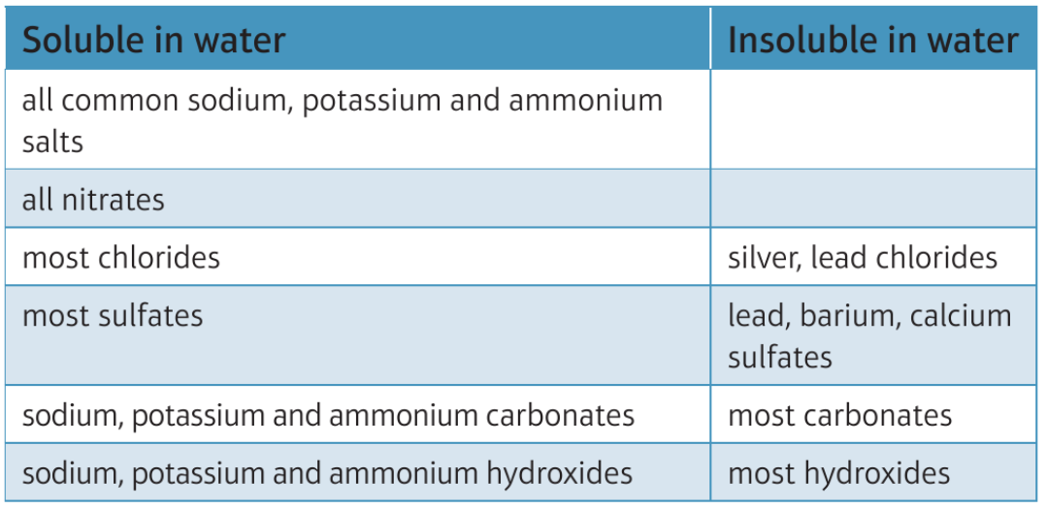

What is a precipitate?

………………………………………………………………………………

Reactions of acids with metals and carbonates

Write a word equation when copper carbonate reacts with sulphuric acid

………………………………………………………………………………

Write a balanced symbol equation when copper carbonate reacts with nitric acid

………………………………………………………………………………

Write the **ionic equation** for the reaction between magnesium carbonate and hydrochloric acid (these equations do not include the spectator ions)

………………………………………………………………………………

Reactions of acids with metals and carbonates

What would you **see** in a reaction when you add metals or metal carbonates with acids?

………………………………………………………………………………

Describe the gas test for hydrogen

………………………………………………………………………………

………………………………………………………………………………

Describe the gas test for carbon dioxide

………………………………………………………………………………

………………………………………………………………………………

Write a word equation when zinc reacts with hydrochloric acid

………………………………………………………………………………

Write a balanced symbol equation when calcium reacts with sulphuric acid

………………………………………………………………………………

Write a half equation to show what happens to magnesium atoms

………………………………………………………………………………

What are ions called if they do not change during a reaction?

………………………………………………………………………………

Alkalis and Neutralisation

Titrations: Label the equipment in the diagram

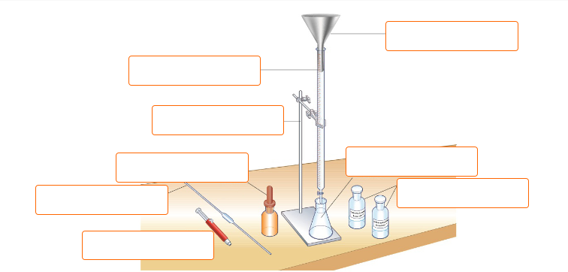

Explain why it is better to use a pipette rather than a measuring cylinder.

……………………………………………………………………………………..

How would you determine the end point of a titration?

……………………………………………………………………………………..

Explain why universal indicator is not a good choice of indicator to use in a titration reaction

……………………………………………………………………………………..……………………………………………………………………………………..

Reactions of acids with metals and carbonates

Complete general equations:

Metal + Acid 🡪 ________ + ____________

Metal carbonate + Acid 🡪 ________ + _____________ + _________________

Solubility:

Write a word equation for the reaction between lead nitrate and sodium chloride.

……………………………………………………………………………………..

What is the insoluble salt formed from the above reaction …………………………………………………………

Lead forms Pb2+ ions.

Write the ionic equation for the formation of lead chloride

……………………………………………………………………………………..

What two solutions could you use to make silver chloride?

……………………………………………………………………………………..

What two solutions could you used to make magnesium hydroxide

……………………………………………………………………………………..

Describe how to prepare an insoluble salt of barium sulfate from barium nitrate and sodium sulfate

……………………………………………………………………………………..……………………………………………………………………………………..……………………………………………………………………………………..……………………………………………………………………………………..