CC3 Revision Mat: Atomic Structure
Isotopes
Define what an isotope is
………………………………………………………………………………………………………………………………………………………………………………………………………………………………………………

Calculate the relative atomic mass of the following isotopes:
- 69% ⁶³Cu and 31% ⁶⁵Cu

- 79% ²⁴Mg, 10% ²⁵Mg and 11% ²⁶Mg

Neon has a relative atomic mass of 20.2 and is made up of 2 atoms: ²⁰Ne and ²²Ne. Explain which of these isotopes is the most abundant.
………………………………………………………………………………………………………………………………………………………………………………………………………………………………………………

Atomic Number:
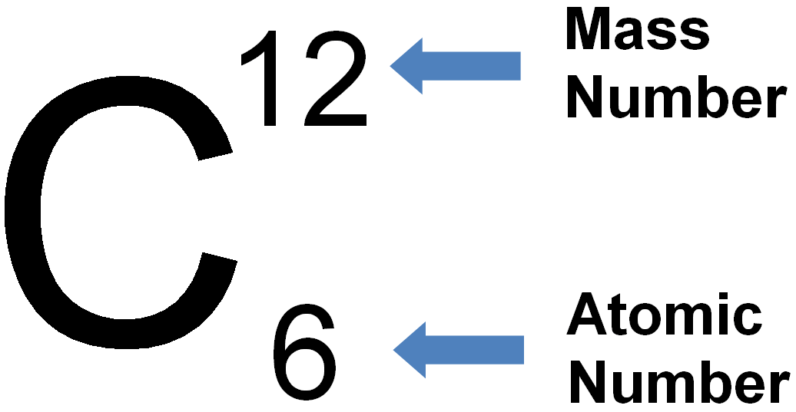
Define mass number:
………………………………………………………………………………………………………………………………………………………………………………
Define atomic number:
………………………………………………………………………………………………………………………………………………………………………………
How do you calculate the number of protons from the mass and atomic number?
…………………………………………………………………………………
Symbol | Mass number | Atomic number | Protons | Neutrons | Electron
K
Ar
Si
N
O

A manganese atom has 25 protons, 30 neutrons and 25 electrons.
What is the mass number? ___________
What is the atomic number? __________
Structure of the atom:
Draw a diagram of an atom
Label the 3 subatomic particles

What particles are found inside the nucleus of an atom?
_______________ and ________________

What particles are found in shells?
__________________________________
Complete the table:
 | Relative mass | Relative charge
Proton
Neutron
Electron

Explain why atoms have no overall charge>
………………………………………………………………………………………………………………………………………………………………………………………………………………………………………………………………

