**States of matter, mixtures, filtration and crystallisation**

**Filtration and Crystallisation:**

Label the diagram including keywords: filtrate, residue and suspension

[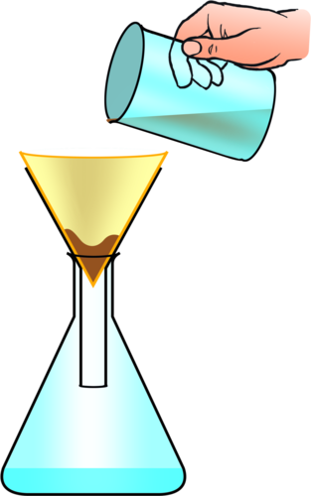](http://www.google.com/url?sa=i&rct=j&q=&esrc=s&source=images&cd=&cad=rja&uact=8&ved=0ahUKEwiC-ZbqhqjQAhVI7xQKHeaaDYkQjRwIBw&url=http%3A%2F%2Fwww.mstworkbooks.co.za%2Fnatural-sciences%2Fgr7%2Fgr7-mm-02.html&bvm=bv.138493631,d.ZGg&psig=AFQjCNFeJL5ezcKkpwpJYc_lAymMhEGo2g&ust=1479206241863867)

How does filtration separate mixtures (keywords: soluble and insoluble)

______________________________________________________________________________________________________

Label the diagram:

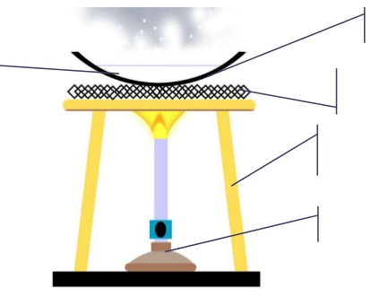

What process removes the liquid from the solution ____________________________

Give a safety precaution ________________

**Mixtures:**

Define ‘pure’ substance:

______________________________________________________________________________________________________

Define a mixture:

______________________________________________________________________________________________________

Draw a heating curve for a mixture:

[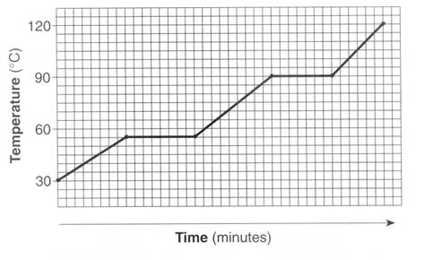](http://www.google.com/url?sa=i&rct=j&q=&esrc=s&source=images&cd=&cad=rja&uact=8&ved=0ahUKEwi-9OuNhajQAhWCRhQKHbCODIkQjRwIBw&url=http%3A%2F%2Fwww.kentchemistry.com%2Flinks%2FMatter%2FHeatingCurve.htm&psig=AFQjCNG1PL7D8C8IJKPf5zic6xpoUYTJxQ&ust=1479205784981459)

Describe what happens when a solid melts in terms of particles and forces of attraction

________________________________________________________________________________________________________________________________________

**States of Matter**

Draw the particle diagrams

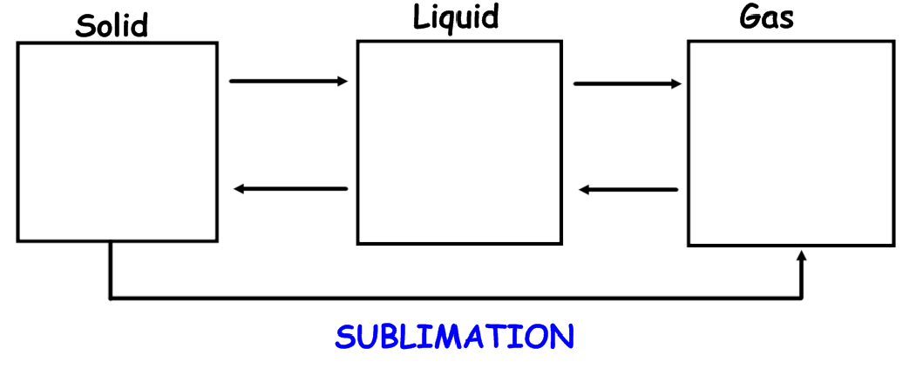

What is meant by physical changes?

____________________________________________________________________

Label where substance is a solid, liquid and a gas:

[](http://www.google.com/url?sa=i&rct=j&q=&esrc=s&source=images&cd=&cad=rja&uact=8&ved=0ahUKEwi-9OuNhajQAhWCRhQKHbCODIkQjRwIBw&url=http%3A%2F%2Fwww.kentchemistry.com%2Flinks%2FMatter%2FHeatingCurve.htm&psig=AFQjCNG1PL7D8C8IJKPf5zic6xpoUYTJxQ&ust=1479205784981459)

What is the melting point? __________

What is the boiling point? ___________

At 65oC what state of matter is the substance in? ____________________