**Chromatography, Distillation and Drinking water**

**Drinking water:**

Describe a process how you could get pure water from sea water

____________________________________________________________________________________________________________________________________________________________________________________________________________

**Distillation:**

What two processes happen in distillation?

__________________________________



**Chromatography:**

What is chromatography used for?

______________________________________________________________________________________________________

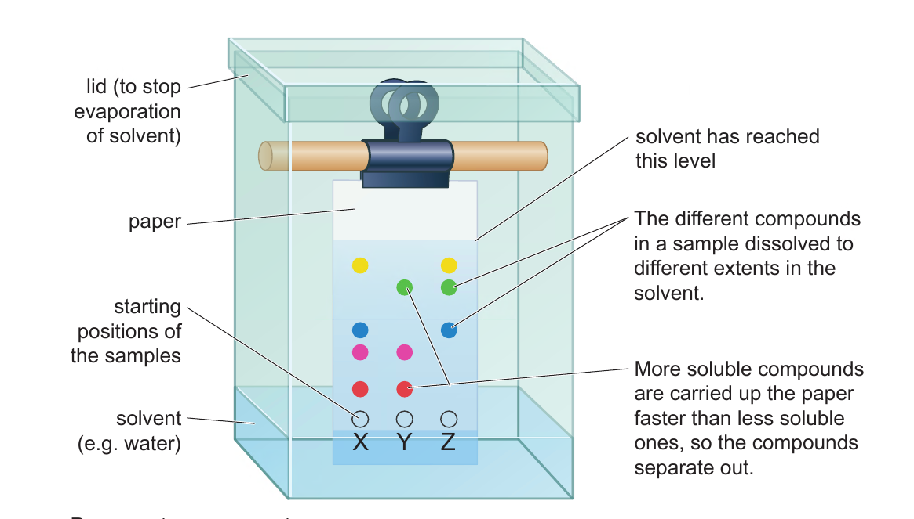

Name the mobile phase _________________

What is the stationary phase?

­­­­__________________________________

What is the solvent front?  
__________________________________

What is the reason why the baseline is drawn in pencil?

__________________________________

What is the equation for calculating Rf value?

**Fractional Distillation:**

What is fractional distillation used for?

____________________________________________________________________

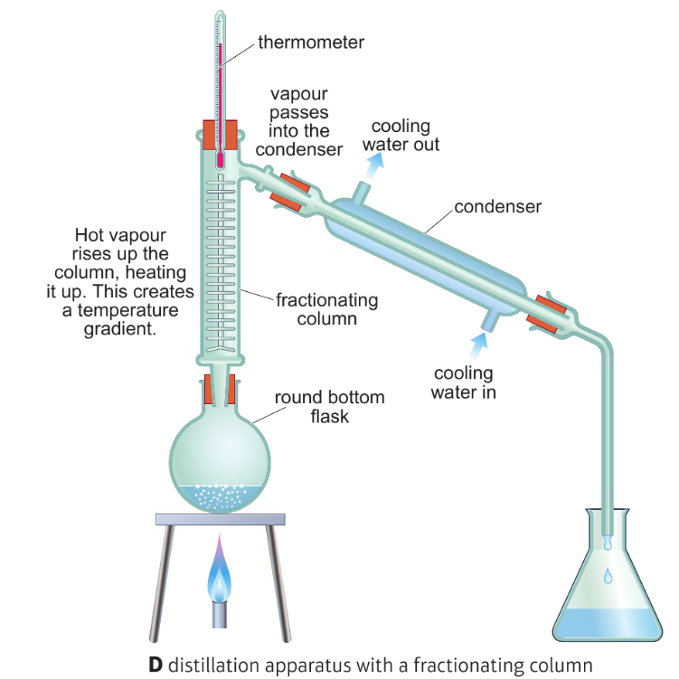

**Chromatography:**

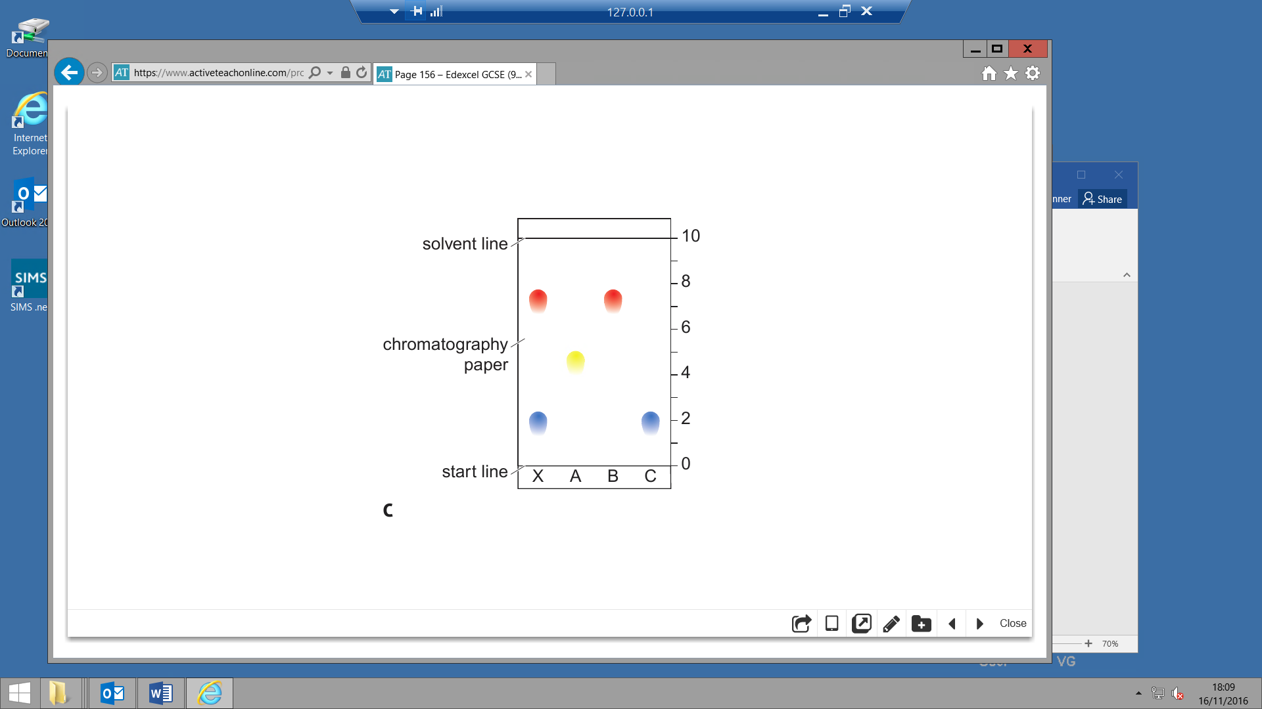

Which food colourings (A, B or C) is in substance X? ________________________

Calculate the Rf value:

Food colouring A _____________________

Food colouring B _____________________

**Drinking Water:**

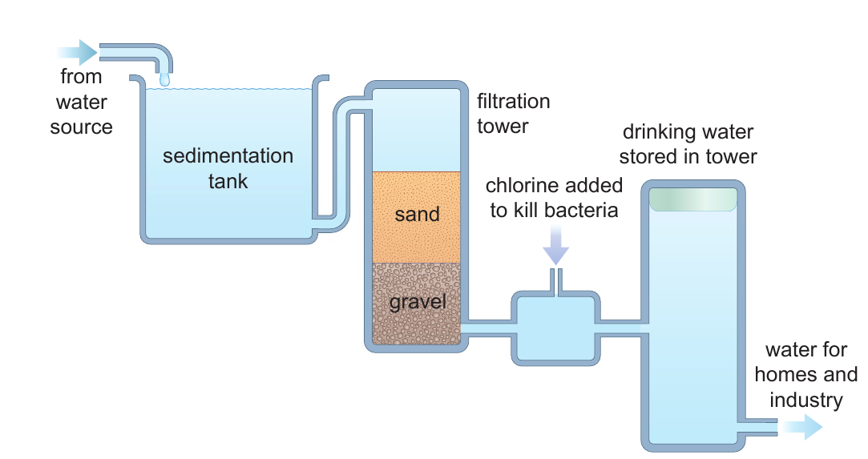

Describe the process of sedimentation

______________________________________________________________________________________________________

Describe the process of filtration

______________________________________________________________________________________________________

Describe the process of chlorination

______________________________________________________________________________________________________

Explain the importance of chemical analysis of water

______________________________________________________________________________________________________