**CB9 Revision Mat**

Biotic factors and communities

State what biotic factors are

…………………………………………………………………………………………………………………………………………………………………………………………

Name some biotic factors organisms will compete for

…………………………………………………………………………………………………………………………………………………………………………………………

Describe how introducing a predator can affect a community

………………………………………………………………………………………………………………………………………………………………………………………………………………………………………………………………..……………………………………………………………………………………………………………………

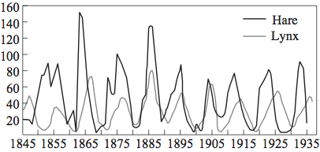

Identify the predator ……………………………………………………………

Identify the prey …………………………………………………………………….

Explain your answers

……………………………………………………………………..…………………………………………………………………………………………………………………....

Ecosystems

Define community

……………………………………………………………………………………..……………………………………………………………………………………..

Define population

……………………………………………………………………………………..……………………………………………………………………………………..

Define habitat

……………………………………………………………………………………..……………………………………………………………………………………..

Describe how to use quadrats to estimate a population size

……………………………………………………………………………………..……………………………………………………………………………………..……………………………………………………………………………………..……………………………………………………………………………………..

In a 1m2 quadrat on a rocky shore there are 25 limpets. The total area is 500m2.

Estimate the total population size of limpets

……………………………………………………………………………………..

Describe how organisms in a rainforest are interdependent

……………………………………………………………………………………..……………………………………………………………………………………..……………………………………………………………………………………..……………………………………………………………………………………..

Abiotic factors and communities

State what abiotic factors are

………………………………………………………………………………………………………………………………………………………………………………………………

List examples of abiotic factors

………………………………………………………………………………………………………………………………………………………………………………………………

Describe how one abiotic factor would differ moving **away** from a tree

……………………………………………………………………………………..……………………………………………………………………………………………………….

Describe how a belt transect can be used to investigate the effect of abiotic factors on organisms

……………………………………………………………………………………..……………………………………………………………………………………..……………………………………………………………………………………..……………………………………………………………………………………………………………………………………………………………………………………………..………………………………………………………………………………………………………………………

Explain the effects of drought on an ecosystem

……………………………………………………………………………………..……………………………………………………………………………………..……………………………………………………………………………………………………………………………………………………………………………………..………………………………………………………………………………………………………………………

The water cycle

Describe how water is cycled in the water cycle

…………………………………………………………………………………..……………………………………………………………………………………………………………………………………………………………………………………………..……………………………………………………………………………………………………………………………………………………………………………………………..…………………………………………………………………………………………………………

Describe the process of desalination

…………………………………………………………………………………..…………………………………………………………………………………………………………………………………………………………………………………………..…………………………………………………………………………………………………………..

Preserving biodiversity

Describe what reforestation is

…………………………………………………………………………………..…………………………………………………………………………………………………………

Describe what conservation is

…………………………………………………………………………………..…………………………………………………………………………………………………………

Explain why endangered organisms are being kept in captivity.

…………………………………………………………………………………..…………………………………………………………………………………………………………

Biodiversity and humans

Explain the advantages of fish farming

……………………………………………………………………………………………………………………………………………………………………………………………..……………………………………………………………………………………………..……………………………………………………………………………………………..

Explain the disadvantages of fish farming

……………………………………………………………………………………………..……………………………………………………………………………………………..……………………………………………………………………………………………..……………………………………………………………………………………………..

Describe the difference between indigenous and non-indigenous

……………………………………………………………………………………………………………………………………………………………………………………………..

Describe how the overuse of fertilisers in a field nearby can cause fish in the lake to die

……………………………………………………………………………………………..…………………………………………………………………………………………..……………………………………………………………………………………………..……………………………………………………………………………………………..…………………………………………………………………………………………..……………………………………………………………………………………………..……………………………………………………………………………………………..…………………………………………………………………………………………………………………………………………………………………………………………………..

Parasitism and mutualism

Define parasitism

…………………………………………………………………………………………………………………………………………………………………………

Explain how a tapeworm is adapted to living inside its hosts

……………………………………………………………………………………………………………………………………………………………………………………………………………………………………………………………………………………………………………………………………………………

Explain how headlice are adapted to living on hair and skin

……………………………………………………………………………………………………………………………………………………………………………………………………………………………………………………………………………………………………………………………………………………

Define mutualism

……………………………………………………………………………………………………………………………………………………………………………………………………………………………………………………………..

Tube worms live near hydrothermal vents. Tube worms and chemosynthetic bacteria have a mutualistic relationship. Explain how.

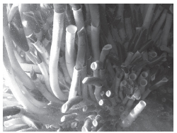

……………………………………………………………………………………………………………………………………………………………………………………………………………………………………………………………..

The nitrogen cycle

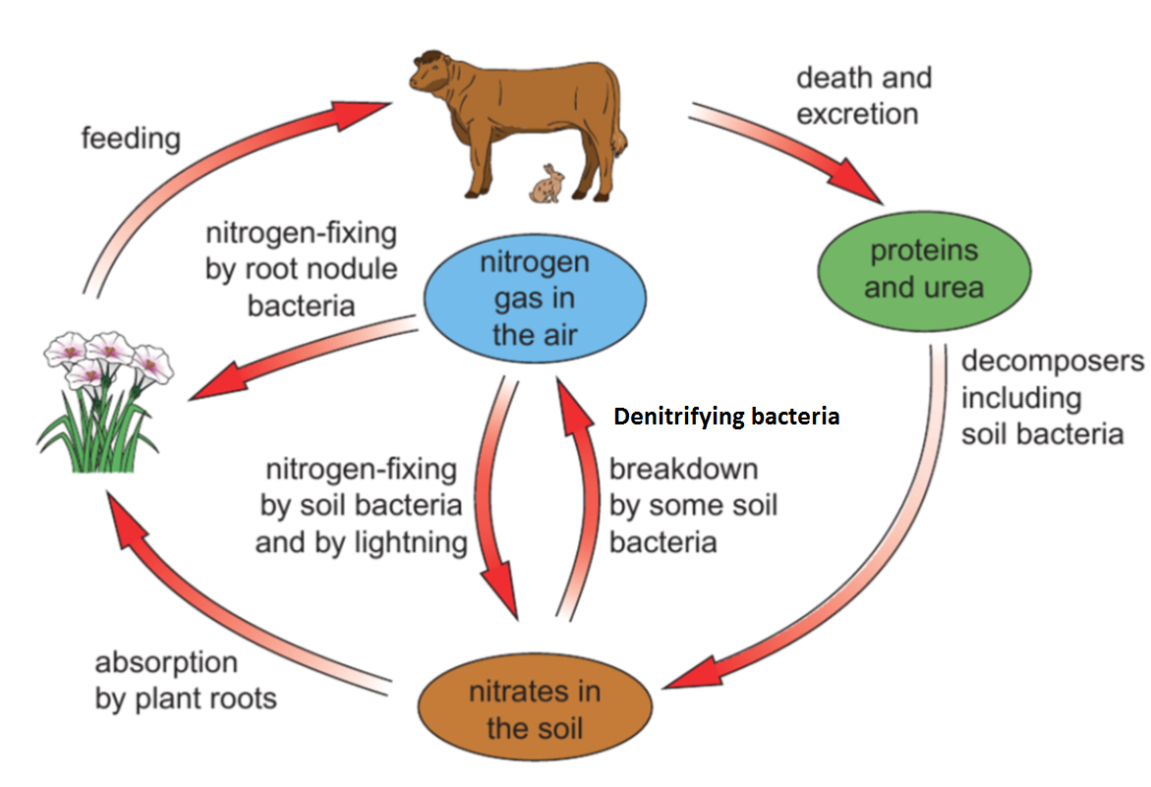

State what nitrates are needed for in plants

…………………………………………………………………………………………………………………

Explain the role of bacteria in producing nitrates available to plants

…………………………………………………………………………………………………………………………………………………………………………………………………………………………………………………………………………………………………………………………………………………………………………………………………………………………………………………………………………

Explain how crop rotation can ensure levels of nitrates in the soil remain high

……………………………………………………………………………………………………………………………………………………………………………………………………………………………………

Describe how nitrates in plants are cycled to become nitrates in the soil

…………………………………………………………………………………………………………………………………………………………………………………………………………………………………………………………………………………………………………………………………………………………………………………………………………………………………………………………………………

The carbon cycle

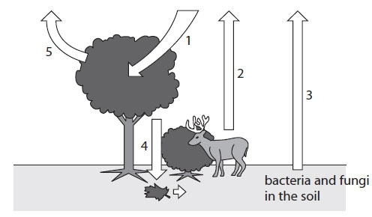

Identify processes that increase levels of carbon dioxide in the atmosphere

…………………………………………………………………………………………………………………………………………………………………………

Identify processes that decrease levels of carbon dioxide in the atmosphere

…………………………………………………………………………………………………………………………………………………………………………

Describe the role of decomposers in the carbon cycle

……………………………………………………………………………………………………………………………………………………………………………………………………………………………………………………………………………………………………………………………………………………

Explain the effect on the carbon cycle with an increasing population

……………………………………………………………………………………………………………………………………………………………………………………………………………………………………………………………………………………………………………………………………………………