**CB8 Revision Mat**

The Heart

Label the structures of the heart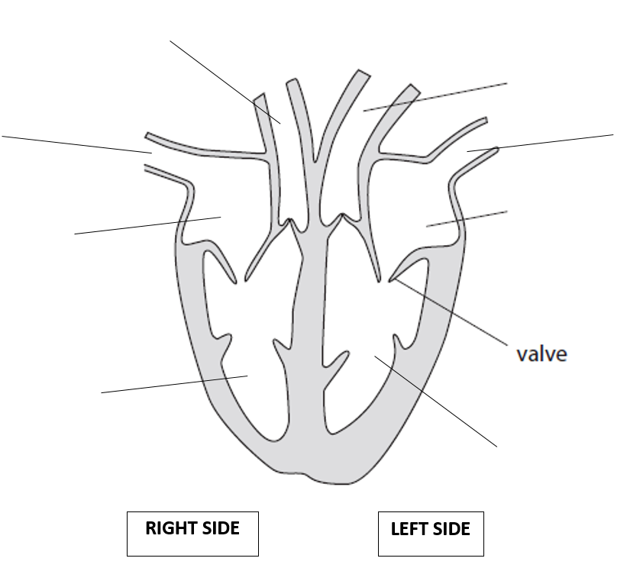

Blood

Describe the role of lymphocytes

…………………………………………………………………………………………………………………………………………………………………………………………

Describe the role of phagocytes

…………………………………………………………………………………………………………………………………………………………………………………………

Describe the role of erythrocytes

…………………………………………………………………………………………………………………………………………………………………………………………

Describe the role of platelets

…………………………………………………………………………………………………………………………………………………………………………………………

The circulatory system

List the components in the circulatory system

……………………………………………………………………………………………………………………………………………………………………………………………..

Describe the role of each component in the circulatory system

……………………………………………………………………………………………..……………………………………………………………………………………………………………………………………………………………………………………………..……………………………………………………………………………………………..………………………………………………………………………………………………

Describe how arteries are adapted to their function

……………………………………………………………………………………………………………………………………………………………………………………………..

Describe how veins are adapted to their function

……………………………………………………………………………………………………………………………………………………………………………………………..

Explain the role of valves in veins

………………………………………………………………………………………………………………………………………………………………………………………………

Explain how erythrocytes are adapted to their function

………………………………………………………………………………………………………………………………………………………………………………………………………………………………………………………………………………………………………………………………………………………………………………………………

Efficient transport and exchange

Identify substances that need to be exchanged in the body

……………………………………………………………………………………..……………………………………………………………………………………..

Name the process by which substances are exchanged by

……………………………………………………………………………………..

Explain how capillaries are adapted to allow for fast exchange of substances

……………………………………………………………………………………..

……………………………………………………………………………………..

Describe how surface area to volume ratio is linked to rate of exchange

……………………………………………………………………………………..

……………………………………………………………………………………..

Describe how to calculate surface area to volume ratio

……………………………………………………………………………………..

……………………………………………………………………………………..

Explain how the alveoli are adapted for efficient gas exchange

……………………………………………………………………………………..

……………………………………………………………………………………..

……………………………………………………………………………………..

Cellular respiration continued

Explain why aerobic and anaerobic respiration is an exothermic process

…………………………………………………………………………………..…………………………………………………………………………………………………………

Describe how lactic acid concentrations would change during exercise

…………………………………………………………………………………..…………………………………………………………………………………………………………

Explain why lactic acid concentration in the blood decreases after exercise has finished

…………………………………………………………………………………..…………………………………………………………………………………………………………

Describe the effect of temperature on the rate of respiration

………………………………………………………………………………………………

Explain the effect of temperature on the rate of respiration

………………………………………………………………………………………………………………………………………………………………………………………………

Cellular respiration

State the equation for aerobic respiration

……………………………………………………………………………………………………………………………………………………………………………………………..

State where aerobic respiration happens

……………………………………………………………………………………………..

State the equation for anaerobic respiration

……………………………………………………………………………………………………………………………………………………………………………………………..

State where anaerobic respiration happens

……………………………………………………………………………………………..

Describe the effects of exercise on the body

……………………………………………………………………………………………..……………………………………………………………………………………………..……………………………………………………………………………………………..

Explain the effects of exercise on the body

……………………………………………………………………………………………..……………………………………………………………………………………………..……………………………………………………………………………………………..……………………………………………………………………………………………..

Explain why athletes recover faster after exercise than unfit people

……………………………………………………………………………………………..……………………………………………………………………………………………..……………………………………………………………………………………………..

The Heart

Explain how the blood leaving the pulmonary artery is different to the blood leaving the aorta

……………………………………………………………………………………

……………………………………………………………………………………

……………………………………………………………………………………

Explain why the left side of the heart is thicker than the right side

……………………………………………………………………………………

……………………………………………………………………………………

……………………………………………………………………………………

……………………………………………………………………………………

State the equation to calculate cardiac output

……………………………………………………………………………………

Calculate the cardiac output of a heart that pumps out 0.88L of blood 60 times a minute

……………………………………………………………………………………

Explain why regular exercise increases the cardiac output

……………………………………………………………………………………

……………………………………………………………………………………

……………………………………………………………………………………