**CB7 Revision Mat**

The menstrual cycle

Describe the effect of oestrogen on the uterus lining

…………………………………………………………………………………………………………………………………………………………………………………………

Describe the effect of progesterone on the uterus lining

…………………………………………………………………………………………………………………………………………………………………………………………

Describe what happens during ovulation

……………………………………………………………………………………..……………………………………………………………………………………………………

Describe what happens during menstruation

……………………………………………………………………………………..……………………………………………………………………………………………………

State 2 barrier methods of contraception

……………………………………………………………………………………..………

Describe how condoms prevent ferilisation

…………………………………………………………………………………………………………………………………………………………………………………………

Explain how the hormone pill prevents fertilisation

……………………………………………………………………………………..…………………………………………………………………………………………………………………………………………………………………………………………..……………………………………………………………………………………………………

Hormonal control of metabolic rate (HIGHER)

Describe what is meant by metabolic rate

……………………………………………………………………………………………………………………………………………………………………………………………..

Describe how negative feedback can control the amount of thyroxine in the blood

……………………………………………………………………………………………………………………………………………………………………………………………..

Describe the effect of thyroxine

……………………………………………………………………………………………………………………………………………………………………………………………..

Explain how the body responds to low levels of thyroxine in the blood

……………………………………………………………………………………………………………………………………………………………………………………………..……………………………………………………………………………………………………………………………………………………………………………………………..

State 3 target organs of adrenalin

………………………………………………………………………………………………

Explain how adrenalin prepares the body for fight or flight response

……………………………………………………………………………………………..……………………………………………………………………………………………………………………………………………………………………………………………..……………………………………………………………………………………………..……………………………………………………………………………………………………………………………………………………………………………………………..

Hormones

Describe how hormones are carried in the body

……………………………………………………………………………………..

State the name given to organs that secrete hormones

……………………………………………………………………………………..

Identify the different places that secrete hormones

Name an example of a hormone released for each

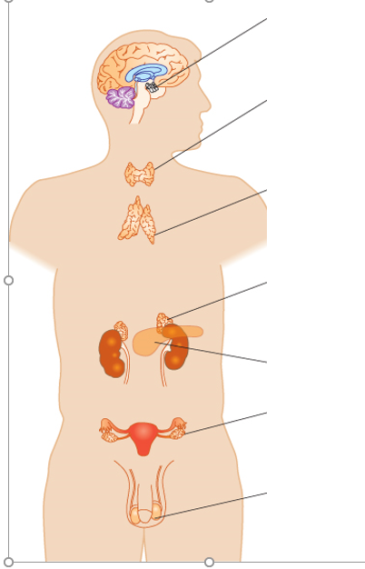

Diabetes

Describe what causes type 1 diabetes

…………………………………………………………………………………..………………………………………………………………………………………………………………………………

Describe how type 1 diabetes is treated

…………………………………………………………………………………..………………………………………………………………………………………………………………………………

Describe what causes type 2 diabetes

…………………………………………………………………………………..………………………………………………………………………………………………………………………………

Describe how type 2 diabetes is treated …………………………………………………………..………………………………………………………………………………………………………………………………………………………

Describe how BMI/waist:hip ratio and type 2 diabetes is linked

…………………………………………………………………………………..…………………………………………………………………………………………………………………………………………………………………………………………………………………..…………………………………………………………………………………………………………………………………………………………………………………………………………………..……………………

Control of blood glucose (HIGHER)

Describe how the body responds to low levels of glucose in the blood (who detects, release and effect)

…………………………………………………………………………………..…………………………………………………………………………………………………………………………………………………………………………………………………………………..………………………………………………………………………………………………………..…………………………………………………………………………………………………………………………………………………………………………………………………………………..…………………………………………………………………………………………………………………………………………………………………………………………………………………..……………………

Control of blood glucose

Describe how the body responds to high levels of glucose in the blood (who detects, release and effect)

…………………………………………………………………………………..…………………………………………………………………………………………………………………………………………………………………………………………………………………..………………………………………………………………………………………………………..…………………………………………………………………………………………………………………………………………………………………………………………………………………..…………………………………………………………………………………………………………………………………………………………………………………………………………………..……………………

Assisted reproductive technology

State the names of two hormones given to women undergoing IVF

……………………………………………………………………………………………………………………………………………………………………………………………..

Describe what happens in IVF

……………………………………………………………………………………………………………………………………………………………………………………………..…………………………………………………………………………………………………………………………………………………………………………………………………………………..……………………

Explain why LH and FSH are used in clomifene therapy

…………………………………………………………………………………..…………………………………………………………………………………………………………………………………………………………………………………………………………………..……………………

Hormones and the menstrual cycle (HIGHER)

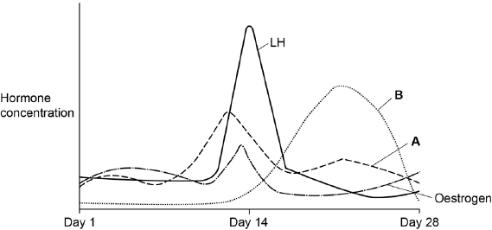

Identify hormone A and B

……………………………………………………………………………………

……………………………………………………………………………………

Describe the role of FSH

……………………………………………………………………………………

……………………………………………………………………………………

Describe the role of LH

……………………………………………………………………………………

……………………………………………………………………………………

Explain how oestrogen, LH and FSH interact to prepare the body for a fertilised egg

……………………………………………………………………………………

……………………………………………………………………………………

……………………………………………………………………………………

……………………………………………………………………………………

……………………………………………………………………………………

……………………………………………………………………………………

……………………………………………………………………………………

……………………………………………………………………………………

……………………………………………………………………………………