**CB6 Revision Mat**

Transpiration

Describe how water is lost from leaves

……………………………………………………………………………………………………………………………………………………………………………………………..…………………

State the vessel water and mineral ions are transported around the plant in

………………………………………………………………………………………………………

Absorbing water and mineral ions

Explain how root hair cells are adapted to their function

……………………………………………………………………………………………………………………………………………………………………………………………..…………………

Explain how water flows from the soil into the cytoplasm of a root hair cells

……………………………………………………………………………………………………………………………………………………………………………………………..…………………………………………………………………………………………………………………………

Explain how water flows from the soil into the cell walls of a root hair cell

……………………………………………………………………………………..………………………………………………………………………………………………………………………………………………………………………………………………………………..…………………

Describe how plants take in mineral ions to make new proteins

……………………………………………………………………………………………………………………………………………………………………………………………..…………………

Factors that affect photosynthesis

Describe the effect of temperature on the rate of photosynthesis

……………………………………………………………………………………………………………………………………………………………………………………………..……………………

Describe the effect of light intensity on the rate of photosynthesis

………………………………………………………………………………………………………..

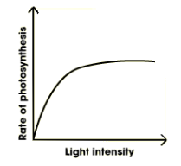

Describe the relationship between light intensity and rate of photosynthesis prior to it levelling off

………………………………………………………………………………………………………..

………………………………………………………………………………………………………..

Explain the effect of light intensity on the rate of photosynthesis

……………………………………………………………………………………………………………………………………………………………………………………………………………………

Describe the effect of carbon dioxide on the rate of photosynthesis

…………………………………………………………………………………………………………………………………………………………………………………………………………………….

Photosynthesis

State the word equation for photosynthesis

……………………………………………………………………………………

Describe how products produced in photosynthesis are used in plants

……………………………………………………………………………………

……………………………………………………………………………………

……………………………………………………………………………………

Explain why photosynthesis is an endothermic reaction

……………………………………………………………………………………

……………………………………………………………………………………

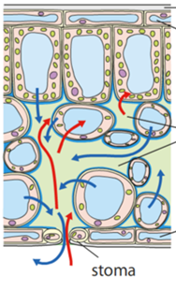

Explain how leaves are adapted for their function

……………………………………………………………………………………

……………………………………………………………………………………

……………………………………………………………………………………

……………………………………………………………………………………

Translocation

State the vessel that sucrose is transported around the plant in

……………………………………………………………………………………………………………………………………………………………………………………………..

Explain why sieve cells have very little cytoplasm

……………………………………………………………………………………………………………………………………………………………………………………………..……………………

Explain why companion cells have many mitochondria

……………………………………………………………………………………………………………………………………………………………………………………………..……………………

Transpiration

State 3 factors that would increase transpiration in plants

……………………………………………………………………………………

……………………………………………………………………………………

……………………………………………………………………………………

Describe how a student could investigate the effect of wind on transpiration (include controls, independent and dependent variables)

……………………………………………………………………………………

……………………………………………………………………………………

……………………………………………………………………………………

……………………………………………………………………………………

……………………………………………………………………………………

……………………………………………………………………………………

……………………………………………………………………………………

……………………………………………………………………………………

……………………………………………………………………………………

Describe how the xylem is adapted for its function

……………………………………………………………………………………

……………………………………………………………………………………

……………………………………………………………………………………

……………………………………………………………………………………

……………………………………………………………………………………

……………………………………………………………………………………