**CB5 Revision Mat**

Cardiovascular disease

What is cardiovascular disease?

…………………………………………………………………………………………………………………………………………………………………………………………

What lifestyle choices increase your risk of cardiovascular disease?

…………………………………………………………………………………………………………………………………………………………………………………………

How do you calculate BMI?

……………………………………………………………………………………………

What does your BMI have to be over if you are classed as obese?

……………………………………………………………………………………………

How does smoking cause disease?

…………………………………………………………………………………………………………………………………………………………………………………………………………………………………………………………………………………………………………………………………………………………………………………………………………………………………………………………………………………

Explain how stents and bypasses treat CVD

………………………………………………………………………………………………………………………………………………………………………………………………………………………………………………………………………………………

Non-communicable diseases

Give a reason why drinking too much alcohol is a problem for the society the person lives in

…………………………………………………………………………………………………………………………………………………………………………………………

Health and Disease

What is the WHO definition of health?

………………………………………………………………………………………………………………………………………………………………………………………………………………………………………………………………

Define disease

…………………………………………………………………………………………………………………………………………………………………………

What are diseases caused by?

……………………………………………………………………………………

Explain the difference between communicable and non-communicable diseases

……………………………………………………………………………………………………………………………………………………………………………………………………………………………………………………………………………………………………………………………………………………

Give an example of a communicable disease

……………………………………………………………………………………

Give an example of a non-communicable disease

……………………………………………………………………………………

Suggest why someone with HIV, a disease that attacks the immune system is more likely to get other communicable diseases

……………………………………………………………………………………………………………………………………………………………………………………………………………………………………………………………………………………………………………………………………………………

Non-communicable diseases

What causes non-communicable diseases:

1. ……………………………………………………………
2. ……………………………………………………………

What is malnutrition?

……………………………………………………………………………………………….……………………………………………………………………………………………….

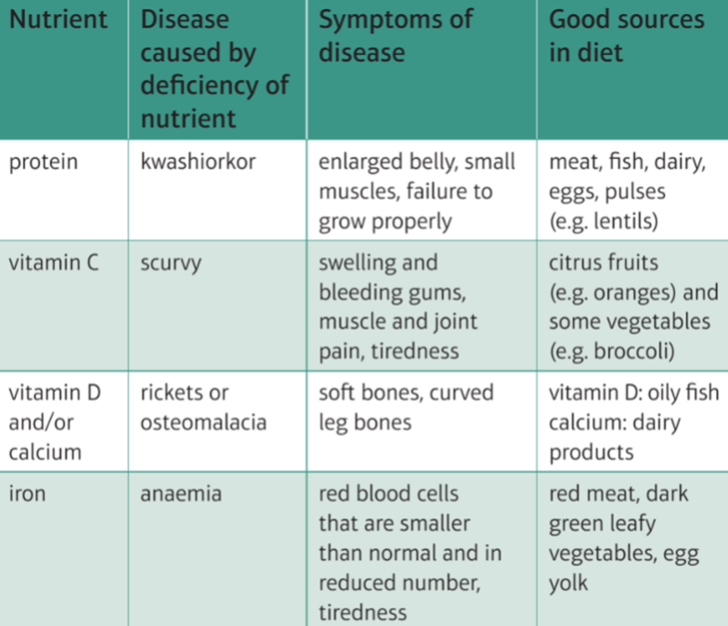

Suggest how you would treat scurvy

……………………………………………………………………………………………….

What disease is caused by drinking too much alcohol?

……………………………………………………………………………………………..

Explain why liver disease is a non-communicable disease

………………………………………………………………………………………………………………………………………………………………………………………………

Pathogens

What types of organisms cause diseases:



|  |  |  |
| --- | --- | --- |
| **Disease** | **Pathogen that causes disease** | **Symptoms** |
| Tuberculosis |  |  |
| Cholera |  |  |
| HIV |  |  |
| Chalera dieback |  |  |
| Malaria |  |  |

Explain why the above diseases are examples of communicable diseases

……………………………………………………………………………………………………………………………………………………………………………………………………………………………………………………