**CB4 Revision Mat:**

**Classification:**

Complete the table identifying the kingdoms and their main characteristics.

|  |  |
| --- | --- |
| Kingdom | Characteristics |
|  |  |
|  |  |
|  |  |
|  |  |
|  |  |

What can be said about the DNA analysis of closely related organisms?

…………………………………………………………………………………………………………………………………………………………………………………………

Explain how genetic analysis led to Archaea being placed in their own domain.

…………………………………………………………………………………………………………………………………………………………………………………………

…………………………………………………………………………………………………………………………………………………………………………………………

**Darwin’s theory cont.**

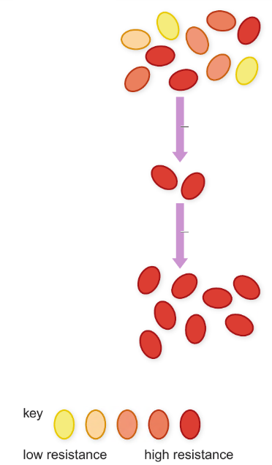

Explain how bacteria become resistance to antibiotics, supporting Darwin’s theory.

…………………………………………………………………………………………………………………………………………………………………………………………

…………………………………………………………………………………………………………………………………………………………………………………………

…………………………………………………………………………………………………………………………………………………………………………………………

…………………………………………………………………………………………………………………………………………………………………………………………

…………………………………………………………………………………………………………………………………………………………………………………………

…………………………………………………………………………………………………………………………………………………………………………………………

**Darwin’s theory:**

What is natural selection?

…………………………………………………………………………………………………………………………………………………………………………………………

How does natural selection lead to evolution?

…………………………………………………………………………………………………………………………………………………………………………………………

**Evidence of human evolution:**

What is evolution?

…………………………………………………………………………………………………………………………………………………………………………………………

Place the fossils in order of discover (oldest to youngest)

*Homo sapiens, Homo habilis, Ardipithecus ramidus, Australopithecus afarensis and Homo erectus*

Oldest: ………………………………………………………..

……………………………………………………………………….

……………………………………………………………………….

……………………………………………………………………….

Youngest: …………………………………………………….

How do stone tools provide evidence for human evolution?

…………………………………………………………………………………………………………………………………………………………………………………………

…………………………………………………………………………………………………………………………………………………………………………………………

**Genetic engineering of bacteria (Higher)**

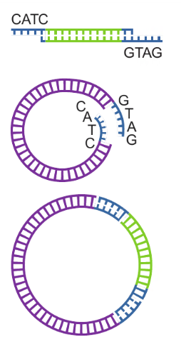

Explain how genetic engineering of bacteria is carried out.

*Include following keywords: restriction enzymes, sticky ends, ligase, vector*

…………………………………………………………………………………………………………………………………………………………………………………………

……………………………………………………………………………………………

…………………………………………………………………………………………………………………………………………………………………………………………

……………………………………………………………………………………………

…………………………………………………………………………………………………………………………………………………………………………………………

……………………………………………………………………………………………

…………………………………………………………………………………………………………………………………………………………………………………………

……………………………………………………………………………………………

…………………………………………………………………………………………………………………………………………………………………………………………

……………………………………………………………………………………………

**Genes in agriculture and medicine**

What are the benefits of selective breeding?

…………………………………………………………………………………………………………………………………………………………………………………………

……………………………………………………………………………………………

What are the risks of selective breeding?

…………………………………………………………………………………………………………………………………………………………………………………………

……………………………………………………………………………………………

Explain the advantages and disadvantages of **GM herbicide resistant plants:**

Advantages

…………………………………………………………………………………………………………………………………………………………………………………………

Disadvantages

…………………………………………………………………………………………………………………………………………………………………………………………

……………………………………………………………………………………………

Explain the advantages and disadvantages of **GM insulin**

Advantages

…………………………………………………………………………………………………………………………………………………………………………………………

Disadvantages

…………………………………………………………………………………………………………………………………………………………………………………………

……………………………………………………………………………………………

**Breeds and varieties**

What is selective breeding?

…………………………………………………………………………………………………………………………………………………………………………………………

……………………………………………………………………………………………

State characteristics that plants and animals are bred for:



What is genetic engineering?

………………………………………………………………………………………………………………………………………………………………………………………………………………………………………………………………………………………

Explain the advantages and disadvantages of GM rice ‘ golden rice’

Advantages:

……………………………………………………………………………………………………………………………………………………………………………………………………………………………………………………………………………………………………………………………………………………………………………………

Disadvantages:

……………………………………………………………………………………………………………………………………………………………………………………………………………………………………………………………………………………………………………………………………………………………………………………