**CB3 Revision Mat:**

**Alleles**

What is an allele?

……………………………………………………………………………………………

Define the following terms:

**Homozygous**

……………………………………………………………………………………………

**Heterozygous**

……………………………………………………………………………………………

**Dominant**

……………………………………………………………………………………………

**Recessive**

……………………………………………………………………………………………

**Genotype**

……………………………………………………………………………………………

**Phenotype**

……………………………………………………………………………………………

How do genetic diagrams show if the characteristic has dominant or recessive alleles?

……………………………………………………………………………………………

Complete genetic diagram

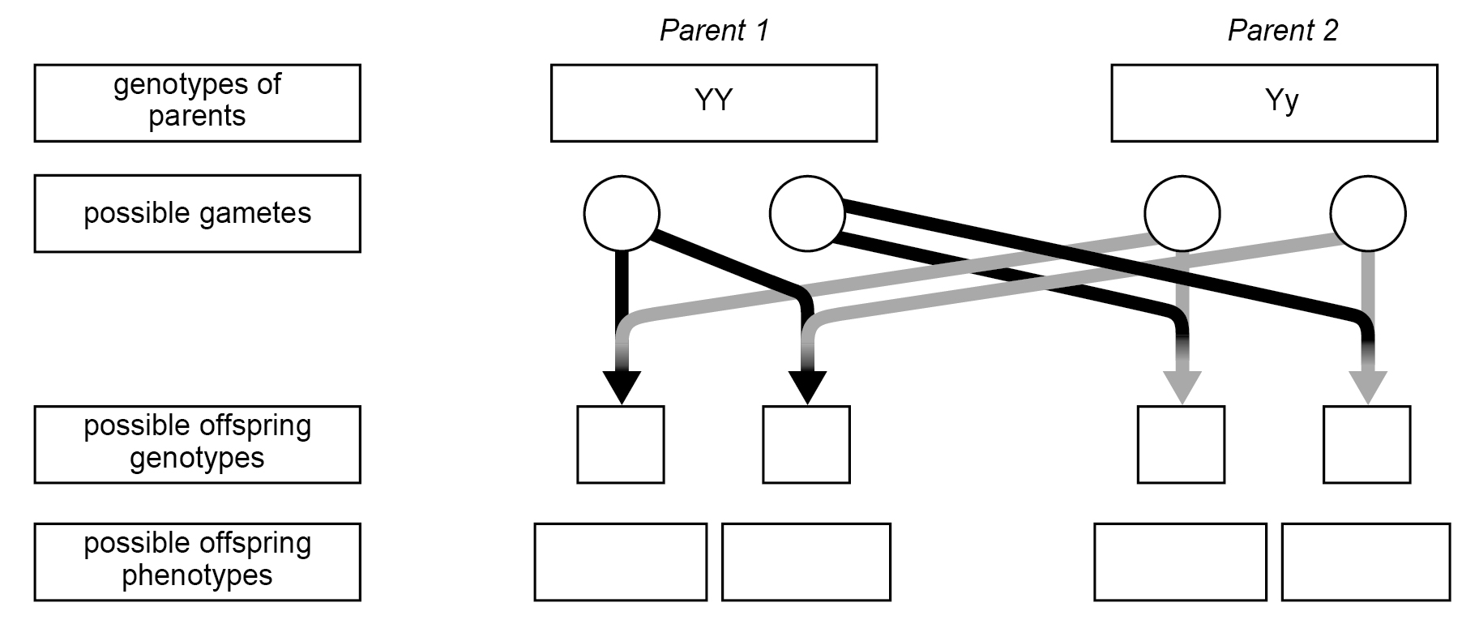

**DNA**

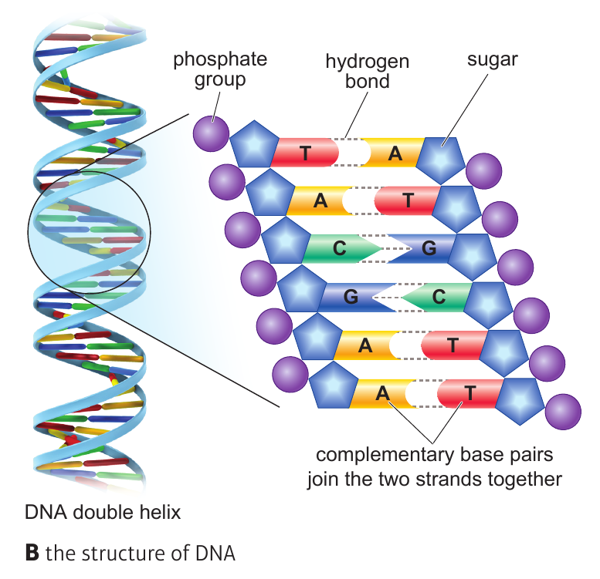

Describe the structure of DNA:

…………………………………………………………………………………………………………………………………………………………………………………………

……………………………………………………………………………………………

What is a gene?

…………………………………………………………………………………………………………………………………………………………………………………………

**DNA Extraction:**

What substance causes DNA to precipitate?

……………………………………………………………………………………………

What equipment is needed to filter a solution?

…………………………………………………………………………………………………………………………………………………………………………………………

Explain why the sample needs to be crushed.

…………………………………………………………………………………………………………………………………………………………………………………………

Explain why protease is used.

…………………………………………………………………………………………………………………………………………………………………………………………

**Meiosis**

Describe the process of meiosis:

…………………………………………………………………………………………………………………………………………………………………………………………

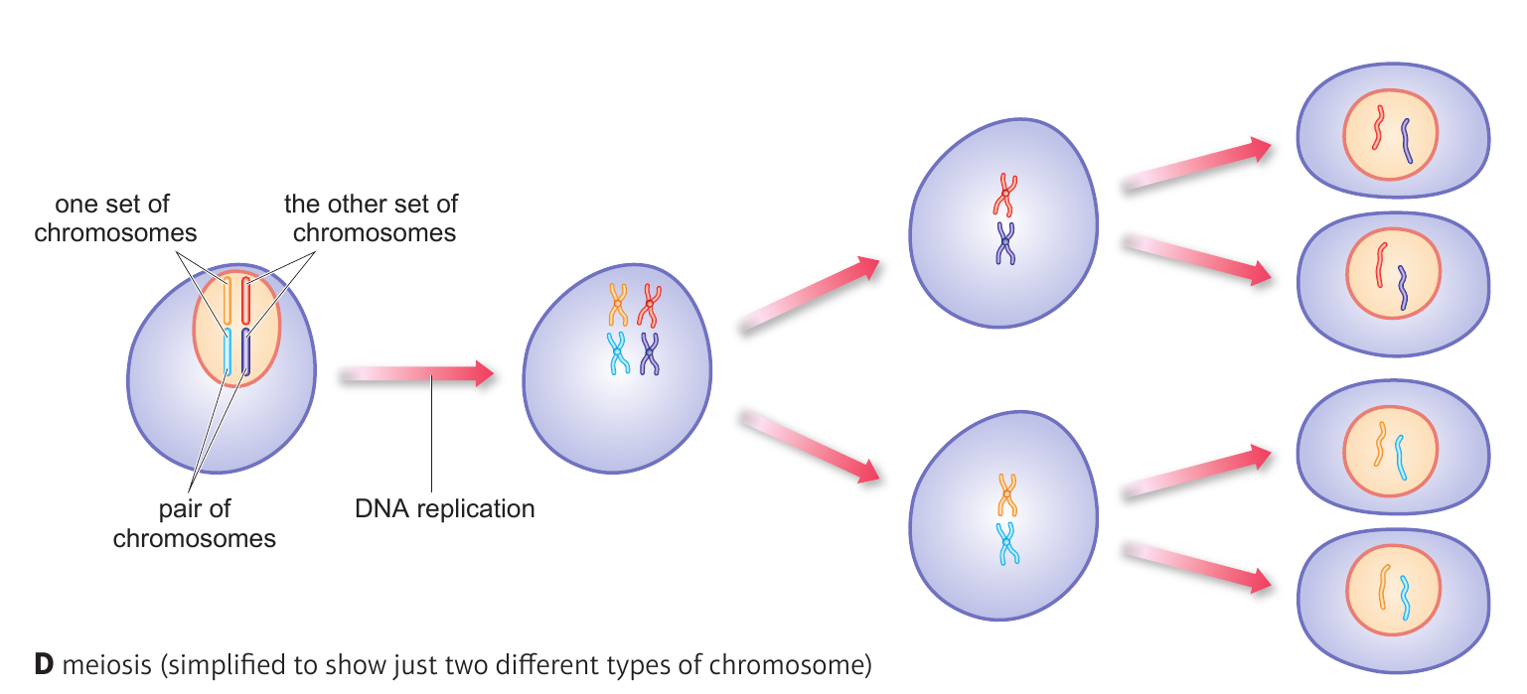

How many chromosomes do gametes (sex cells) have? …………………………………………………………

Describe the process of fertilisation

…………………………………………………………………………………………………………………………………………………………………………………………

How many chromosomes does a zygote have? …………

**Compare and contrast mitosis and meiosis:**

|  |  |
| --- | --- |
| Similarities | Differences |
|  |  |
|  |  |
|  |  |
|  |  |

**Variation:**

What are the two types of variation?



List examples of each type of variation in each column and examples of variation caused by both

|  |  |  |
| --- | --- | --- |
|  |  | **Both** |
|  |  |  |
|  |  |  |
|  |  |  |

What is meant by continuous variation and give an example

…………………………………………………………………………………………………………………………………………………………………………………………

What is meant by discontinuous variation and give an example

…………………………………………………………………………………………………………………………………………………………………………………………

**Human Genome project:**

What is the human genome project?

…………………………………………………………………………………………………………………………………………………………………………………………

What are the advantages of mapping a genome?

………………………………………………………………………………………………………………………………………………………………………………………………………………………………………………………………………………………

**Gene mutation:**

What is a mutation?

…………………………………………………………………………………………………………………………………………………………………………………………

Explain why the risk of skin cancer increases with the amount of sunlight your skin received

…………………………………………………………………………………………………………………………………………………………………………………………

Explain how mutations cause variation

………………………………………………………………………………………………………………………………………………………………………………………………………………………………………………………………………………………

**Pedigree Analysis**

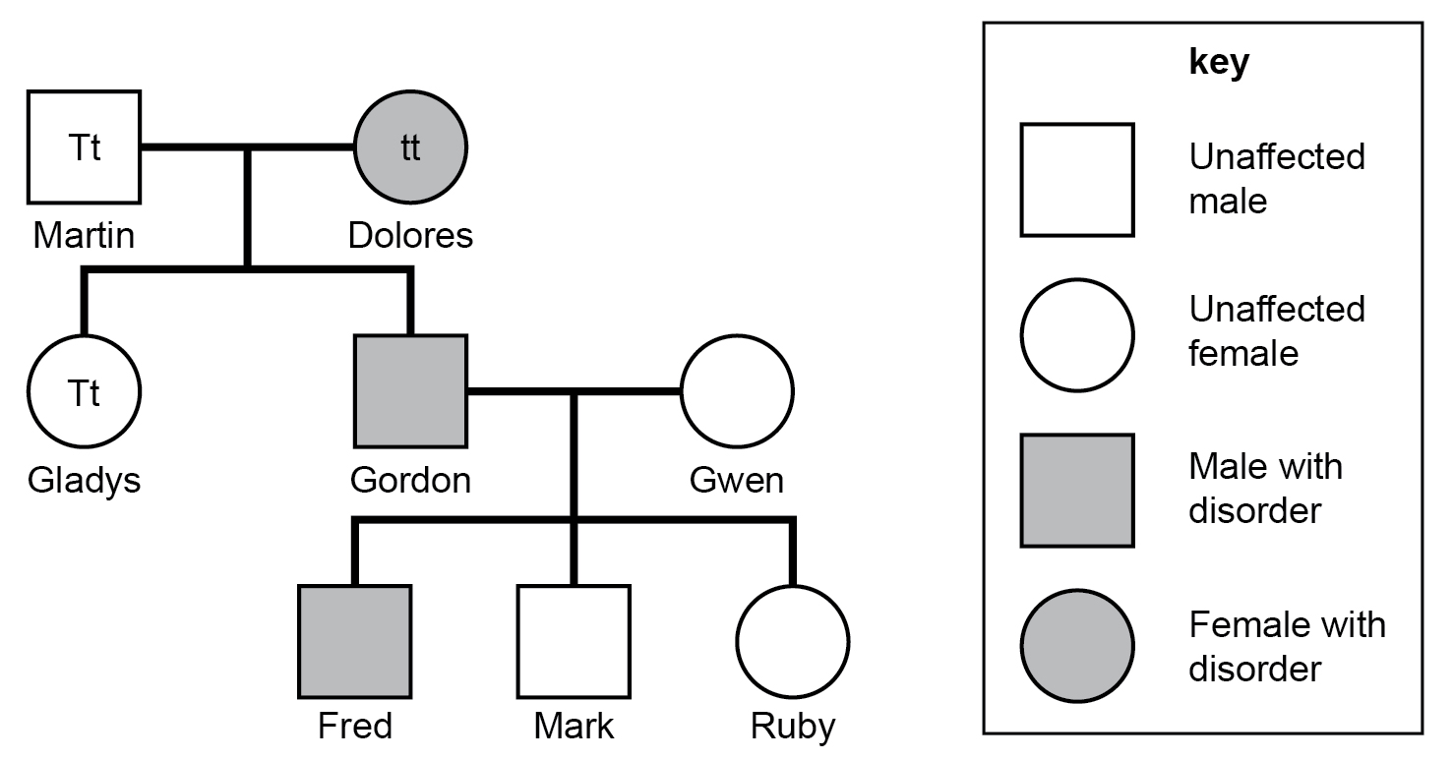

Which of Mark’s grandparent’s is homozygous?

……………………………………………………………………………………………

What must Gwen’s genotype be?

……………………………………………………………………………………………

What is the ratio of Gordon and Gwen’s children for affected to unaffected? ……………………………………..

**Inheritance**

What are the sex chromosomes of a female?

……………………………………………………………………………………………

What are the sex chromosomes of a male?

……………………………………………………………………………………………

Which gamete decides the sex of a child? …………...

Complete Punnett square

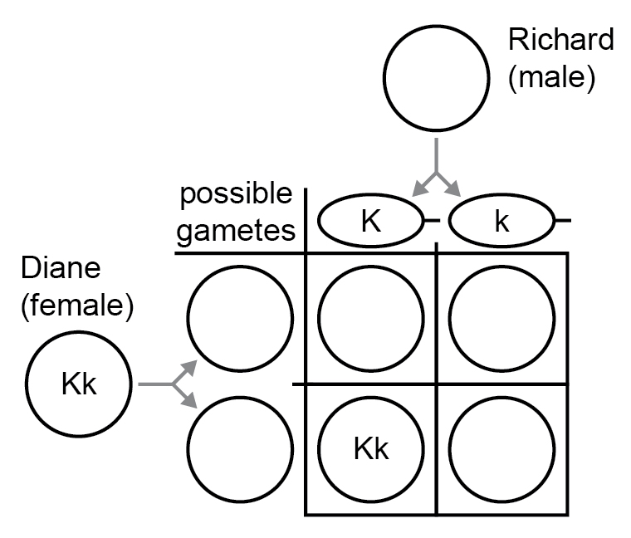

What is the percentage of homozygous recessive offspring? ……………………………………………………………………

What is the percentage of heterozygous offspring? ……………………………………………………………………

Use a Punnett square to show that the chance of two parent’s having a girl is 50%