**CB2 Revision Mat**

**Mitosis:**

Describe the process of mitosis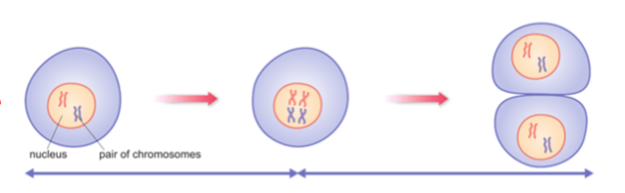

…………………………………………………………………………………………………………………………………………………………………………………………

What is mitosis needed for?

……………………………………………………………………………………

What does the term diploid mean? Give an example of diploid cells

……………………………………………………………………………………

What does the term haploid mean? Give an example of haploid cells

……………………………………………………………………………………

Stages of mitosis:

Identify each stage

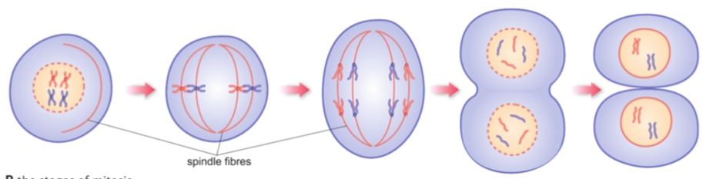

What is the difference between sexual and asexual reproduction?

…………………………………………………………………………………………………………………………………………………………………………………………

**Growth in animals**

What is growth?

…………………………………………………………………………………………………………………………………………………………………………………………

Percentile charts:

[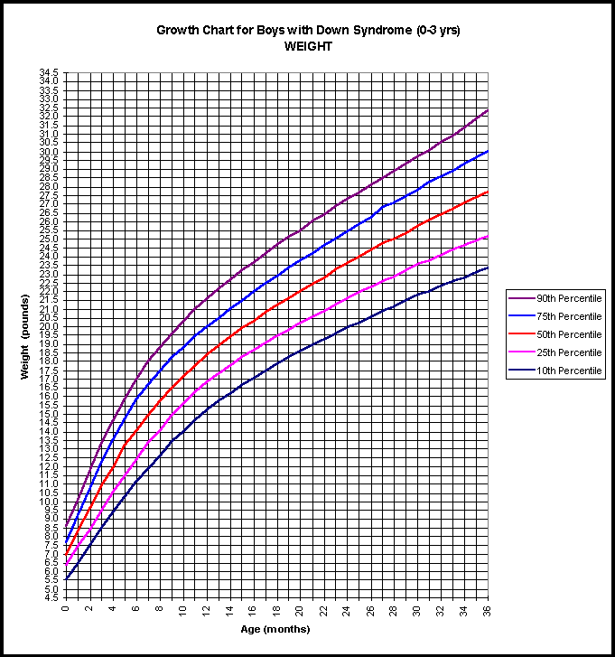](http://www.google.com/url?sa=i&rct=j&q=&esrc=s&source=images&cd=&cad=rja&uact=8&ved=0ahUKEwiSnoaGt-nRAhUFOxoKHfZaBV4QjRwIBw&url=http://www.growthcharts.com/charts/DS/charts.htm&psig=AFQjCNEDrYr0xGLTOxJznj3XrPQiYGOxMg&ust=1485850621283746)

What is meant by being on the 95th percentile?

………………………………………………………………………………………………………………………………………………………………………………………..

What is cell differentiation?

…………………………………………………………………………………………………………………………………………………………………………………………

How is a red blood cell adapted for its function? …………………………………………………………………………………………………………………………………………………………………………………………

Explain how a single fertilised egg cell can develop into billions of different cells in a human adult

……………………………………………………………………………………………………………………………………………………………………………………………………………………………………………………………………………………………………………………………………………………………………………………

…………………………………………………………………………………………………………………………………………………………………………………………

**Stem Cells**

What are the two types of stem cells in humans?

1. …………………………………………………………………….
2. …………………………………………………………………….

What is the difference between these two types?

……………………………………………………………………………………………

……………………………………………………………………………………………

Where are stem cells found in plants?

……………………………………………………………………………………………

What process do stem cells undergo to become specialised?

……………………………………………………………………………………………

**Growth in plants**

What is found at the end of shoots and roots to enable plants to keep growing?

……………………………………………………………………………………………

What processes to cells undergo in plants?

M………………………….

E…………………………..

D………………………….

How are root hair cells adapted for their function?

…………………………………………………………………………………………………………………………………………………………………………………………

How do you calculate percentage change in mass?

……………………………………………………………………………………………

**Neurotransmission speeds**

What is a synapse?

…………………………………………………………………………………………………………………………………………………………………………………………

What is released from synapses?

……………………………………………………………………………………………

What do synapses do to the speed of neurotransmission?

……………………………………………………………………………………………

**Reflex arc:**

Label the 3 neurons in the diagram below.

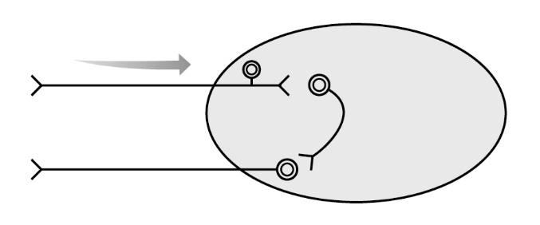

Complete flow chart for the reflex arc:

R……………………………… 🡪 …………………………………….. 🡪 ………………………………. 🡪 …………………………………….. 🡪 E…………………………….

What are the advantages of reflex arcs?

…………………………………………………………………………………………………………………………………………………………………………………………

**The Nervous System continued**

Identify structures on sensory neurone:

U ________________

V ________________

W ________________

X ________________

Y ________________

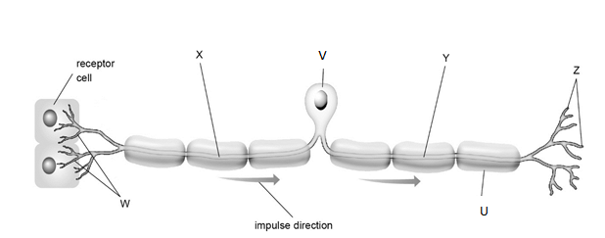

Explain why dendrons and axons are usually long.

……………………………………………………………………………………………

……………………………………………………………………………………………

Identify the motor neurone and the relay neurone.

What is the function of each?

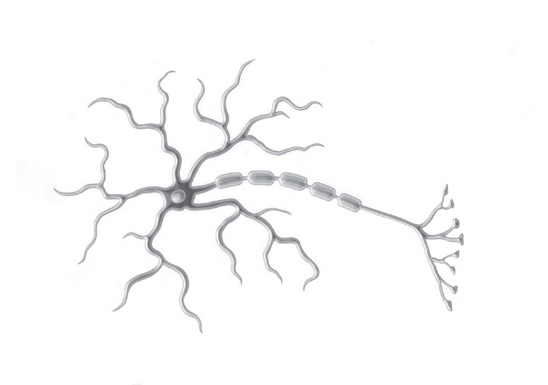

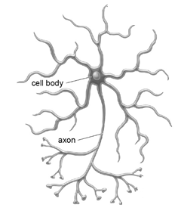

**The Nervous System**

What does the central nervous system consist of?

1. …………………………………………………………….
2. …………………………………………………………….

What do receptor cells do?

……………………………………………………………………………………………

Complete the table summarising the three types of neurones and their functions.

|  |  |
| --- | --- |
| Neurone | Function |
|  |  |
|  |  |
|  |  |

What is the role of the myelin sheath?

……………………………………………………………………………………………

……………………………………………………………………………………………

When the brain coordinates a response impulses are sent to effects such as M…………………… or G……………………….

**Stem Cells cont**

Complete table

|  |  |
| --- | --- |
| Advantages | Disadvantages |
|  |  |
|  |  |
|  |  |