**CB1 Key Concepts in Biology**

**Microscopes continued:**

Explain why electron microscopes are better than light

microscopes:

……………………………………………………………………………………………………………………………………………………………………………………………………………………………………………………………………………………………………………………………………………………………………………………………………………………………………………………………………………………………………………………………………………………………………………………………………………………………………………………………………………………………………………………………………………………………………………………………………………………………………………………………………………………

What is the equation for calculating magnification? (Draw the triangle)

An image has a length of 3mm. It has been magnified by x50. Calculate the actual length

How do you convert to the following:

**mm 🡪 um 🡪 nm 🡪 pm**

**Microscopes:**

Label the microscope:

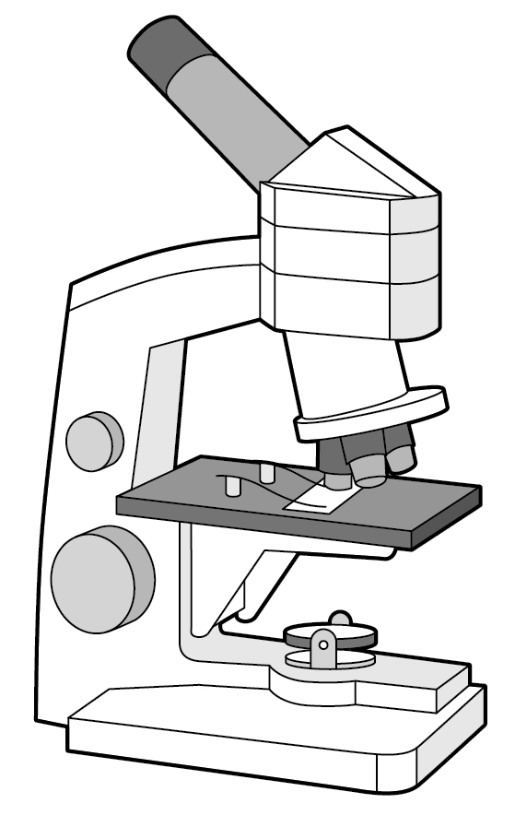

How do you calculate the total magnification from eyepiece lens and objective lens?

What does the term resolution mean?

What does the term magnification mean?

Draw a bacterial cell and label the parts:

What are the two types of DNA found in bacterial cells:

1. ___________________
2. ___________________

Draw an animal cell and label the 5 organelles.

Draw a plant cell and label the 8 organelles

What are the functions of the following: *(Highlight the organelles only found in plants)*

Chloroplasts

Nucleus

Ribosomes

Mitochondria

Cell wall

Vacuole

Cell membrane

Cytoplasm

**Enzyme activity:**

Name 3 factors that affect enzyme activity

1. _____________________
2. _____________________
3. _____________________

What does ‘optimum’ mean?

……………………………………………………………………………………

Use the graphs to describe what is happening in each.

[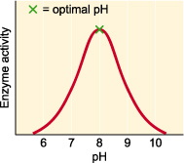](http://www.google.com/url?sa=i&rct=j&q=&esrc=s&source=images&cd=&cad=rja&uact=8&ved=0ahUKEwiUhrmdspzQAhWH0RQKHdgHCw8QjRwIBw&url=http%3A%2F%2Fwww.rsc.org%2FEducation%2FTeachers%2FResources%2Fcfb%2Fenzymes.htm&psig=AFQjCNHD4nWs76gWF9HUSKXoR_l-FXRoBA&ust=1478805578574481)

[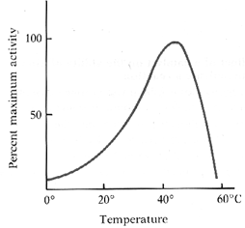](http://www.google.com/url?sa=i&rct=j&q=&esrc=s&source=images&cd=&cad=rja&uact=8&ved=0ahUKEwjfq9y8spzQAhUCsBQKHZNfCRIQjRwIBw&url=http%3A%2F%2Fscience.halleyhosting.com%2Fsci%2Fsoph%2Fenzyme%2Fenzfactorstemp.htm&bvm=bv.138169073,d.ZGg&psig=AFQjCNHihqsrsDmb_00Z0jKeZyjP9jMkmA&ust=1478805634697567)

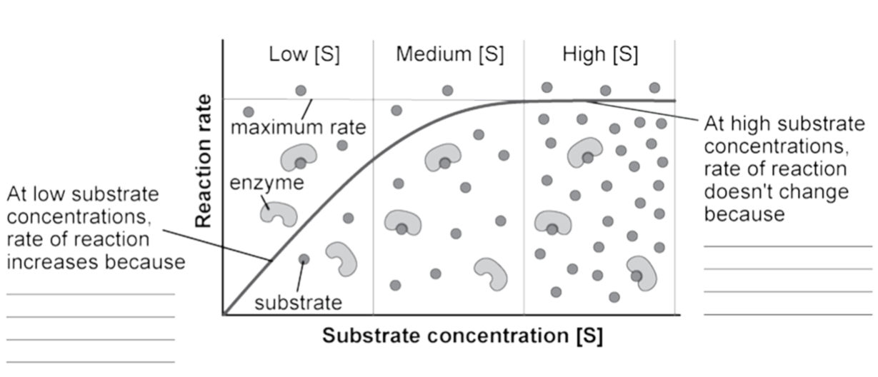

**Enzymes:**

Enzymes are **biological catalysts** which mean they speed up the rate of reaction without ……………………………………………………………………………………

Enzymes are proteins which means they are made up of ………………………………………………………………

Proteins 🡪 ____________ (by enzyme _____________)

Starch 🡪 _____________ (by enzyme _____________)

Lipids 🡪 ______________ (by enzyme _____________)

**Enzyme action:**

Using the diagram below describe how enzymes work. Label the diagram.

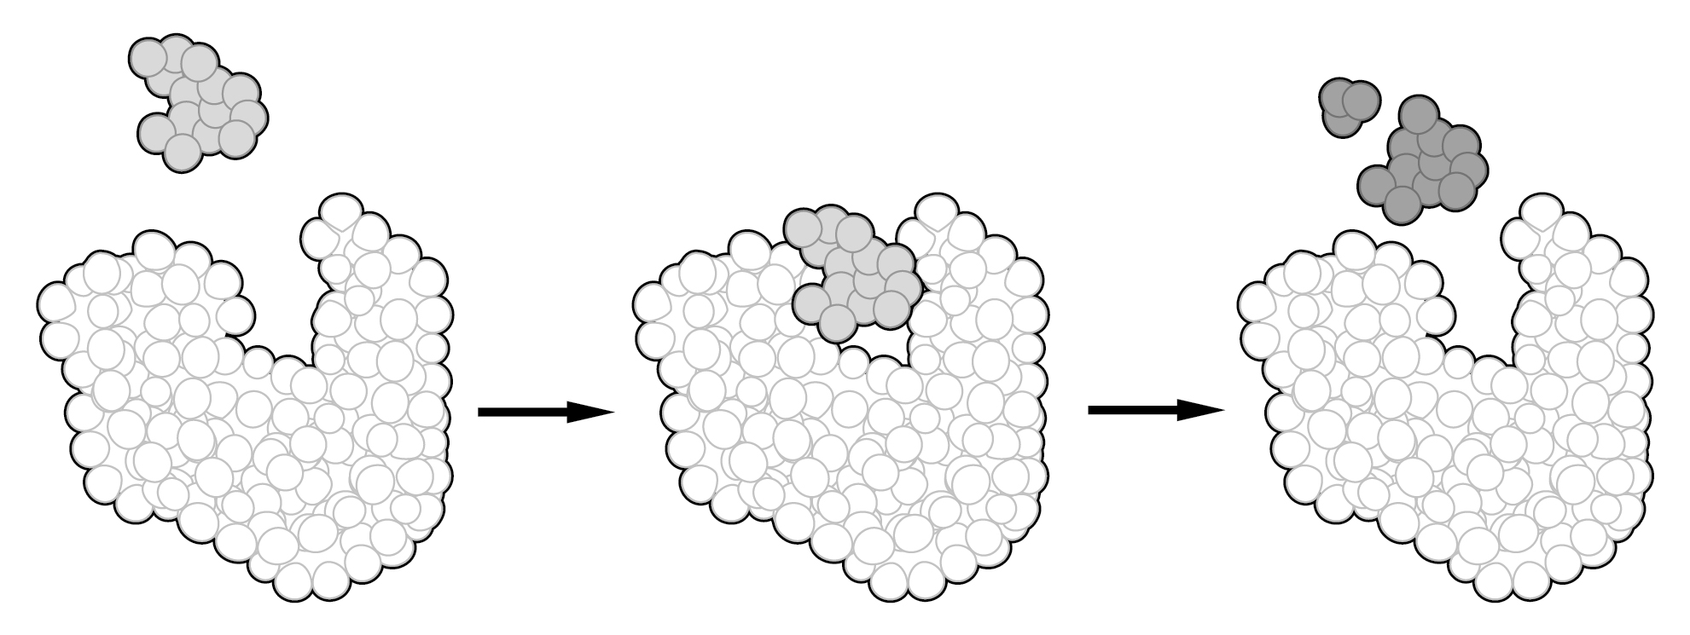

………………………………………………………………………………………………………………………………………………………………………………………………………………………………………………………………

**Specialised cells:**

**Draw a ciliated epithelial cell:**

Describe how this cell is adapted to its function of absorbing food.

………………………………………………………………………………………………………………………………………………………………………………………………………………………………………………………………

**Draw a sperm cell:**

Describe how the sperm cell is adapted to its function

…………………………………………………………………………………………………………………………………………………………………………………………………………………………………………………………………………………………………………………………………………………………………………………………………………………………………………

Draw an egg cell

Describe how the egg cell is adapted to its function

……………………………………………………………………………………………………………………………………………………………………………………………………………………………………………………………………………………………………………………………………………………