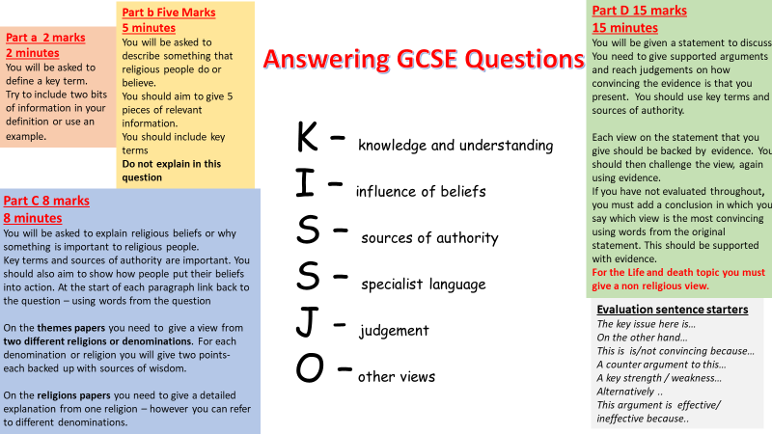
Question ‘d’
Question d is worth the most marks in every paper. It is worthwhile creating a table of brief arguments for and against the statement as a plan before you begin your answer. It will ask you to discuss and make a judgement on a particular statement. Make a point, use evidence from a source of authority, explain what this evidence suggests and how it links to the statement. The best answers of‘d’ questions will use evaluative language and will comment on how convincing each argument is. You should use evaluative sentence starters such as;
One line of argument is …
This is further supported by…
This is a convincing/strong/weak/limited argument because…
However….
On the other hand…
Moreover…
The most convincing argument is… because…
KISSJO is a useful checklist when answering a ‘d’ question.

Useful tips from Eduqas
- ‘a’ questions will only ever relate to the eight concepts given for that topic
- ‘b’ questions will always be ‘describe’ questions
- ‘c’ questions in Paper 1 will always ask for two religious views
- ‘d’ questions will assess your analysis and evaluation skills. No other question will require you to analyse a topic.
- ‘d’ questions must show that you have reached a judgement about the statement and not just give two opposing points.
- Only question 2d of Paper 1 demands a non-religious view. You may however use non-religious views in other ‘d’ answers if you think it is appropriate.
- Sources of authority include people of importance as well as sacred texts and holy books.
- Sources of authority do not have to be a quote if there is not an appropriate quote to use. Instead, you might write ‘Jesus taught compassion, therefore Christians would believe that …’
- Referring to a specific passage when giving a quote is not necessary and will not gain extra marks. Eg saying, “In John 1:14 it says…”
- Religious literacy will gain credit – use specialist language throughout every question, not just in the ‘a’ Questions.

