Knowledge Organiser – Lifestyle Indicators (B2)
Lifestyle indicators  Lifestyle data:  - Smoking  - Alcohol  - Drug use  - Inactivity  Physiological data  - BMI  - Blood pressure  - Peak flow  - Pulse  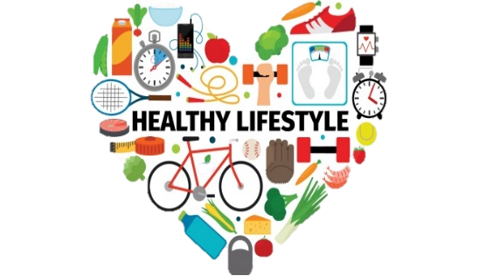 | 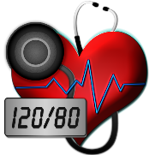  Blood pressure  Current physical health:  - Cause headaches  - Visual disturbance  - Pounding in the head  - May not cause any problems at all ‘the silent killer’  Risk to future health:  - Damages arteries, causing hardening, attracting cholesterol  - Increased risk of cardiovascular disease, stroke, dementia. | 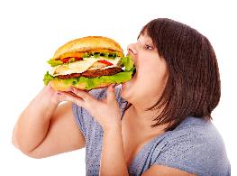  BMI (Overweight)  Current physical health:  - At risk of increasing weight  - May find exercising harder, which makes the problem worse Suggests he is consuming too many calories  Risk to future health:  - Leads to obesity  - Poor mobility  - Joint/muscle pain  - Shortness of breath  - sleep disturbance  - Obesity related disease (heart disease, diabetes etc…) | 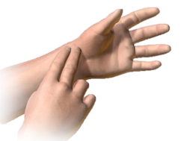  Pulse  Current physical health:  - Unhealthy lifestyle, e.g. poor diet, lack of exercise, drug use.  - His heart is having to work harder to pump oxygenated blood. May cause him to feel dizzy, sweaty, feint, making it harder to exercise  Risk to future health:  - Damage to arteries causing raised blood pressure, heart disease  - Increased risk of stroke  - Increased risk of premature death | 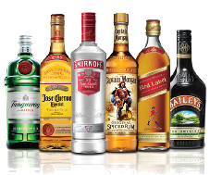  Alcohol  Current physical health:  - Decrease heart/breathing rate  - Poor decision making  - Accidents  - Nausea and vomiting  - Dehydration/hangovers  - Disturbed sleep  - Contributes to weight gain  - May be addicted to alcohol  Risk to future health:  - Liver disease  - Obesity  - Dementia  - Heart disease/cancer | 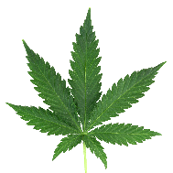  Drugs  (Cannabis)  Current physical health:  - Poor decision making  - Forgetfulness  - Anxiety  - Lower reaction time  - Loss of sex drive  - May be addicted to cannabis  Risk to future health:  - Psychosis  - Increased risk of heart disease and stroke  - Decline in IQ
Smoking  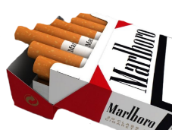  Current Physical health:  - Causes bad breath  - Stained fingers, nails & teeth  - Loss of sense taste and smell  - Increased heart rate  Risk to future health:  - Raises blood pressure  - Increases risk of heart disease  - Increases risk of stroke  - Leads to mouth, throat and lung cancers | Diet (Takeaways)  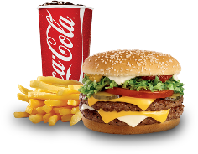  Current physical health:  - At risk of increasing weight  - May find exercising harder  - Malnutrition, obesity, cardio vascular disease, cancer  Risk to future health:  - Obesity  - Poor mobility  - Joint/muscle pain  - Shortness of breath  - Heart disease/cancer | BMI (Underweight)  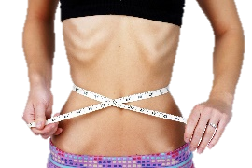  Current physical health:  - At risk of losing weight  - Lack of energy  - Poor immune system  Risk to future health:  - Anaemia  - Stunted bone growth  - Heart failure  - Tiredness  - Cancer  - Rickets  - Other deficiency diseases | Peak flow reading  Current physical health:  - Susceptibility to respiratory diseases  - May get out of breath easily, may cough or wheeze  - Needs to improve cardiovascular fitness  Risk to future health:  - Reduced mobility  - Increased weight  - May have serious asthma attack | Inactivity  Current physical health:  - Low energy levels  - Weight gain  - Loss of mobility  - Muscle and joint pain  - Poor stamina/flexibility  Risk to future health:  - Heart disease  - Obesity  - Muscle wastage/stiff joints  - Osteoporosis | 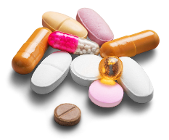  Drugs  (Prescription drugs)  Current physical health:  - Cause drowsiness  - Slurred speech  - Dizziness  - Memory loss  - Slow heart rate  Risk to future health:  - Addiction/dependency  - Risks overdose/death

